Supporting information for:

Downregulation of peroxidase activity of platinum cube enables minute-time scale colorimetric signaling of hypoxanthine for fish freshness monitoring

Xiaoming Ma^{a, b}, Tingting Fengª, Peng Zhangª, Hui Zhangª, Xuan Huª, Yuying Yangª, Zhen Wangª, Huifang Zhangª, Dong Pengª, Xiaoqi Laiª, Xun Li^{b}*, Jianguo Xuª*

ª School of Food and Biological Engineering, Hefei University of Technology, Hefei 230009, PR China
^{b} Key Laboratory of Organo-Pharmaceutical Chemistry of Jiangxi Province, School of Chemistry and Chemical Engineering, Gannan Normal University, Ganzhou 341000, PR China

*Correspondence should be addressed to Dr. Prof. Jianguo Xu.
E-mail: jgxu0816@163.com (orcid.org/0000-0002-0187-2623, J. Xu).
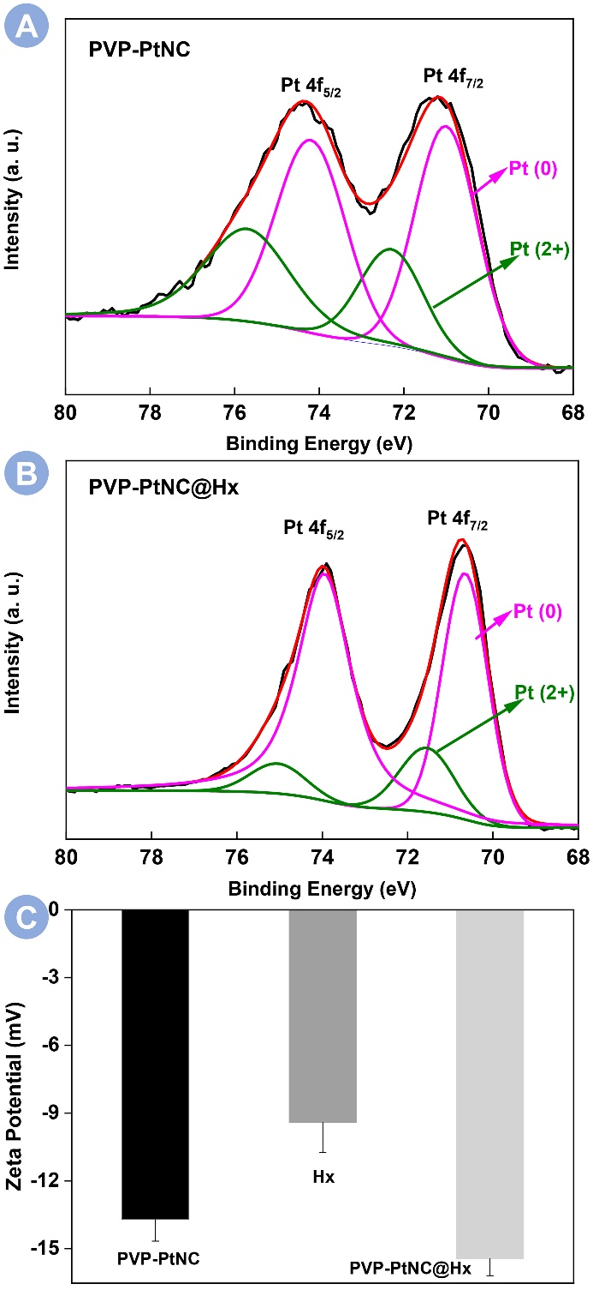
Fig. S1. Pt 4f XPS spectra of PVP-PtNC before (A) and after (B) incubated with Hx. Black, red, magenta and green lines represent the raw curve, the fitted curve, the Pt⁰ and the Pt²⁺ components’ curves, respectively. (C) Zeta potential measurements of PVP-PtNC, Hx, and their mixture.

Interaction of PVP-PtNC with Hx
To understand deeply the surface electronic structures of PVP-PtNC, the charge states of Pt species are investigated by XPS. As seen in Fig. S1A, the PVP-PtNC showed four peaks at 71.03, 72.33, 74.26, and 75.74 eV. According to the literature, the binding energies for Pt (0) 4f_{7/2} and 4f_{5/2} are 71.1 and 74.4 eV, respectively. The peaks of PVP-PtNCs at 71.03 and 75.74 eV can be assigned to Pt (0) 4f_{7/2} and 4f_{5/2}, respectively. In the absence of target HX, the fraction of Pt (II) and Pt (0) is determined as 34.6% and 65.4%, respectively. Interestingly, the addition of Hx to react with PVP-PtNC decreased the content of Pt (II) because the fraction of Pt (II) and Pt (0) is determined as 83.9% and 16.1% in Fig. S1B. The comparative results indicate the reduction of Pt (II) by H_{X}. In addition, the zeta potential of the synthesized PVP-PtNCs and HX solution were -13.7 mV and -9.4 mV, respectively, in Fig. S1C. Their mixture of PtNC@HX changed the zeta potential to -15.4 mV. Therefore, Hx is able to potentially regulate the peroxidase-like activity of PVP-PtNCs through electrostatic adsorption and there is an in-situ reduction interaction between Hx and PVP-PtNCs.

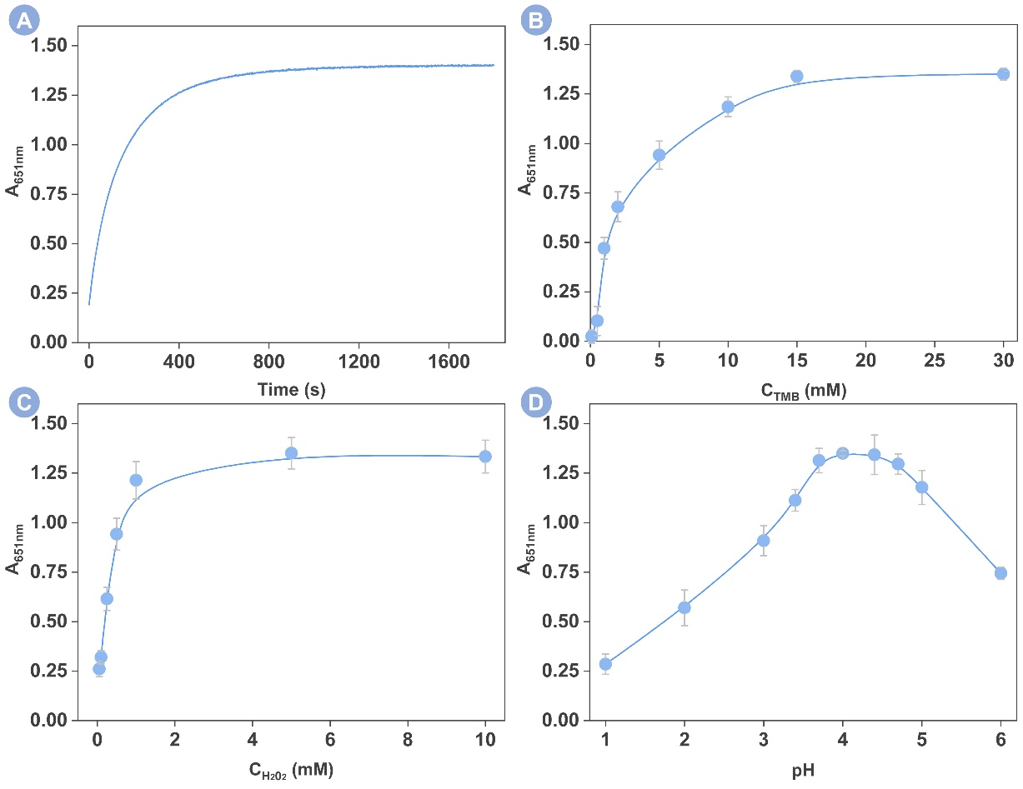
Fig. S2. Influences of (A) the reaction time, (B) the concentration of TMB, (C) the concentration of H₂O₂. and (D) the pH of the reaction solution on the catalytic reaction between TMB and H₂O₂. Errors are obtained from three repetitive experiments.

Optimization of experimental conditions
To achieve the best assay performance, the experimental conditions that are closely related to the catalytical reaction such as the reaction time, the TMB concentration, the H₂O₂ concentration, and the pH of the reaction solution, were investigated in Fig. S2. The dynamic monitoring of the peak absorption as a function of the reaction time is shown in Fig. S2A. The peak absorption was initially increased and then leveled off indicating the optimal reaction time is 10 min. Likewise, when the TMB concentration in Fig. S2B was greater than 15 mM and the H₂O₂ concentration was greater than 1 M in Fig. S2C, the peak absorption also reached a plateau, suggesting the concentration of TMB at 15 mM and the H₂O₂ at 1 M are optimal for building the sensing system. Last but not least, we optimized the pH of the reaction solution. As explored in Fig. S2D, the employing of 0.1M acetic acid/sodium acetate buffer to control the pH value of the reaction solution as 4 can achieve the highest signal output. Below or above this value, the peak absorption has deteriorated. We thus controlled the pH value of the reaction solution as 4 to investigate the Hx detection.

Table S1. Comparison of reported methods with the current one for Hx detection.
Method | Linear range (μM) | LOD (μM) | Time (min) | Ref.
Fluorescent assay | 5-120 | 1.2 | 15 | (Zhang, Kwok, Yu, Tang, & Ng, 2018)
Paper-based device | 10-700 | 3.1 | 30 | (Mustafa & Andreescu, 2020)
Microfluidic paper biosensor | 36.9-296 | 13.3 | 5 | (Mooltongchun & Teepoo, 2019)
Electrochemical assay | 20-512 | 9.5 | ＞60 | (Albelda, Uzunoglu, Santos, & Stanciu, 2017)
Colorimetric assay | 0.5-25 | 0.96 | 10 | This work

References
Albelda, J A V, Uzunoglu, A, Santos, G N C, Stanciu, L A (2017) Graphene-titanium dioxide nanocomposite based hypoxanthine sensor for assessment of meat freshness. Biosens. Bioelectron., 89(Pt 1), 518-524
Mooltongchun, M, Teepoo, S (2019) A Simple and Cost-effective Microfluidic Paper-Based Biosensor Analytical Device and its Application for Hypoxanthine Detection in Meat Samples. Food Analytical Methods, 12(12), 2690-2698
Mustafa, F, Andreescu, S (2020) Paper-Based Enzyme Biosensor for One-Step Detection of Hypoxanthine in Fresh and Degraded Fish. ACS Sens, 5(12), 4092-4100
Zhang, Z, Kwok, R T K, Yu, Y, Tang, B Z, Ng, K M (2018) Aggregation-induced emission luminogen-based fluorescence detection of hypoxanthine: a probe for biomedical diagnosis of energy metabolism-related conditions. J Mater Chem B, 6(28), 4575-4578

