Table 3. Subgroup analyses for drinking tap water and risk of UGI cancer incidence by age and gender†.
Subgroups | Number of cases | HRs (95%CI) |  | P _{interaction}
UGI cancer |  | 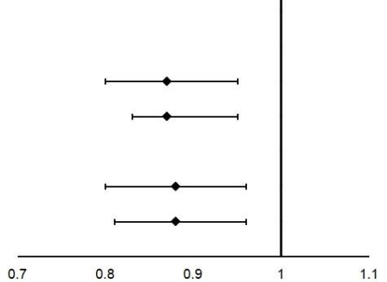
Age at baseline |  |  |  | 0.77
<55years | 3196 | 0.87(0.80-0.95)
≥55years | 2284 | 0.87(0.83-0.95)
Gender |  |  |  | 0.92
Female | 2528 | 0.88(0.80-0.96)
Male | 2952 | 0.88(0.81-0.96)
EC |  | 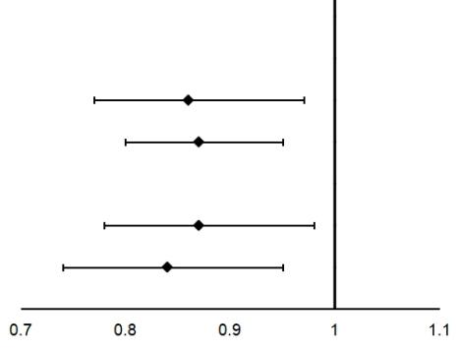
Age at baseline |  |  |  | 0.76
<55years | 1833 | 0.86(0.77-0.97)
≥55years | 1280 | 0.87(0.80-0.95)
Gender |  |  |  | 0.54
Female | 1625 | 0.87(0.78-0.98)
Male | 1488 | 0.84(0.74-0.95)
GC |  | 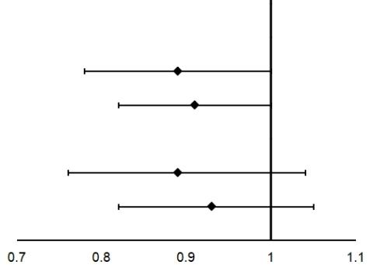
Age at baseline |  |  |  | 0.46
<55years | 1363 | 0.89(0.78-1.00)
≥55years | 1004 | 0.91(0.82-1.00)
Gender |  |  |  | 0.69
Female | 903 | 0.89(0.76-1.04)
Male | 1464 | 0.93(0.82-1.05)
Abbreviations: HR=hazard ratio; 95% CI=95% confidence interval; UGI=upper gastrointestinal. EC=esophageal cancer; GC=gastric cancer.
Bold text indicates statistical significance (P <0.05).
†Adjusted for age at baseline, gender, body mass index, smoking, alcohol drinking, family history of UGI cancer, education level, nutrition intervention arms, and frequency intakes of fruit and vegetable.

Table 4. Subgroup analyses by nutrition intervention for the association between drinking tap water and risk of UGI cancer incidence†.
Subgroups | Number of cases | HRs (95%CI) | 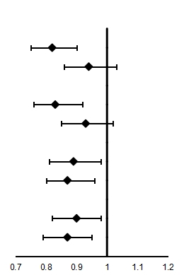 | P _{interaction}
UGI cancer
Factor A |  |  |  | 0.06
No | 2713 | 0.82(0.75-0.90)
Yes | 2767 | 0.94(0.86-1.03)
Factor B |  |  |  | 0.07
No | 2757 | 0.83(0.76-0.92)
Yes | 2723 | 0.93(0.85-1.02)
Factor C |  |  |  | 0.87
No | 2627 | 0.89(0.81-0.98)
Yes | 2853 | 0.87(0.80-0.96)
Factor D |  |  |  | 0.51
No | 2671 | 0.90(0.82-0.98)
Yes | 2809 | 0.87(0.79-0.95)
 |  |  | 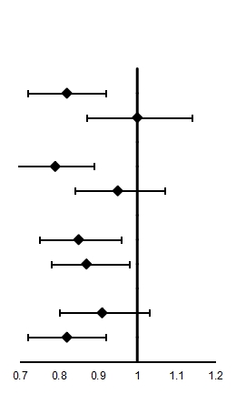
EC
Factor A |  |  |  | 0.24
No | 1502 | 0.82(0.72-0.92)
Yes | 1611 | 1.00(0.87-1.14)
Factor B |  |  |  | 0.03
No | 1586 | 0.79(0.69-0.89)
Yes | 1527 | 0.95(0.84-1.07)
Factor C |  |  |  | 0.71
No | 1496 | 0.85(0.75-0.96)
Yes | 1617 | 0.87(0.78-0.98)
Factor D |  |  |  | 0.17
No | 1470 | 0.91(0.80-1.03)
Yes | 1643 | 0.82(0.72-0.92)
GC |  |  | 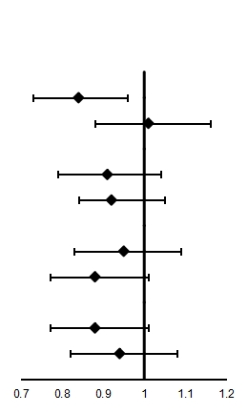
Factor A |  |  |  | 0.12
No | 1211 | 0.84(0.73-0.96)
Yes | 1156 | 1.01(0.88-1.16)
Factor B |  |  |  | 0.83
No | 1171 | 0.91(0.79-1.04)
Yes | 1196 | 0.92(0.80-1.05)
Factor C |  |  |  | 0.51
No | 1131 | 0.95(0.83-1.09)
Yes | 1236 | 0.88(0.77-1.01)
Factor D |  |  |  | 0.56
No | 1201 | 0.88(0.77-1.01)
Yes | 1166 | 0.94(0.82-1.08)
Abbreviations: HR=hazard ratio; 95% CI=95% confidence interval; UGI=upper gastrointestinal. EC=esophageal cancer; GC=gastric cancer.
Bold text indicates statistical significance (P <0.05).
†Adjusted for age at baseline, gender, body mass index, smoking, alcohol drinking, family history of UGI cancer, education level, nutrition intervention arms, and frequency intakes of fruit and vegetable.

