Supporting information
for

The original of the ion transport, charge transfer and energy exchange in the electrochemical interface
Guoping Gao
Guoping Gao¹*, Lin-Wang Wang²*
¹MOE Key Laboratory for Non-equilibrium Synthesis and Modulation of Condensed Matter, Shaanxi Province Key Laboratory of Advanced Functional Materials and Mesoscopic Physics, School of Physics, Xi'an Jiaotong University, Xi'an, Shaanxi 710049, China
E-mail: guopinggao@xjtu.edu.cn
²Institute of Semiconductors, Chinese Academy of Sciences, Beijing 100083, China
E-mail:lwwang@semi.ac.cn

- The distribution of the charge

Table S1 the charge states of the whole system, two water layers and Pt electrode
 | 0th | 1st | 2nd | 3rd | 4th | 5th | 6th
total | -0.69 | +0.23 | +1.06 | +1.30 | +1.40 | +1.45 | +1.50
Water layers | +0.71 | +1.54 | +1.45 | +1.81 | +1.93 | +1.94 | +1.74
Pt electrode | -1.40 | -1.31 | -0.39 | -0.52 | -0.53 | -0.49 | -0.24

Table S2 the location of the obtained electron
 | 0 | 1st | 2nd | 3rd | 4th | 5th
$$N_{ic}$$ | 1.07 | 0.60 | 0.21 | 0.09 | 0.04 | 0.02
Sum up peaks 1, 2 | 1.02 | 0.61 | 0.20 | 0.08 | 0.03 | 0.03
Peak 1 | 0.71 | 0.41 | 0.13 | 0.05 | 0.02 | 0.01
Peak 2 | 0.31 | 0.20 | 0.07 | 0.03 | 0.01 | 0.02

- The orbital analysis of water, protonated water under different conditions
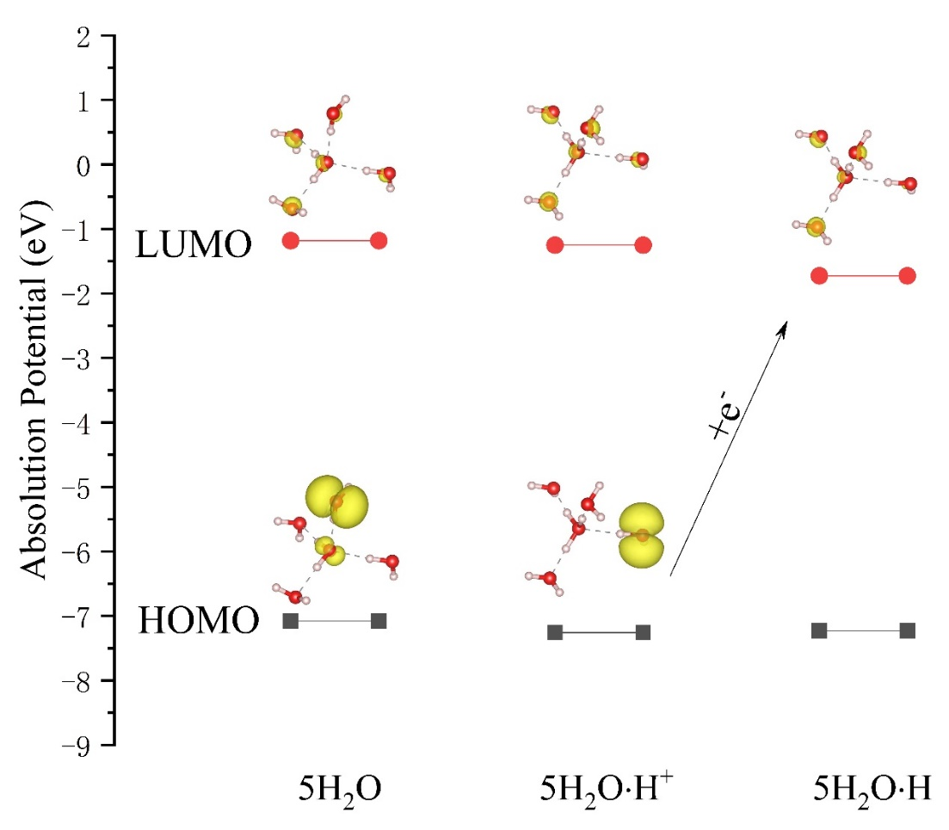
Figure S1 The HOMO-LUMO energy level of clusters: 5H₂O, 5H₂O﹒H⁺, and 5H₂O﹒H. The HOMO-LUMO energy levels of 5H₂O are -7.08 V and -1.18 V. With an extra H⁺, the HOMO-LUMO energy levels decrease to -7.26 V and -1.25 V. The LUMO energy levels of 5H₂O and 5H₂O﹒H⁺ are over 3 V higher than the applied potentials in this work. If we add an electron to the 5H₂O﹒H⁺, the occupied energy level is -1.72 V, which is still much higher than the applied potential. Therefore, the H⁺ will not be reduced in the water.
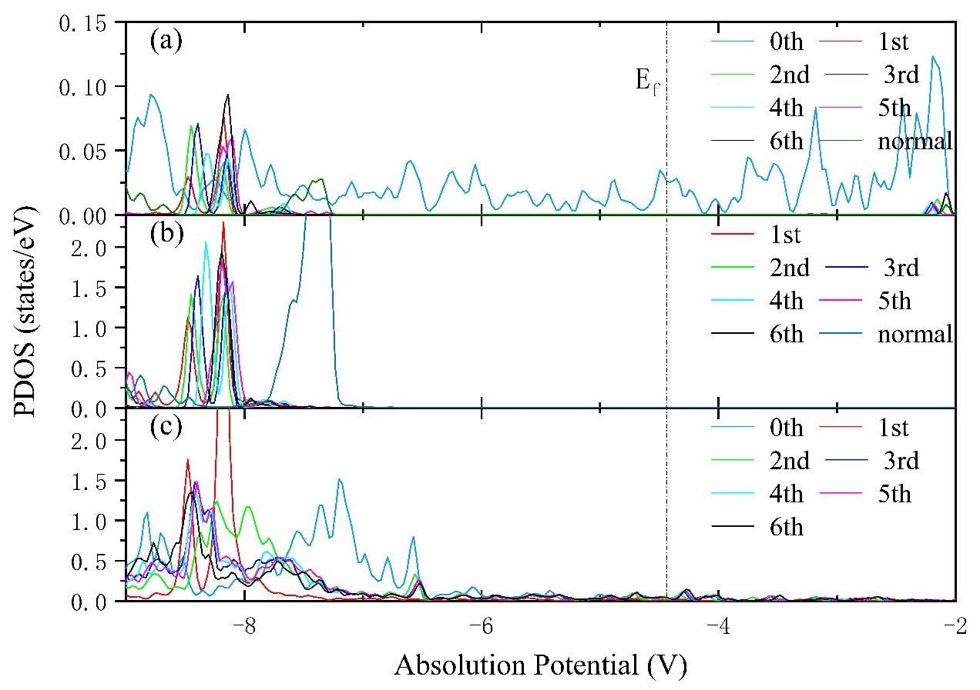
Figure S2 The PDOS of H-s (a) and O-p (b) in the H₃O⁺, and O-p (c) of a water in the first water layer during the proton migration and reduction process. The label ‘normal’ is the PDOS of H-s or O-p of a normal in the 3rd water layer, which is present as a reference. When the H* is on the Pt surface (0th layer), the H-s of H* are present in (a), while no O-p in the H₃O⁺ is available to show in (b).
As we can see from figures S2a and S2b, the highest occupied energy levels of H-s and O-p in the H₃O⁺ are below 7.0 eV, which are deeper these in normal water. The proton migration only slightly changes the highest occupied energy level of H-s and O-p in the H₃O⁺, No PDOS of them shift over the Fermi level. Thus, the H₃O⁺ is not reduced during the proton migration. When the H* adsorption on the Pt surface, the H-s spans across the Fermi Level, indicating the H* are obtained electron and reduced in this step. Induced by the negatively charged Pt electrode, there is always a small PDOS of O-p of water in the first water layer span across the Fermi level. Therefore, during the proton migration and reduction steps, the Oxygen in the first water layer can host some extra electrons.

- The electron exchange between system and external reservoir during the proton migration and reduction under different potentials and H* coverage
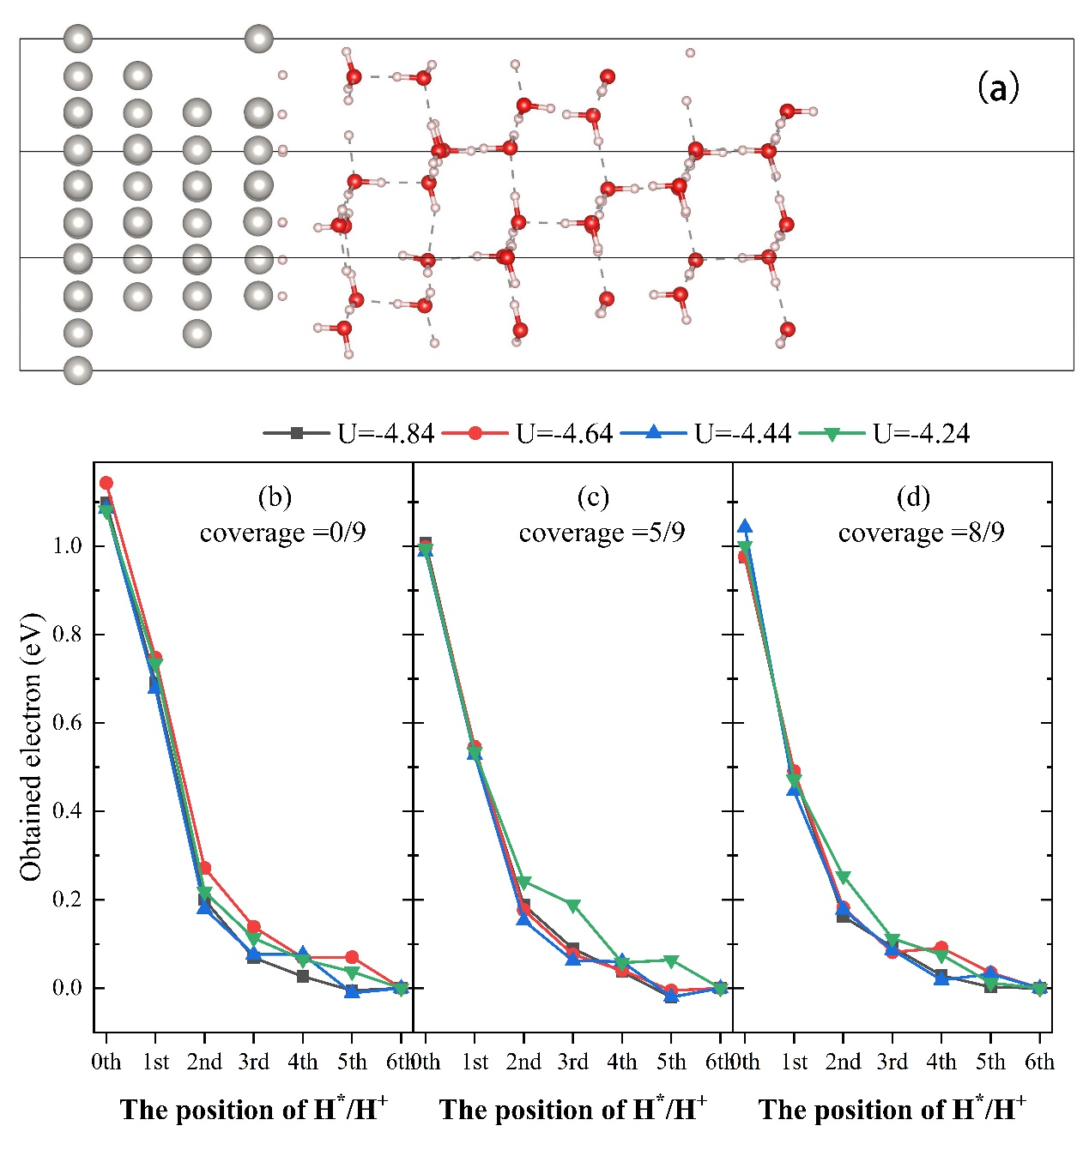
Figure S3 The obtained electron of the whole system when the proton migration from the outer Helmholtz layer (6th) to Pt electrode (0th) under different potentials. (b) the coverage of H* is 0/9; (c) the coverage of H* is 5/9; (d) the coverage of H* is 8/9.

Table S3 The average obtained electrons during proton migration from the outer to inner Helmholtz layers and reduction under the H* coverage of 0/9, 5/9 and 8/9.
 | $$θ=1/9$$ | $$θ=6/9$$ | $$θ=9/9$$
Outer to Inner | 0.71 | 0.54 | 0.47
Reduction | 0.40 | 0.46 | 0.53
Total | 1.11 | 1.00 | 1.00
We used the single-side model (Fig.S1a) to investigate the influence of H* coverage on the obtained electrons as shown in Fig. S1 and Table S1. Similar charge transfer behavior can be found in the different H* coverages when the proton migrated toward the electrode. However, as the H* coverage increases from 0 to 8/9, the adsorbed H* will weaken the polarity in the electrode-solvent interface. Therefore, the $N_{ic}$ obtained during the migration from the outer to inner Helmholtz layers decreases from 0.71e- to 0.47e-, while the $N_{rc}$ obtained during the reduction increases slightly from 0.40e- to 0.53e-. The $N_{oe}$ during the whole process converges to 1.0 e⁻ at higher H* coverage.
- The calculation detail of grand free energy
The grand free energy of the charged system is defined by:
$G_{grand}=E^{q}+qU_{abs}+ZPE+TS$ (S1)
Here, $E^{q}$is the total energy of the charged system, $qU_{abs}$ is the electron’s energy at U_{abs}. During the proton migration, there are two states for proton: proton in the water layer and proton on the Pt surface. We assumed the entropy difference between the proton in the water layer and it on the Pt surface is zero, so the contribution of TS is not considered in this equation. The $ZPE$ is the proton’s frequency contribution to zero-point energy. To obtain the zero-point energy E_{ZPE}, we only consider the contribution of the clusters involved in the reactions and neglect the contribution of Pt (111) and water layers. When the proton is in the water layer, the frequency difference between H₃O⁺ and normal water in the water layer is considered as the proton’s frequency. The frequencies of H* are calculated to obtain E_{ZPE} of a proton on the Pt surface.
- The process of reference potential determination and the derivation of the local pH value as a function of U_{abs} of the electrode and its distance from the electrode
Figure S4 The free energy difference between proton at 1st water layer and it at 6th water layer as a function of applied potential.

The free energy difference between proton at 1st water layer and it at 6th water layer as a function of applied potential can be fitted by the equation:
$∆G=-0.64{(U}_{abs}+4.99)$ (S2)
The slope of -0.64 is close to the $N_{ic}$ (0.60 e⁻) during the proton migration. -4.99 is the potential of zero total charge of Pt (111) electrodes. Under this potential, the pH of the solvent is universal. Combining formula (2) in the manuscript, we can extend equation S2 to the other water layers, then equation S2 can be rewritten via equation S3
$∆G=-N_{ic}{(U}_{abs}+4.99)=-\frac{AZ}{d}(U_{abs}+4.99)=-\frac{1.66}{d}{(U}_{abs}+4.99)$ (S3)
Assumed the pH of bulk solvent (outer Helmholtz layer) is pH₀, and the concentration of proton is C₀, based on the Boltzmann distribution equation, the concentration of proton near the electrode can be obtained via equation S4
$C=C_{0}e^{(-\frac{∆G}{kT})}=C_{0}e^{(\frac{\frac{1.66}{d}(U_{abs}+4.99)}{kT})}$ (S4)
The corresponding pH value can be obtained by equation S5
$pH={pH}_{0}-\frac{1.66{(U}_{abs}+4.99)}{dkTln10}$ (S5)

