Supplementary Material
Preparation of fractured nanoquartz: surface features and cell membrane damage

Chiara Bellomo^{1,2}, Cristina Pavan^{1,2,3}, Gianluca Fiore^{1,4}, Guillermo Escolano-Casado^{1,4}, Lorenzo Mino^{1,4}, Francesco Turci^{1,2,4,*}
¹Department of Chemistry, University of Turin, Turin, Italy
²“G. Scansetti” Interdepartmental Centre for Studies on Asbestos and Other Toxic Particulates, University of Turin, Turin, Italy
³Louvain Centre for Toxicology and Applied Pharmacology, Université catholique de Louvain, Brussels, Belgium
⁴Nanostructured Interfaces and Surfaces Interdepartmental Centre, University of Turin, Turin, Italy

This document includes:
- FE-SEM micrographs of gQ-n1, gQ-n2 and gQ-n3;
- DLS analysis of gQ-n1 and gQ-n2;
- TEM micrographs of gQ-n3;
- Analysis of the d-spacing of gQ-n3

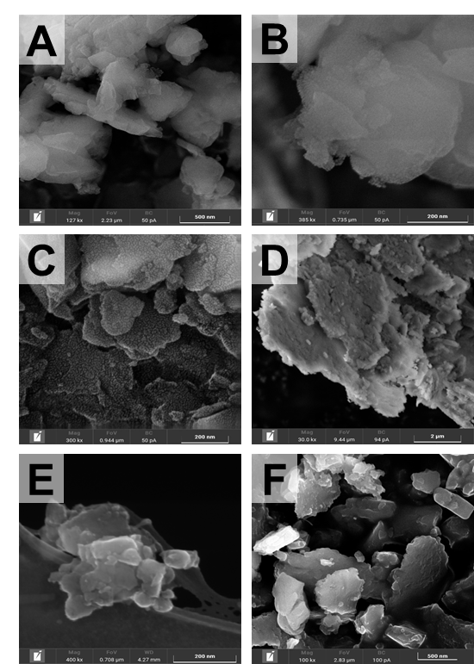

Figure S1. SEM micrographs of (A-B) gQ-n1, (C-D) gQ-n2, (E-F) gQ-n3 at various magnification (reported on the micrographs).

Figure S2. Hydrodynamic size reported in intensity-distribution and number-distribution of gQ-n1 and gQ-n2 measured by DLS analysis. Particles were dispersed in water and in different biologically relevant media, i.e., Triton X (TRX), dioctyl sulfosuccinate sodium salt (AOT), bovine serum albumin (BSA), phosphate buffered saline (PBS, 10 mM, pH 7.4), artificial phagolysosome fluid (ALF, pH 4.5), and filtered through 200-nm pore size filter.

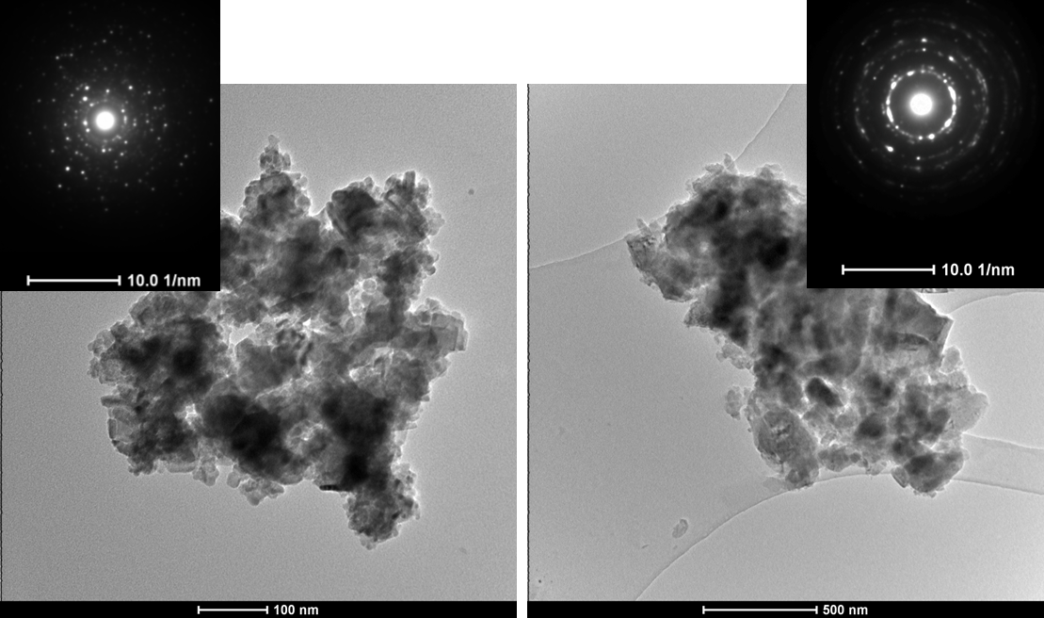
Figure S3. TEM micrographs of gQ-n3 and relative multiple reflection and rings which confirm the crystalline nature of the powder.

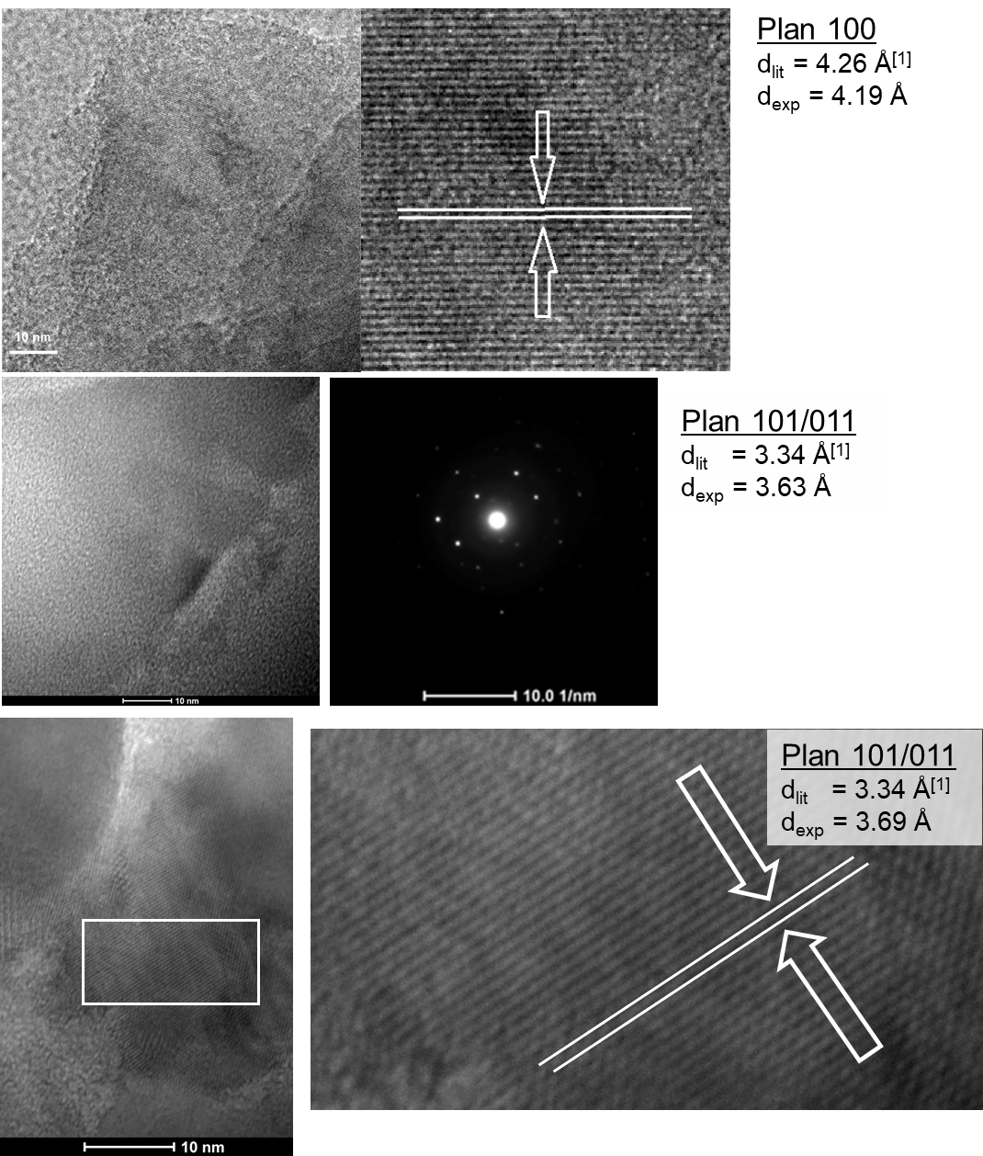

Figure S4: Elaboration of TEM data and individuation of the crystal planes of gQ-n3.

1) Levien, Louise, Charles T. Prewitt, and Donald J. Weidner. "Structure and elastic properties of quartz at pressure." American Mineralogist 65.9-10 (1980): 920-930.

