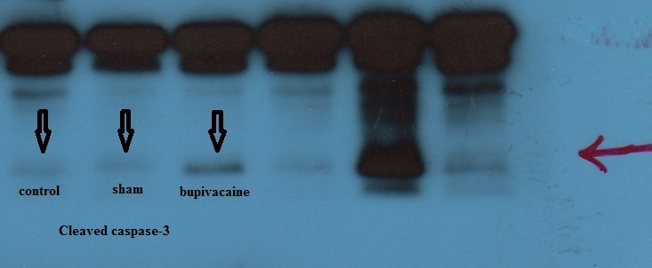
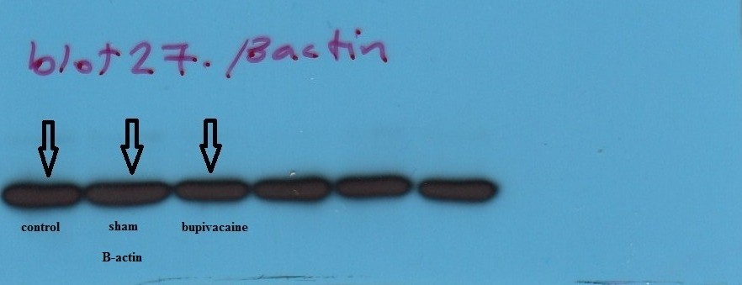
Figure 1. The identified wells represent Caspase-3, Cleaved Caspase-3 and B-actin and other wells are related to another studies.

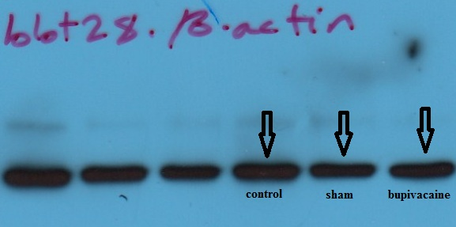
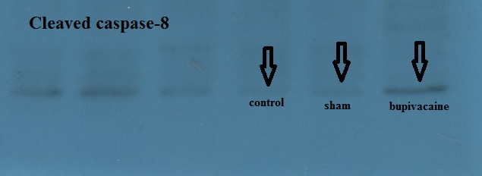
Figure 3. The identified wells represent cleaved Caspase-8 and B-actin and other wells are related to another studies.

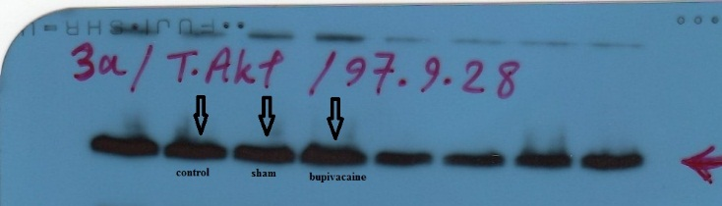
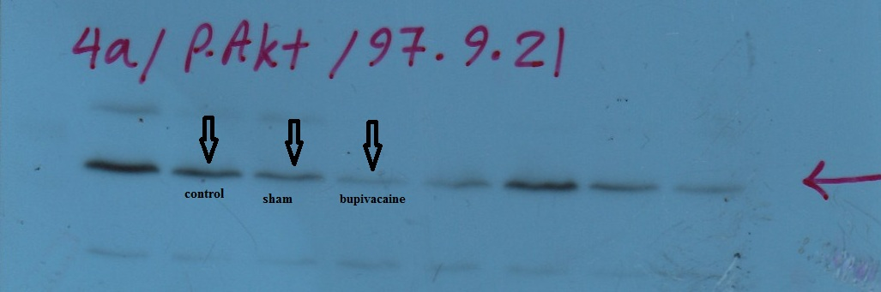
Figure 3. The identified wells represent T.Akt and P.Akt and other wells are related to another studies.

