Supplementary Information

Self-healing passive cooling utilizing endothermic reaction of NH₄NO₃/H₂O driven by moisture sorption for photovoltaic cell

Seonggon Kim^{1,2}, Jong Ha Park², Jae Won Lee², Yongchan Kim^{1,2}, Yong Tae Kang^{1,2*}

¹School of Mechanical Engineering, Korea University, 145 Anam-ro, Seongbuk-gu, Seoul 02841, Republic of Korea
²Research Center for Plus Energy Building Innovative Technology, 145 Anam-ro, Seongbuk-gu, Seoul 02841, Republic of Korea

*Corresponding author
E-mail: ytkang@korea.ac.kr, Tel: +82-2-3290-5952, Fax: +82-2-922-3260
Table S1. Components analysis using energy dispersive X-ray spectrometer
 | Element (wt%)
Materials | O | Na | Mg | Al | Si | Ca | K | Fe | P
Zeolite 13X | 40.7 | 15.1 | 1.5 | 17.9 | 24.3 | 0.5 | - | - | -
Zeolite 5A | 41.9 | 2.6 | 0.9 | 18.9 | 22.1 | 13.6 | - | - | -
Zeolite 3A | 38.8 | 9.3 | 2.6 | 17.1 | 25.1 | - | 6.3 | 0.8 | -
Zeolite Y | 49.5 | 0.8 | - | 14.2 | 35.5 | - | - | - | -
SAPO-34 | 39.0 | 19.0 | 0 | 20.8 | 20.0 | - | - | - | 1.2
SSZ-13 | 51.42 | - | - | 7.27 | 41.31 | - | - | - | -

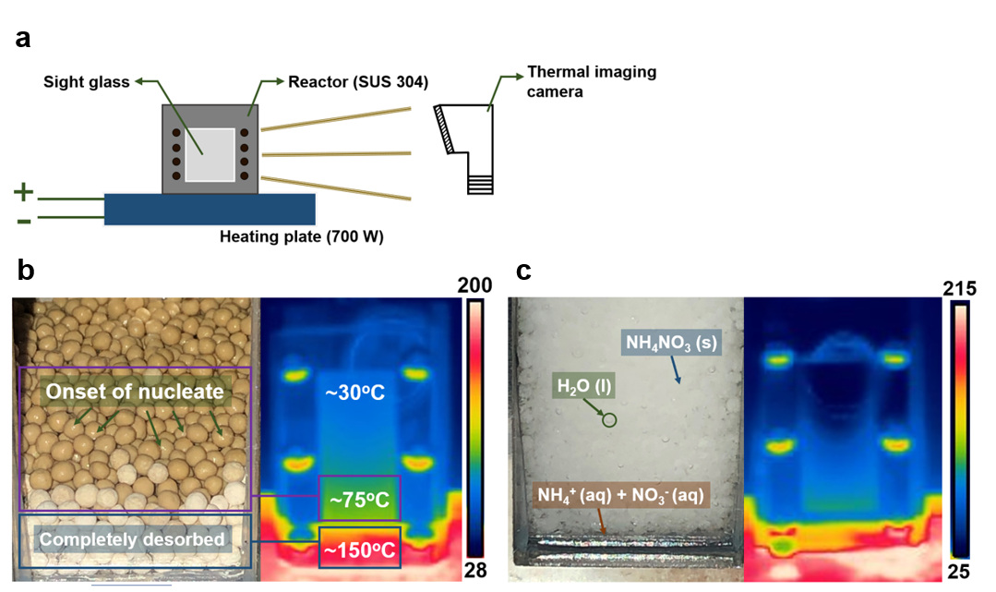
Figure S1. Visualization analysis during heat dissipation process; a) Schematic of thermal imaging experiment; b) Latent cooling using zeolite 13X/H₂O; c) Endothermic reaction cooling using NH₄NO₃/H₂O

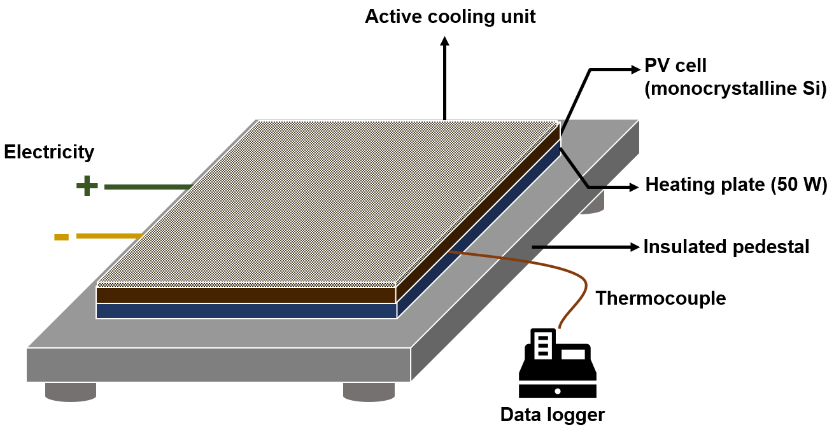
Figure S2. Experimental device for evaluation of heat dissipation performances

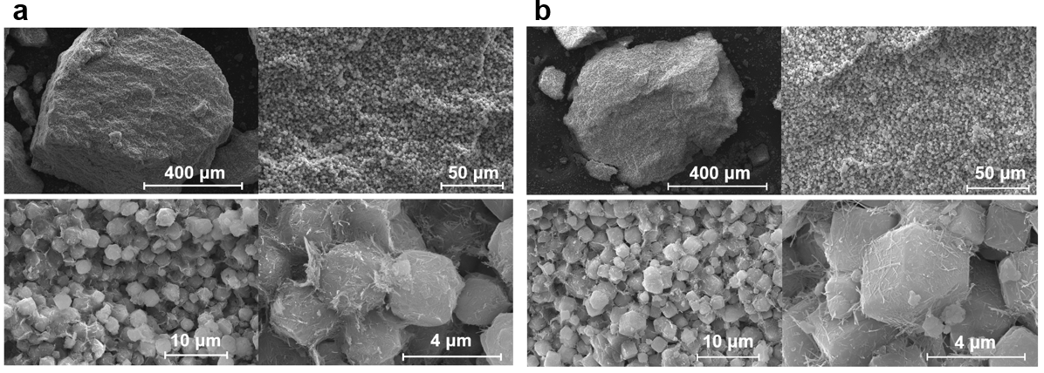
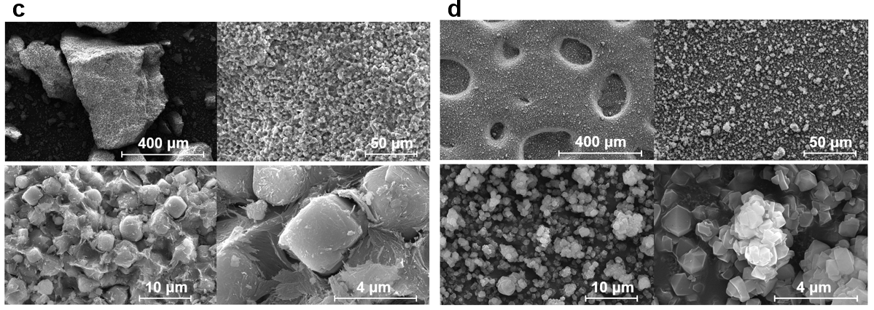
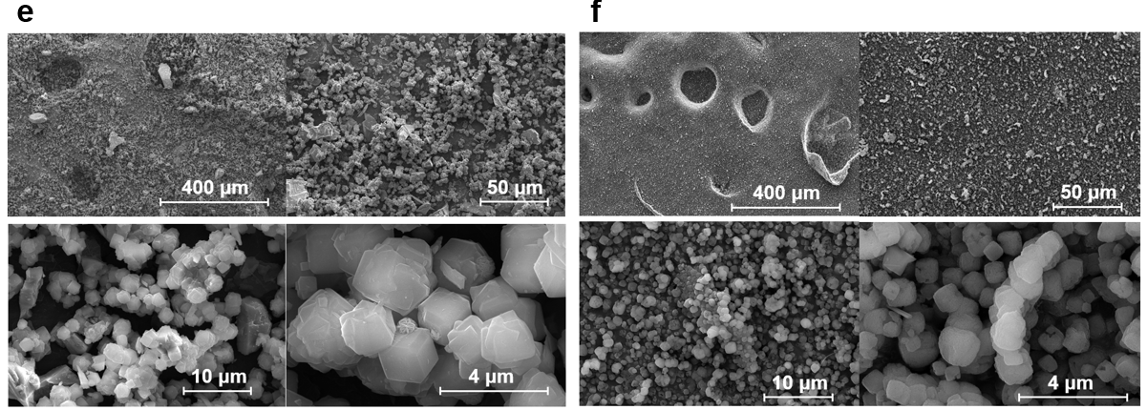
Figure S3. FE-SEM images for mesoporous materials; a) Zeolite 13X; b) Zeolite 5A; c) Zeolite 3A; d) Zeolite Y; e) SAPO-34; f) SSZ-13

Table S2. Theoretical solubility difference in the range of 20-70 ºC and endothermic reaction heat
Materials |  | Reaction heat (kJ/mol) | Solubility difference (g/g)
Solute | Solvent | Reaction heat (kJ/mol) | Solubility difference (g/g)
NH₄Cl | H₂O | 14.76 | 0.92
NH₄NO₃ | H₂O | 28.05 | 3.96
KCl | H₂O | 17.21 | 0.47
Na₂CO₃ | CH₃COOH | 26.48 | 0.022
CoSo₄∙7H₂O | SOCl₂ | 90.82 | 0.87

Table S3. Materials cost of MS-ER cooling unit (A exchange rate was applied: 1 $ = 1,000 KRW)
Materials | Manufacturer | Package | Price (KRW) | Price ($) | Price ($/g)
Ammonium nitrate | Daejung Chemicals | 25 kg | 57,500 | 57.5 | 0.0023
Water | Daejung Chemicals | 20 kg | 16,300 | 16.3 | 0.000815
Zeolite 13X | IVENG | 1 kg | - | 1.98 | 0.00198

Table S4. Cost analysis of PV cell in terms of cooling unit (The cost of monocrystalline silicone is calculated based on the PV cell of LG Electronics. The operating expense is considered for building integrated PV data.)
 | Material cost |  | Maintenance  ($/W)
 | Monocrystalline Si ($/W) | Cooling unit ($/W) | Maintenance  ($/W)
PV cell with natural air cooling | 0.767 | - | 0.25
PV cell with MS-ER | 0.767 | 0.261 | 0.25

