Pyrolysis characteristics, kinetics and biochar of fermented pine-sawdust-based waste

Yiteng Zhang^{a,b}, Jun Hu^{a,b}, Xingxing Cheng^{a,b,}*, Mudassir Hussain Tahir^{c}
ªSchool of Energy and Power Engineering, Shandong University, Jinan, 250061, China
^{b}National Engineering Laboratory for Reducing Emissions from Coal Combustion, Jinan, 250061, China
^{c}Department of Chemistry, Division of Science and Technology, University of Education, Lahore, 54000, Pakistan
Corresponding author: 17923 Jingshi Road, Jinan, 250061, China.
E-mail address: xcheng@sdu.edu.cn (X. Cheng).

Samples | Time/min | Absorbance/mg/L
PD-500 | 180 | 4.97
PD-600 | 180 | 4.95
PD-700 | 180 | 4.87
PD-800 | 180 | 4.25
FPD-500 | 180 | 4.48
FPD-600 | 180 | 3.72
FPD-700 | 180 | 3.65
FPD-800 | 180 | 3.40
Table S1 The balanced concentration of MB solution

The morphological features of pine sawdust-derived biochar (PD-800) and biochar of fermented pine sawdust (FPD-800) were examined using SEM imaging (Fig.S1). The PD-800 presented a fat and rugged surface with no clear porous and massive collapse structure. In contrast to PD (Fig.S1), the roughness degree of surface of FPD-800 increased, and the apparent porous structure could be observed after fermentation and carbonization at 800 ℃. Microbial fermentation contributed to the cracking and melting of pine sawdust. Then, a feature that can have a positive impact on the adsorption efficiency were found with a complex robust structure and stereoscopic pore network.
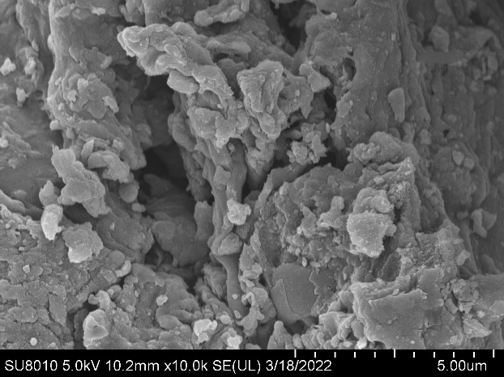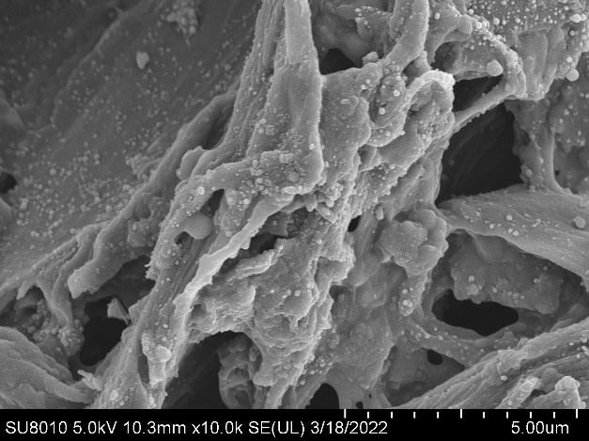 (a) (b)
Fig. S1 SEM patterns of (a) PD and (b) FPD.

