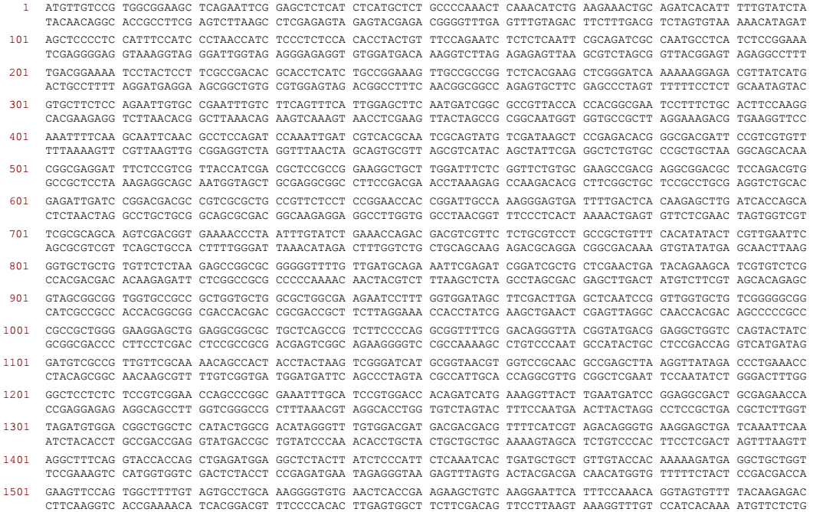
Figure S1. Complete ORF of 4CL gene.

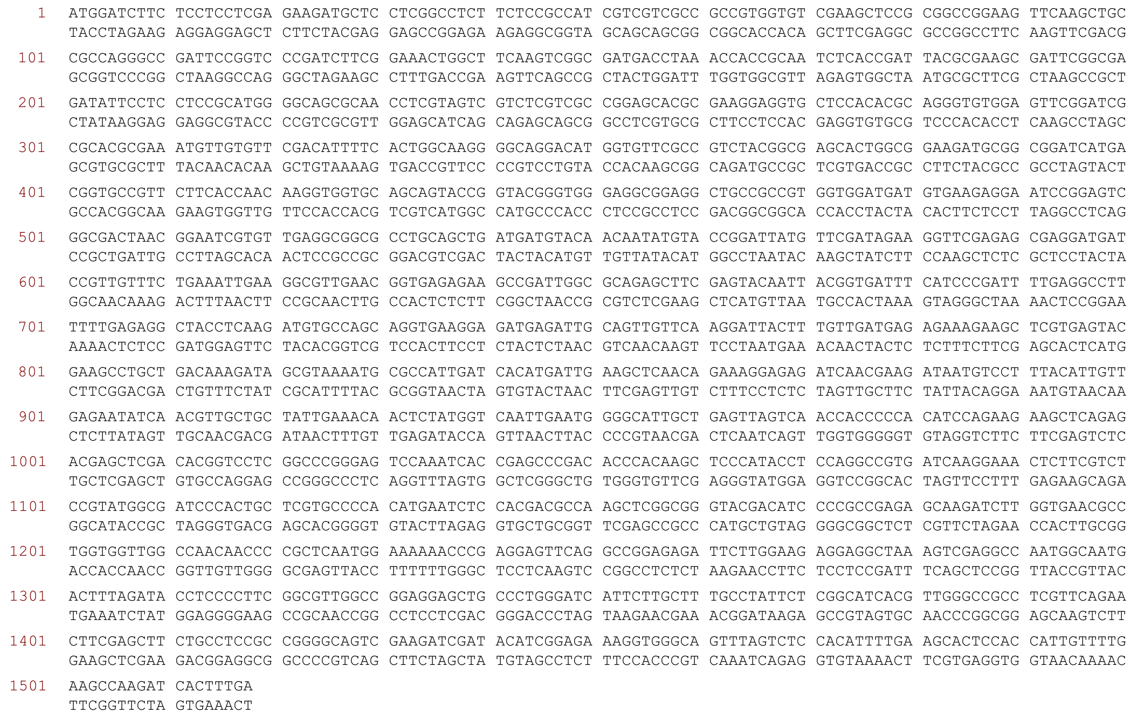
Figure S2. Complete ORF of C4H gene.

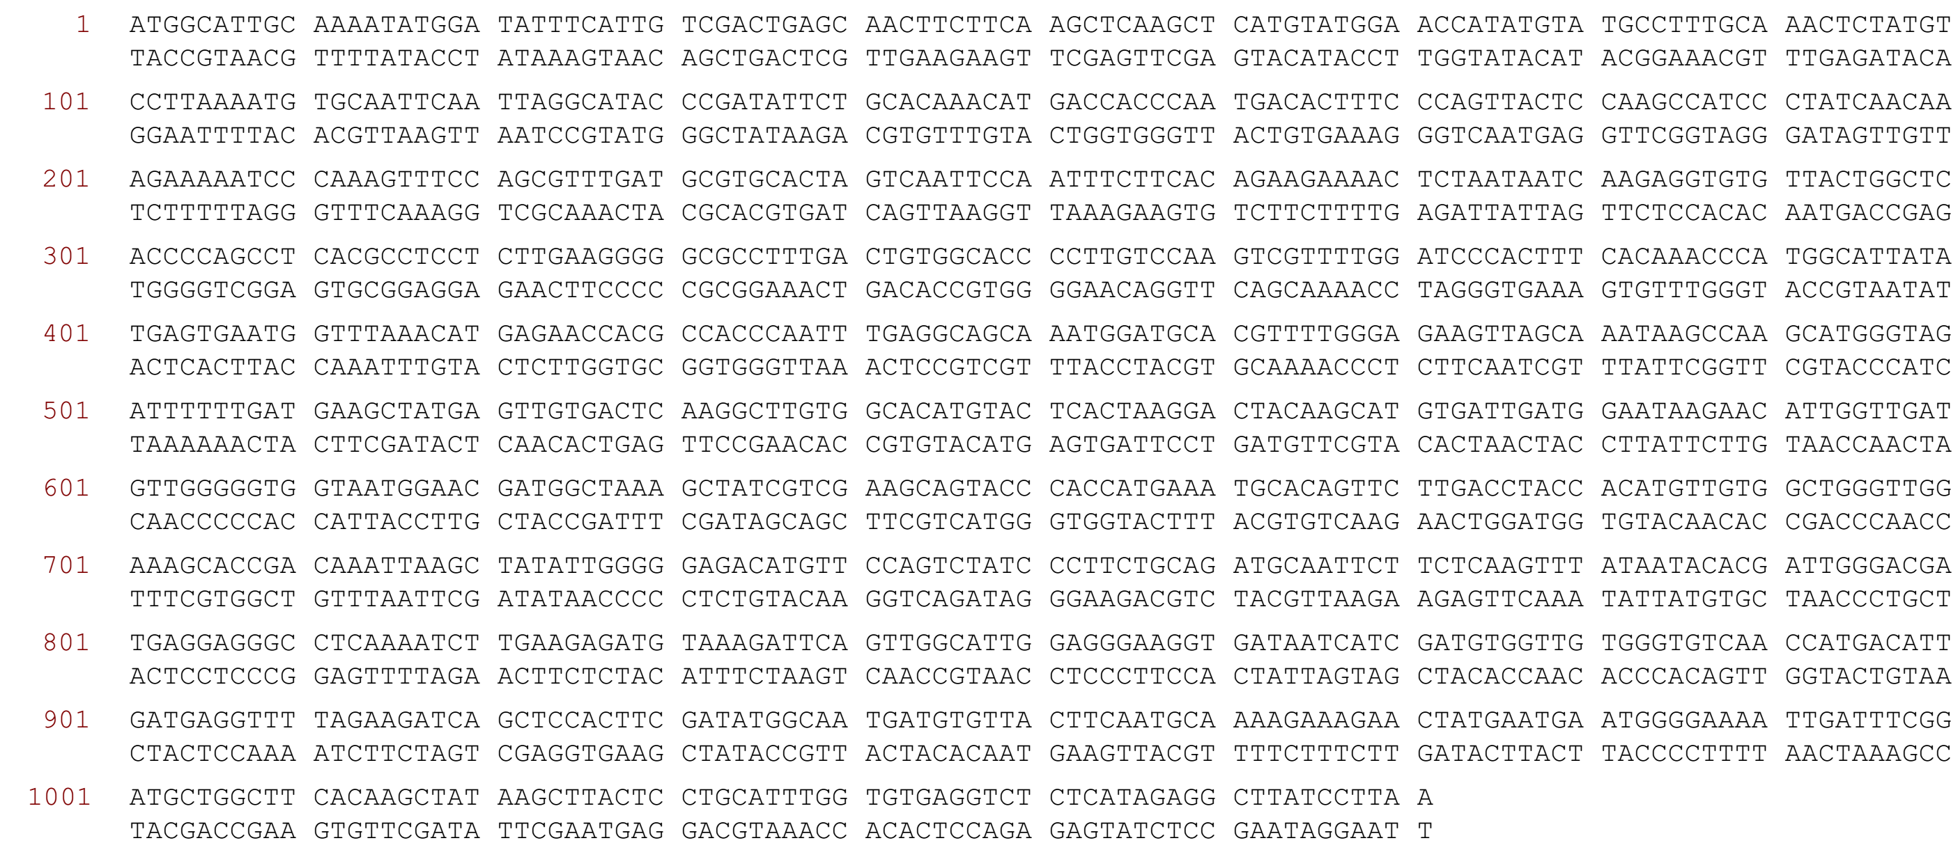
Figure S3. Complete ORF of CVOMT gene.

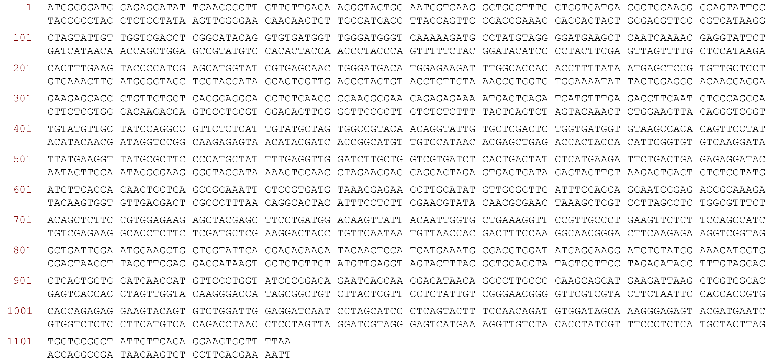
Figure S4. Complete ORF of ACTIN gene.

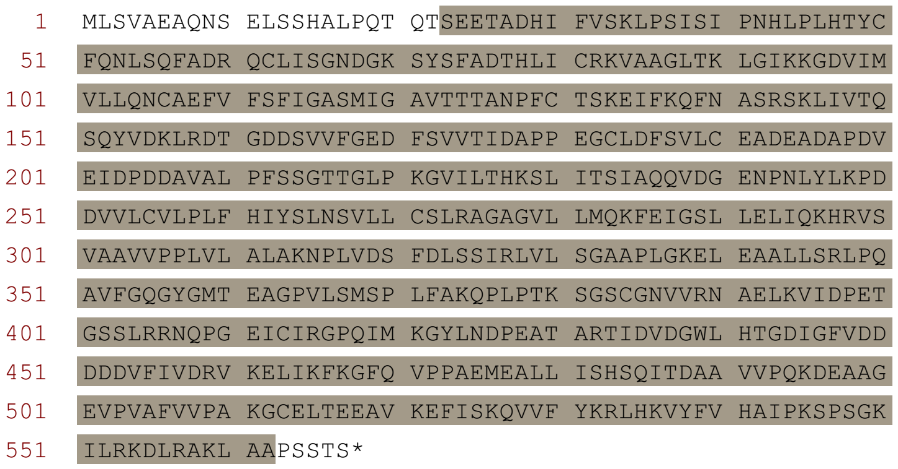
Figure S5. Protein sequence of 4CL gene. The conserved functional domain has been highlighted by grey color.

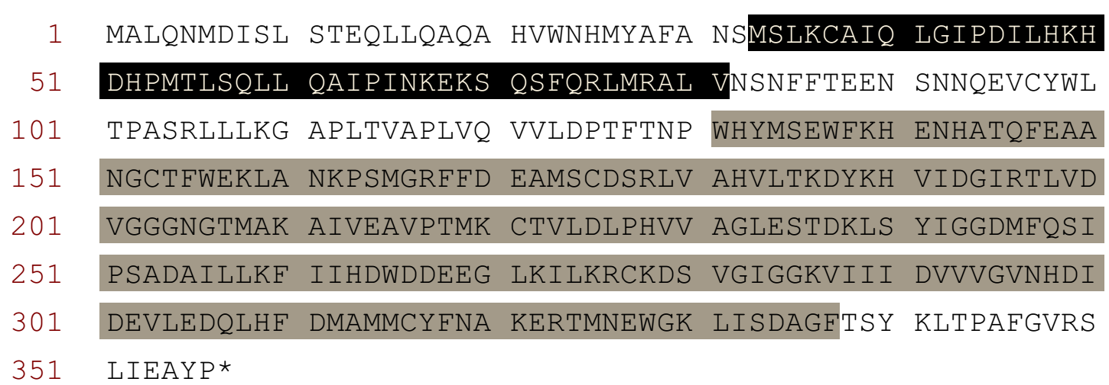
Figure S6. Protein sequence of CVOMT gene. The conserved functional domains have been highlighted by grey and black colors.

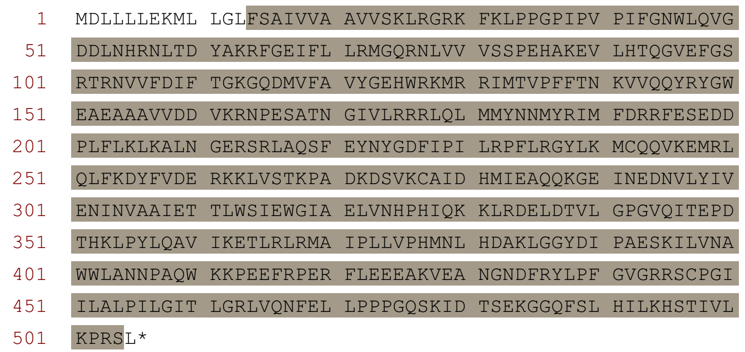
Figure S7. Protein sequence of C4H gene. The conserved functional domain has been highlighted by grey color.

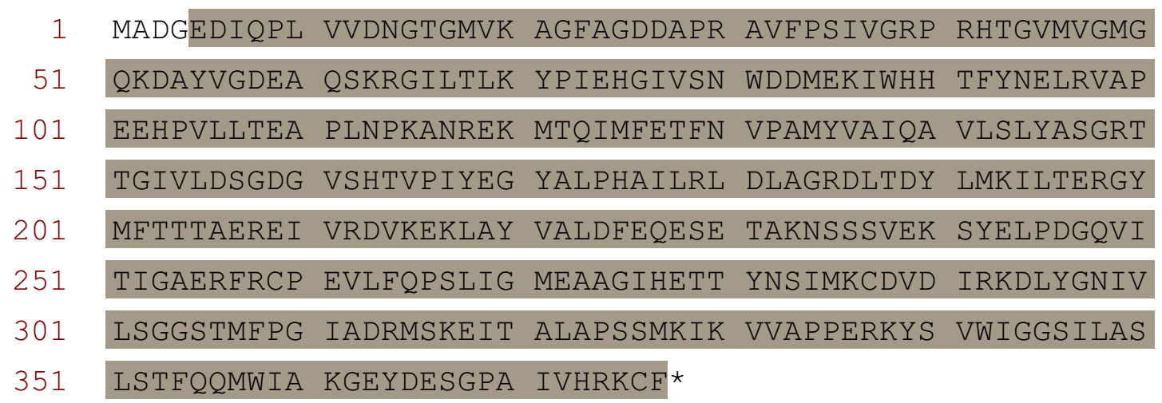
Figure S8. Protein sequence of ACTIN gene. The conserved functional domain has been highlighted by grey color.

