Reversible conversions between skyrmions and skyrmioniums
Sheng Yang, ^{#,1} Yuelei Zhao, ^{#,1} Kai Wu,¹ Zhiqin Chu,^{2,3} Xiaohong Xu,^{4,5} Xiaoguang Li, ^{*,6} Johan Åkerman^{*,7} and Yan Zhou^{*,1}
¹School of Science and Engineering, The Chinese University of Hong Kong, Shenzhen, 518172, China.
² Department of Electrical and Electronic Engineering, The University of Hong Kong, Hong Kong, 999077, China
³School of Biomedical Sciences, The University of Hong Kong, Hong Kong, 999077, China
⁴Research Institute of Materials Science of Shanxi Normal University & Collaborative Innovation Center for Shanxi Advanced Permanent Magnetic Materials and Technology, Linfen, 041004, China.
⁵School of Chemistry and Materials Science of Shanxi Normal University & Key Laboratory of Magnetic Molecules and Magnetic Information Materials of Ministry of Education, Linfen, 041004, China.
⁶Center for Advanced Material Diagnostic Technology, College of Engineering Physics, Shenzhen Technology University, Shenzhen, 518118, China.
⁷Department of Physics, University of Gothenburg, Gothenburg, 41296, Sweden.

#These authors contributed equally.
Corresponding Author
* E-mail: lixiaoguang@sztu.edu.cn
* E-mail: johan.akerman@physics.gu.se
* E-mail: zhouyan@cuhk.edu.cn

Fig. S1
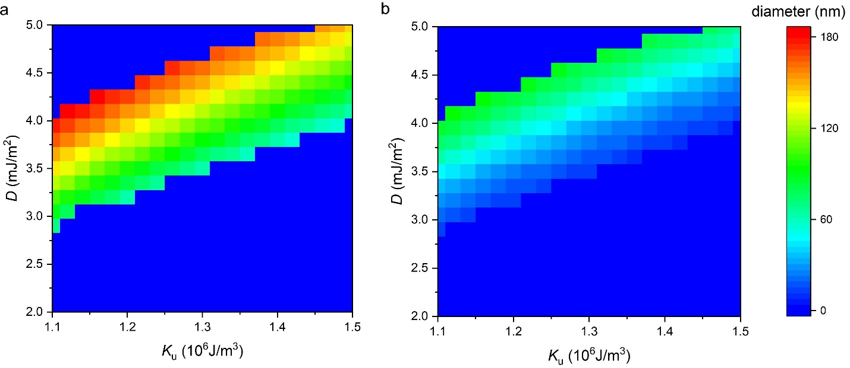
Fig. S1 a, Diagram of the outer diameter D_{out}. b, the inner diameter D_{in} of the skyrmionium as a function of DMI constant D and the magnetic anisotropy energy density K_{u}.

Fig. S2
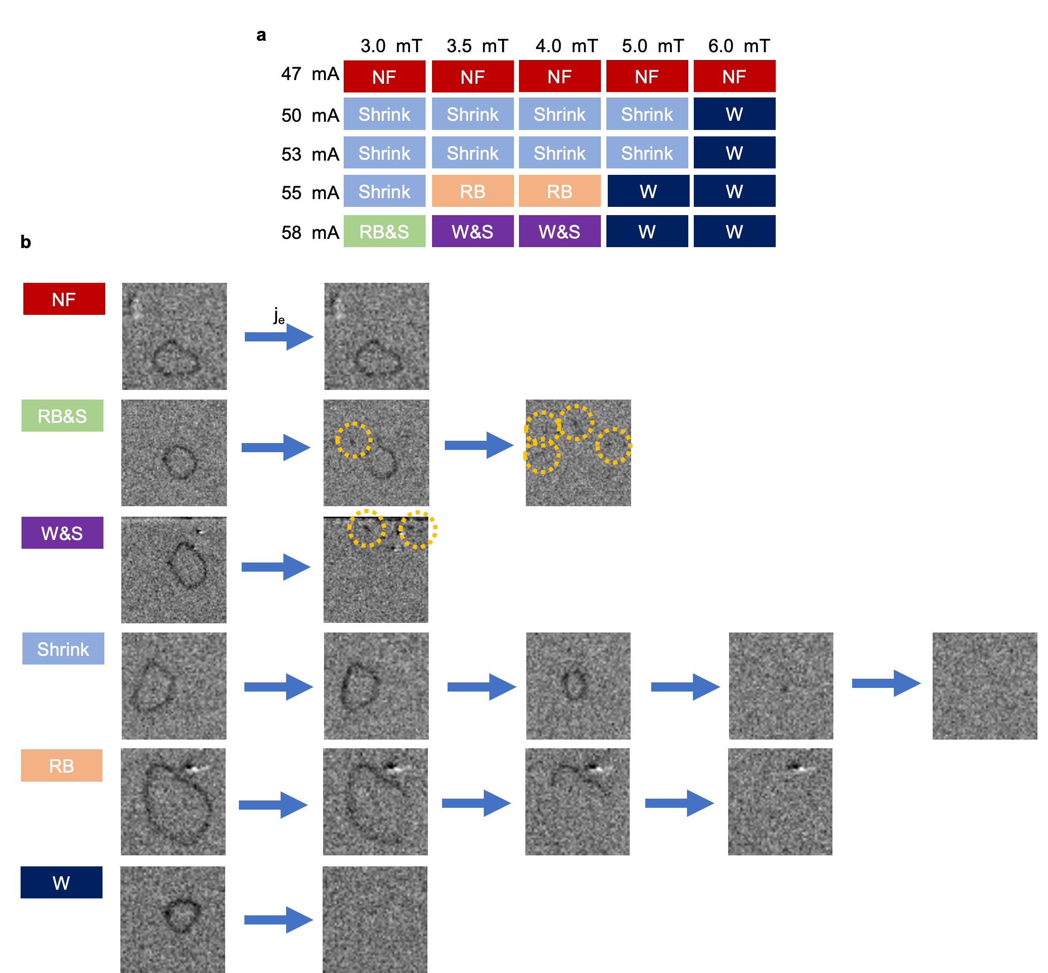
Fig. S2 NF (No Function): the skyrmionium does not change significantly under the stimulation of pulses. Shrink: the skyrmionium shrinks and simultaneously moves without any SkHE. RB (Ring breaks): the skyrmionium ring breaks. RB&S (Ring break and skyrmion): the skyrmionium ring breaks, and multiple skyrmions are created. W&S (Wiped and skyrmion): the skyrmionium is obliterated, and multiple skyrmions are created. W (Wipe): the skyrmionium is obliterated.
The results of the current-driven skyrmionium dynamics in our device are shown in Fig. S2b. We use multiple square pulses applied in the device to drive the skyrmionium into motion. Unless otherwise stated, all square pulse and sinusoidal pulses used in the experiments have a pulse width of 50 μs. The skyrmionium is quite sensitive to out-of-plane field and current amplitude, as shown in Fig. S2a. When the square pulses are at amplitude I_{sq} ≤ 47 mA (1.68 × 10¹¹ A/m²), the skyrmionium does not change significantly. We have marked the box with NF for ‘No Function’ in Fig. S2a and Fig S2b. Multiple 47 mA square pulses can generate enormous amounts of heat, but the skyrmionium can remain stationary, implying that heat cannot drive the skyrmionium into motion or change its size. As we gradually increase the I_{sq}, we soon find that 50 mA (1.79 × 10¹¹ A/m²) is the threshold I_{sq} above which the skyrmionium is driven into motion.
When the magnetic field is set to 3.0 mT and the square pulse amplitudes I_{sq} are varied from 50 mA to 55 mA (1.79 × 10¹¹ A/m² to 2.00 × 10¹¹ A/m²), we observe that the skyrmionium shrinks and simultaneously moves without SkHE (see Fig. S2b). These moving and shrinking processes have already been discussed in detail in the research article. However, when I_{sq} increases to 58 mA (2.01 × 10¹¹ A/m²), the skyrmionium undergoes a ring break process, and the device generates some skyrmions at the same time (labelled as RB&S, see Fig. S2b). Specifically, the device can intrinsically generate skyrmions using square pulses with I_{sq} = 58 mA under a 3.0 mT to 4.0 mT +z field [supporting video 1]. As the skyrmions are created in a different location from that of the skyrmionium, they are very unlikely to be the fragments of the skyrmionium. Therefore, the creation of the skyrmions is irrelevant to the destruction process of the skyrmionium.
When the magnetic field is increased to 4.0 mT, we can observe the same moving and shrinking process when I_{sq} ≤ 55 mA, and we can also observe the ring breaking process (labelled as RB, see Fig. 2b). When I_{sq} is increased to 58 mA, the skyrmionium is directly obliterated, and multiple skyrmions are created (labelled as W&S, see Fig. 2b). Again, the creation of these skyrmions is irrelevant to the destruction of the skyrmionium. It is worth noting that the ring breaking process can only occur in a narrow range (field of 3.5 mT to 4 mT, I_{sq} = 55 mA or field of 3.0 mT, I_{sq} = 58 mA). Theoretically, the two skyrmions with opposite Q form the skyrmionium ring, and the process of ring breaking occurs because the inner skyrmion experiences the opposite SkHE to the outer skyrmion. [Phys. Rev. B 94, 094420] Once SOT is applied to the skyrmionium, one side of the skyrmionium ring becomes thin and can be easily broken.
As the range increase from 3.5 mT to 4 mT, the same moving and shrinking process occurs when I_{sq} ≤ 55 mA. However, the skyrmionium can be obliterated directly when I_{sq} ≥ 55 mA (labelled as W, see Fig. S2b). With a 6.0 mT field, the skyrmionium can be obliterated directly as long as I_{sq} ≥ 50 mA.

