Graph 1
Haemoglobin values before and after the formalin treatments. The increase in haemoglobin was statistically significant; p=0.022.
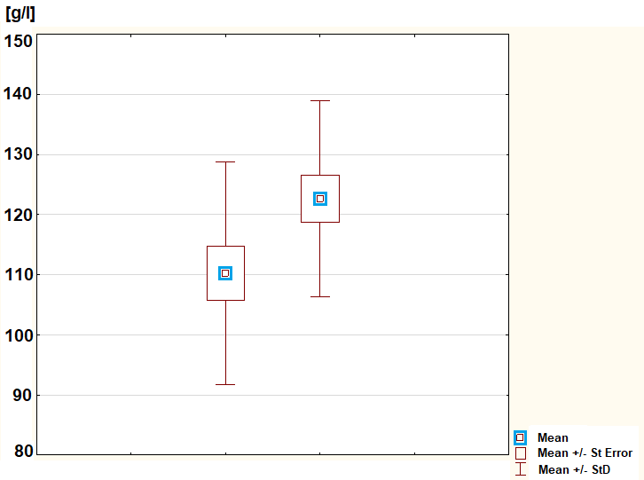

Graph 2
Rectal bleeding score (sum of frequency and amount of bleeding) before the first and after the last formalin treatment. The improvement was statistically significant; p˂0.001.
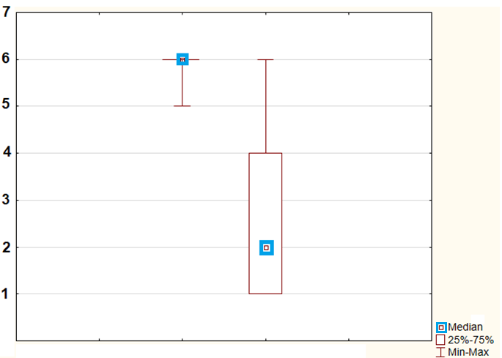

Graph 3
Endoscopy score on the day of the first and last formalin treatment. The improvement was statistically significant; p˂0.001.
