Supplementary Materials for

Intergenerational Neuroprotection by an Intestinal Sphingolipid in Caenorhabditis elegans

Wenyue Wang¹, Tessa Sherry¹, Xinran Cheng², Qi Fan¹, Rebecca Cornell¹, Jie Liu², Zhicheng Xiao² and Roger Pocock¹

Correspondence to: roger.pocock@monash.edu

This PDF file includes:

Materials and Methods
Figs. S1 to S7

Other Supplementary Materials for this manuscript include the following:

Data S1 to S5

Materials and Methods

C. elegans strains and culture
Worms were maintained according to standard protocols at 20ºC on nematode growth medium (NGM) plates with Escherichia coli (OP50) bacteria as a food source. The wild-type strain used was Bristol, N2. Mutant strains were backcrossed to N2 a minimum of 3 times, and animals were well-fed for at least two generations prior to experiments. A list of strains and transgenes used in this study is provided in Table S4.

C. elegans expression constructs and transgenic strain generation
Reporter gene constructs were generated by PCR amplifying DNA elements and cloning into Fire vectors. Constructs were injected into young adult hermaphrodites using standard methods.

Pasah-1::nls::gfp reporter construct: A 2044 bp sequence upstream of the asah-1 start codon was amplified from C. elegans genomic DNA with forward and reverse primers incorporating a HindIII restriction site. The HindIII digest promoter fragment was ligated into HindIII digested pPD95.67 vector, resulting in Pasah-1::NLS::gfp. Pasah-1::NLS::gfp was injected at 25 ng/µl, with 5 ng/µl of Pmyo-2::mCherry vector and 120 ng/µl bacterial DNA. The resultant Pasah-1::NLS::gfp extrachromosomal array line was integrated using UV irradiation. The integrated Pasah-1::NLS::gfp (rp165) was backcrossed to N2 6 times prior to analysis.
Pges-1::asah-1 overexpression construct:
asah-1 cDNA (1183 bp) was amplified from an N2 cDNA library and cloned into a Pges-1::egl-8 vector (digested with NheI-NcoI to remove the egl-8 sequence) using the In-Fusion HD Cloning Kit (Takara Bio).
Pdpy-7::asah-1 overexpression construct:
asah-1 cDNA (1183 bp) was amplified from an N2 cDNA library and cloned into a Pdpy-7::nls-dsRed2 vector (digested with BamHI-EcoRI to remove the nls-dsRed2 sequence) using the In-Fusion HD Cloning Kit (Takara Bio).
Pmyo-3::asah-1 overexpression construct:
asah-1 cDNA (1183 bp) was amplified from an N2 cDNA library and cloned into the pPD95.86 vector using the In-Fusion HD Cloning Kit (Takara Bio) after linearizing the vector with NheI-NcoI.
Prab-3::asah-1 overexpression construct:
asah-1 cDNA (1183 bp) was amplified from an N2 cDNA library and cloned into a Prab-3::nfya-1 vector (digested with KpnI-NcoI to remove the nfya-1 sequence) using the In-Fusion HD Cloning Kit (Takara Bio).
Pmec-4::asah-1 overexpression construct:
asah-1 cDNA (1183 bp) was amplified from an N2 cDNA library and cloned into the pSM::Pmec-4::unc-54 3′UTR vector using the In-Fusion HD Cloning Kit (Takara Bio) after linearizing the vector with NheI.
Pges-1::sptl-1 overexpression construct:
sptl-1 cDNA (1378 bp) was amplified from an N2 cDNA library and cloned into a Pges-1::egl-8 vector (digested with NheI-NcoI to remove the egl-8 sequence) using the In-Fusion HD Cloning Kit (Takara Bio).
Pges-1::sphk-1 overexpression construct:
sphk-1 cDNA (1423 bp) was amplified from an N2 cDNA library and cloned into a Pges-1::egl-8 vector (digested with NheI-NcoI to remove the egl-8 sequence) using the In-Fusion HD Cloning Kit (Takara Bio).

Pharmacological treatment
Ursolic acid (UA, Sigma Aldrich) was dissolved in DMSO to a stock solution of 10 mg/ml. UA was added to a 3.5 cm petri dish prior to adding NGM agar, with DMSO added to control plates. All plates were prepared fresh prior to each experiment and used within 2 days. To reduce metabolic breakdown of UA by bacteria, 150 µl of heat-killed OP50 (65ºC for 30 min) was seeded on NGM plates (containing UA or DMSO) and dried overnight at 20ºC. 5 µl of live OP50 (1/10 dilution with LB broth) was added to the dead bacteria to enable worm growth.

Sphingosine-1-phosphate application
Sphingosine-1-phlosphate (S1P, Sigma Aldrich #73914) was dissolved in methanol to a stock solution of 2mM. After pouring NGM agar into a 3.5cm petri dish, S1P was added and mixed, while methanol was added to control plates. All plates were prepared fresh prior to each experiment and used within 2 days. To reduce metabolic breakdown of S1P by bacteria, 150 µl of heat-killed OP50 (65ºC for 30 min) was seeded and spread on NGM plates (containing S1P or methanol) and dried overnight at 20ºC. 5 µl of live OP50 (1/10 dilution with LB broth) was added to the dead bacteria to enable worm growth.

Sphingosine-1-phosphate fluorescein application
Sphingosine-1-phosphate fluorescein (Echelon #S-200F) was dissolved in methanol to a stock solution of 1mM. To reduce metabolic breakdown of S1P fluorescein by bacteria, 150 µl of heat-killed (65ºC for 30 min) OP50 was mixed with S1P fluorescein or methanol (as control), seeded on NGM plates and used immediately once it dried.

Intergenerational experiments
P0 animals were treated from mid-L4 to young adult for 16 hours with UA or S1P (DMSO and methanol were used as controls, respectively), then worms were transferred to untreated plates for 3 hours to lay semi-synchronized eggs. Mothers were removed after laying and progeny (F1 generation) cultured on untreated plates. When F1 animals reached the 1-day old adult stage, they were transferred to new untreated plates for 3 hours to lay eggs (F2 generation), and this was repeated for the progeny of these animals (F3 generation). For each generation, PLM degeneration defects are scored in 3-day old adults.

CRISPR-Cas9 genome editing
Endogenous asah-1::f2a::gfp::h2b reporter: asah-1(rp176[asah-1::f2a::gfp::h2b]) was generated using Cas9 protein, tracrRNA and a crRNA (TGGTAGattggattcaacat) from IDT. A dsDNA hybrid donor sequence of f2a::gfp::h2b was amplified by PCR, as described previously ¹. To facilitate the scoring of asah-1 expression, a nuclear-localized gfp was inserted downstream of the asah-1 coding region, separated by a F2A sequence that splits the endogenous ASAH-1 and GFP-H2B proteins.
asah-1 promoter mutagenesis: For mutagenesis of asah-1 promoter motifs, crRNAs and single-stranded oligonucleotide (ssODN) donors were used as follows:
CEH-60 motif: crRNA (aaaaccggtgtgattgatga), ssODN (ttgtaaattatgctccataaaccaaaaaccggtgtgattgatgacattttcatgagggaaataaattaaa). Mutation of the motif introduced a NotI restriction site (GCGGCCGC) to facilitate genotyping.
PQM-1 motif site: crRNA (aagtgataaggagtaaagtg), ssODN (acattttcatgagggaaataaattaaaaagtgataaggagtaaagtgtggccacgtgttttccgcaaaaa). Mutation of the motif introduced a BamHI restriction site (GGATCC) to facilitate genotyping.

RNA-mediated interference (RNAi) experiments
HT115(DE3) E. coli bacteria expressing RNAi plasmids for specific genes or empty vector (L4440) were grown in Luria broth (LB) + ampicillin (50 µg/ml) at 37ºC for 16 h. Saturated RNAi cultures were plated on RNAi plates and dried for 24 h. L4 hermaphrodites were plated on RNAi plates and incubated for one generation at 20ºC, unless otherwise stated. Due to the potency of rme-2 RNAi in preventing progeny survival, we diluted the rme-2 RNAi bacteria to 10% with 90% L4440 RNAi bacteria. Dilution of rme-2 RNAi bacteria to 10% was shown previously to reduce embryonic yolk levels ².

Microscopy
Worms were anesthetized using 20 mM sodium azide (NaN₃) for neuroanatomical scoring and levamisole (0.1 ng/μl) for fluorescence measurements. Worms were mounted on 5% agarose pads on glass slides. Images were acquired using a Zeiss Axio Imager M2 and Zen software tools. Figures were prepared using ImageJ and Adobe Photoshop and Illustrator.

Phenotypic analysis
PLM neuron phenotypic analysis was performed on L1 larvae and 3-day old adults, where indicated. Axonal breaks were identified only when the distal fragment was visible. PVQ axon guidance analysis was performed on L1 larvae. All phenotypic scoring was performed in triplicate on independent days.

asah-1 expression analysis
Expression of Pasah-1::gfp and asah-1::f2a::gfp::h2b was imaged and measured in six pairs of intestinal nuclei from the second anterior pair backwards (expression in the first pair of anterior nuclei was weak and inconsistent). Texas red fluorescence in each nucleus was used as background.

Sequence alignment
asah-1 promoter sequences for nematode species were extracted from WormBase (http://www.wormbase.org) and aligned using Clustal Omega ³.

RNA sequencing
N2 gravid hermaphrodites were bleached with hypochlorite solution and eggs hatched overnight in M9 buffer. Resultant synchronized L1 larvae were fed with OP50 and incubated for 34 h until they reached the L3 stage. These worms were washed from the plates with M9 buffer and exposed to UA (50 µM), DMSO (vehicle) or no treatment for 12 h. After treatment, worms (now L4 larvae) were harvested and washed with M9 buffer three times to remove bacteria, before being resuspended in Trizol and flash frozen in liquid nitrogen. Total RNA was extracted by phase separation with chloroform, followed by the RNeasy Mini Kit (Qiagen) protocol. RNAse-free DNase was applied to RNA samples to remove DNA contamination. Library preparation and sequencing on Illumina HiSeq instruments were performed by the Monash Micromon Sequencing Facility and data analysis performed by the Monash Bioinformatics Platform. The transcriptome of five independent replicates for each group were analyzed. RNA-seq data was converted to a per-gene read-count matrix using RNAsik pipeline v1.5.0. Briefly, single-end reads were mapped to the C. elegans genome (WBcel235) using STAR ⁴ in splice-aware mode, duplicates were marked using Picard Markduplicates, and reads were assigned to gene models (exonic only) from the WBcel235 annotation using featureCounts v1.5.2 ⁵. Genes were only considered "testable" if they had at least 10 read-counts in a sample and at least 1.0 counts-per-million in at least 3 samples. After applying this filter for testable genes, 14,037 protein-coding genes were retained. Differentially expressed genes between treatment and control were identified using the EdgeR-quasi workflow ⁶.

cDNA preparation and quantitative PCR
Total RNA was isolated as described for RNA sequencing but with independent samples. cDNA synthesis was performed using the iScript Kit (Biorad). Quantitative-PCR (q-PCR) was performed using PowerUp SYBR Green (Thermo Fisher). cDNA samples from three biological replicates were run in triplicate. Relative transcript levels were normalized to the housekeeping gene cdc-42.

ChIP-seq data analysis
Published ChIP-seq datasets for CEH-60 ⁷ and PQM-1 ^{8, 9} were used to identify binding peak in the asah-1 promoter using IGV ¹⁰.

Locomotion analysis
Worm locomotion was analyzed at room temperature on day 1 and day 3 adults using WormLab imaging (MBF Bioscience). NGM plates used for tracking were freshly seeded with 20 µl OP50, 10 min prior to each experiment. Animals treated with UA or DMSO were randomly picked for tracking. 6 animals were placed on each plate and their tracks recorded for 6 min. To allow worms to adapt to the new conditions, the initial minute of tracking was not included for analysis. The average speed was calculated from the total distance moved (forward + backward) during the 5 min time period.

Body length analysis
Worm body length was analyzed at room temperature on day 1 and day 3 adults using WormLab imaging (MBF Bioscience). NGM plates used for body length measurement were freshly seeded with 20 µl OP50, 10 min prior to each experiment. Animals treated with UA or DMSO were randomly picked for measurement. 6 animals were placed on each plate for imaging and their body length measured automatically by the WormLab software.

Data reporting and statistics
All experiments were performed in three independent replicates with experimenter blinded to genotype. Statistical analysis was performed in GraphPad Prism 9 using one-way analysis of variance (ANOVA) followed by Dunnett’s or Tukey’s multiple comparison tests for three or more conditions. An unpaired t test was performed if the comparison was for two conditions. Values expressed as mean SE. Differences with a p value < 0.05 were considered significant.

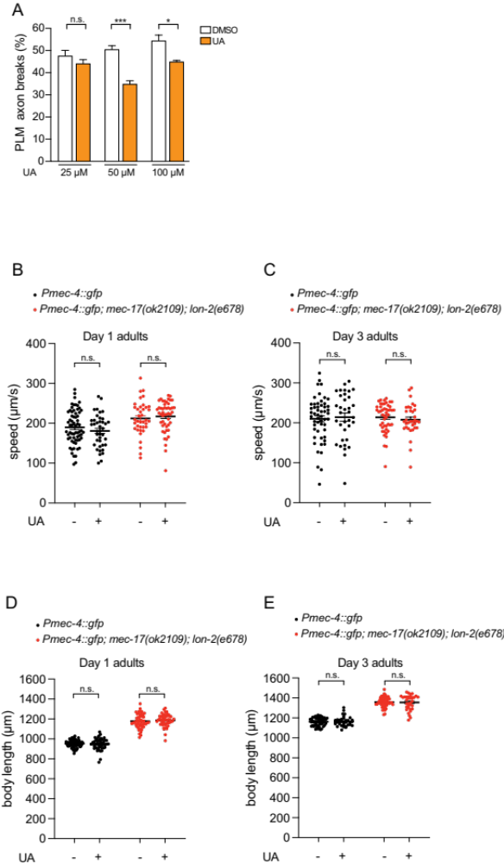
Fig. S1. UA analysis of axon degeneration and worm growth/behavior
(A) Continuous exposure (P0 - L4 larva to F1 - adult) of UA at 50 or 100 μM but not 25 μM rescues PLM axon breaks in mec-17(ok2109); lon-2(e678) animals. n = 99 to 103. P values from one-way analysis of variance (ANOVA). *P ≤ 0.05; ***P ≤ 0.001; n.s., not significant. Error bars indicate SEM.
(B and C) Quantification of locomotion speed of zdIs5 and zdIs5; mec-17(ok2109); lon-2(e678) F1 animals at day 1 (B) and day 3 (C) of adulthood treated with DMSO (control) or UA (P0 mothers treated for 16 h, L4 - young adult). Data presented as speed in μm/s (points). n = 38 to 65. P values from unpaired t test. n.s., not significant. Error bars indicate SEM.
(D and E) Quantification of body length of zdIs5 and zdIs5; mec-17(ok2109); lon-2(e678) F1 animals at day 1 (D) and day 3 (E) of adulthood treated with DMSO (control) or UA (P0 mothers treated for 16 h, L4 - young adult). Data presented as individual lengths in μm (points). n = 46 to 66. P values from unpaired t test. n.s., not significant. Error bars indicate SEM.

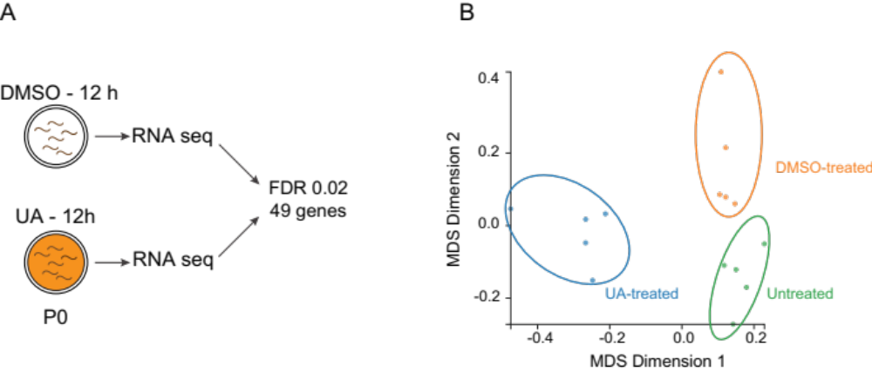

Fig. S2. UA RNA sequencing analysis
(A) Schematic of transcriptome analysis following UA exposure. Total RNA isolated from L4 larvae exposed to DMSO or UA for 12 h. 49 genes were regulated by UA exposure (FDR 0.02).
(B) Multidimensional scale plot (MDS) of untreated, DMSO-treated (control) and UA-treated RNA sequencing samples.

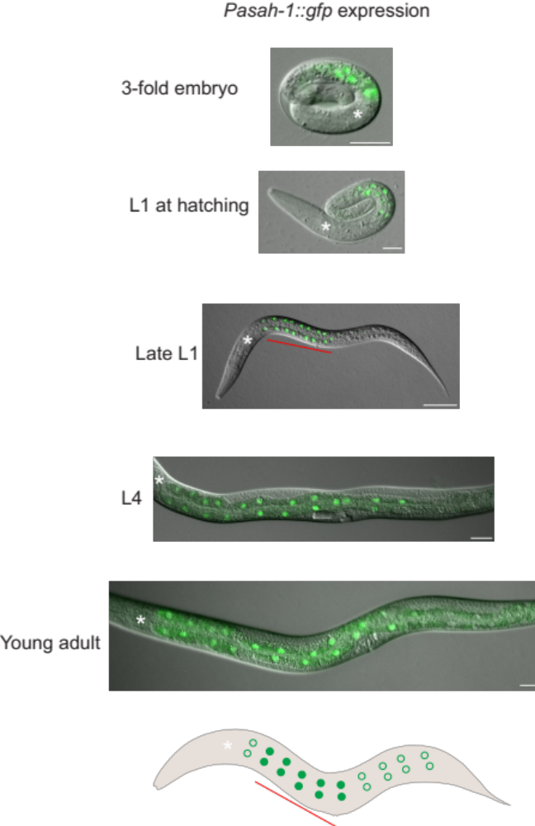

Fig. S3. asah-1 transcriptional reporter expression analysis
The Pasah-1::NLS::gfp transcriptional reporter (rpIs165) is expressed in the intestine from the 3-fold stage of embryogenesis (A) throughout larval development (B) and into adulthood. Schematic of each animal is shown above the fluorescent micrographs. Note: Pasah-1::NLS::gfp expression is brighter in the anterior intestine (red line). Anterior to the left in larval image. Pharynx marked by a white asterisk. Scale bars: 20 μm.

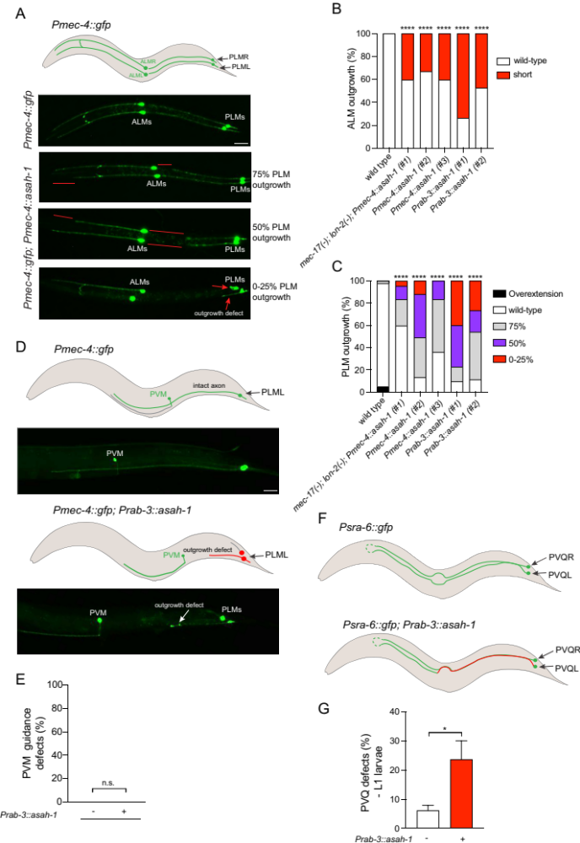
Fig. S4. asah-1 overexpression analysis
(A) Schematic and fluorescent micrographs of ALM and PLM anatomy in L1 larval wild-type (top micrograph) and Pmec-4::asah-1 overexpressing (bottom micrographs) animals expressing the Pmec-4::gfp transgene (zdIs5). Outgrowth defects are marked with red lines and arrows. Scale bar: 20 μm.
(B and C) Quantification of ALM (B) and PLM (C) outgrowth defects in wild-type, mec-17(ok2109); lon-2(e678); Pmec-4::asah-1, Pmec-4::asah-1 and Prab-3::asah-1 animals. The ALM and PLM outgrowth defects correspond to the micrographs in (A). n = 39 to 60. P values from two-way analysis of variance (ANOVA). ****P ≤ 0.0001 compared to control.
(D and E) Schematics and fluorescent micrographs (D) and quantification (E) of PVM axon guidance in L4 larval wild-type and Prab-3::asah-1 overexpressing animals expressing the Pmec-4::gfp transgene (zdIs5). n = 45 to 75. P values from unpaired t test. n.s., not significant.
(F and G) Schematics and fluorescent micrographs (F) and quantification (G) of PVQ axon guidance in L1 larval wild-type and Prab-3::asah-1 overexpressing animals expressing the Psra-6::gfp transgene (oyIs14). n = 65 to 73. P values from unpaired t test. *P ≤ 0.05. Error bars indicate SEM.

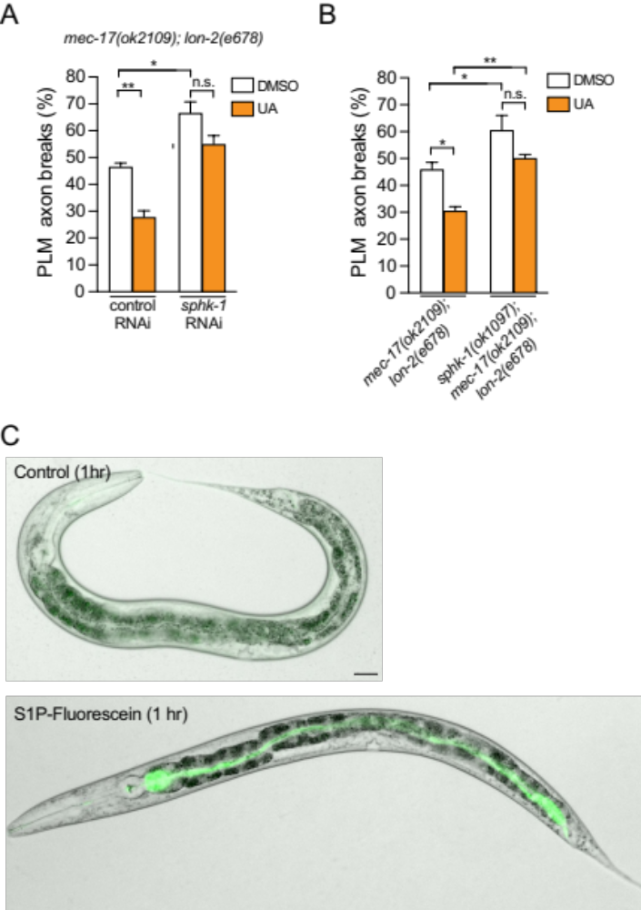

Fig. S5. Analysis of sphk-1 function and S1P-Fluorescein detection
(A and B) Loss of sphk-1 using RNAi (A) or the sphk1-(ok1097) deletion mutant (B) enhances PLM axon breaks mec-17(ok2109); lon-2(e678) and prevents the protective effect of UA. n = 74 to 128 (A) and 99 to 105 (B). P values from one-way analysis of variance (ANOVA). *P ≤ 0.05; **P ≤ 0.01. Error bars indicate SEM.
(C) Brightfield and fluorescent image overlay of L4 hermaphrodites exposed to control (methanol) or S1P-Fluorescein for 1 h. S1P-Fluorescein is detected in the intestinal lumen. Scale bar: 20 μm.

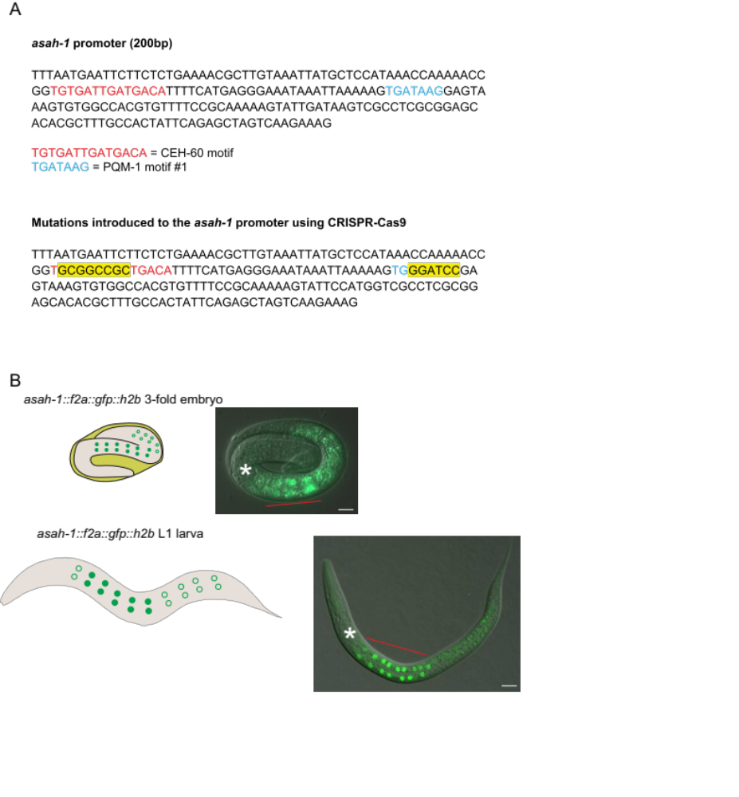
Fig. S6. Analysis of the asah-1 endogenous reporter
(A) Nucleotide sequence 200 bp upstream of the asah-1 start codon. Upper sequence shows the wild-type sequence highlighting putative transcription factor binding motifs for: CEH-60 (red), PQM-1 (blue - motif). The bottom sequence shows the independent mutations introduced to delete each putative transcription factor binding motif (yellow highlights) that introduced the following restriction enzyme recognition sequences: CEH-60 motif (NotI) and PQM-1 motif (BamHI).
(B) GFP-H2B expression from the asah-1::f2a::gfp::h2b endogenous reporter (rpIs176) is detected in the intestine from late embryogenesis (3-fold stage) throughout larval development and into adulthood. Schematic of each animal is shown next to the fluorescent micrographs. Note: Pasah-1::NLS::gfp expression is consistently brighter in the anterior intestine (red line). Anterior to the left in the worm image. Pharynx marked by a white asterisk. Scale bar: 20 μm.

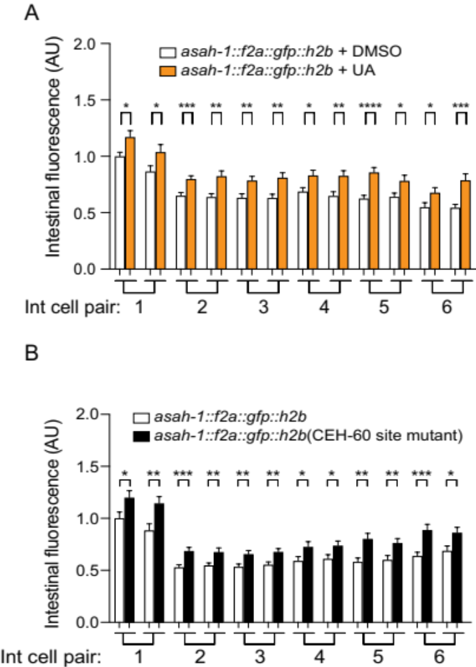

Fig. S7. Regulation of endogenous asah-1 expression
(A) GFP-H2B expression from the asah-1::f2a::gfp::h2b endogenous reporter increases when animals are exposed to UA. Quantification of nuclear fluorescence from each pair of intestinal cells per worm is shown (Int cell pair 1 = second pair of intestinal cells from the pharynx). n = 28 to 30. P value assessed by unpaired t test. *P ≤ 0.05, **P ≤ 0.01, ***P ≤ 0.001, ****P ≤ 0.0001. Error bars indicate SEM.
(B) Mutation of putative CEH-60 binding motif in the asah-1 promoter induces GFP-H2B expression from the asah-1 endogenous reporter. Quantification of nuclear fluorescence from each pair of intestinal cells per worm is shown (Int cell pair 1 = second pair of intestinal cells from the pharynx). n = 29. P value assessed by unpaired t test. *P ≤ 0.05, **P ≤ 0.01, ***P ≤ 0.001. Error bars indicate SEM.

Data Table S1. (separate excel file)
RNA sequencing data.

Data Table S2. (separate excel file)
Source data.

Data Table S3. (separate excel file)
C. elegans strains used in this study.

Data Table S4. (separate excel file)
Plasmids and cloning primers used in this study.

Data Table S5. (separate excel file)
Oligonucleotides used for qPCR in this study.

Supplementary References

1. Dokshin, G.A., Ghanta, K.S., Piscopo, K.M. & Mello, C.C. Robust Genome Editing with Short Single-Stranded and Long, Partially Single-Stranded DNA Donors in Caenorhabditis elegans. Genetics 210, 781-787 (2018).
2. Perez, M.F., Francesconi, M., Hidalgo-Carcedo, C. & Lehner, B. Maternal age generates phenotypic variation in Caenorhabditis elegans. Nature 552, 106-109 (2017).
3. Sievers, F. et al. Fast, scalable generation of high-quality protein multiple sequence alignments using Clustal Omega. Mol Syst Biol 7, 539 (2011).
4. Dobin, A. et al. STAR: ultrafast universal RNA-seq aligner. Bioinformatics 29, 15-21 (2013).
5. Liao, Y., Smyth, G.K. & Shi, W. featureCounts: an efficient general purpose program for assigning sequence reads to genomic features. Bioinformatics 30, 923-930 (2014).
6. Chen, Y., Lun, A.T. & Smyth, G.K. From reads to genes to pathways: differential expression analysis of RNA-Seq experiments using Rsubread and the edgeR quasi-likelihood pipeline. F1000Res 5, 1438 (2016).
7. Dowen, R.H. CEH-60/PBX and UNC-62/MEIS Coordinate a Metabolic Switch that Supports Reproduction in C. elegans. Dev Cell 49, 235-250 e237 (2019).
8. Tepper, R.G. et al. PQM-1 complements DAF-16 as a key transcriptional regulator of DAF-2-mediated development and longevity. Cell 154, 676-690 (2013).
9. Niu, W. et al. Diverse transcription factor binding features revealed by genome-wide ChIP-seq in C. elegans. Genome Res 21, 245-254 (2011).
10. Robinson, J.T. et al. Integrative genomics viewer. Nat Biotechnol 29, 24-26 (2011).

