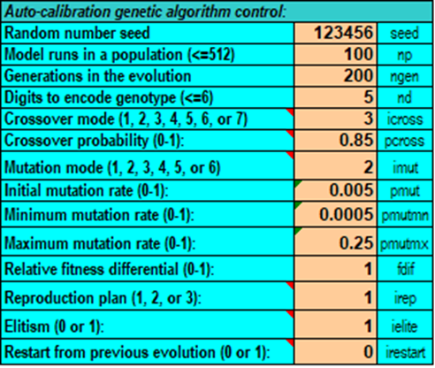
1-Model default values in genetic algorithm automatic calibration control settings

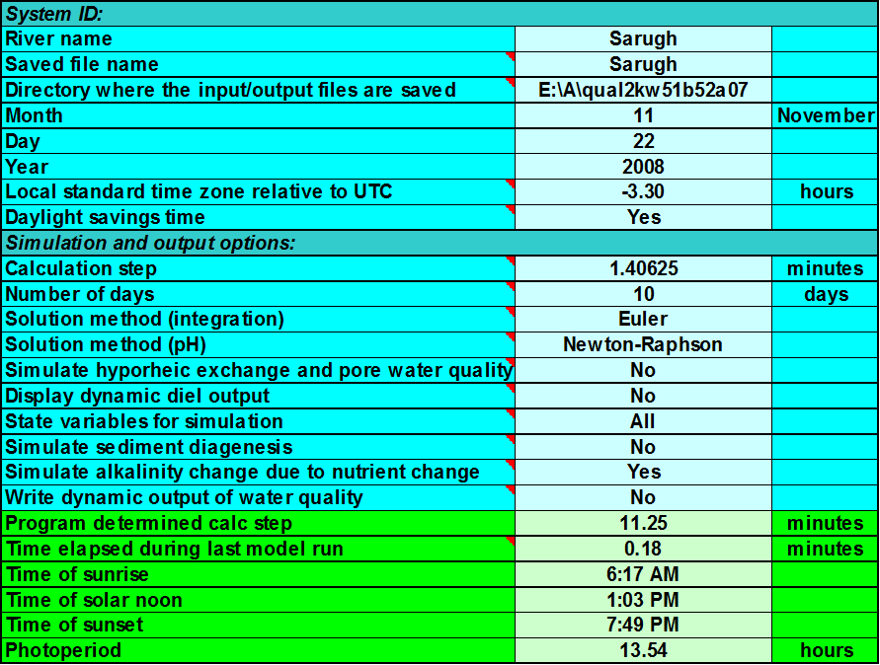
2- Initial settings of the model in spring

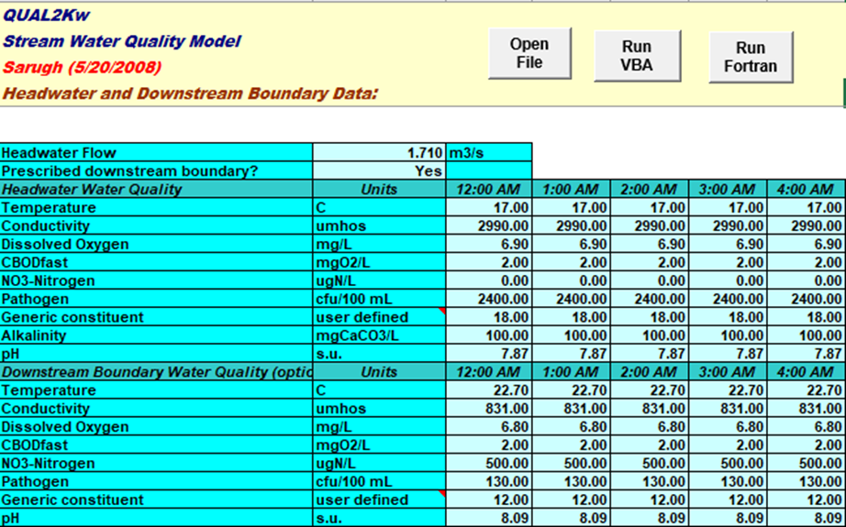
3-Information about the border conditions of the Sarouq River in spring

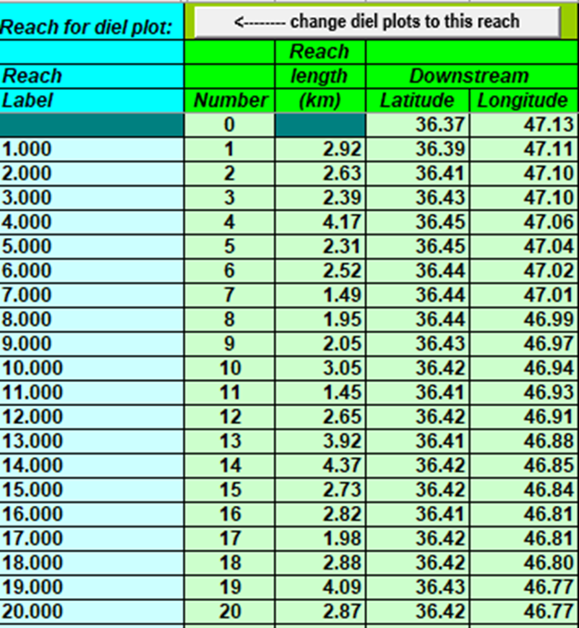
4-Information related to the length of intervals and their geographical coordinates

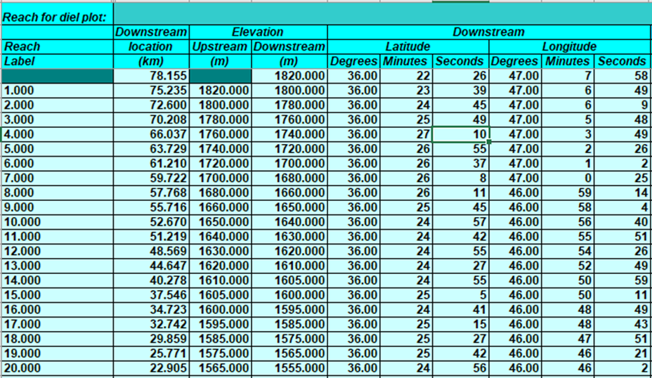
5-Hydraulic information related to Sarouq river sections

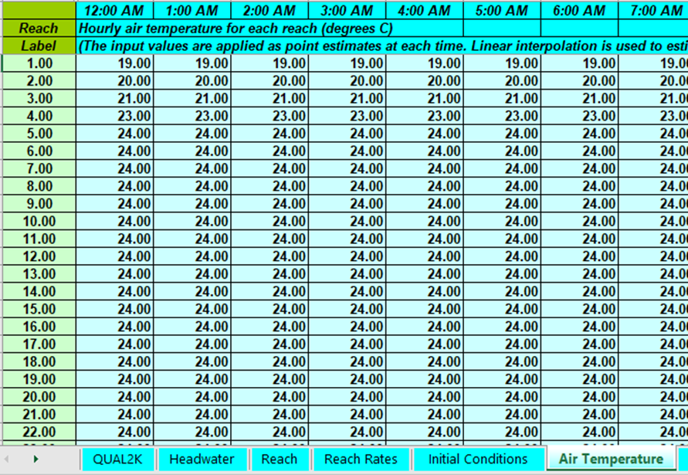
6-Air temperature in the study area during the spring simulation period
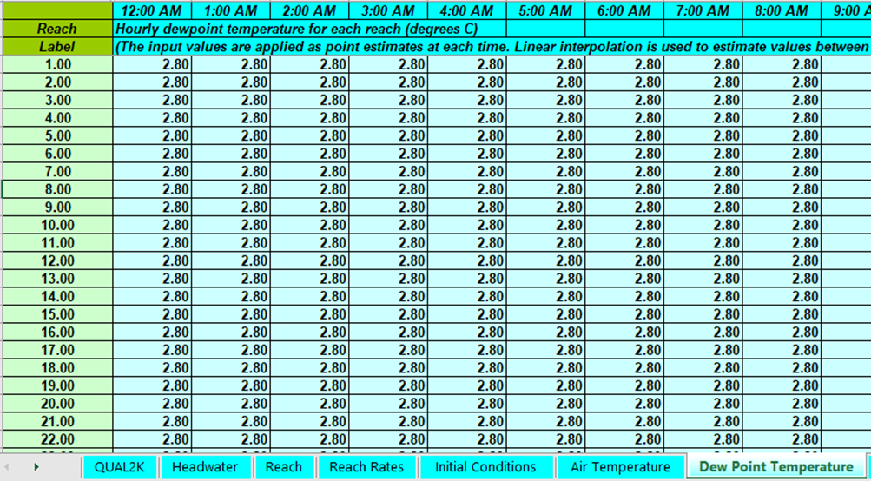
7-Dew point temperature in the study area in the spring simulation period

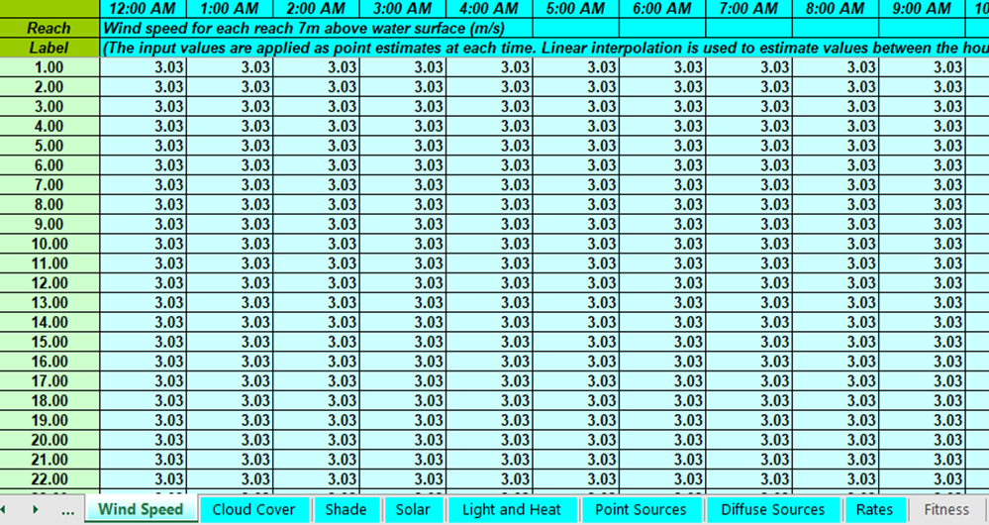
8-Wind speed in the study area during the spring simulation period

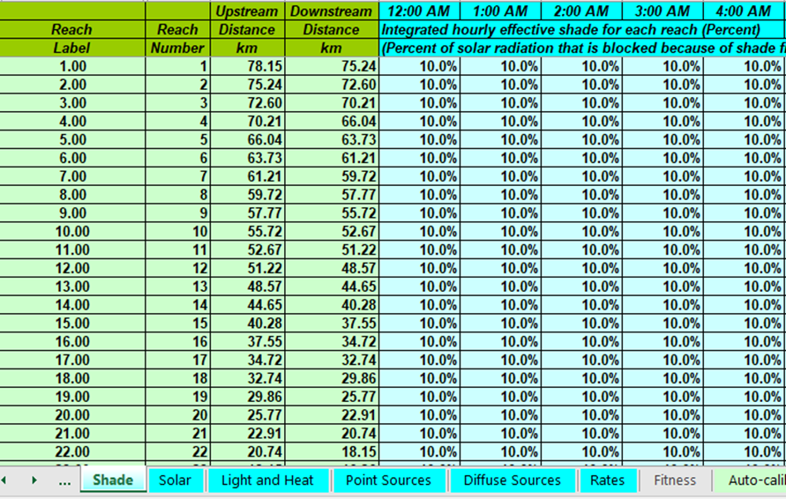
9-Shading percentage in the study area in the spring simulation period

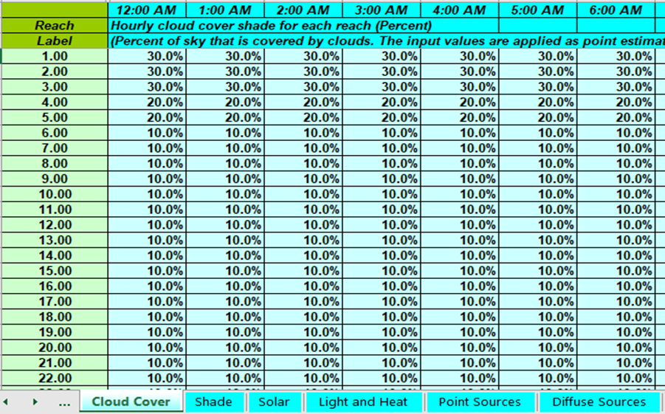
10-The percentage of cloud cover in the study area in the spring simulation period

