Linking single nucleotide polymorphisms to metabolic risk and matrix remodeling in abdominal aortic aneurysms

Chrysania Lim^{1,2#}, Muhammad Yogi Pratama^{1,2,3#}, Michele Silvestro^{1,2,3}, Cristobal Rivera^{1,2,3}, Philip S. Tsao⁴, Lars Maegdefessel^{5,6,7}, Katherine A. Gallagher⁸, Thomas Maldonado¹, Bhama Ramkhelawon ^{1,3*}

¹Division of Vascular and Endovascular Surgery, Department of Surgery, New York University Langone Medical Center, New York, USA.

²Department of Biomedicine, Indonesia International Institute for Life-Sciences (i3L), Jakarta, Indonesia

³Department of Cell Biology, New York University Langone Medical Center, New York, USA.

⁴VA Palo Alto Health Care System, Palo Alto, CA & Department of Medicine, Stanford University School of Medicine, Stanford, CA, USA

⁵Department of Vascular and Endovascular Surgery, Technical University Munich, Munich, Germany

⁶German Center for Cardiovascular Research (DZHK), Berlin, Germany, partner site Munich Heart Alliance

⁷Department of Medicine, Karolinska Institute, Stockholm, Sweden

⁸Department of Surgery, University of Michigan, Ann Arbor, MI, USA

# These authors contributed equally to this work

* Correspondence should be addressed to BR (bhama.ramkhelawon@nyulangone.org)

Supplementary Table

Supplementary Table 1. Summary of study participant characteristics from 15 studies
Study | SNP ID | Associated Genes | Region | Sample size |  | Age (mean) | Men (n) | Clinical manifestations (n)
 |  |  |  | Case | Control | Age (mean) | Men (n) | Aortic dilation (mm) | Smoking history | Hypertension | Dyslipidemia | Diabetes | Coronary Artery Disease (CAD) | Peripheral Artery Disease (PAD)
Galora et al, 2015 | rs1466535, rs6674171, rs3019885 | LRP1, TDRD10, SLC30A8 | Italy | 423 |  | 73.5 | 376 | 50 | 366 | 302 | 195 | 41 | 163 | 118
Saracini et al, 2012 | rs13925, rs1799750, rs2071307, rs2252070, rs2276109, rs2285053, rs243865, rs243866, rs3025058, rs486055, rs4898, rs9619311 | MMP-9, MMP-1, ELN, MMP-13, MMP-12, MMP-2, MMP-3, MMP-10, TIMP1, TIMP3 | Italy |  | 423 | 72 | 366 | 19 | 267 | 179 | 50 | 49 | 107 | 67
Wei et al, 2014 | rs10757278, rs1333049 | CDKN2A, CDKN2B | China | 155 |  | 69.2 | 138 | 54.2 | 132 | 108 | 118 | 18 | 53 | NA
Zuo et al, 2015 | rs1800469, rs1626340, rs3773643, rs4522809, rs5182, rs12695895 | TGFB1, TGFBR1, TGFBR2, AGTR1 | China |  | 310 | 69.5 | 276 | 17 | 167 | 143 | 138 | 46 | 80 | NA
Bown et al, 2008 | rs1333049 | CDKN2A, CDKN2B | UK | 899 |  | 73 | 814 | 52 | 799 | 528 | 401 | 87 | 262 | NA
 |  |  |  |  | 815 | 66 | 798 | <25 | 556 | 309 | 294 | 85 | 94 | NA
Baas et al, 2010 | rs10819634, rs1571590, rs1626340, rs764522, rs3087465, rs1036095, rs4522809 | TGFBR1, TGFBR2 | Netherlands | 736 |  | 71.7 | 663 | 57.3 | 686 | 443 | NA | NA | NA | NA
 |  |  |  |  | 1024 | NA | NA | NA | NA | NA | NA | NA | NA | NA
Lucarini et al, 2009 |  | ACE, AT1R, TGFBR1 | France | 201 |  | 71.5 | 175 | 61 | 140 | 145 | 82 | NA | NA | NA
 |  |  |  |  | 252 | 70.6 | 216 | 19 | 45 | 21 | 32 | NA | NA | NA
Jabłońska et al, 2020; | rs121917864, rs352139, rs352140, rs3775290, rs3775291, rs3775296, rs5743708, rs5743836 | TLR2, TLR3, TLR9 | Austria | 104 |  | 70.5 | 93 | 53.6 | 61 | 85 | NA | 21 | 25 | 43
Jabłońska et al, 2021 | rs1800795, rs1800796, rs361525, rs1800629 | IL-6, TNF-α | Austria |  | 112 | 69.7 | 74 | NA | 11 | 0 | NA | 0 | 0 | 0
Zhao et al, 2016 | rs2230806 | ABCA1 | China | 126 |  | 62.3 | 86 | NA | 24 | 22 | NA | 22 | NA | NA
 |  |  |  |  | 119 | 61.5 | 72 | NA | 27 | 46 | NA | 24 | NA | NA
Saratzis et al, 2014 | rs3091244 | CRP | Greece | 351 |  | 69 | 322 | 62.5 | 257 | 271 | 161 | 77 | NA | 72
 |  |  |  |  | 391 | 73 | 327 | 24 | 311 | 300 | 156 | 88 | NA | 70
Saratzis et al, 2014 | rs3091244 | CRP | UK | 371 |  | 72 | 347 | 54 | 326 | 187 | 226 | 58 | NA | NA
 |  |  |  |  | 362 | 71 | 345 | 24 | 302 | 178 | 189 | 52 | NA | NA
Crkvenac Gregorek et al, 2016 | rs5186, rs3918242, rs4646994, rs333 | CCR5, ACE, AT1R, MMP-9 | Croatia | 117 |  | 69 | 102 | NA | 53 | 93 | 65 | 14 | 43 | 8
 |  |  |  |  | 117 | 64 | 67 | NA | 14 | 11 | 2 | 0 | 0 | 0
Rašiová et al, 2021 | rs7635818 | CNTN3 | Slovak | 166 |  | 72.5 | 147 | 57 | 134 | 151 | 142 | 45 | 94 | NA
 |  |  |  |  | 163 | 69.2 | 133 | 18.4 | 149 | 152 | 148 | 44 | 80 | NA
Saratzis et al, 2015 | rs3773643, rs3918242, rs2276109, rs1799752, rs1799983, rs1801133 | MMP-3, MMP-9, MMP-12, ACE, eNOS, MTHFR | Greece | 397 |  | 69 | 365 | 62 | 290 | 306 | 183 | 87 | NA | 16
 |  |  |  |  | 393 | 72 | 330 | 24 | 314 | 303 | 157 | 90 | NA | 16
Saratzis et al, 2015 |  | MMP-3, MMP-9, MMP-12, ACE, eNOS, MTHFR | UK | 400 |  | 72 | 372 | 54 | 360 | 208 | 252 | 112 | NA | 36
 |  |  |  |  | 400 | 71 | 380 | 24 | 340 | 200 | 212 | 60 | NA | 32
Biros et al, 2011 | rs5516 | KLK1 | HIMS | 19 |  | 73.2 | 19 | 58.7 | 17 | 12 | 5 | 1 | NA | NA
 |  |  |  | 590 |  | 73.3 | 590 | 35.4 | 504 | 315 | 265 | 62 | NA | NA
 |  |  |  |  | 695 | 73.1 | 695 | 21.2 | 431 | 263 | 231 | 49 | NA | NA
Biros et al, 2011 | rs5516 | KLK1 | Australia | 60 |  | 72.7 | 53 | 60.5 | 45 | 40 | 29 | 10 | NA | NA
 |  |  |  | 165 |  | 71.7 | 126 | 38.5 | 137 | 121 | 114 | 31 | NA | NA
 |  |  |  |  | 100 | 65.4 | 64 | 19.9 | 74 | 68 | 53 | 35 | NA | NA
Data Availability |  |  |  |  |  | 100% | 96.875% | 81.25% | 96.875% | 96.875% | 81.25% | 87.5% | 37.5% | 37.5%

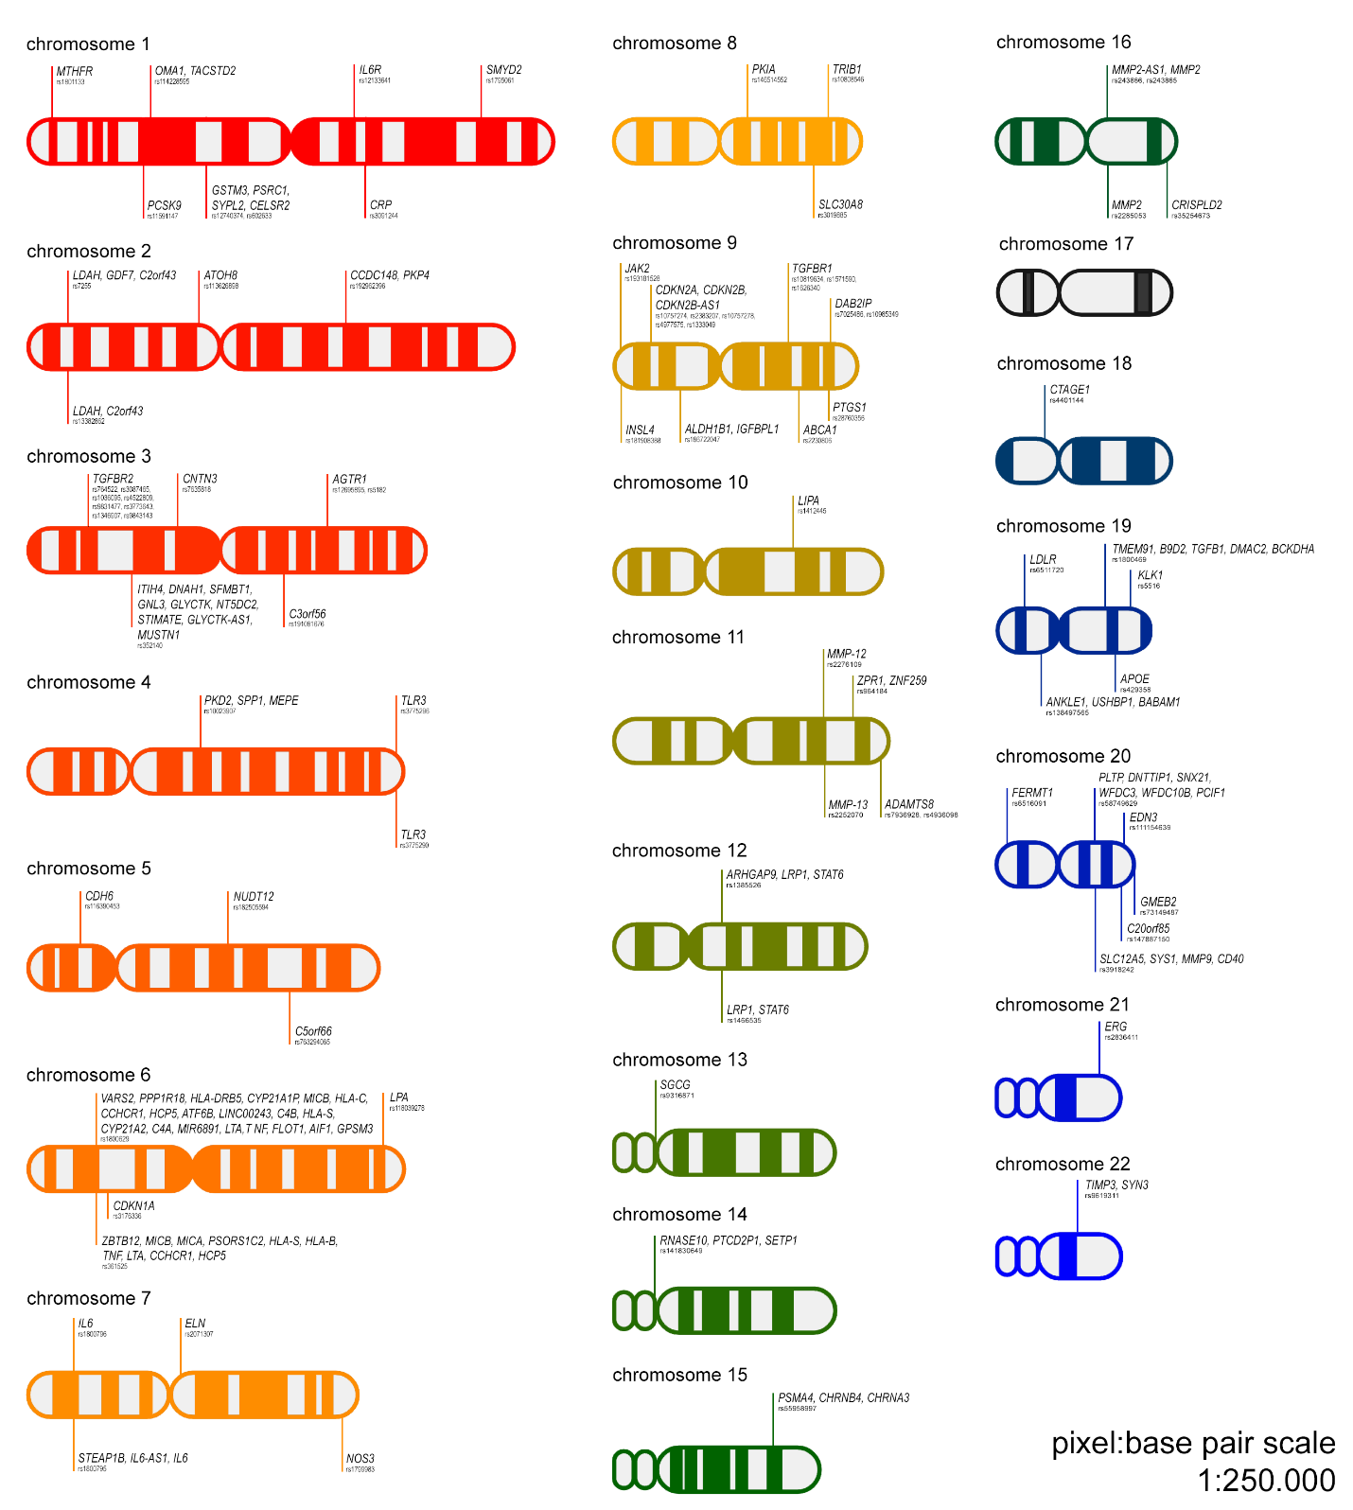
Supplementary Figure 1. Full chromosomal mapping of 86 SNPs associated with AAA, in 1:250.000 scale of pixel to base pair.

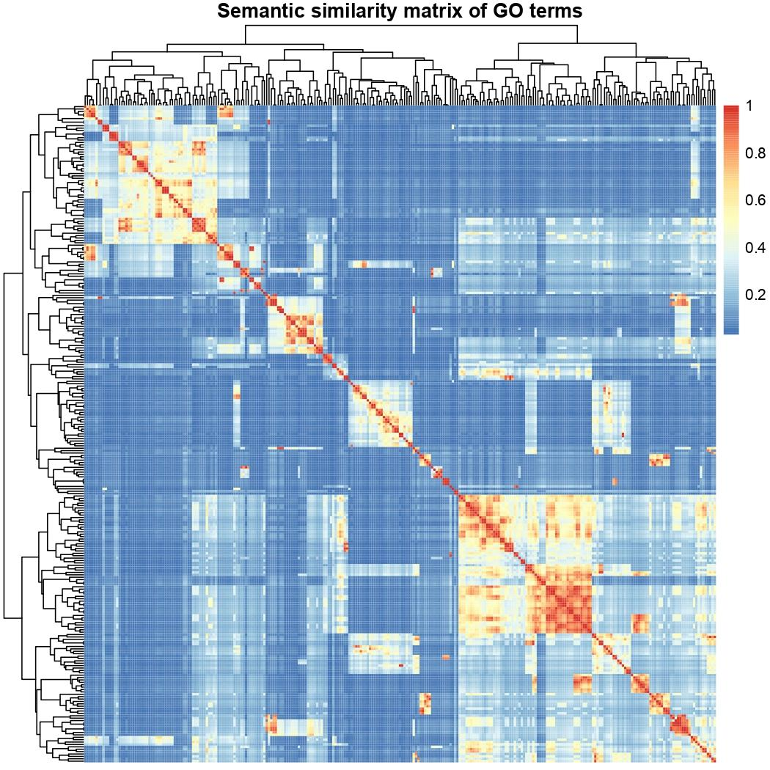
Supplementary Figure 2. Semantic-similarity based matrix of gene ontology terms from AAA associated genes. The rows and columns of the matrix represent the different enriched terms. This distance matrix is done using Lin as semantic similarity measure.

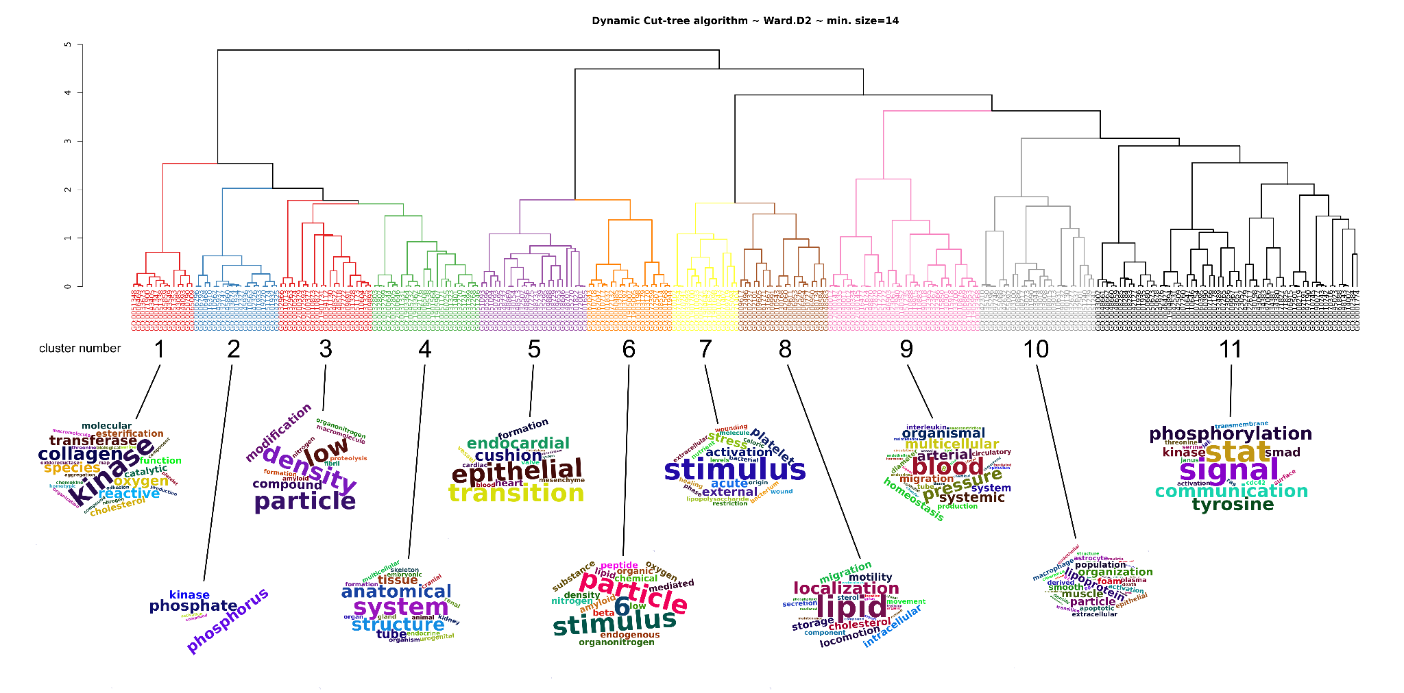
Supplementary Figure 3. Dendrogram of gene ontology terms from AAA associated genes semantic-similarity based distance matrix. The number of clusters was calculated using a dynamic cut tree algorithm. The wordcloud visualizes the interpretation of the clusters in the dendrogram. The wordcloud shows only the most frequent terms within each cluster.

