Supplementary Information

Kinetic Accommodations in Mechanistic Modeling

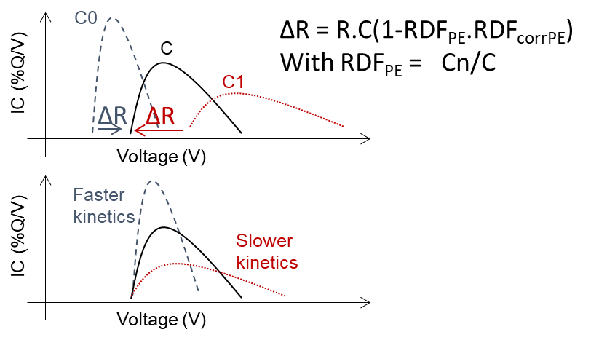
Figure S1. Kinetic accommodation Principles. R is the cell resistance, C the requested rate, RDF_{PE} the rate degradation factor, and RDF_{corrPE} the additional correction needed.

Summary of simulations
Table S1. Summary of all simulations performed in this work with emulation parameters (PI: perfect irradiance, C: cloudy).

Cell  # | LR | OFS | R | RDF_{PE} |  | RDF_{CorrPE} |  | RDF_{NE} |  | Duty cycle | Paths
 |  |  |  | a | b | a | b | a | b | Duty cycle | Resolution
1 | 1.200 | 4.000 | -0.100 | 0.064 | -0.836 | 3.916 | -0.306 | 0.443 | -0.217 | PI - 03/21/2017 | 1%
2 | 1.199 | 4.033 | -0.099 | 0.064 | -0.840 | 3.921 | -0.304 | 0.444 | -0.216 | PI - 03/21/2017 | 1%
5 | 1.195 | 3.964 | -0.100 | 0.064 | -0.838 | 3.884 | -0.303 | 0.445 | -0.219 | PI - 01/01/2017 | 2.5%
6 | 1.201 | 3.969 | -0.101 | 0.064 | -0.833 | 3.935 | -0.303 | 0.439 | -0.218 | PI - 02/01/2017 | 2.5%
7 | 1.202 | 4.002 | -0.100 | 0.064 | -0.841 | 3.899 | -0.307 | 0.444 | -0.217 | PI - 03/01/2017 | 2.5%
8 | 1.189 | 4.022 | -0.100 | 0.064 | -0.840 | 3.885 | -0.304 | 0.443 | -0.217 | PI - 04/01/2017 | 2.5%
9 | 1.209 | 4.024 | -0.100 | 0.063 | -0.829 | 3.884 | -0.308 | 0.447 | -0.218 | PI - 05/01/2017 | 2.5%
10 | 1.191 | 4.018 | -0.099 | 0.064 | -0.838 | 3.903 | -0.307 | 0.445 | -0.217 | PI - 06/01/2017 | 2.5%
11 | 1.206 | 3.979 | -0.100 | 0.065 | -0.842 | 3.884 | -0.305 | 0.442 | -0.218 | PI - 07/01/2017 | 2.5%
12 | 1.202 | 4.023 | -0.100 | 0.064 | -0.829 | 3.937 | -0.304 | 0.442 | -0.217 | PI - 08/01/2017 | 2.5%
13 | 1.193 | 4.011 | -0.100 | 0.064 | -0.841 | 3.885 | -0.305 | 0.441 | -0.217 | PI - 09/01/2017 | 2.5%
14 | 1.190 | 3.992 | -0.099 | 0.064 | -0.841 | 3.900 | -0.307 | 0.447 | -0.217 | PI - 10/01/2017 | 2.5%
15 | 1.205 | 4.021 | -0.100 | 0.064 | -0.829 | 3.950 | -0.304 | 0.441 | -0.218 | PI - 11/01/2017 | 2.5%
16 | 1.200 | 4.022 | -0.100 | 0.064 | -0.828 | 3.930 | -0.306 | 0.443 | -0.217 | PI - 12/01/2017 | 2.5%
17 | 1.189 | 3.985 | -0.101 | 0.064 | -0.830 | 3.887 | -0.304 | 0.439 | -0.217 | PI - 01/01/2017 | 2.5%
18 | 1.204 | 4.018 | -0.100 | 0.063 | -0.838 | 3.887 | -0.304 | 0.439 | -0.215 | PI - 02/01/2017 | 2.5%
19 | 1.192 | 3.976 | -0.100 | 0.064 | -0.831 | 3.897 | -0.308 | 0.445 | -0.217 | PI - 03/01/2017 | 2.5%
20 | 1.192 | 3.977 | -0.099 | 0.065 | -0.839 | 3.921 | -0.305 | 0.440 | -0.218 | PI - 04/01/2017 | 2.5%
21 | 1.212 | 3.974 | -0.100 | 0.064 | -0.829 | 3.930 | -0.305 | 0.447 | -0.217 | PI - 05/01/2017 | 2.5%
22 | 1.203 | 3.972 | -0.100 | 0.064 | -0.840 | 3.945 | -0.305 | 0.445 | -0.216 | PI - 06/01/2017 | 2.5%
23 | 1.201 | 4.027 | -0.100 | 0.064 | -0.833 | 3.912 | -0.306 | 0.442 | -0.217 | PI - 07/01/2017 | 2.5%
24 | 1.206 | 3.994 | -0.100 | 0.064 | -0.828 | 3.900 | -0.305 | 0.444 | -0.219 | PI - 08/01/2017 | 2.5%
25 | 1.210 | 3.997 | -0.099 | 0.064 | -0.840 | 3.935 | -0.307 | 0.440 | -0.218 | PI - 09/01/2017 | 2.5%
26 | 1.199 | 3.977 | -0.099 | 0.064 | -0.831 | 3.890 | -0.307 | 0.446 | -0.217 | PI - 10/01/2017 | 2.5%
27 | 1.205 | 3.972 | -0.101 | 0.064 | -0.839 | 3.880 | -0.308 | 0.445 | -0.215 | PI - 11/01/2017 | 2.5%
28 | 1.201 | 3.986 | -0.100 | 0.064 | -0.835 | 3.891 | -0.305 | 0.439 | -0.219 | PI - 12/01/2017 | 2.5%
29 | 1.204 | 4.035 | -0.099 | 0.065 | -0.841 | 3.922 | -0.306 | 0.441 | -0.218 | C - 01/05/2017 | 5%
30 | 1.193 | 3.965 | -0.101 | 0.064 | -0.840 | 3.927 | -0.306 | 0.442 | -0.218 | C - 11/11/2016 | 5%
31 | 1.196 | 4.025 | -0.101 | 0.064 | -0.836 | 3.927 | -0.309 | 0.443 | -0.215 | C - 11/14/2016 | 5%
32 | 1.209 | 4.010 | -0.100 | 0.065 | -0.831 | 3.928 | -0.307 | 0.442 | -0.215 | C - 11/16/2016 | 5%
33 | 1.189 | 3.994 | -0.099 | 0.064 | -0.834 | 3.943 | -0.307 | 0.444 | -0.216 | C - 04/17/2016 | 5%
34 | 1.211 | 3.981 | -0.101 | 0.064 | -0.834 | 3.884 | -0.307 | 0.440 | -0.215 | C - 07/28/2016 | 5%
35 | 1.205 | 3.988 | -0.100 | 0.064 | -0.838 | 3.879 | -0.309 | 0.446 | -0.218 | C - 06/13/2016 | 5%
36 | 1.208 | 3.991 | -0.100 | 0.064 | -0.837 | 3.898 | -0.304 | 0.443 | -0.216 | C - 11/23/2016 | 5%
37 | 1.207 | 4.039 | -0.099 | 0.064 | -0.829 | 3.940 | -0.309 | 0.439 | -0.219 | C - 07/26/2016 | 5%
38 | 1.188 | 4.015 | -0.101 | 0.064 | -0.842 | 3.947 | -0.307 | 0.440 | -0.216 | PI - 11/11/2016 | 2.5%
39 | 1.192 | 3.963 | -0.099 | 0.064 | -0.843 | 3.905 | -0.305 | 0.447 | -0.219 | PI - 11/14/2016 | 2.5%
40 | 1.204 | 4.039 | -0.101 | 0.064 | -0.839 | 3.896 | -0.305 | 0.445 | -0.217 | PI - 01/05/2017 | 2.5%
41 | 1.198 | 4.008 | -0.101 | 0.064 | -0.837 | 3.923 | -0.306 | 0.439 | -0.218 | PI - 04/17/2016 | 2.5%
42 | 1.212 | 3.988 | -0.101 | 0.064 | -0.842 | 3.912 | -0.305 | 0.440 | -0.215 | PI - 07/28/2016 | 2.5%
43 | 1.195 | 4.018 | -0.101 | 0.064 | -0.828 | 3.943 | -0.309 | 0.445 | -0.215 | PI - 11/16/2016 | 2.5%
44 | 1.197 | 4.016 | -0.100 | 0.064 | -0.832 | 3.930 | -0.306 | 0.444 | -0.216 | PI - 06/13/2016 | 2.5%
45 | 1.192 | 4.026 | -0.101 | 0.065 | -0.829 | 3.891 | -0.304 | 0.443 | -0.216 | PI - 07/27/2016 | 2.5%
46 | 1.210 | 3.968 | -0.099 | 0.064 | -0.841 | 3.901 | -0.304 | 0.442 | -0.216 | PI - 11/23/2016 | 2.5%
47 | 1.200 | 4.033 | -0.100 | 0.063 | -0.834 | 3.881 | -0.306 | 0.442 | -0.219 | PI - 03/31/2017 | 2.5%
48 | 1.207 | 3.999 | -0.101 | 0.064 | -0.834 | 3.949 | -0.309 | 0.445 | -0.218 | PI - 06/01/2017 | 2.5%
49 | 1.196 | 4.035 | -0.099 | 0.064 | -0.838 | 3.942 | -0.305 | 0.445 | -0.218 | PI - 10/19/2017 | 2.5%
50 | 1.196 | 4.004 | -0.101 | 0.064 | -0.833 | 3.925 | -0.305 | 0.445 | -0.217 | PI - 03/11/2017 | 2.5%
51 | 1.191 | 4.033 | -0.099 | 0.064 | -0.843 | 3.916 | -0.307 | 0.444 | -0.218 | PI - 08/02/2017 | 2.5%
52 | 1.189 | 4.002 | -0.099 | 0.064 | -0.833 | 3.943 | -0.304 | 0.444 | -0.219 | PI - 09/18/2017 | 2.5%
53 | 1.189 | 3.964 | -0.099 | 0.064 | -0.838 | 3.886 | -0.308 | 0.444 | -0.215 | PI - 02/01/2017 | 2.5%
54 | 1.190 | 3.971 | -0.101 | 0.063 | -0.832 | 3.896 | -0.304 | 0.446 | -0.218 | PI - 05/22/2017 | 2.5%
55 | 1.206 | 4.012 | -0.100 | 0.064 | -0.839 | 3.886 | -0.304 | 0.439 | -0.219 | PI - 10/17/2017 | 2.5%
56 | 1.211 | 3.970 | -0.100 | 0.064 | -0.832 | 3.936 | -0.306 | 0.442 | -0.216 | C - 03/31/2017 | 5%
57 | 1.206 | 4.032 | -0.100 | 0.064 | -0.843 | 3.897 | -0.306 | 0.447 | -0.216 | C - 06/01/2017 | 5%
58 | 1.194 | 4.034 | -0.099 | 0.064 | -0.838 | 3.893 | -0.307 | 0.446 | -0.217 | C - 10/19/2017 | 5%
59 | 1.204 | 4.024 | -0.099 | 0.064 | -0.830 | 3.917 | -0.308 | 0.447 | -0.217 | C - 03/11/2017 | 5%
60 | 1.195 | 4.012 | -0.101 | 0.064 | -0.844 | 3.892 | -0.304 | 0.441 | -0.217 | C - 08/02/2017 | 5%
61 | 1.198 | 3.985 | -0.100 | 0.063 | -0.834 | 3.900 | -0.305 | 0.440 | -0.217 | C - 09/18/2017 | 5%
62 | 1.195 | 3.972 | -0.099 | 0.064 | -0.837 | 3.945 | -0.303 | 0.447 | -0.215 | C - 02/01/2017 | 5%
63 | 1.208 | 4.024 | -0.101 | 0.064 | -0.836 | 3.909 | -0.304 | 0.444 | -0.217 | C - 05/22/2017 | 5%
64 | 1.193 | 4.002 | -0.101 | 0.064 | -0.839 | 3.909 | -0.303 | 0.441 | -0.218 | C - 10/17/2017 | 5%

Supplementary Tables and Figures
Figure S2: (a-f) RMSE dependency on maximum degradation of at least one of the degradation modes. (f) diagnosis error induced by cell-to-cell variations for more than 14,000,000 samples.
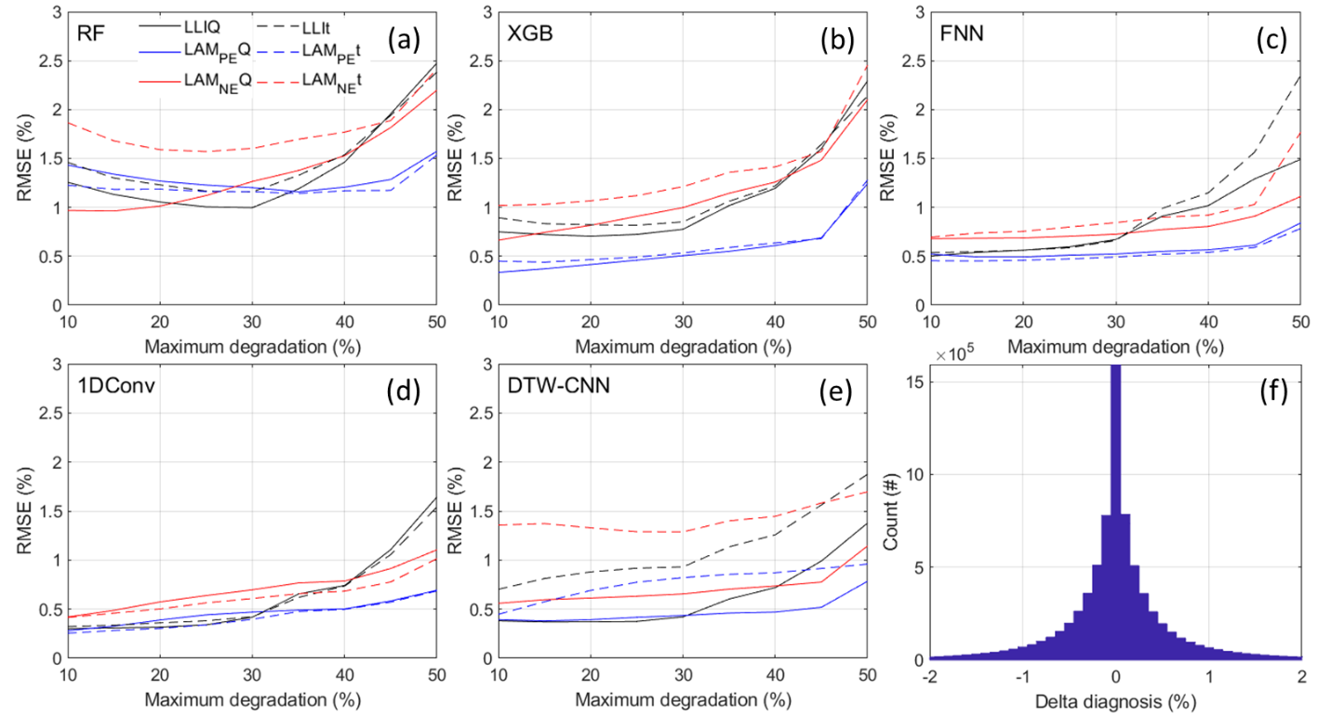

Table S2: Complete statistics for the alidation on the same day and on different days for the full dataset and degradations limited to at most 25% for each degradation mode.
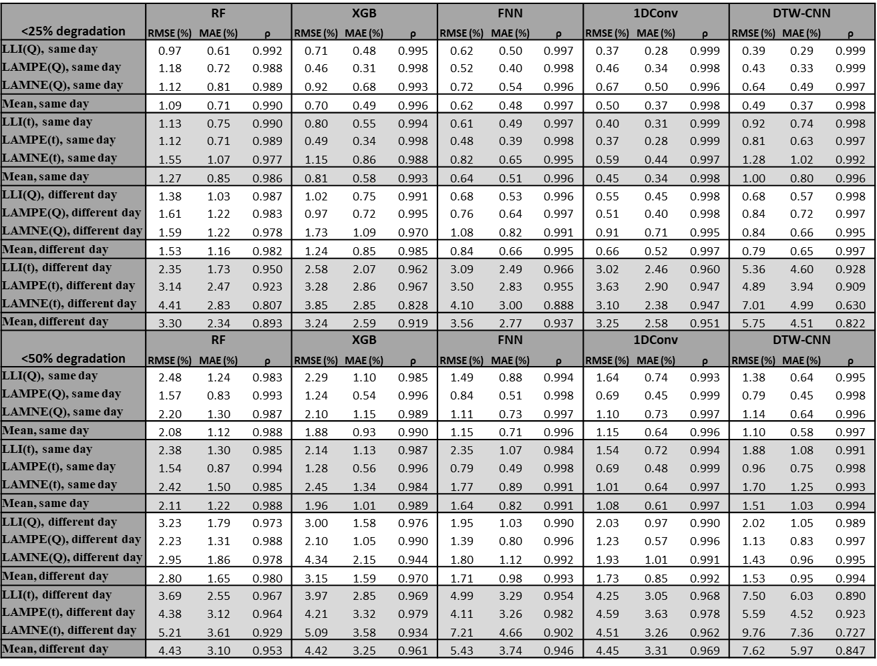
Table S3: Complete statistics for the validation on cloudy days when less than 25% of each degradation modes.
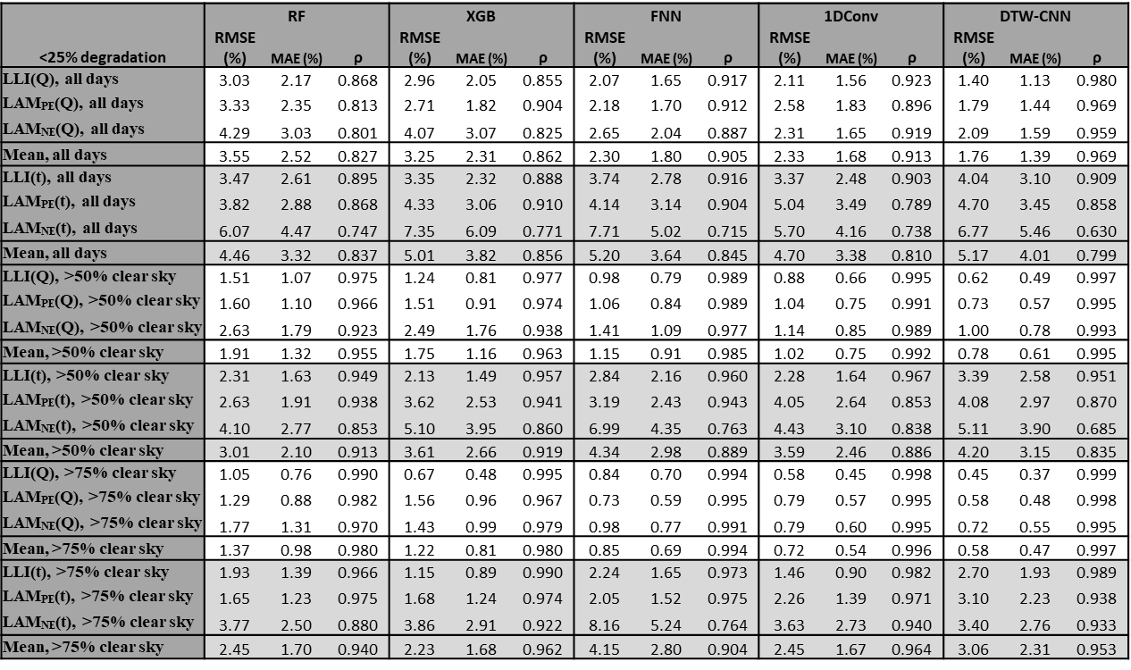
Table S4: Complete statistics for the validation on cloudy days when less than 50% of each degradation modes.
