SUPPLEMENTAL
METHODS
Analysis
The variables were considered as the following for the score's value before conducting the analysis in RStudio software.
- Depression Symptom (levels 0, 1 and 2):
if (Sadness >= 1) Sadness = 1
if (Anxiety >= 1) Anxiety = 1
if (Weeping >= 1) Weeping = 1
if (Demotivation >= 1) Demotivation = 1
if (Irritability >= 1) Irritability = 1
if (Guilty >= 1) Guilty = 1
if (Suicidal Ideation >= 1) Suicidal Ideation = 1
Depression Symptom = Σ (all symptoms)
if (Depression Symptom <= 1) Depression Symptom = 0
if (Depression Symptom >= 2 AND <= 4) Depression Symptom = 1
if (Depression Symptom >= 5) Depression Symptom = 2

- Gestational Problem (levels 0, 1, 2 and 3):
y₁: if (Contraction OR Bleeding OR Threatened Miscarriage) y₁ = 1 / else y₁ = 0
y₂: if (Hypertension OR Pre-Eclampsia) y₁ = 1 / else y₁ = 0
y₃: if (Infection AND Fever) y₃ = 1 / else y₃ = 0
Gestational Problem = y₁ + y₂ + y₃ + Gestational Diabetes
if (Gestational Problem >= 3) Gestational Problem = 3

- Drugs (levels 0, 1 and 2):
if (Alcohol >= 1) Alcohol = 1
if (Smoke >= 1) Smoke = 1
if (Marijuana >= 1) Marijuana = 1
Drugs = Alcohol + Smoke + Marijuana
if (Drugs >= 2) Drugs = 3

- House Income (levels 0, 1 and 2):
if (House Income <= 5) House Income = 0
if (House Income == 6) House Income = 1
if (House Income >= 7) House Income = 2

- Mother Education (levels 0, 1 and 2):
if (Mother Education <= 5) Mother Education = 0
if (Mother Education == 6 OR == 7) Mother Education = 1
if (Mother Education >= 8) Mother Education = 2

- Father Education (levels 0, 1 and 2):
if (Father Education <= 5) Father Education = 0
if (Father Education == 6 OR == 7) Father Education = 1
if (Father Education >= 8) Father Education = 2

- Stress (levels 0, 1, 2 and 3): job change, partner losing job, moving home, death of a loved one, problems with justice system, being robbed, witness a crime, live alone and poverty;
if (Job Change >= 1) Job Change = 1
if (Partner Losing Job >= 1) Partner Losing Job = 1
if (Moving Home >= 1) Moving Home = 1
if (Death of a loved one >= 1) Death of a loved one = 1
if (Problem with Justice System >= 1) Problem with Justice System = 1
if (Being robbed >= 1) Being robbed = 1
if (Witness a Crime >= 1) Witness a Crime = 1
if (Live Alone >= 1) Live Alone = 1
if (Poverty >= 1) Poverty = 1
Stress = Σ (all stress)
if (Stress >= 3) Stress = 3

- Aggression (levels 0, 1 and 2): physical, psychological, verbal and sexual aggression by partner, family member or others.
if (Physical by Partner >= 1) Physical by Partner = 1
if (Physical by Familiar >= 1) Physical by Family Member = 1
if (Physical by Others >= 1) Physical by Others = 1
if (Psychological by Partner >= 1) Psychological by Partner ₌ 1
if (Psychological by Family Member >= 1) Psychological by Family Member ₌ 1
if (Psychological by Others >= 1) Psychological by Others = 1
if (Verbal by Partner >= 1) Verbal by Partner ₌ 1
if (Verbal by Family Member >= 1) Verbal by Family Member ₌ 1
if (Verbal by Others >= 1) Verbal by Others ₌ 1
if (Sexual by Partner >= 1) Sexual by Partner ₌ 1
if (Sexual by Family Member >= 1) Sexual by Family Member ₌ 1
if (Sexual by Others >= 1) Sexual by Others ₌ 1
Aggression = Σ (all aggressions)
if (Aggression == 1 OR == 2) Aggression = 1
if (Aggression >= 3) Aggression = 2

SUPPLEMENTAL FIGURES and TABLES
Supplemental Figure 1 - EFs Distribution. Distribution of response levels for EF variables. The numbers of individuals (n) are displayed in the respective graphs, with 0 meaning "No problem" and the highest number representing the worst case.

Supplemental Figure 2 - FH Distribution. Distribution of response levels for FH variables. In all graphs, the number of individuals (n) was 904. Autism Spectrum Disorder (ASD); Attention Deficit Disorder (ADD); Obsessive Compulsive Disorder (OCD); with 0 meaning "No FH" and 1 representing “positive FH”.

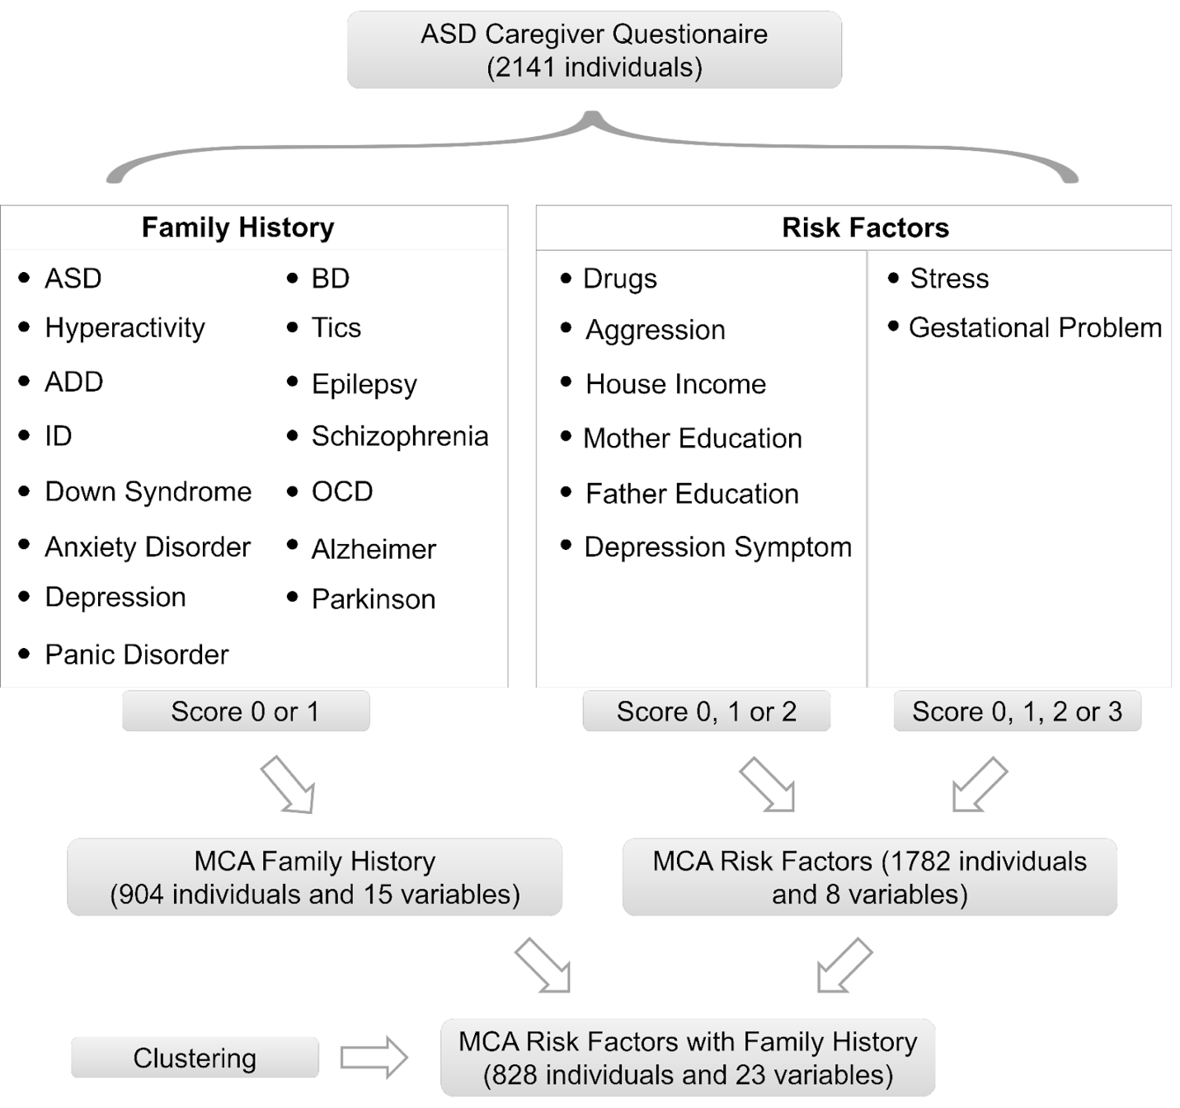

Supplemental Figure 3 - Flowchart. Flowchart of the methodological approach. Autism Spectrum Disorder (ASD); Bipolar Disorder (BD); Attention Deficit Disorder (ADD); Intellectual Disability (ID); Obsessive Compulsive Disorder (OCD).

A
C
B

Supplemental Figure 4 - MCA with environmental factors and FH variables (828 individuals and 23 variables). A, Barplot of contribution of variables to first dimension; B, Barplot of contribution of variables to second dimension; C, MCA biplot visualization of response levels. Autism Spectrum Disorder (ASD); Bipolar Disorder (BD); Attention Deficit Disorder (ADD); Obsessive Compulsive Disorder (OCD); Intellectual Disability (ID).

Supplemental Tables
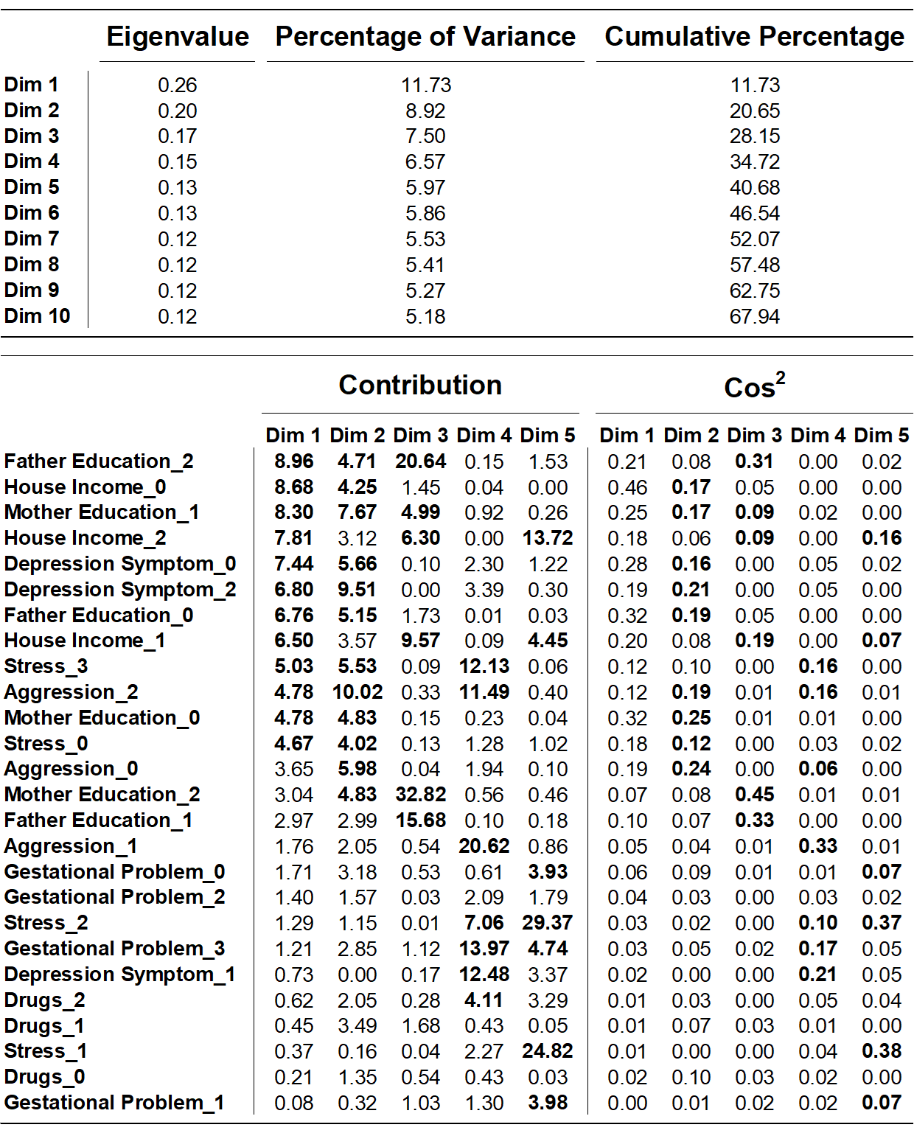
Supplemental Table 1 - Eigenvalues, Inertia, Contributions and Cos² of EF. EF (1782 individuals and 8 variables) - The eigenvalues and proportion of explained inertia of the first ten dimensions, contributions for the variables and squared cosines. Bold characters correspond to positive characteristics.
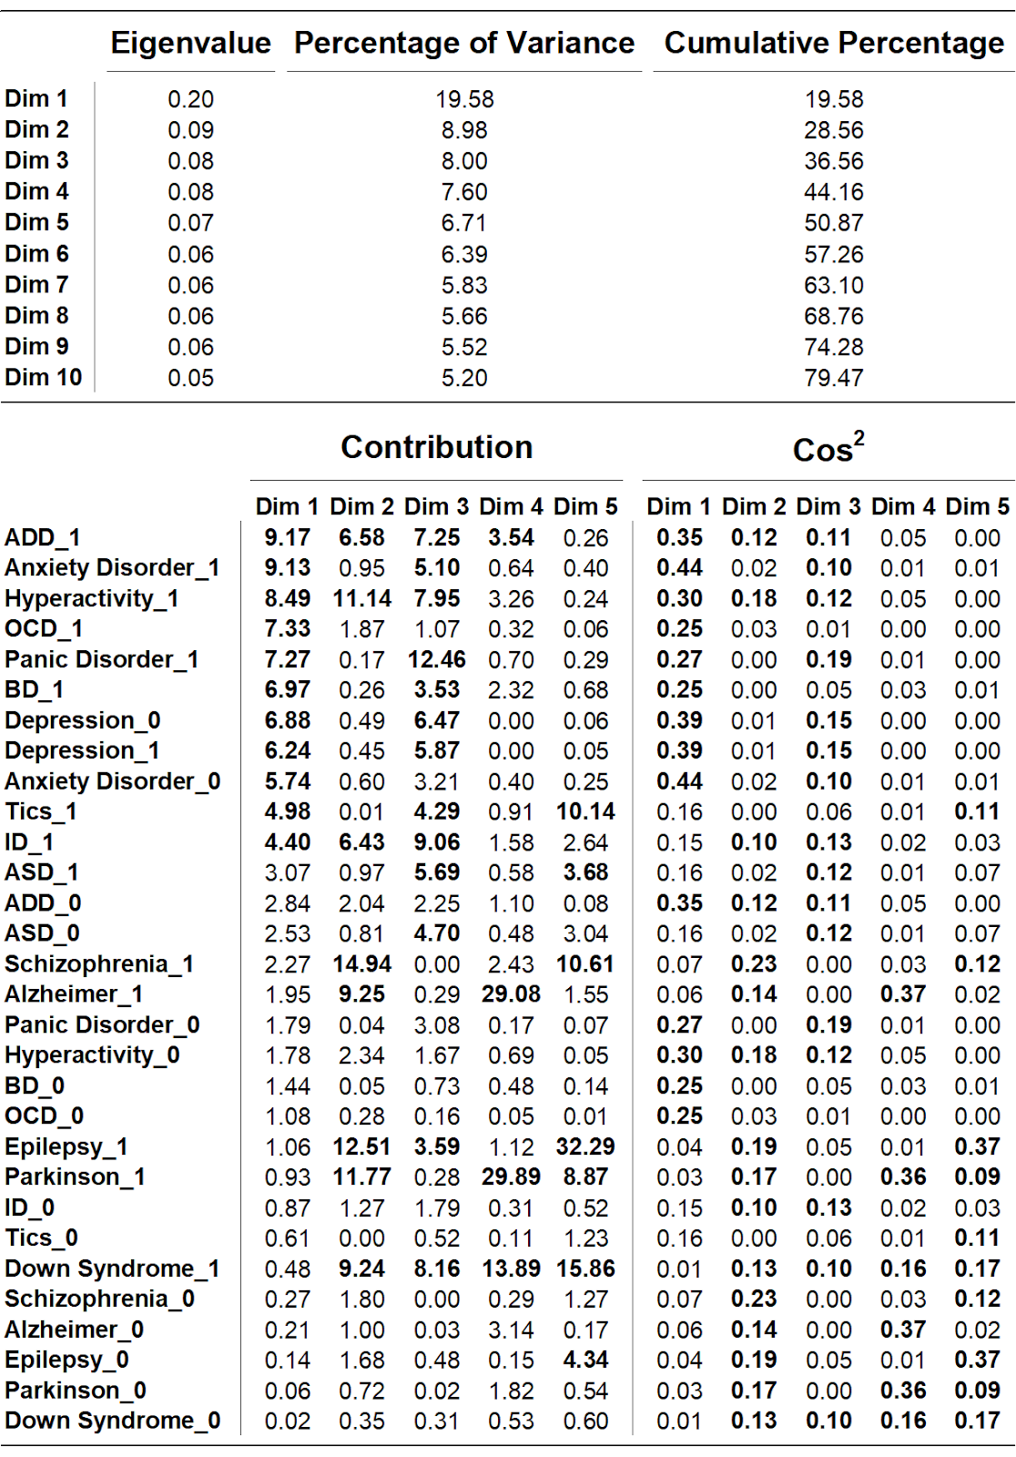

Supplemental Table 2 - Eigenvalues, Inertia, Contributions and Cos² of FH. FH for psychiatric disorders - The eigenvalues and proportion of explained inertia of the first ten dimensions, contributions for the variables and squared cosines. Bold characters correspond to positive characteristics. Autism Spectrum Disorder (ASD); Bipolar Disorder (BD); Attention Deficit Disorder (ADD); Obsessive Compulsive Disorder (OCD); Intellectual Disability (ID).
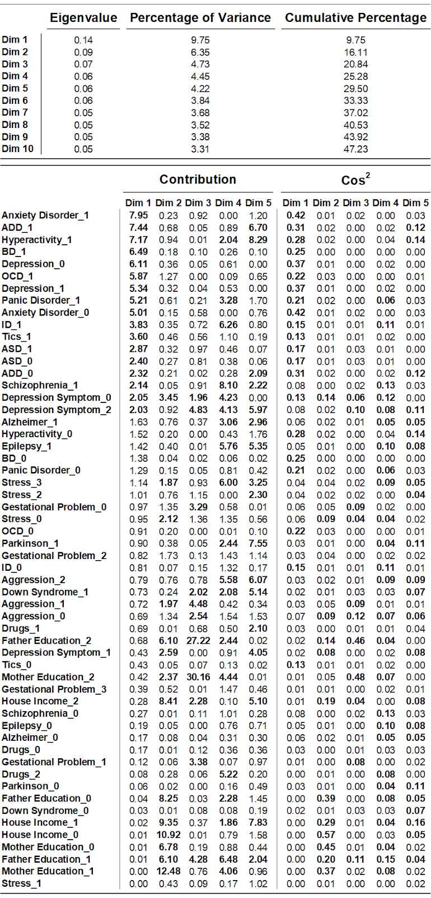

Supplemental Table 3 - Eigenvalues, Inertia, Contributions and Cos² of EF and FH. EF and FH for psychiatric disorders - The eigenvalues and proportion of explained inertia of the first ten dimensions, contributions for the variables and squared cosines. Bold characters correspond to positive characteristics. Autism Spectrum Disorder (ASD); Bipolar Disorder (BD); Attention Deficit Disorder (ADD); Obsessive Compulsive Disorder (OCD); Intellectual Disability (ID).

