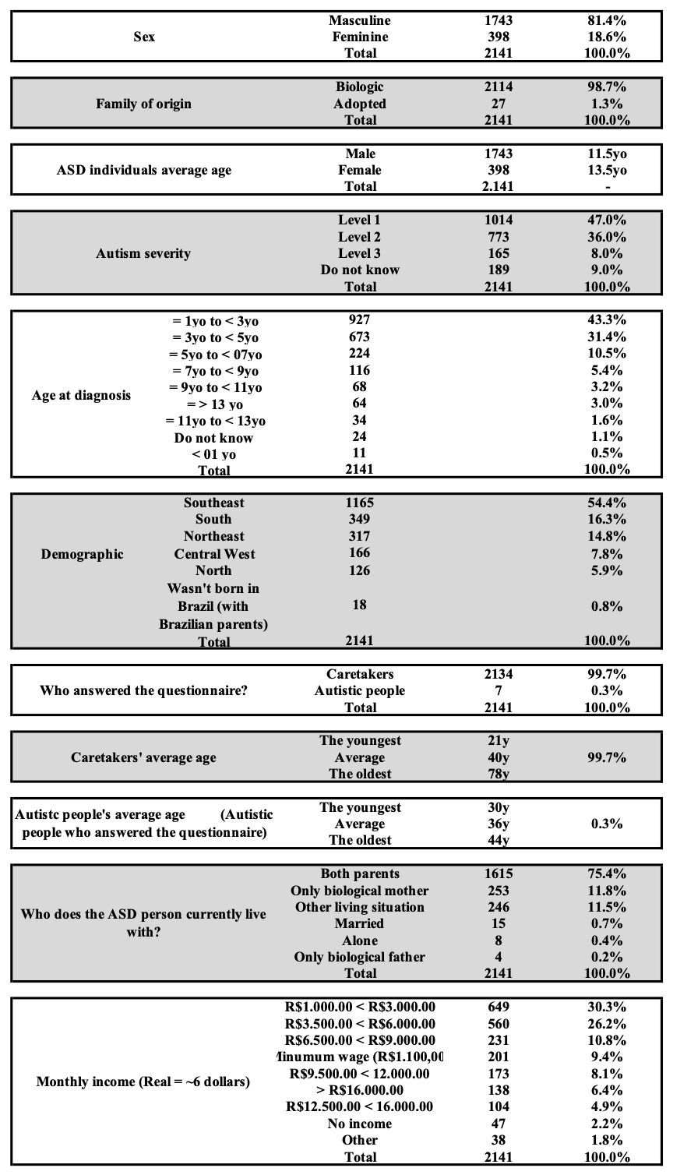
Table 1 - Sample description (n = 2141).

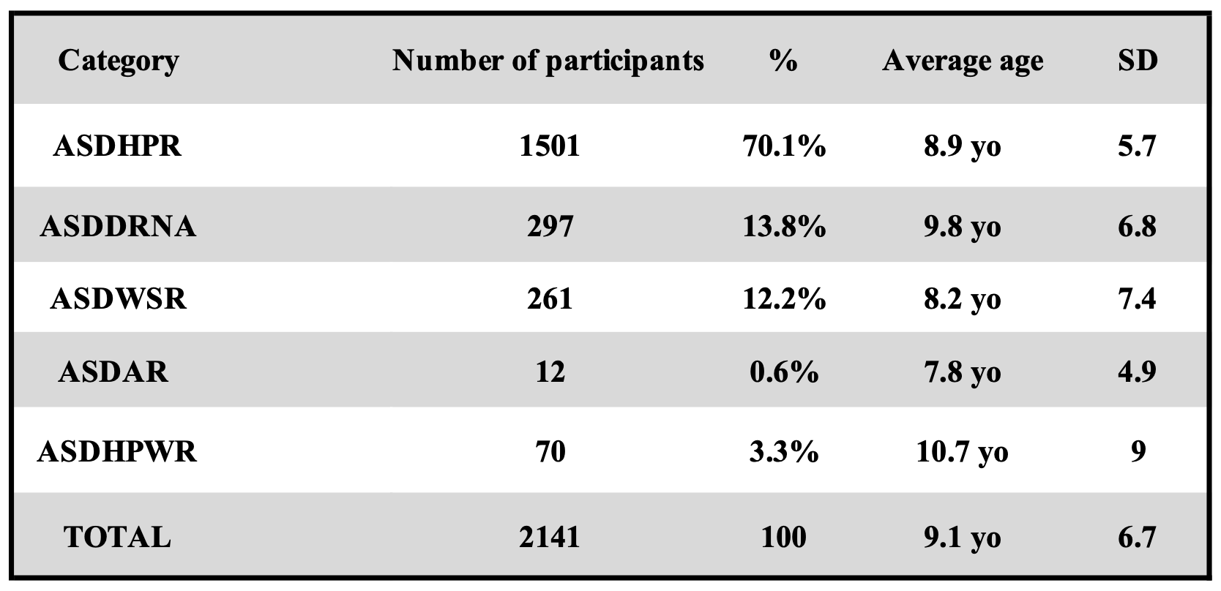
Table 2. Diagnosis assessment. 1501 ASDHPR = ASD individuals Diagnosed by a Health Professional, with a Report; 297 ASDDRNA = ASD individuals Diagnosed by a health professional, but the Report was Not Available; 261 ASDWSR = ASD individuals diagnosed by a health professional that Will Send a Report; 12 ASDAR = ASD individuals Auto Reported; and 70 ASDHPWR = ASD individuals diagnosed by a Health Professional, but Without a Report. Average age = of the proband when the questionnaire was filled. SD = standard deviation.

