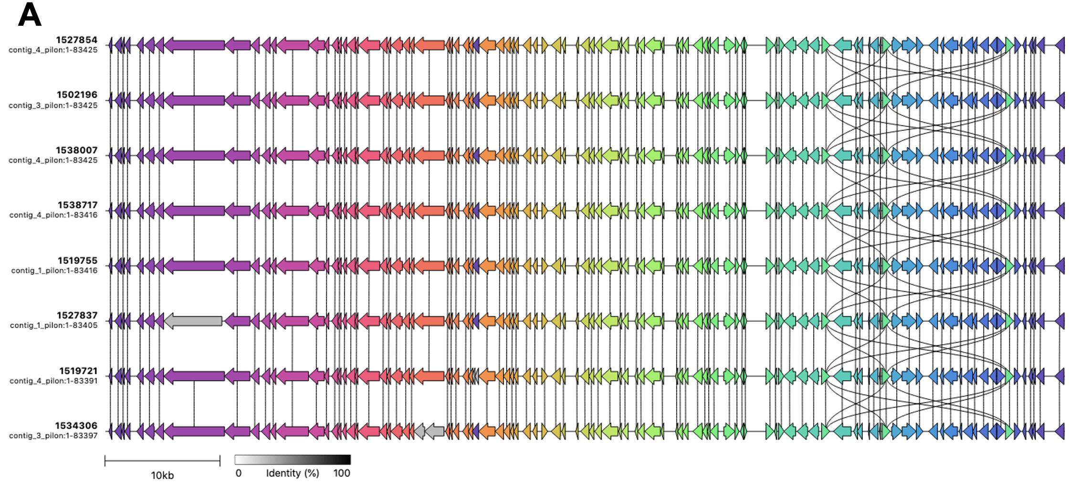
Supplementary Figure 1. Comparison of plasmid p893816 with other sequences (A) Alignment of England, UK, IncFII plasmids harbouring bla_{CTX-M-27}. Links show sequences (CDS) ≥ 95% sequence similarity.
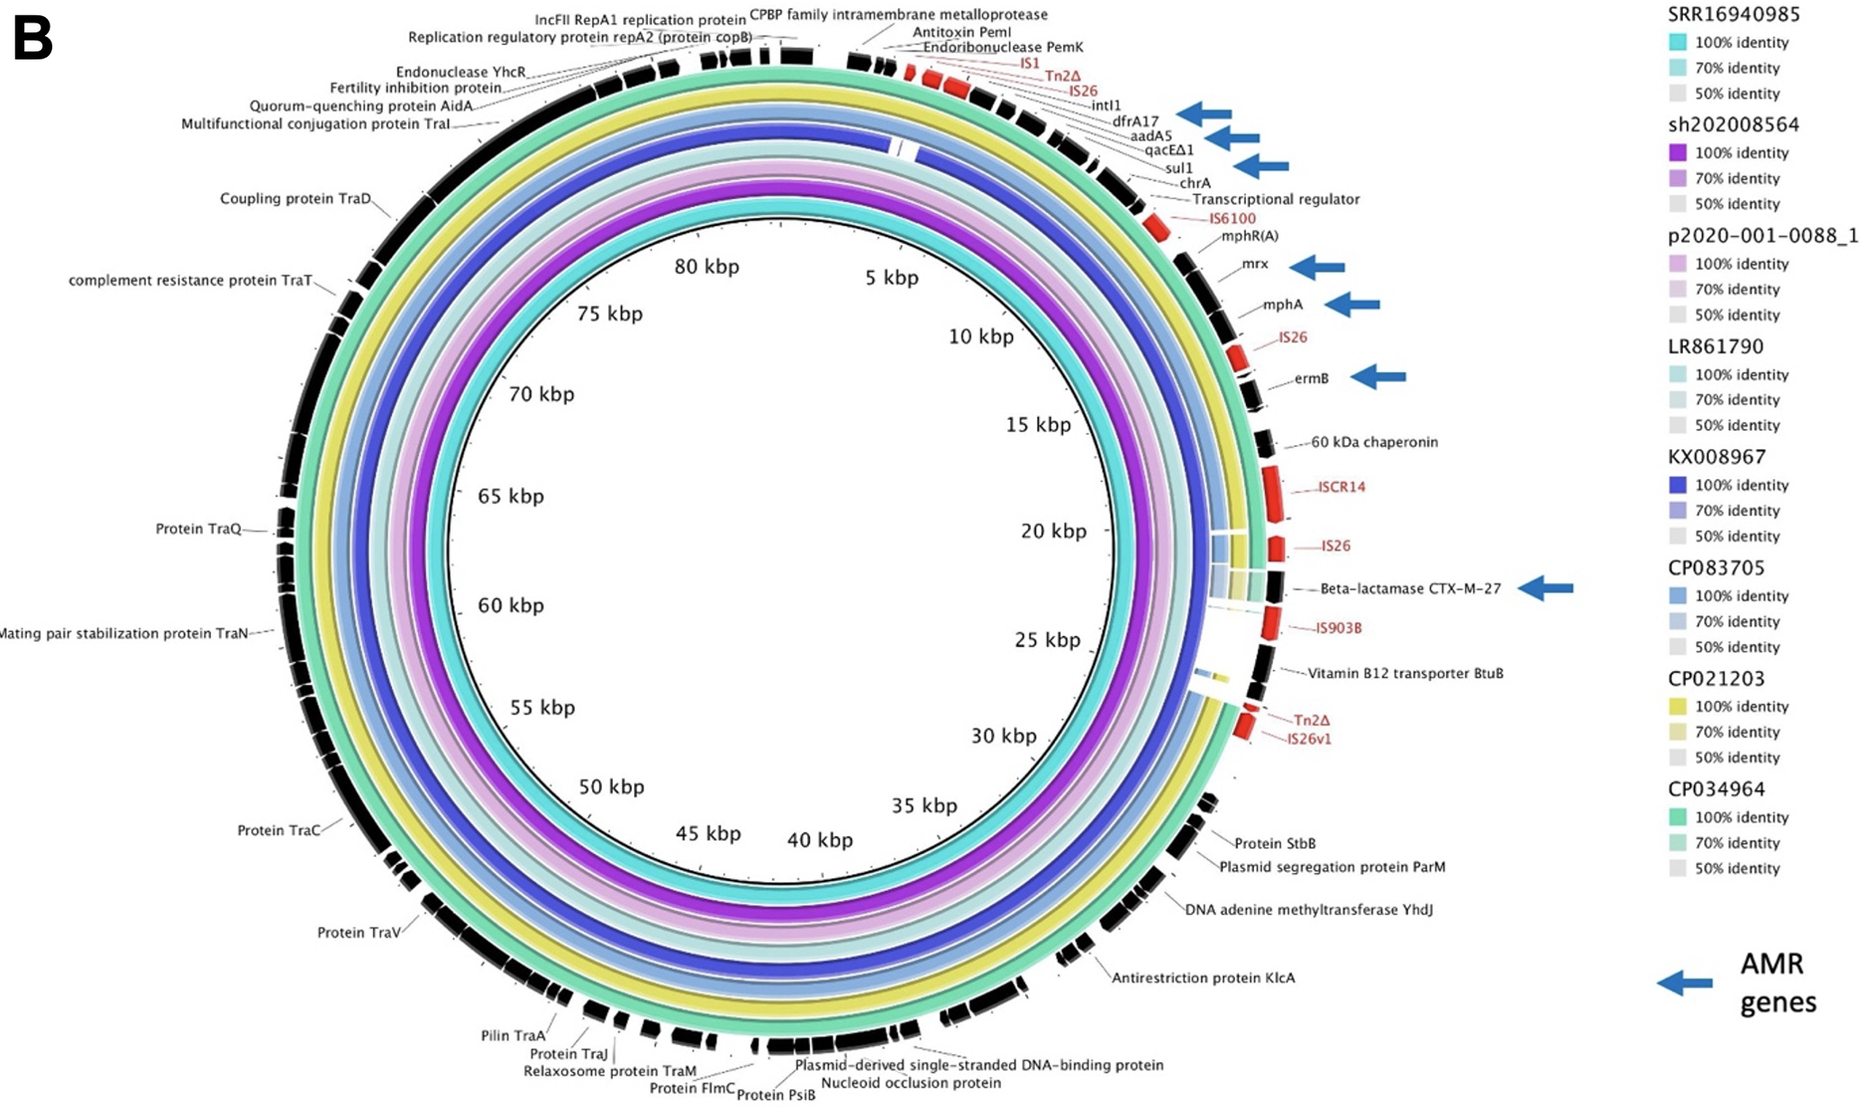
B

(B) FII plasmids in BAPS5 isolates carrying bla_{CTX-M-27} from different countries are virtually identical to p893816 and other plasmids from the UK and have differences from plasmids in public data. Rings are coloured by plasmid and BLAST similarity according to the inlaid keys, with gene annotations shown and labelled in the outermost ring in black. AMR genes are indicated by blue arrows. IS and transposon fragments are in red. The BRIG plot shows the virtual identity of plasmids in Table 2, differences from p183660 (KX008967) and three other plasmids selected from a BLAST search with > 95% identity, as examples. Note that these three plasmids have large insertions and/or rearrangements vs. p893816, that segments matching p893816 may not be contiguous in these plasmids and genes matching bla_{CTX-M-27} (bla_{CTX-M-9}-group) with ~70% identity are bla_{CTX-M-1} group 1 and have a different origin.

Supplementary Table 1. Accession numbers, epidemiological metadata, genotypic and phylogenetic subtyping, and gene presence for all isolates in this study.

Supplementary Table 2. Antimicrobial susceptibility testing results, genotypic/phylogenetic subgroups, and genotypic AMR profiles of a subset of 14 representative isolates. Interpretation was according to European Committee on Antimicrobial Susceptibility Testing (EUCAST) standards.⁶¹ All isolates in this table carry the dfrA1 gene and have gyrA_D87G, gyrA_S83L and parC_80I QRDR mutations.
 | Minimum Inhibitory Concentrations (MICs) [mg/L] |  |  |  |  |  |  | Genes
Accession | CIP | GEN | CRO | AZM | MEC | ERT | SXT | bla_{CTX-M-27} | erm(B) | mph(A) | qnrB19 | sul1 | sul2
SRR17120129 | 6 | 0.75 | >32 | >256 | 0.125 | 0.006 | >32 | P | P | P | P | P | A
SRR17099017 | 6 | 0.75 | 12 | >256 | 0.125 | 0.008 | >32 | P | P | P | P | P | P
SRR17038739 | 6 | 0.75 | 24 | >256 | 0.094 | 0.006 | >32 | P | P | P | P | P | P
SRR16940985 | 6 | 0.75 | 16 | >256 | 0.094 | 0.006 | >32 | P | P | P | P | P | P
SRR16940973 | 4 | 0.75 | 32 | >256 | 0.125 | 0.008 | >32 | P | P | P | P | P | P
SRR16842826 | 4 | 0.5 | 32 | >256 | 0.125 | 0.006 | >32 | P | P | P | P | P | A
SRR16842843 | 6 | 0.75 | 32 | >256 | 0.094 | 0.006 | >32 | P | P | P | P | P | P
SRR16612616 | 6 | 0.75 | 32 | >256 | 0.094 | 0.008 | >32 | P | P | P | P | P | A
SRR15512411 | 4 | 0.75 | 32 | >256 | 0.125 | 0.008 | >32 | P | A | P | P | P | A
SRR16598676 | 6 | 0.75 | 0.012 | >256 | 0.094 | 0.004 | >32 | A | A | P | P | P | A
SRR16821273 | 6 | 0.75 | 0.012 | >256 | 0.064 | 0.006 | >32 | A | A | P | A | P | A
SRR14407961 | 6 | 0.75 | 0.016 | 12 | 0.064 | 0.004 | >32 | A | A | A | P | A | P
SRR14792720 | 4 | 0.75 | 0.016 | >256 | 0.38* | 0.006 | >32 | A | P | P | A | P | P
SRR14782977 | 4 | 0.75 | 0.016 | >256 | 0.5* | 0.006 | >32 | A | P | P | A | P | P
*Microcolonies in zone of inhibition
 |  |  | Susceptible |  |  |  |  |  |  |  | Absent
 |  |  | Resistant |  |  |  |  |  |  |  | Present

Supplementary Table 3. Bioinformatics packages used in this study.

Package | Command | Version | Used in | Citation | Reference(s)
BCFTOOLS,⁴⁴ | bcftools | 1.9-80-gff3137d | Figure 2 | Danecek, P., et al. (2021). | Danecek, P., et al. (2021). Twelve years of SAMtools and BCFtools. Gigascience 10(2).
BLAST Ring Image Generator (BRIG),⁶⁰ | BRIG | 0.95 | Figure S1B | Alikhan, N.-F., et al. (2011). | Alikhan, N.-F., et al. (2011). BLAST Ring Image Generator (BRIG): simple prokaryote genome comparisons. BMC Genomics 12(1): 402.
Burrow Wheeler Aligner (BWA),⁴¹ | BWA | 0.7.17-r118 | Figure 2 | Li, H. and R. Durbin (2009). | Li, H. and R. Durbin (2009). Fast and accurate short read alignment with Burrows-Wheeler transform. Bioinformatics 25(14): 1754-1760.
Clinker,⁵⁷ | Clinker | 0.0.21 | Figure S1A | Gilchrist and Chooi, (2021) | Gilchrist, C., & Chooi, Y. H. (2021). Clinker & clustermap.js: Automatic generation of gene cluster comparison figures. Bioinformatics (Oxford, England), btab007. Advance online publication. https://doi.org/10.1093/bioinformatics/btab007
Enterobase cgMLST V1 + Hier CC V1, NINJA MJ GrapeTree,^{35,36} | NINJA MJ | 1.1.3 | Figure 1 | Zhou, Z., et al. (2018) and Zhou, Z., et al. (2020). | Zhou, Z., et al. (2018). GrapeTree: visualization of core genomic relationships among 100,000 bacterial pathogens. Genome Res 28(9): 1395-1404. Zhou, Z., et al. (2020). The EnteroBase user's guide, with case studies on Salmonella transmissions, Yersinia pestis phylogeny, and Escherichia core genomic diversity. Genome Res 30(1): 138-152.
Fixstart,⁵⁶ | fixstart | 1.5.5 | Figure S1A | Hunt et al., (2015) | Hunt, M., Silva, N. D., Otto, T. D., Parkhill, J., Keane, J. A., & Harris, S. R. (2015). Circlator: automated circularization of genome assemblies using long sequencing reads. Genome biology, 16, 294. https://doi.org/10.1186/s13059-015-0849-0
GNU bash,⁷⁶ | bash | 4.3.30 | Figure 2 | GNU, P (2007). | GNU, P. (2007). Bash, Free Software Foundation: Unix Shell Program.
Gubbins,⁴⁷ | gubbins | 3.2.1 | Figure 2 | Croucher, N. J., et al. (2015). | Croucher, N. J. et al. Rapid phylogenetic analysis of large samples of recombinant bacterial whole genome sequences using Gubbins. Nucleic Acids Res 43, e15-e15, doi:10.1093/nar/gku1196 (2015).
Guppy | guppy_basecaller | 3.4.5+f1fbfb | Figure 2 | N/A | N/A
Interactive Tree of Life (iTOL),³⁷ | N/A | 5 | Figures 1 and 2 | Letunic, I. and P. Bork (2021). | Letunic, I. and P. Bork (2021). Interactive Tree Of Life (iTOL) v5: an online tool for phylogenetic tree display and annotation. Nucleic Acids Research 49(W1): W293-W296.
IQTREE,⁴⁸ | iqtree | 2.2.0.3 | Figure 2 | Nguyen, L. T., et al. (2015). | Nguyen, L. T., et al. (2015). IQ-TREE: a fast and effective stochastic algorithm for estimating maximum-likelihood phylogenies. Mol Biol Evol 32(1): 268-274.
MiniMap2,³³ | minimap | 2.17-r941 | Figure 2 | Li, H. (2018). | Li, H. Minimap2: pairwise alignment for nucleotide sequences. Bioinformatics 34, 3094-3100, doi:10.1093/bioinformatics/bty191 (2018).
MULTIQC,⁴⁰ | multiqc | 1.12 | Figure 2 | Ewels, P., et al. (2016). | Ewels, P., et al. (2016). MultiQC: summarize analysis results for multiple tools and samples in a single report. Bioinformatics 32(19): 3047-3048.
MYKROBE,⁵⁴ | mykrobe | 0.11.0 | Figure 2 | Hunt, M., et al. (2019). | Hunt, M., et al. (2019). Antibiotic resistance prediction for Mycobacterium tuberculosis from genome sequence data with Mykrobe. Wellcome Open Res 4: 191.
NCBI-AMRFINDERPLUS,⁵² | amrfinder | 3.10.24 | Figure 2 | Feldgarden, M., et al. (2021) | Feldgarden, M., et al. (2021). AMRFinderPlus and the Reference Gene Catalog facilitate examination of the genomic links among antimicrobial resistance, stress response, and virulence. Scientific Reports 11(1): 12728.
Picard,⁴² | MarkDuplicates | 2.27.2 | Figure 2 | Picard Toolkit (2019). | Picard Toolkit. (2019). Broad Institute, GitHub Repository. https://broadinstitute.github.io/picard/; Broad Institute
Pilon,³² | pilon | 1.23 | Figure S1B | Walker, B. J. et al (2014). | Walker, B. J. et al (2014). Pilon: An Integrated Tool for Comprehensive Microbial Variant Detection and Genome Assembly Improvement. PLOS ONE 9, e112963, doi:10.1371/journal.pone.0112963
PROKKA,³⁴ | prokka | 1.14.6 | Figure 2  Figure S1A | Seemann, T. (2014). | Seemann, T. (2014). Prokka: rapid prokaryotic genome annotation. Bioinformatics 30(14): 2068-2069.
QUAST,⁵¹ | quast | 5.0.2 | Figure 2 | Gurevich, A., et al. (2013). | Gurevich, A., et al. (2013). QUAST: quality assessment tool for genome assemblies. Bioinformatics 29(8): 1072-1075.
R,⁷⁷ | R | 4.1.3 | Figure 2 | R Core Team (2022). | R Core Team (2022). R: A language and environment for statistical computing. Vienna, Austria., R Foundation for Statistical Computing.
Rhier Bayesian Analysis of Genetic Population Structure (RhierBAPS),⁴⁹ | BAPS | 1.0.1 | Figures 1 and 2 | Tonkin-Hill et al., (2018) and Cheng, Lu et al., (2013). | Tonkin-Hill et al., (2018). RhierBAPS: An R Implementation of the Population Clustering Algorithm hierBAPS. Wellcome Open Research 3 (July): 93. Cheng, Lu et al., (2013). Hierarchical and Spatially Explicit Clustering of DNA Sequences with BAPS Software. Molecular Biology and Evolution 30 (5): 1224–28.
SAMTOOLS,⁴⁴ | samtools | 1.11-4 | Figure 2 | Li, H. (2011). | Li H. A statistical framework for SNP calling, mutation discovery, association mapping and population genetical parameter estimation from sequencing data. Bioinformatics (2011) 27(21) 2987-93.
SED,⁴⁶ | sed | 4.2.2 | Figure 2 | GNU, s (2013). | GNU, s. (2013). GNU sed, Free Software Foundation.
Sequencing Read Archive (SRA) Toolkit,³⁸ | fastq-dump | 2.11.0 | Figure 2 | SRA Toolkit Development Team (2022). | SRA Toolkit Development Team (2022). https://trace.ncbi.nlm.nih.gov/Traces/sra/sra.cgi?view=software.
SONNEITYPING script: parse_mykrobe_predict.py,⁵³ | [SCRIPT] | 20210201 | Figure 2 | Holt, K et al. (2021) | Holt, K, Hawkey, J, and Paranagama, K (2021). https://github.com/katholt/sonneityping
Trimmomatic,³⁹ | Trimmomatic | 0.39 | Figure 2 | Bolger, A. M., et al. (2014). | Bolger, A. M., et al. (2014). Trimmomatic: a flexible trimmer for Illumina sequence data. Bioinformatics 30(15): 2114-2120.
Unicycler.³¹ | unicycler | 0.5.0 | Figure 2 | Wick, R. R., et al. (2017). | Wick, R. R., et al. (2017). Unicycler: Resolving bacterial genome assemblies from short and long sequencing reads. PLOS Computational Biology 13(6): e1005595.
Unicycler.³¹ | unicycler | 0.4.8 | Figure S1B | Wick, R. R., et al. (2017). | Wick, R. R., et al. (2017). Unicycler: Resolving bacterial genome assemblies from short and long sequencing reads. PLOS Computational Biology 13(6): e1005595.

