An image for abbreviated article abstract about nano particle preparation

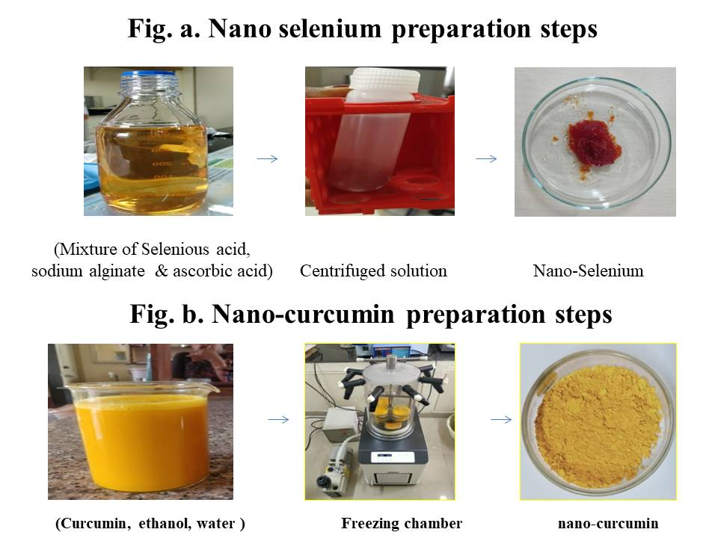
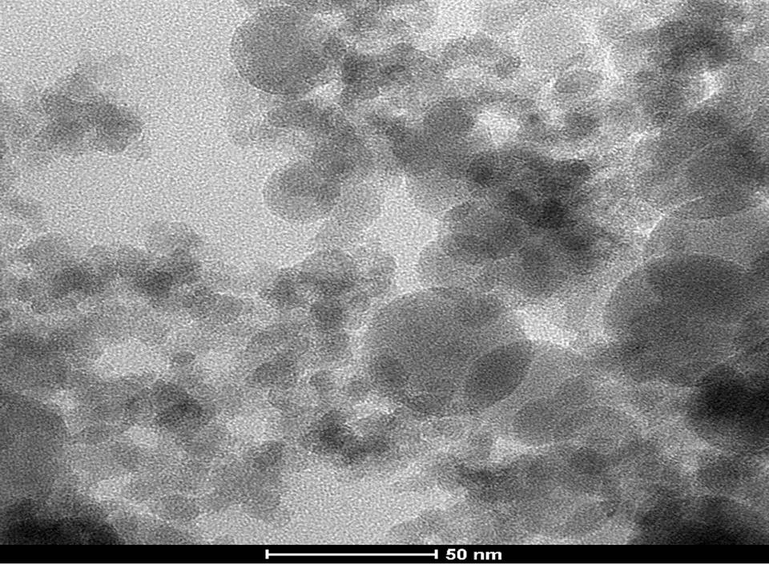
Nano-selenium Nano-curcumin

Graphical Table of Contents
Growth performance in different groups of broiler chickens supplemented with nanoselenium and nanocurcumin

