Supplementary Information

Nanocellulose-based electrodes and Separator toward Sustainable and Flexible All-solid-state Supercapacitor
Zejun Ding¹, Xuan Yang², Yanjun Tang^{1, *}
¹ National Engineering Laboratory of Textile Fiber Materials and Processing Technology, Zhejiang Sci-Tech University, Xiasha Higher Education Park Avenue 2 No. 928, Hangzhou 310018, China
² Key Lab Biomass Chemical Engineering, Ministry of Education, College of Chemical & Biological Engineering, Zhejiang University, 38 Zheda Road, Hangzhou 310027, China
* Corresponding author: tangyj@zstu.edu.cn

Material characterization
The crystal structures were characterized X-ray diffraction (XRD, A8 Advance, BRUKER AXS GMBH., Germany). Field emission scanning electron microscopy (FE-SEM, GeminiSEM500, Carl Zeiss AG, Germany) and transmission electron microcopy (TEM, JEM-1400Flas, JEOL Ltd., Japan) were used to observe the microstructures. The cross-sections of the membranes were obtained by liquid nitrogen cooling and brittle fracture. The tensile strength of the membranes was tested using an electronic universal material testing machine (EJA SERIES, Thwing-Albert Co., Ltd., USA). The water contact angles of pure RGO membrane and RCC composite membranes were tested using a video contact angle tester (JB-82B, Chengde Dingsheng Testing Machine Co., Ltd., China). The surface electrical resistance of the RGO membrane and RCC composite membranes was tested using a four-probe tester (ST-2258C, Suzhou Jingge Electronic Co., Ltd., China), the samples were cut into 1cm×1cm sheets. The thickness of the membranes was measured using a micrometer (MNT090025, Shanghai Meinaite Industrial Co., Ltd., China)

Electrochemical measurements
All the electrochemical measurements were carried out at an electrochemical workstation (CHI760E, Shanghai Chenhua Instrument Factory, China). The electrochemical properties of RGO membrane and RCC composite membranes were studied in a three-electrode configuration, using a platinum sheet electrode and a saturated calomel electrode as the counter electrode and the reference electrode, respectively. All the tests were conducted at room temperature, and aqueous solution of 1.0 M Na₂SO₄ was used as the liquid electrolyte. Cyclic voltammetry (CV) measurements at different scan rates and galvanostatic charge/discharge (GCD) tests at varied current densities were done with the potential window from -0.8 to 0 V. The volumetric specific capacitance (C, F·cm⁻³) of the electrode was calculated according to the GCD profiles based on the following equation.(Shao et al. 2018; Zou et al. 2019)
$C=It/vΔV$ (1)
Where, I (A), t (s), ΔV (V), and v (cm³) are the discharging current, the discharging time, the discharging potential range, and the volume of electrode, respectively.
The nanocellulose based symmetric FASC was assembled by sandwiching a 1.0 M Na₂SO₄-saturated CNF membrane separator (1 cm×2 cm) between two RCC-1.0 composite membrane electrodes (1 cm×2 cm). For testing, two Ni sheets were connected with the two RCC-1.0 composite membranes, and a polyethylene film was used to package the fabricated FASC. The electrochemical properties of FASC were conducted in a two-electrode configuration. Its specific capacitances, energy densities, and power densities were deduced from GCD profiles based on the following equations.(Shao et al. 2018; Zou et al. 2019)
$C_{V}=It/vΔV$ (2)
$E=C_{V}{ΔV}^{2}/7.2$ (3)
$P=E×3.6/t$ (4)
Where C_{V}, E, and P refer to volumetric capacitance (F·cm⁻³), volumetric energy density (mW·h·cm⁻³), and volumetric power density (W·cm⁻³) of the FASC, respectively. I, t, v, and ΔV stand for discharge current (A), discharge time (s), total volume of two RCC-1.0 composite membrane electrodes and a CNF membrane separator (cm³), and discharge potential window of device (V), respectively.

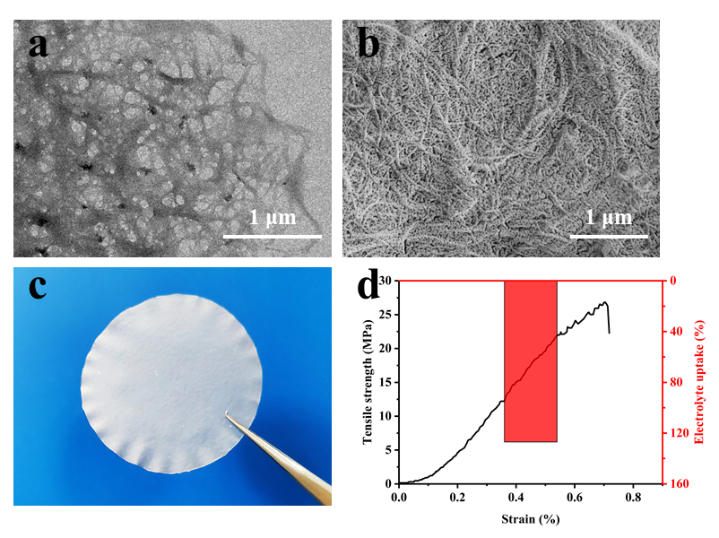
Fig. S1 The detail information of CNF and CNF membrane: (a) TEM image of CNF; (b) SEM image of CNF membrane with mesopores; (c) digital image of CNF membrane; (d) tensile stress-strain curve and electrolyte uptake of the CNF membrane.

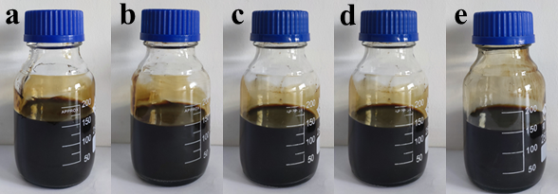
Fig. S2 The homogenized suspension of GO and GO/CNC/CNF-x: (a) GO suspension; (b) GO/CNC/CNF-0.5;(c) GO/CNC/CNF-1.0;(d) GO/CNC/CNF-1.5;(e) GO/CNC/CNF-2.0.

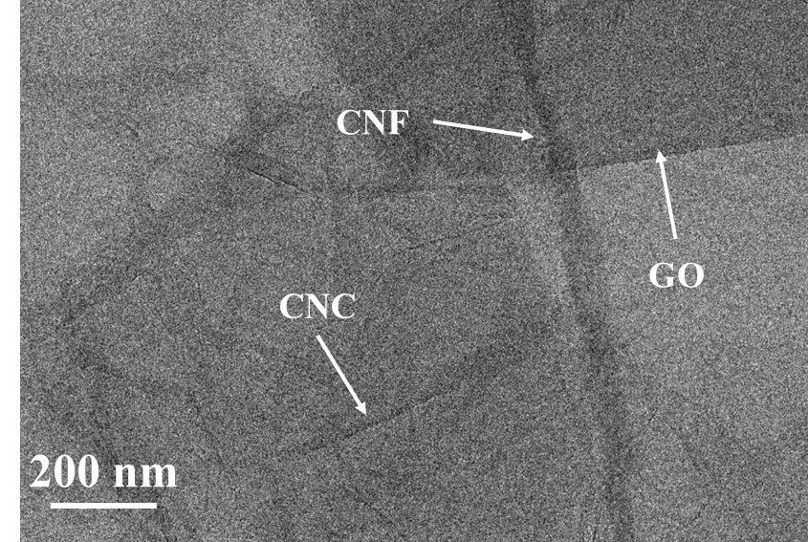
Fig. S3 The TEM image of GO/CNC/CNF-1.0 composite. After drying, nanocellulose (CNC and CNF) could spontaneously absorbed on the surface of GO through hydrogen bonds and van der Waals force.

Table S1 Comparison of the electrochemical performance of the RCC-1.0 in this work with other reported graphene-based electrode in literature.
electrode materials | electrolyte | specific capacitance (F·cm⁻³) | references
RGO/CNC/CNF | 1.0 M Na₂SO₄ | 193.3 | this work
cellulose/RGO/Ag nanoparticles | 2.0 M KCl | 31.1 | (Zou et al. 2019)
microwave-expanded GO | BMIM BF₄/AN | 110.0 | (Murali et al. 2013)
Ni/NiCo₂O₄/RGO | 2.0 M KOH | 2.6 | (Shewale & Yun 2021)
flash-RGO/cellulose | 1.0 M Na₂SO₄ | 2.4 | (Koga et al. 2016)
cellulose-derived carbon nanofibrous/RGO | 6 M KOH | 46.0 | (Kuzmenko et al. 2017)
cellulose/RGO/silver/Fe₂O₃ | 2 M KOH | 75.7 | (Zou et al. 2020)

Table S2 Comparison of the electrochemical performance of the nanocellulose based FASC in this work with other FASC reported in literature.
electrode materials | electrolyte | specific capacitance (F·cm⁻³) | references
RGO/CNC/CNF | Cellulose nanofiber film/Na₂SO₄ | 164.3 | this work
RGO/CNC | PVA/H₂SO₄ gel  electrolyte | 155.8 | (Chen et al. 2018a)
cellulose/RGO/Ag nanoparticles | PVA/KCl gel  electrolyte | 8.6 | (Zou et al. 2019)
cellulose/RGO/silver/Fe₂O₃ | PVA/LiCl gel  electrolyte | 18.2 | (Zou et al. 2020)
RGO | PVA/KOH gel  electrolyte | 0.9 | (Ye et al. 2017)
RGO | PVA/KOH gel  electrolyte | 2.8 | (Zhu et al. 2017)
polypyrrole/RGO | PVA/H₂SO₄ gel  electrolyte | 17.3 | (Guo et al. 2018)
Polyaniline/poly(p-phenylenevinylene)/RGO | PVA/H₂SO₄ gel  electrolyte | 152.0 | (Wee & Hong 2014)
MnO₂/graphene/Ni | cellulose separator/6 M KOH | 14.3 | (Liu et al. 2017)
carbon nanofiber/ polypyrroles/RGO | PVA/H₃PO₄ gel electrolyte | 80.5 | (Chen et al. 2018b)
polyoxometalates/RGO | PVA/H₂SO₄ gel  electrolyte | 115.0 | (Wang et al. 2021)

References
Chen G, Chen T, Hou K, Ma W, Tebyetekerwa M, Cheng Y, Weng W, Zhu M (2018a) Robust, hydrophilic graphene/cellulose nanocrystal fiber-based electrode with high capacitive performance and conductivity. Carbon, 127: 218-227. https://doi.org/https://doi.org/10.1016/j.carbon.2017.11.012.
Chen L, Li D P, Chen L N, Si P C, Feng J K, Zhang L, Li Y H, Lou J, Ci L J (2018b) Core-shell structured carbon nanofibers yarn@polypyrrole@graphene for high performance all-solid-state fiber supercapacitors. Carbon, 138: 264-270. https://doi.org/10.1016/j.carbon.2018.06.022.
Guo X M, Bai N N, Tian Y, Gai L G (2018) Free-standing reduced graphene oxide/polypyrrole films with enhanced electrochemical performance for flexible supercapacitors. Journal of Power Sources, 408: 51-57. https://doi.org/10.1016/j.jpowsour.2018.10.083.
Koga H, Tonomura H, Nogi M, Suganuma K, Nishina Y (2016) Fast, scalable, and eco-friendly fabrication of an energy storage paper electrode. Green Chemistry, 18(4): 1117-1124. https://doi.org/10.1039/c5gc01949d.
Kuzmenko V, Wang N, Haque M, Naboka O, Flygare M, Svensson K, Gatenholm P, Liu J, Enoksson P (2017) Cellulose-derived carbon nanofibers/graphene composite electrodes for powerful compact supercapacitors. Rsc Advances, 7(73): 45968-45977. https://doi.org/10.1039/c7ra07533b.
Liu Y H, Hu M L, Zhang M, Peng L, Wei H L, Gao Y H (2017) Facile method to prepare 3D foam-like MnO2 film/multilayer graphene film/Ni foam hybrid structure for flexible supercapacitors. Journal of Alloys and Compounds, 696: 1159-1167. https://doi.org/10.1016/j.jallcom.2016.12.097.
Murali S, Quarles N, Zhang L L, Potts J R, Tan Z Q, Lu Y L, Zhu Y W, Ruoff R S (2013) Volumetric capacitance of compressed activated microwave-expanded graphite oxide (a-MEGO) electrodes. Nano Energy, 2(5): 764-768. https://doi.org/10.1016/j.nanoen.2013.01.007.
Shao Y L, El-Kady M F, Sun J Y, Li Y G, Zhang Q H, Zhu M F, Wang H Z, Dunn B, Kaner R B (2018) Design and Mechanisms of Asymmetric Supercapacitors. Chemical Reviews, 118(18): 9233-9280. https://doi.org/10.1021/acs.chemrev.8b00252.
Shewale P S, Yun K S (2021) NiCo2O4/RGO Hybrid Nanostructures on Surface-Modified Ni Core for Flexible Wire-Shaped Supercapacitor. Nanomaterials, 11(4): 25. https://doi.org/10.3390/nano11040852.
Wang S, Wang X, Sun C L, Wu Z S (2021) Room-temperature fast assembly of 3D macroscopically porous graphene frameworks for binder-free compact supercapacitors with high gravimetric and volumetric capacitances. Journal of Energy Chemistry, 61: 23-28. https://doi.org/10.1016/j.jechem.2021.01.019.
Wee B H, Hong J D (2014) Multilayered Poly(p-phenylenevinylene)/Reduced Graphene Oxide Film: An Efficient Organic Current Collector in an All-Plastic Supercapacitor. Langmuir, 30(18): 5267-5275. https://doi.org/10.1021/la500636m.
Ye X K, Zhou Q L, Jia C Y, Tang Z H, Zhu Y C, Wan Z Q (2017) Producing large-area, foldable graphene paper. from graphite oxide suspensions by in-situ chemical reduction process. Carbon, 114: 424-434. https://doi.org/10.1016/j.carbon.2016.11.081.
Zhu Y C, Ye X K, Tang Z H, Wan Z Q, Jia C Y (2017) Free-standing graphene films prepared via foam film method for great capacitive flexible supercapacitors. Applied Surface Science, 422: 975-984. https://doi.org/10.1016/j.apsusc.2017.06.074.
Zou Z H, Xiao W, Zhang Y H, Yu H, Zhou W J (2020) Facile synthesis of freestanding cellulose/RGO/silver/Fe2O3 hybrid film for ultrahigh-areal-energy-density flexible solid-state supercapacitor. Applied Surface Science, 500: 10. https://doi.org/10.1016/j.apsusc.2019.144244.
Zou Z H, Zhou W J, Zhang Y H, Yu H, Hu C B, Xiao W (2019) High-performance flexible all-solid-state supercapacitor constructed by free-standing cellulose/reduced graphene oxide/silver nanoparticles composite film. Chemical Engineering Journal, 357: 45-55. https://doi.org/10.1016/j.cej.2018.09.143.

