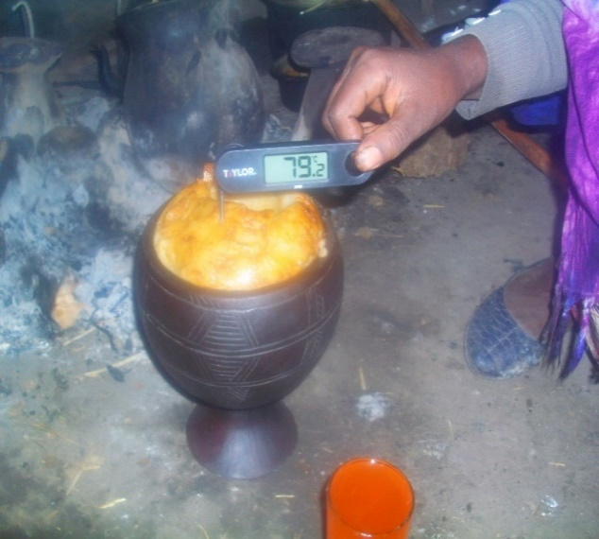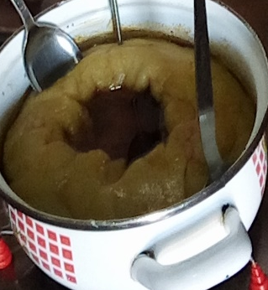

Additional file 1: Porridge serving utensils(Qorii(Lt) and dish(Rt)) in the Arsi Zone, Ethiopia, 2020.

