EFG1 (Enhanced filamentous growth protein 1)
Inhibition by other proteins
(A) Positive feedback loop
Analysis of the white-opaque switch identified a core circuit of four transcriptional regulators – Wor1, Wor2, Czf1 and Efg1 – that control switching via a network of negative and positive feedback loops. In opaque cells, Wor1, Wor2, and Czf1 establish a series of positive feedback loops, maintaining opaque cell identity and repressing EFG1.(Hernday et al., 2013; Zordan et al., 2007)
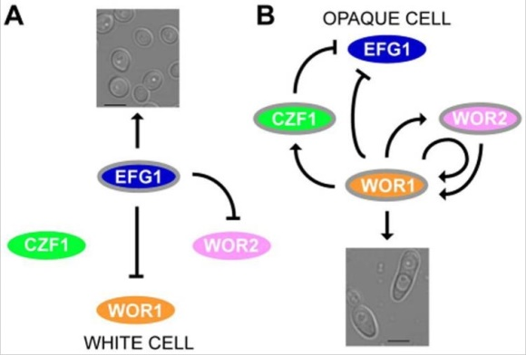 (Depicting the inhibition by WOR1 & CZF1)
(B) HDACi
Histone deacetylase inhibitors (HDACi) on the expression of phenotypes that is associated with virulence and pathogenicity in C. albicans, such as adhesion to epithelial cells and the yeast to hypha transition. Some of the HDACi used for experiments caused a 90% reduction in the adherence of C. albicans to human cultured pneumocytes and significantly inhibited serum-induced germination. Inhibition of germination was correlated with a significant reduction in transcription of EFG1. Inhibition appeared less evident when an HDA1-deficient strain was tested. These results suggest that selective and specific HDACi could prove to be a valid approach for selected at-risk patients in the combined treatment of infections caused by C. albicans. Trichostatin A (TSA), a well characterized HDACi, was shown to significantly affect the frequency and balance of white-opaque switching in C. albicans cells and to enhance the sensitivity of C. albicans to azoles. Recent reports showed that TSA, suberoylanilide hydroxamic acid (SAHA)* and two newly synthesized HDACi can also significantly inhibit the acquisition of resistance and trailing growth in C. albicans (Simonetti et al., 2007)
(*not found any papers showing inhibition on EGF1)
Inhibition by small molecules- BHT inhibitors
The ability of the pathogenic yeast Candida albicans to interconvert between budded and hyphal growth states is termed as budded-to-hyphal transition (BHT).It is important for C. albicans development and virulence. Chemical epistasis analyses suggest that most, but not all, of the BHT inhibitors were acting through either the Efg1 or Cph1 signaling pathways. BHT inhibitors primarily affect the Efg1 pathway but some have effects on other or multiple pathways. Clozapine is a FDA-approved anti-psychotic drug that inhibits dopamine receptors in the brain. Dopamine receptors belong to the family of G-protein-coupled receptors that regulate cAMP levels in mammalian cells. Various clozapine metabolites and functional derivatives are also able to inhibit the BHT, with the likely site of action being the G-protein-coupled receptor Gpr1, which mediates a nutrient response through the cAMP-dependent Efg1 signaling pathway. Other bioactive structural derivatives of clozapine like Fluperlapine, clothiapine, loxapine, amoxapine, and chlorpromazine which have either anti-psychotic or anti-depressant clinical utility, also inhibited the BHT, with the most effective being chlorpromazine. The BHT inhibitors were identified in assays utilizing carbon-limiting Spider media as a hyphal-inducing signal, which impinges on the Efg1 signaling pathway, suggesting that the BHT inhibitors were affecting this signaling pathway. TMB-8(intracellular Ca²⁺ antagonist,inhibits Ca²⁺ release from ER), W-7(Protein Kinase C inhibitor,Calmodulin antagonist), FK-506(Calcineurin phosphatase inhibitor), and nigericin (K+/H+ Ionophore) affect multiple signaling pathways, including the Efg1 and Cph1 pathways, presumably by affecting calcium homeostasis.(Midkiff et al., 2011)
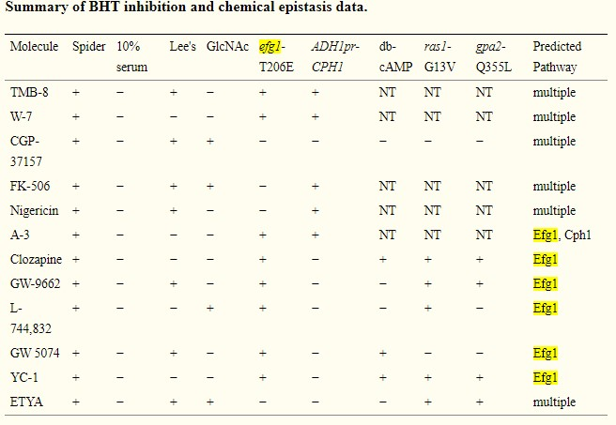(Summary of BHT inhibitors)
Inhibition by Phenolic compound
A small phenolic compound, Biatriosporin D (BD), isolated from an endolichenic fungus, Biatriospora sp., displayed anti-virulence activity by inhibiting adhesion, hyphal morphogenesis and biofilm formation of C. albicans. BD prolonged the survival of worms infected by C. albicans in vivo. Quantitative real-time PCR analysis, exogenous cAMP rescue experiments and intracellular cAMP measurements revealed that BD regulates the Ras1-cAMP-Efg1 pathway by reducing cAMP levels to inhibit the hyphal formation. Further investigation showed that BD could upregulate Dpp3 to synthesize much more farnesol, which could inhibit the activity of Cdc35 and reduce the generation of cAMP. Taken together, these findings indicate that BD stimulates the expression of Dpp3 to synthesize more farnesol that directly inhibits the Cdc35 activity, reducing intracellular cAMP and thereby disrupting the morphologic transition and attenuating the virulence of C. albicans.(Zhang et al., 2017)
Inhibition by lichen-derived small molecule
Lichen-derived small molecule Retigeric acid B (RAB) acted as an inhibitor that significantly inhibited the filamentation of C. albicans, leading to the prolonged survival of nematodes infected by C. albicans. Quantitative real-time PCR analysis and intracellular cAMP measurement revealed RAB regulated the Ras1-cAMP-Efg1 pathway by reducing cAMP level to inhibit the hyphae formation. (Chang et al., 2012)
References
Hernday, A. D., Lohse, M. B., Fordyce, P. M., Nobile, C. J., DeRisi, J. L., & Johnson, A. D. (2013). Structure of the Transcriptional Network Controlling White-Opaque Switching in Candida albicans. Molecular Microbiology, 90(1), 22–35. https://doi.org/10.1111/mmi.12329
Zordan, R. E., Miller, M. G., Galgoczy, D. J., Tuch, B. B., & Johnson, A. D. (2007). Interlocking Transcriptional Feedback Loops Control White-Opaque Switching in Candida albicans. PLOS Biology, 5(10), e256. https://doi.org/10.1371/journal.pbio.0050256

Simonetti, G., Passariello, C., Rotili, D., Mai, A., Garaci, E., & Palamara, A. T. (2007). Histone deacetylase inhibitors may reduce pathogenicity and virulence in Candida albicans. FEMS Yeast Research, 7(8), 1371–1380. https://doi.org/10.1111/j.1567-1364.2007.00276.x

Midkiff, J., Borochoff-Porte, N., White, D., & Johnson, D. I. (2011). Small Molecule Inhibitors of the Candida albicans Budded-to-Hyphal Transition Act through Multiple Signaling Pathways. PLoS ONE, 6(9). https://doi.org/10.1371/journal.pone.0025395

Zhang, M., Chang, W., Shi, H., Zhou, Y., Zheng, S., Li, Y., Li, L., & Lou, H. (2017). Biatriosporin D displays anti-virulence activity through decreasing the intracellular cAMP levels. Toxicology and Applied Pharmacology, 322, 104–112. https://doi.org/10.1016/j.taap.2017.03.004

Chang, W., Li, Y., Zhang, L., Cheng, A., & Lou, H. (2012). Retigeric Acid B Attenuates the Virulence of Candida albicans via Inhibiting Adenylyl Cyclase Activity Targeted by Enhanced Farnesol Production. PLoS ONE, 7(7). https://doi.org/10.1371/journal.pone.0041624

NRG1
Mitochondrial fission inhibitor
Putative mitochondrial fission inhibitor Mdivi-1 to probe the crosstalk between hyphal signaling and metabolism. Mdivi-1 repressed C. albicans hyphal morphogenesis, but the mechanism was independent of its presumed target, the mitochondrial fission GTPase Dnm1. Instead, mdivi-1 triggered extensive metabolic reprogramming, consistent with metabolic stress, and reduced endogenous nitric oxide (NO) levels. Limiting endogenous NO stabilized the transcriptional repressor Nrg1 and inhibited the yeast-to-hyphae transition.
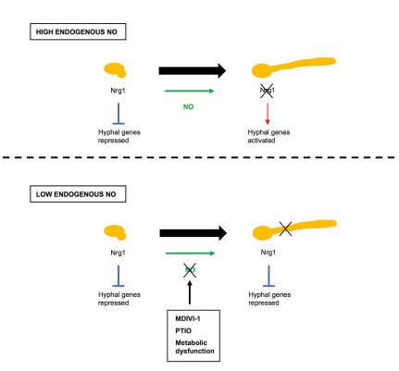 Fig: In yeast cells, the repressor Nrg1 inhibits the hyphal transcriptional program, thereby maintaining yeast morphology. Upon receipt of hyphal-induction signals, endogenous NO contributes to the downregulation of Nrg1 proteins levels, an event that is required for triggering hyphal gene expression and initiating the yeast-to-hyphae transition. (Bottom) reduction of endogenous NO levels by mdivi-1, PTIO, or metabolic dysfunction stabilizes the Nrg1 repressor under hyphae-inducing conditions. Hyphae-specific gene repression is maintained, and cells do not transition from yeast to hyphal morphology.(Koch et al., 2018)

Inhibition by TOR pathway
Hyphal development requires two temporally linked changes in promoter chromatin, which is sequentially regulated by temporarily clearing the transcription inhibitor Nrg1 upon activation of cAMP/protein kinase A and promoter recruitment of the histone deacetylase Hda1 under reduced target of rapamycin (Tor1) signaling.Target of rapamycin (TOR) signaling pathway functions as a global regulator of cellular growth in response to nutrient availability from yeast to human and it controls different cellular processes in fungi. C. albicans has a single TOR kinase, Tor1, which is rapamycin sensitive. The reduced Tor1 signaling during hyphal initiation leads to the expression of the GATA transcription factor Brg1, which recruits the histone deacetylase Hda1 to the promoters of hypha-specific genes, leading to nucleosome repositioning that blocks Nrg1 from binding to the promoters. A critical feature of the temporal integration of the two signaling pathways is that Brg1 can bind to the promoters only when Nrg1 is not bound.(Su et al., 2013)

Inhibition by Tetracyclin*
The ability of Candida albicans to reversibly switch morphologies is important for biofilm formation and dispersion. In this pathogen, Nrg1p functions as a key negative regulator of the yeast-to-hypha morphogenetic transition.Genetically engineered C.albicans tet-NRG1 strain in which NRG1 expression levels can be manipulated by the presence or absence of doxycycline (DOX). To ascertain the role of Nrg1p in regulating the different stages of the C. albicans biofilm developmental cycle, in an in vitro model of biofilm formation, the C. albicans tet-NRG1 strain was able to form mature biofilms only when DOX was present in the medium, but not in the absence of DOX, when high levels of NRG1 expression blocked the yeast-to-hypha transition. (Saville et al., 2006)
(*in genetically engineered C.albicans tet-NRG1 strain)
References
Koch, B., Barugahare, A. A., Lo, T. L., Huang, C., Schittenhelm, R. B., Powell, D. R., Beilharz, T. H., & Traven, A. (2018). A Metabolic Checkpoint for the Yeast-to-Hyphae Developmental Switch Regulated by Endogenous Nitric Oxide Signaling. Cell Reports, 25(8), 2244-2258.e7. https://doi.org/10.1016/j.celrep.2018.10.080

Su, C., Lu, Y., & Liu, H. (2013). Reduced TOR signaling sustains hyphal development in Candida albicans by lowering Hog1 basal activity. Molecular Biology of the Cell, 24(3), 385–397. https://doi.org/10.1091/mbc.E12-06-0477

Saville, S. P., Lazzell, A. L., Bryant, A. P., Fretzen, A., Monreal, A., Solberg, E. O., Monteagudo, C., Lopez-Ribot, J. L., & Milne, G. T. (2006). Inhibition of Filamentation Can Be Used To Treat Disseminated Candidiasis. Antimicrobial Agents and Chemotherapy, 50(10), 3312–3316. https://doi.org/10.1128/AAC.00628-06

