ACTIVE SITE REPORT: NRG1
Active site prediction of NRG1 (Q5A0E5) was done using COACH.
COACH is a meta-server approach for the protein-ligand binding site prediction. Based on structure of target proteins input, COACH will compare bound- specific substructure and sequence profiles and generate complementary ligand binding site predictions using two comparative methods, TM-SITE and S-SITE, which recognize ligand-binding templates from the BioLiP protein function database. These predictions will be combined with results from other methods (including COFACTOR, FINDSITE and ConCavity to generate final ligand binding site predictions. For ligand-binding site prediction, input primary sequence can also be given as input where I-TASSER will be used to generate 3D models first which are then fed into the COACH pipeline.
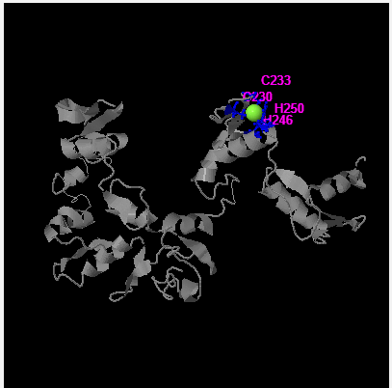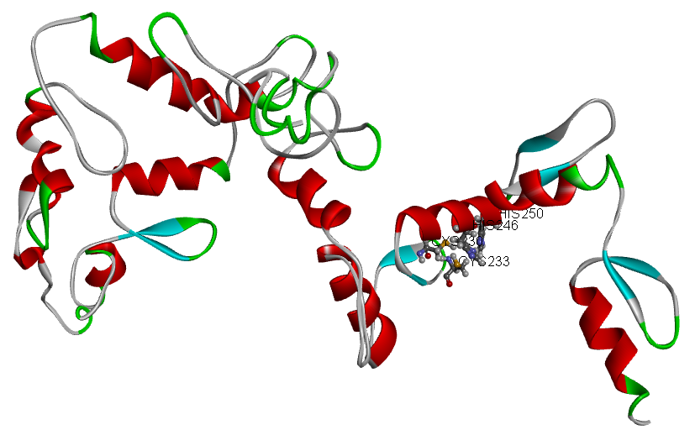
Figure: Predicted ligand binding site residues at position 230, 233, 246 and 250 viewed in Discovery Studio.
Residues are: Cysteine (CYS) at 230 and 233; Histidine (HIS) at 246 and 250.
Table: The features for predicted ligand-binding sites.
C-score | Cluster size | PDB Hit | Binding Ligand | Ligand Binding Site Residues
0.29 | 10 | 2ytoA | ZN | 230, 233, 246, 250
0.09 | 3 | 2i13B | GOL | 242, 245, 269
0.06 | 3 | 2i13B | Nuc. Acid | 157,159,160,163,167,170,186,190,191,194, 195,198,205,207,209,212,216,219,237,239, 242,246,249,267,269,272,276,279
0.03 | 1 | 2i13A | ZN | 246, 250
0.02 | 1 | 2i13B | GOL | 272, 275

C-score is the confidence score of the prediction. C-score ranges [0-1], where a higher score indicates a more reliable prediction. From the Table, the best predicted site is the first one (C = 0.29), with Ligand binding site at 230, 233, 246 and 250. The respective cluster size i.e the total number of templates in a cluster is given in the table. The possible binding ligand information can be viewed in the BioLiP database. The complex with one binding ligand (single complex structure with the most representative ligand in the cluster) and multiple binding ligands (complex structures with all potential binding ligands in the cluster) has also been generated.

