Protein Homology Modeling Report:
Summary

Protein Name | Transcriptional regulator NRG1
Organism | Candida albicans (strain SC5314 / ATCC MYA-2876) (Yeast)
UniProt ID | Q5A0E5
Model Generated using | I-TASSER
Templates used | Multiple

1. Modelling Method:

For protein modeling, I-TASSER was used. I-TASSER is a hierarchical protocol for automated protein structure prediction and structure-based function annotation.

- I-TASSER modeling starts from the structure templates identified by LOMETS from the PDB library. The table below shows the top 10 template-query alignments generated by LOMETS. Templates of high significance measured by the Z-score, i.e. the difference between the raw and average scores in the unit of standard deviation. Z-score > 1 indicate a good alignment.

Rank | PDB Hit | Identity 1 | Identity 2 | Coverage | Normalized Z-score
1 | 5v3jE | 0.15 | 0.18 | 0.85 | 3.70
2 | 5wjqA | 0.13 | 0.18 | 0.88 | 1.55
3 | 5v3jE | 0.12 | 0.18 | 0.77 | 4.24
4 | 5und | 0.17 | 0.10 | 0.49 | 1.03
5 | 5v3j | 0.14 | 0.18 | 0.85 | 1.42
6 | 5v3jE | 0.14 | 0.18 | 0.78 | 6.37
7 | 5wjqD | 0.14 | 0.18 | 0.86 | 1.83
8 | 5v3j | 0.23 | 0.18 | 0.35 | 1.26
9 | 2nbiA | 0.18 | 0.21 | 0.98 | 1.54
10 | 2ebtA | 0.33 | 0.10 | 0.29 | 4.27

The top ten threading templates are represented in the table. Identity1 is the percentage sequence identity of the templates in the threading aligned region with the query sequence, while Identity 2 is the percentage sequence identity of the whole template chains with query sequence. The coverage of the threading alignment is equal to the number of aligned residues divided by the length of query protein. The normalized Z-score of the threading alignments.

- The structure was analyzed with RC PLOT, to highlight the conformation within the model, which showed following statistics:

Region | No of residues
Most favoured regions [A,B,L] | 170
Additional allowed regions [a,b,l,p] | 70
Generously allowed regions [~a,~b,~l,~p] | 15
Disallowed regions [XX] | 5
Non-glycine and non-proline residues | 260
End-residues (excl. Gly and Pro) | 2
Glycine residues | 13
Proline residues | 35

2. The structure of NRG1 as predicted:
a. Structural details of target proteins:
I-TASSER selects the final models, using SPICKER program, based on the pair-wise structure similarity, and reports up to five models which corresponds to the five largest structure clusters. The confidence of each model is quantitatively measured by C-score that is calculated based on the significance of threading template alignments and the convergence parameters of the structure assembly simulations. C-score is typically in the range of [-5, 2], where a C-score of a higher value signifies a model with a higher confidence and vice-versa. The model has an estimated TM-score = 0.47±0.15 and estimated RMSD = 11.0±4.6Å calculated based on C-score which is -2.04 and protein length following the correlation observed between these qualities, as shown in the Table.

Name | C-score | Exp.TM-Score | Exp. RMSD | No. of decoys | Cluster density
Model1 | -2.04 | 0.47+-0.15 | 11.0+-4.6 | 2319 | 0.0477

- 3D image of the homology model, as visualized with Discovery Studio:

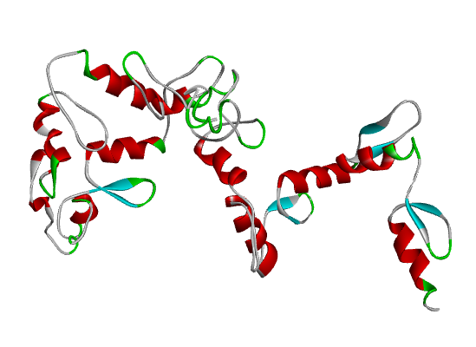
Figure 1.a: 3D Protein Structure Image generated viewed in Discovery Studio.

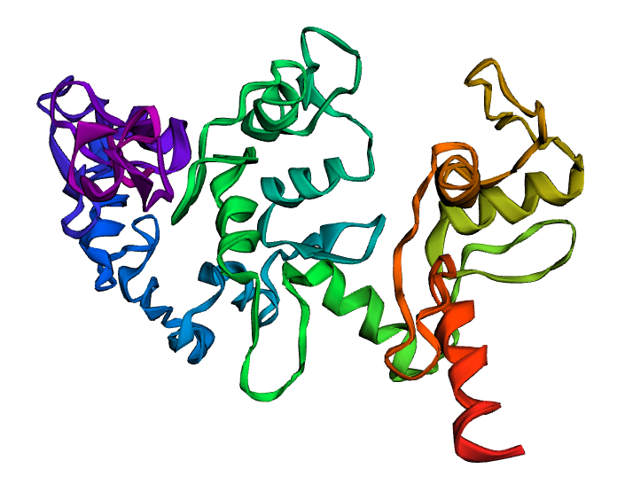
Figure 1.b: 3D Protein Model Structure Image generated viewed in ERRAT (publication quality)

- ERRAT Analyses: The statistics of non-bonded interactions between different atom
Types are analysed and the value of the error function versus position of a 9-residue sliding
Window is plotted.
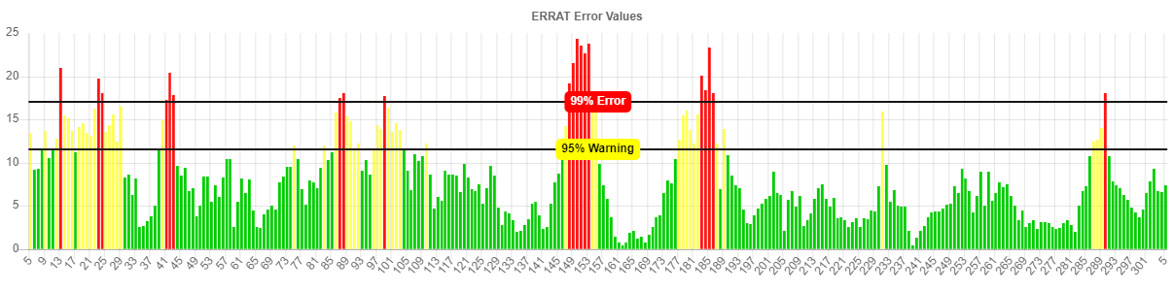
Figure 2a: ERRAT evaluated the model structure and 77.8146 % of an overall quality was observed.
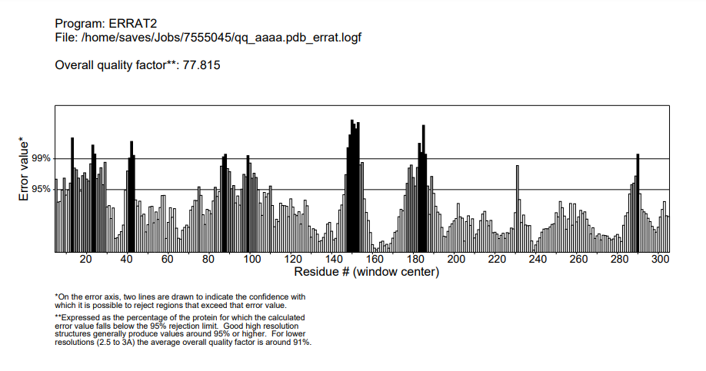
Figure 2b: ERRAT2 evaluated the model structure and 77.815 % of an overall quality was observed.
Observations: The plot generated indicates the confidence and overall quality of the model. On the error axis, two lines were drawn to indicate the confidence with which it is possible to reject that exceeded error value. Expressed as percentage for which the calculated error value fall below 95% rejection limit. The structure having 77.815 % quality factor can be considered to be a reliable one.
3. Model Validation:
- For validation of structure, Ramachandran Plot (RC plot) was used. The Ramachandran plot shows the torsional angles - phi (φ) and psi (ψ) - of the residues (amino acids) in the structure. Glycine residues are separately identified by triangles as these are not restricted to the regions of the plot appropriate to the other side chain types. The colouring/shading on the plot represents the different regions, the darkest areas (here shown in red) correspond to the "core" regions representing the most favorable combinations of phi-psi values. Ideally, one would hope to have over 90% of the residues in these "core" (favoured) regions. The percentage of residues in the "core" region is one of the better guides to stereo chemical quality. Also, residues in the disallowed region should ideally be less than or equal to 0.2%. R C plot was generated using PDBsum (which used PROCHECK for the plot generation). The RC plot for the selected final model is shown in Figure 2.
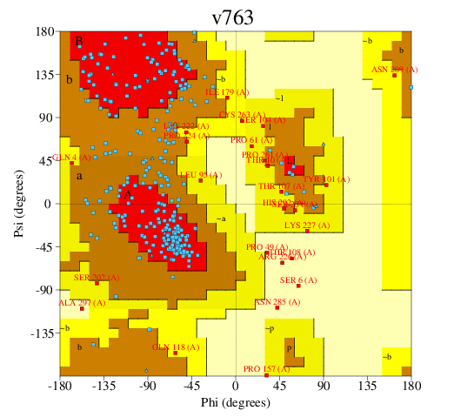

Figure 2: Ramachandran Plot for the model, using PDBsum (PROCHECK)

RC plot statistics (generated by PDBsum) for the selected final model is given in table below:

Region | No of residues | Percentage (%)
Most favoured regions [A,B,L] | 170 | 65.4
Additional allowed regions [a,b,l,p] | 70 | 26.9
Generously allowed regions [~a,~b,~l,~p] | 15 | 5.8
Disallowed regions [XX] | 5 | 1.9
Non-glycine and non-proline residues | 260 | 100
End-residues (excl. Gly and Pro) | 2
Glycine residues | 13
Proline residues | 35

The analysis was based in 118 structures of 2.0 Angstroms resolution and R-factor.
Conclusion: This is the most appropriate model we can model with the available template (s) and can be used for further experiments.

