Waste Activated Sludge Oxidation and Azo Dye Reduction in Microbial Fuel Cell: Optimization of process conditions for high electricity generation and waste treatability
Elif DURNA PİŞKİN, ª Nevim GENÇ *ª
ª Department of Environmental Engineering, Kocaeli University, Kocaeli 41000 Turkey.

e-mail: ngenc@kocaeli.edu.tr

Table of Contents

Figures and Tables

Figure S1. Power density (a), coulombic efficiency (b), azo dye removal (c), COD removal (d) 3

Figure S2. Voltage graph obtained from optimum experiment across 100 Ω external resistance (b) 4
(a) | (b)
(c) | (d)
Figure S1. Actual data versus predicted responses for Power density (a), coulombic efficiency (b), azo dye removal (c), COD removal (d)

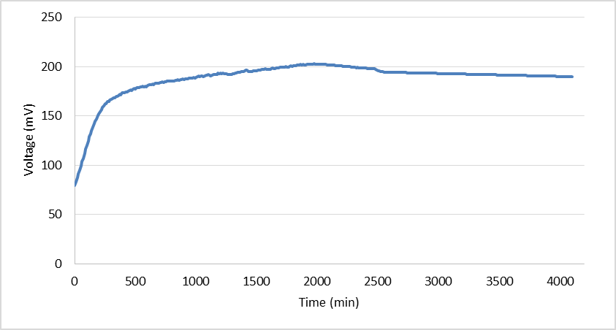
Figure S2. Voltage graph obtained from optimum experiment across 100 Ω external resistance (b)

