A bispecific, crosslinking lectibody activates cytotoxic T cells and induces cancer cell death
Francesca Rosato^{‡1,2}, Rajeev Pasupuleti^{‡3,4}, Jana Tomisch^{1,2}, Ana Valeria Meléndez^{1,2,5}, Dajana Kolanovic^{3,4}, Olga N. Makshakova^{1,6}, Birgit Wiltschi^{3,4,7},* and Winfried Römer^{1,2,8},*
[1] Faculty of Biology, University of Freiburg, Freiburg, Germany.
[2] Signalling Research Centres BIOSS and CIBSS, University of Freiburg, Freiburg, Germany.
[3] ACIB – The Austrian Centre of Industrial Biotechnology, Graz, Austria.
[4] Institute of Molecular Biotechnology, Graz University of Technology, Graz, Austria.
[5] Spemann Graduate School of Biology and Medicine, University of Freiburg, Freiburg, Germany.
[6] Kazan Institute for Biochemistry and Biophysics, FRC Kazan Scientific Center of RAS, Kazan, Russian Federation.
[7] Institute of Bioprocess Science and Engineering, University of Natural Resources and Life Sciences, Vienna, Austria.
[8] Freiburg Institute for Advanced Studies (FRIAS), University of Freiburg, Freiburg, Germany.
‡ These authors contributed equally to this work
* Corresponding authors:
Email addresses: winfried.roemer@bioss.uni-freiburg.de (WR); birgit.wiltschi@acib.at (BW)

ORCID iDs: 0000-0002-9255-9391 (Francesca Rosato), 0000-0002-9399-2699 (Rajeev Pasupuleti), 0000-0002-4656-9345 (Jana Tomisch), 0000-0001-6267-2855 (Ana Valeria Meléndez), 0000-0002-2536-1182 (Dajana Kolanovic), 0000-0002-0615-3513 (Olga N. Makshakova), 0000-0001-5230-0951 (Birgit Wiltschi), 0000-0002-2847-246X (Winfried Römer).

Supplementary Information

Fig. S1
Expression, purification and characterization of Stx1B K9AzK. Coomassie stained SDS gels showed a Expression of Stx1B K9AzK with the addition of AzK at a final concentration of 5 mM during induction with IPTG b no expression of the target protein when the culture medium was not supplemented with AzK during induction. Expression of Stx1B K9AzK with the addition of AzK at a final concentration of 5 mM during induction. M, molecular weight marker, the sizes of the marker bands are indicated; lane 1, clarified lysate; lane 2, flow through after loading clarified lysate on a zinc-charged sepharose column; lane 3, column wash; lanes 4 to 11, elution fractions. c 1.5 µg purified Stx1B K9AzK were subjected to native PAGE, a silver-stained 3-12% PA gel is shown. M, native PAGE marker, marker band sizes indicated in kDa; lane 1, Stx1B K9AzK (MW_{calc}~45 kDa) in its native pentamer conformation. The black arrows indicate the protein bands of interest

Fig. S2
Electrospray ionization mass spectrometry (ESI-MS) measurements of intact a Stx1B, b Stx1B K9AzK, c scFv OKT3 and d scFv OKT3 E129AzK. The proteins identified from the peaks are detailed in the Table S1

Fig. S3
Isothermal titration calorimetry (ITC) analysis of the interaction of a Stx1B and b Stx1B K9AzK with globotriaose. Raw data (top panel) and the binding isotherms obtained by plotting integrated data from titrations (bottom panel) are shown

Fig. S4
Size analysis of the Stx1B-scFv OKT3 conjugate. a Representative size exclusion chromatogram of the IEDDA reaction mixture. b Protein standards aprotinin (Apr)- 6500 Da, ovalbumin (O)- 43000 Da, conalbumin (C)- 75000 Da, aldolase (Ald)- 158000 Da and ferritin (F)- 440000 Da were run on the S200 Increase 10/300 GL column for calibration. The column void volume (V₀) 7.88 mL was determined by Blue dextran 2000. The gel-phase distribution coefficient (K_{av}) was calculated using the formula K_{av}=(V_{e}-V_{o})/(V_{b}-V_{o}) where V_{e} is elution volume and V_{b} is the column bed volume (24 mL). A calibration curve was plotted with K_{av} versus the logarithm of molecular weight. The calibration curve calculated from molecular weight standards is a straight line with a coefficient of determination (R²) of 0.9972. The red circle represents the Stx1B-scFv OKT3 conjugate and the green circle unreacted scFv OKT3 E129TCO. The straight-line equation
K_{av}= (-0.3208) x (MW)+1.9415 deduced from the calibration curve was used to determine the experimental molecular weights of the unknown as stated in Table S3

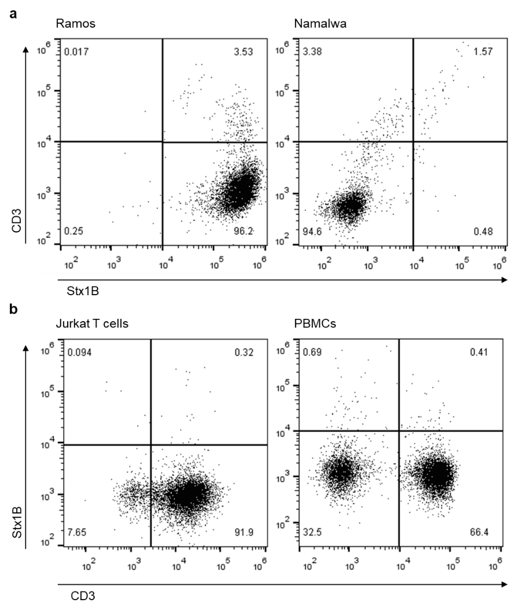

Fig. S5
Characterization of target and effector cells for the expression of Gb3 and CD3 antigens by flow cytometry. Representative dot plots of flow cytometry analysis of gated living a Ramos and Namalwa, b Jurkat T cells and PBMCs from healthy donors incubated with Stx1B-Cy5 and anti-human CD3 FITC antibody for 30 minutes on ice. a Representative dot plots of Gb3⁺ Ramos cells (left) and Gb3⁻ Namalwa cells incubated with 2.6 nM Stx1B-Cy5 (x-axis) and anti-human CD3 FITC antibody (OKT3 clone). Both Ramos and Namalwa cells are CD3⁻ cell lines. b Representative dot plots of human Jurkat T cells (left) and PBMCs (right) screened for their CD3 and Gb3 antigens expression. Jurkat and PBMCs are both CD3⁺ and Gb3⁻
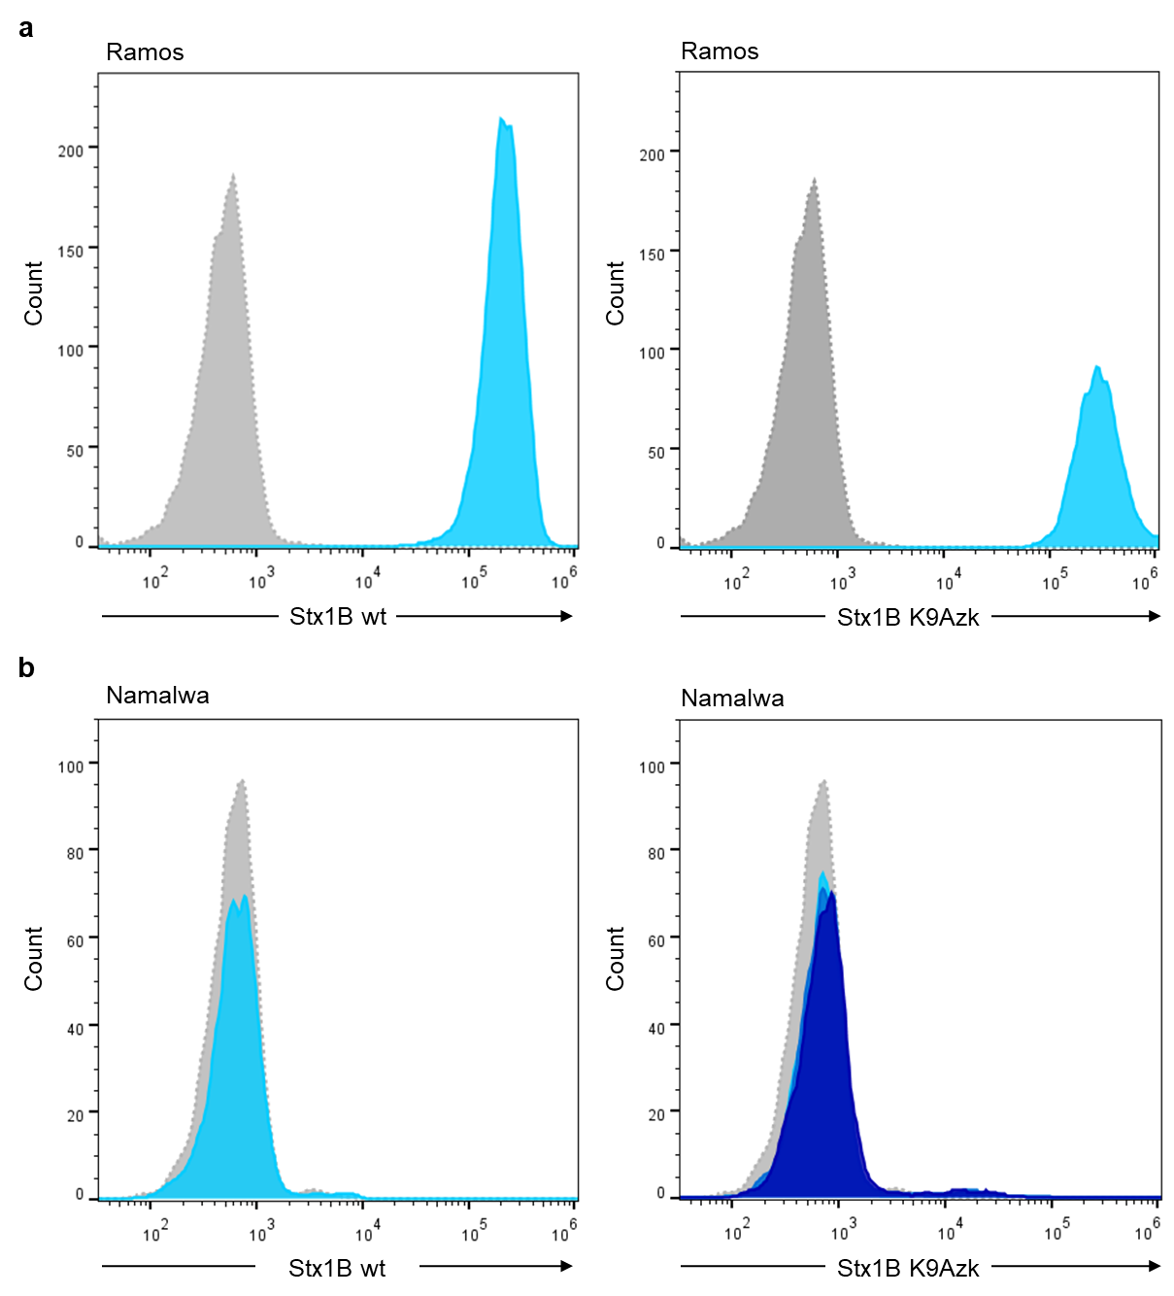

Fig. S6
Comparative analysis of Stx1B wild-type and mutant proteins binding to tumor cells. Representative histograms of flow cytometry analysis of gated living a Ramos and b Namalwa, incubated with Stx1B or Stx1B K9AzK for 30 minutes on ice. The number of cells within the live population (y-axis) is plotted against the fluorescence intensity of tested proteins (x-axis). a Histograms of fluorescence intensity of Gb3⁺ Ramos cells incubated with Stx1B wt (left) and Stx1B K9AzK (right) (dotted, gray: negative control; light blue: 2.6 nM). Histograms show protein binding to the GSL Gb3 exposed on the surface of Ramos cells for both tested proteins. b Histograms of fluorescence intensity of Namalwa cells incubated with Stx1B wt (left) (dotted, gray: negative control; light blue: 2.6 nM). The right plot depicts histograms of fluorescence intensity for Stx1B K9AzK (dotted, gray: negative control; light blue: 2.6 nM; blue: 13 nM; dark blue: 26 nM). Fluorescence intensity does not change following incubation of AzK-incorporating Stx1B with Gb3⁻ cells, excluding unspecific binding of the protein to cell surface, even when incubated with higher Stx1B K9AzK concentrations (13 nM and 26 nM). All treated cells were stained with anti-6-His epitope tag AF647 antibody to detect the presence of wild-type and mutant proteins at the plasma membrane

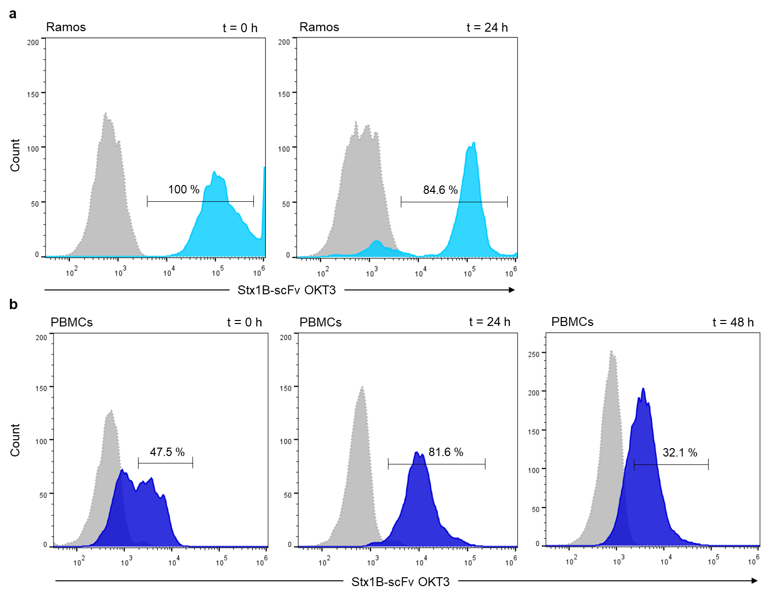

Fig. S7
Binding of the Stx1B-scFv OKT3 lectibody to tumor and effector cells after 24 and 48 hours co-incubation. Representative histograms of flow cytometry analysis of gated living a Ramos, and b PBMCs from healthy donors co-incubated in presence of Stx1B-scFv OKT3 for 30 minutes on ice (t = 0 h) or for 24 and 48 hours at 37°C (t = 24 h, t = 48 h). The number of cells within the live population (y-axis) is plotted against the fluorescence intensity of Stx1B-scFv OKT3 (x-axis). a Histograms of fluorescence intensity of Gb3⁺ Ramos incubated with Stx1B-scFv OKT3 for different time points (dotted, gray: negative control; light blue: 3.5 nM). Histograms depict a stable lectibody binding to Ramos cells after 24 hours (right plot). b Histograms of fluorescence intensity of PBMCs incubated with Stx1B-scFv OKT3 for different time points (dotted, gray: negative control; blue: 35.6 nM). Histograms display lectibody binding to CD3 receptors on treated cells. At t = 24 h and t = 48 h following incubation with Gb3⁺ Ramos and Stx1B-scFv OKT3, the lectibody can still be partly detected at the membrane of effector cells

Tables

Table. S1
Analysis of ESI-MS spectral data. Theoretical molecular weights calculated using massXpert [160] were compared to the observed molecular weights of the protein samples. The difference in molecular weight was derived from subtracting observed mass from calculated mass in Daltons; NA, not applicable.

Figure no. | Sample | Calculated  mass (Da) | Observed  mass (Da) | Difference in  mass (Da) | Remarks
Fig. S3a | Stx1B-4xH | 8564.1263 | 8564.1313 | -0.0050 | 2xH cleaved during analysis
Fig. S3a | Stx1B-3xH | 8427.0674 | 8427.0748 | -0.0074 | 3xH cleaved during analysis
Fig. S3a | Stx1B-2xH | 8290.0085 | 8290.0117 | -0.0032 | 4xH cleaved during analysis
Fig. S3b | Stx1B K9AzK-6xH | 8952.27 | 8951.28 | 0.99 | AzK incorporation
Fig. S3c | scFv OKT3-6xH | 29904.1160 | 29904.1623 | -0.0463 | NA
Fig. S3d | scFv OKT3 E129AzK-6xH | 30035.88 | 30038.17 | -2.29 | 2x disulfide bonds

Table. S2
Stx1B-scFv OKT3 conjugate identified by mass analysis. The in-gel tryptic digest of the 50 kDa band from lane 4, Fig 3b confirmed peptides corresponding to scFv OKT3 and Stx1B in the Stx1B-scFv OKT3 conjugate. ID, Identity; Da, Daltons.
Sample | Protein IDs | Peptide sequence | Observed  mass (Da) of the peptide
50 kDa band (lane 4, Fig 3b) | scFv OKT3 | ASGYTFTR | 901.42938
 |  | ATLTTDKSSSTAYMQLSSLTSEDSAVYYCAR | 3422.5494
 |  | GYTNYNQK | 986.44576
 |  | LASGVPAHFR | 1053.572
 |  | LEINRADTAPTGSEQK | 1728.8642
 |  | MSCKASGYTFTR | 1423.6224
 |  | PGQGLEWIGYINPSR | 1685.8526
 |  | QRPGQGLEWIGYINPSR | 1970.0122
 |  | SSSTAYMQLSSLTSEDSAVYYCAR | 2692.1633
 |  | VDIVLTQSPAIMSASPGEK | 1958.003
 |  | VTMTCSASSSVSYMNWYQQK | 2389.0025
 |  | WIYDTSK | 911.43888
 |  | YYDDHYSLDYWGQGTTLTVSSAK | 2669.1922
 | Stx1B | TNACHNGGGFSEVIFR | 1764.8002
 |  | VEYTKYNDDDTFTVK | 1836.8418
 |  | VGDKELFTNR | 1177.6091
 |  | YNDDDTFTVK | 1216.5248

Table. S3
Experimental molecular weights calculated from the calibration curve shown in Fig. S4. Analysis showed that three scFv OKT3 molecules were conjugated to one Stx1B pentamer. Proteins eluted from two peaks in SEC (Fig. S4) correspond to Stx1B-scFv OKT3 conjugate and unreacted scFv OKT3 E129TCO. Theoretical molecular weights were calculated using Expasy ProtParam. NA, not applicable

sample type | sample name | log MW | Kav | Theoretical  MW (Da) | Experimental  MW (Da)
standard | aprotinin | 3.81 | 0.72 | 6500 | NA
standard | ovalbumin | 4.68 | 0.43 | 43000 | NA
standard | conalbumin | 4.87 | 0.37 | 75000 | NA
standard | aldolase | 5.19 | 0.27 | 158000 | NA
standard | ferritin | 5.64 | 0.13 | 440000 | NA
sample | scFv OKT3 E129TCO | 4.41 | 0.52 | 29927 | 26300
sample | Stx1B pentamer + 3 molecules of scFv OKT3 + linkers | 5.17 | 0.28 | 139456 | 149325

