Supporting Information for
Fabrication of regenerated cellulose fibers using phosphoric acid plus hydrogen peroxide treated wheat straw in DMAc/LiCl solvent system
Qing Wang ^{a, b, c}, Heng Zhao ^{c}, Li Zhao ^{b}, Mei Huang ^{b}, Dong Tian ^{b}, Shihuai Deng ^{b}, Jinguang Hu ^{c*}, Xinquan Zhang ^{a*}, and Fei Shen ^{b*}
ª College of Grassland Science and Technology, Sichuan Agricultural University, Chengdu, Sichuan 611130, P. R. China.
^{b} Institute of Ecological and Environmental Sciences, Sichuan Agricultural University, Chengdu, Sichuan 611130, P. R. China.
^{c} Department of Chemical and Petroleum Engineering, Schulich School of Engineering, the University of Calgary, Calgary T2N 4H9, Canada.
To whom correspondence should be addressed:
*Jinguang Hu Email: jinguang.hu@ucalgary.ca
*Xinquan Zhang Email: zhangxq@sicau.edu.cn
*Fei Shen Email: fishen@sicau.edu.cn
Content:
Fig. S1 Preparation of the saturated DMAc/LiCl solution.
Fig. S2 The employed dyes.
Fig. S3 The components of CEF under various conditions of PHP treatment. (a – c) Cellulose recovery; (d – f) Hemicellulose removal.
Fig. S4 The dissolution states of WS and CEF in saturated DMAc/LiCl.
Fig. S5 XRD diffraction patterns of the model materials.
Fig. S6 The mechanical properties of RCFs in the wet state.
Table S1 The conditions of PHP treatment.
Table S2 The mechanical properties of RCFs.
.
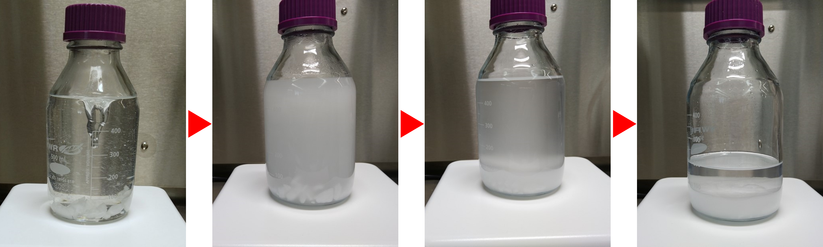
Fig. S1 Preparation of the saturated DMAc/LiCl solution.
Add excessive anhydrous LiCl into 500 mL DMAc, stir at 60°C for 12 h, then let it rest at room temperature until an evident stratification appears. The supernatant is a saturated DMAc/LiCl solution, which could dissolve cellulose.

Fig. S2 The employed dyes.

Fig. S3 The components of CEF under various conditions of PHP treatment. (a – c) Cellulose recovery; (d – f) Hemicellulose removal.
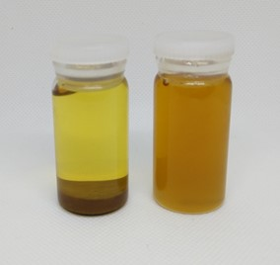
WS material cannot dissolve in DMAc/LiCl, but the solution color turns yellow due to the precipitation of some organic substances.
The CEF can dissolve in DMAc/LiCl, and no residue could be observed.
Fig. S4 The dissolution states of WS and CEF in saturated DMAc/LiCl.

Fig. S5 XRD diffraction patterns of the model materials.

Fig. S6 The mechanical properties of RCFs in the wet state.
Table S1 The conditions of PHP treatment
Time (h) | Temperature (℃) | H₃PO₄ concentration (%)
2 | 30 | 80
3 | 30 | 80
4 | 30 | 80
2 | 30 | 80
2 | 40 | 80
2 | 50 | 80
2 | 40 | 65
2 | 40 | 80
2 | 40 | 85

Use a single factor completely randomized experiment to study the cellulose contents and lignin removal under various conditions of PHP treatment, as the data shows in Fig. 1g – l and Fig. S3. Variables are pretreatment time (2 h, 3 h, 4 h), temperature (30℃, 40℃, 50℃), and H₃PO₄ concentration (65%, 70%, 75%, 80%, 85%). To study the effects of PHP treatment on RCFs, the CEF separated under the pretreatment conditions in Table S1 were chosen to produce RCFs.

Table S2 The mechanical properties of RCFs※
PHP | Young's modulus (GPa) | Toughness (MJ/m³)
2 h | 4.04 ± 1.88 | 8.10 ± 4.80
3 h | 4.91 ± 0.65 | 6.65 ± 3.14
4 h | 9.06 ± 3.29 | 8.46 ± 2.38
30℃ | 4.22 ± 0.79 | 3.59 ± 0.61
40℃ | 4.37 ± 0.64 | 11.84 ± 2.08
50℃ | 3.26 ± 0.69 | 13.87 ± 1.44
65% | 5.18 ± 0.56 | 8.23 ± 2.50
80% | 4.37 ± 0.64 | 8.88 ± 5.34
85% | − | −
※Note: All data presented as "average ± SD".

