Supplementary
Table S1: Antibody panel CyTOF
Label | Specificity | Clone | Antibody vendor | Catalogue number | Dilution
⁸⁹Y | CD45 | HI30 | Fluidigmª | 3089003B | 1/200
¹¹⁵In | CD5 | UCHT2 | Biolegend^{b} | 300602 | 1/100
¹⁴¹Pr | CD196 (CCR6) | G034E3 | Fluidigm | 3141003A | 1/200
¹⁴²Nd | CD19 | HIB19 | Fluidigm | 3142001B | 1/200
¹⁴³Nd | cPARP | F21-852 | Fluidigm | 3143011A | 1/50
¹⁴⁴Nd | CD66b | REA306 | Miltenyi^{c} | 130-108-019 | 1/50
¹⁴⁵Nd | CD4 | RPA-T4 | Biolegend | 300541 | 1/100
¹⁴⁶Nd | CD8a | RPA-T8 | Biolegend | 301053 | 1/200
¹⁴⁷Sm | CD117 (C-kit) | 104D2 | BioLegend | 313202 | 1/100
¹⁴⁸Nd | CD14 | M5E2 | Biolegend | 301843 | 1/100
¹⁴⁹Sm | CD25 (IL-2Ra) | 2A3 | Fluidigm | 3149010B | 1/100
¹⁵⁰Nd | CD185 (CXCR5) | J252D4 | BioLegend | 356902 | 1/100
¹⁵¹Eu | CD123 | 6H6 | Fluidigm | 3151001B | 1/100
¹⁵²Sm | TCRγδ | 11F2 | Fluidigm | 3152008B | 1/50
¹⁵³Eu | CD7 | CD7-6B7 | Biolegend | 343111 | 1/100
¹⁵⁴Sm | CD163 | GHI/61 | Biolegend | 333602 | 1/100
¹⁵⁵Gd | CD278 (ICOS) | C398.4A | BioLegend | 313502 | 1/50
¹⁵⁶Gd | CD294 (CRTH2) | BM16 | Biolegend | 350102 | 1/50
¹⁵⁷Gd | ACE-2 | AC18F | Novus Biologicals^{d} | NBP2-80035-100UG | 1/100
¹⁵⁸Gd | CD209 (DC-SIGN) | 9E9A8 | Biolegend | 330102 | 1/100
¹⁵⁹Tb | CD197 (CCR7) | G043H7 | Biolegend | 353237 | 1/200
¹⁶⁰Gd | FoxP3 | PCH101 | eBioscience^{e} | 14-4776-82 | 1/50
¹⁶¹Dy | KLRG1 (MAFA) | REA261 | Miltenyi | Special order | 1/100
¹⁶²Dy | CD11c | Bu15 | Biolegend | 337221 | 1/200
¹⁶³Dy | CD152 (CTLA-4) | BNI3 | BioLegend | 369602 | 1/100
¹⁶⁴Dy | CD161 | HP-3G10 | Biolegend | 339919 | 1/100
¹⁶⁵Ho | CD127 (IL-7Ra) | A019D5 | Fluidigm | 3165008B | 1/200
¹⁶⁶Er | Tbet | 4B10 | BioLegend | 644825 | 1/100
¹⁶⁷Er | CD27 | O323 | Biolegend | 302839 | 1/200
¹⁶⁸Er | HLA-DR | L243 | Biolegend | 307651 | 1/200
¹⁶⁹Tm | CD45RA | HI100 | Fluidigm | 3169008B | 1/100
¹⁷⁰Er | CD3 | UCHT1 | Biolegend | 300443 | 1/100
¹⁷¹Yb | CD206 | 15-2 | Biolegend | 321127 | 1/200
¹⁷²Yb | CD38 | HIT2 | Biolegend | 303535 | 1/200
¹⁷³Yb | CD45RO | UCHL1 | Biolegend | 304239 | 1/100
¹⁷⁴Yb | CD335 (NKp46) | 92E | Biolegend | 331902 | 1/100
¹⁷⁵Yb | PD-1 | EH12.2H7 | Biolegend | 329941 | 1/100
¹⁷⁶Yb | CD56 | B159 | BD Biosciences^{f} | 555514 | 1/100
²⁰⁹BI | CD16 | 3G8 | Fluidigm | 3209002B | 1/200
ª Fluidigm, South San Francisco, CA, USA. ^{b} Biolegend, San Diego, CA, USA. ^{c} Miltenyi Biotech, Bergisch Gladbach, Germany. ^{d} Novus Biologicals Centennial, CO, USA ^{e} eBioscience, San Diego, CA, USA. ^{F} BD Biosciences Franklin Lakes, NJ, USA . ACE2, Angiotensin-converting enzyme 2. CCR, C-C chemokine receptor. CD, cluster of differentiation. CRTH2, prostaglandin D2 receptor 2. CXCR, CXC chemokine receptor. FOXP3, forkhead box P3. HLA-DR, human leukocyte antigen-D-related. IL-2R, interleukin-2 receptor. IL-7Rα, interleukin-7 receptor α. KLRG1, killer cell lectin-like receptor subfamily G member 1. MAFA, mast cell function-associated antigen. PD-1, programmed cell death protein. Tbet, T-box transcription factor TBX21. TCR, T-cell receptor. All markers were stained on the cell surface.
Table S2: Barcoding panel
Label | Specificity | Clone | Antibody vendor | Catalogue number | End dilution
¹⁰⁶Cd | B2M | 2M2 | Biolegendª | 316302 | 1/50
¹¹⁰Cd | B2M | 2M2 | Biolegend | 316302 | 1/50
¹¹¹Cd | B2M | 2M2 | Biolegend | 316302 | 1/50
¹¹²Cd | B2M | 2M2 | Biolegend | 316302 | 1/50
¹¹⁴Cd | B2M | 2M2 | Biolegend | 316302 | 1/50
¹¹⁶Cd | B2M | 2M2 | Biolegend | 316302 | 1/50
¹⁹⁸Pt | B2M | 2M2 | Biolegend | 316302 | 1/50
ª Biolegend, San Diego, CA, USA. B2M, Beta-2 microglobulin.

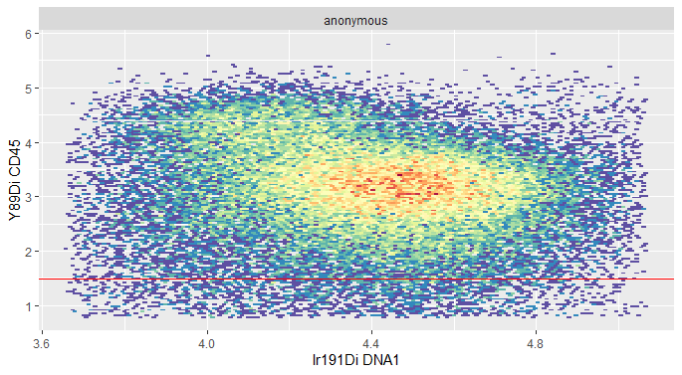
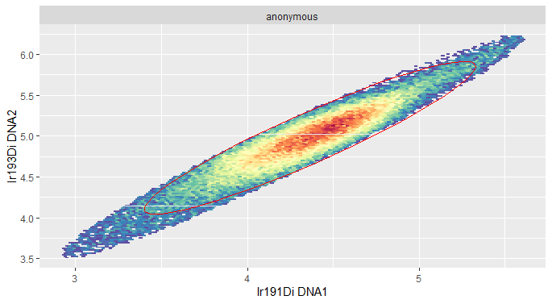
A B

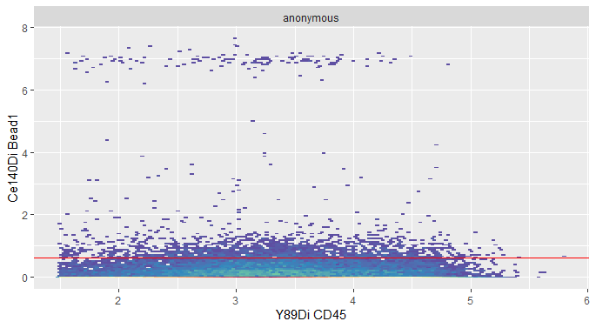
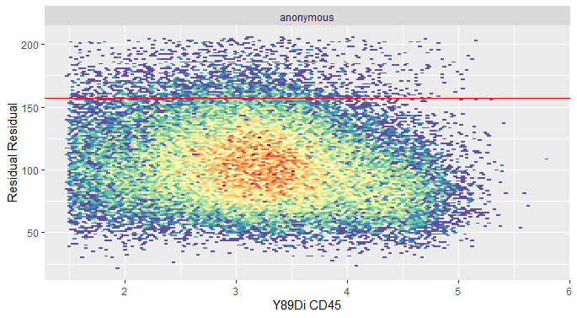
C D

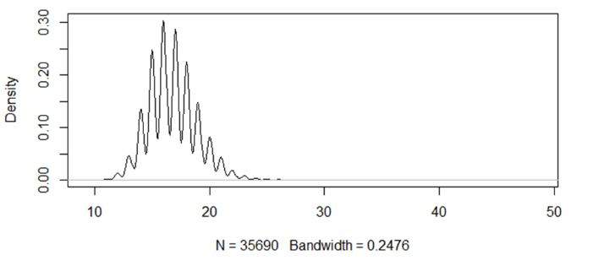
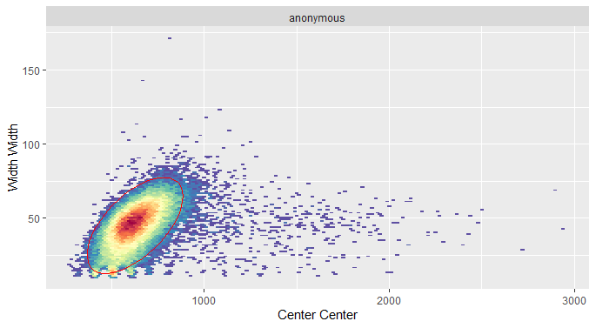
E F

Supplementary Figure S1: Pre-processing mass cytometry data.
(A) Selection events with positive DNA staining. For further analysis 95% of all events with a positive DNA staining were selected, encircled in red. (B) Selection CD45⁺ events. Red line represents the cut-off point used during the pre-processing, all events above this threshold were selected. (C) Removal of events with high residual value, a Gaussian parameter created during normalization. All events below the red line were selected (D) Removal of calibrating beads from the data. Red line represents the cut-off point, all events below the threshold were selected. (E) Selection of events with appropriate width and center values, Gaussian parameters created during normalization. Events within the red circle represent the events that were selected. (F) Removal events with an increased event length. All events with an event length of 24 or beneath were selected

A
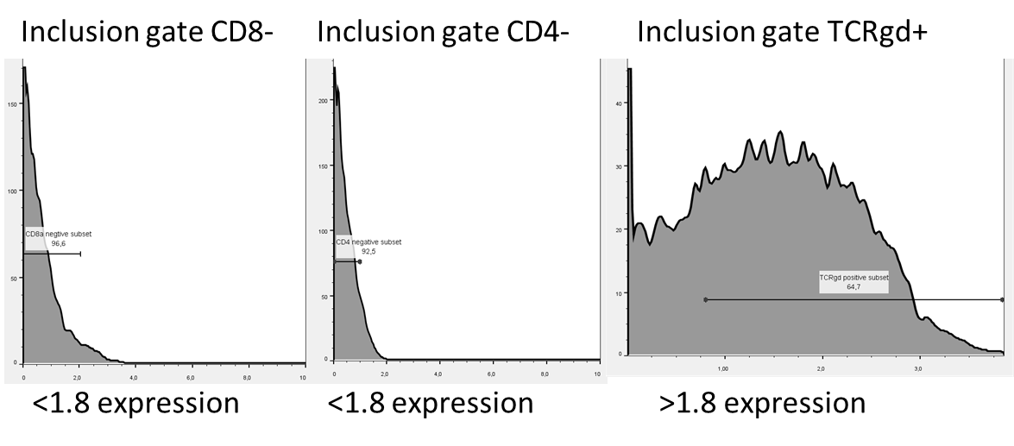
B
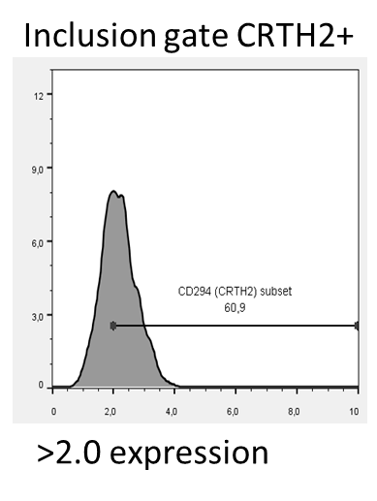
Supplementary figure S2: Manual gating strategy for (A)Th2 cells (B) for TCRgd T cells.

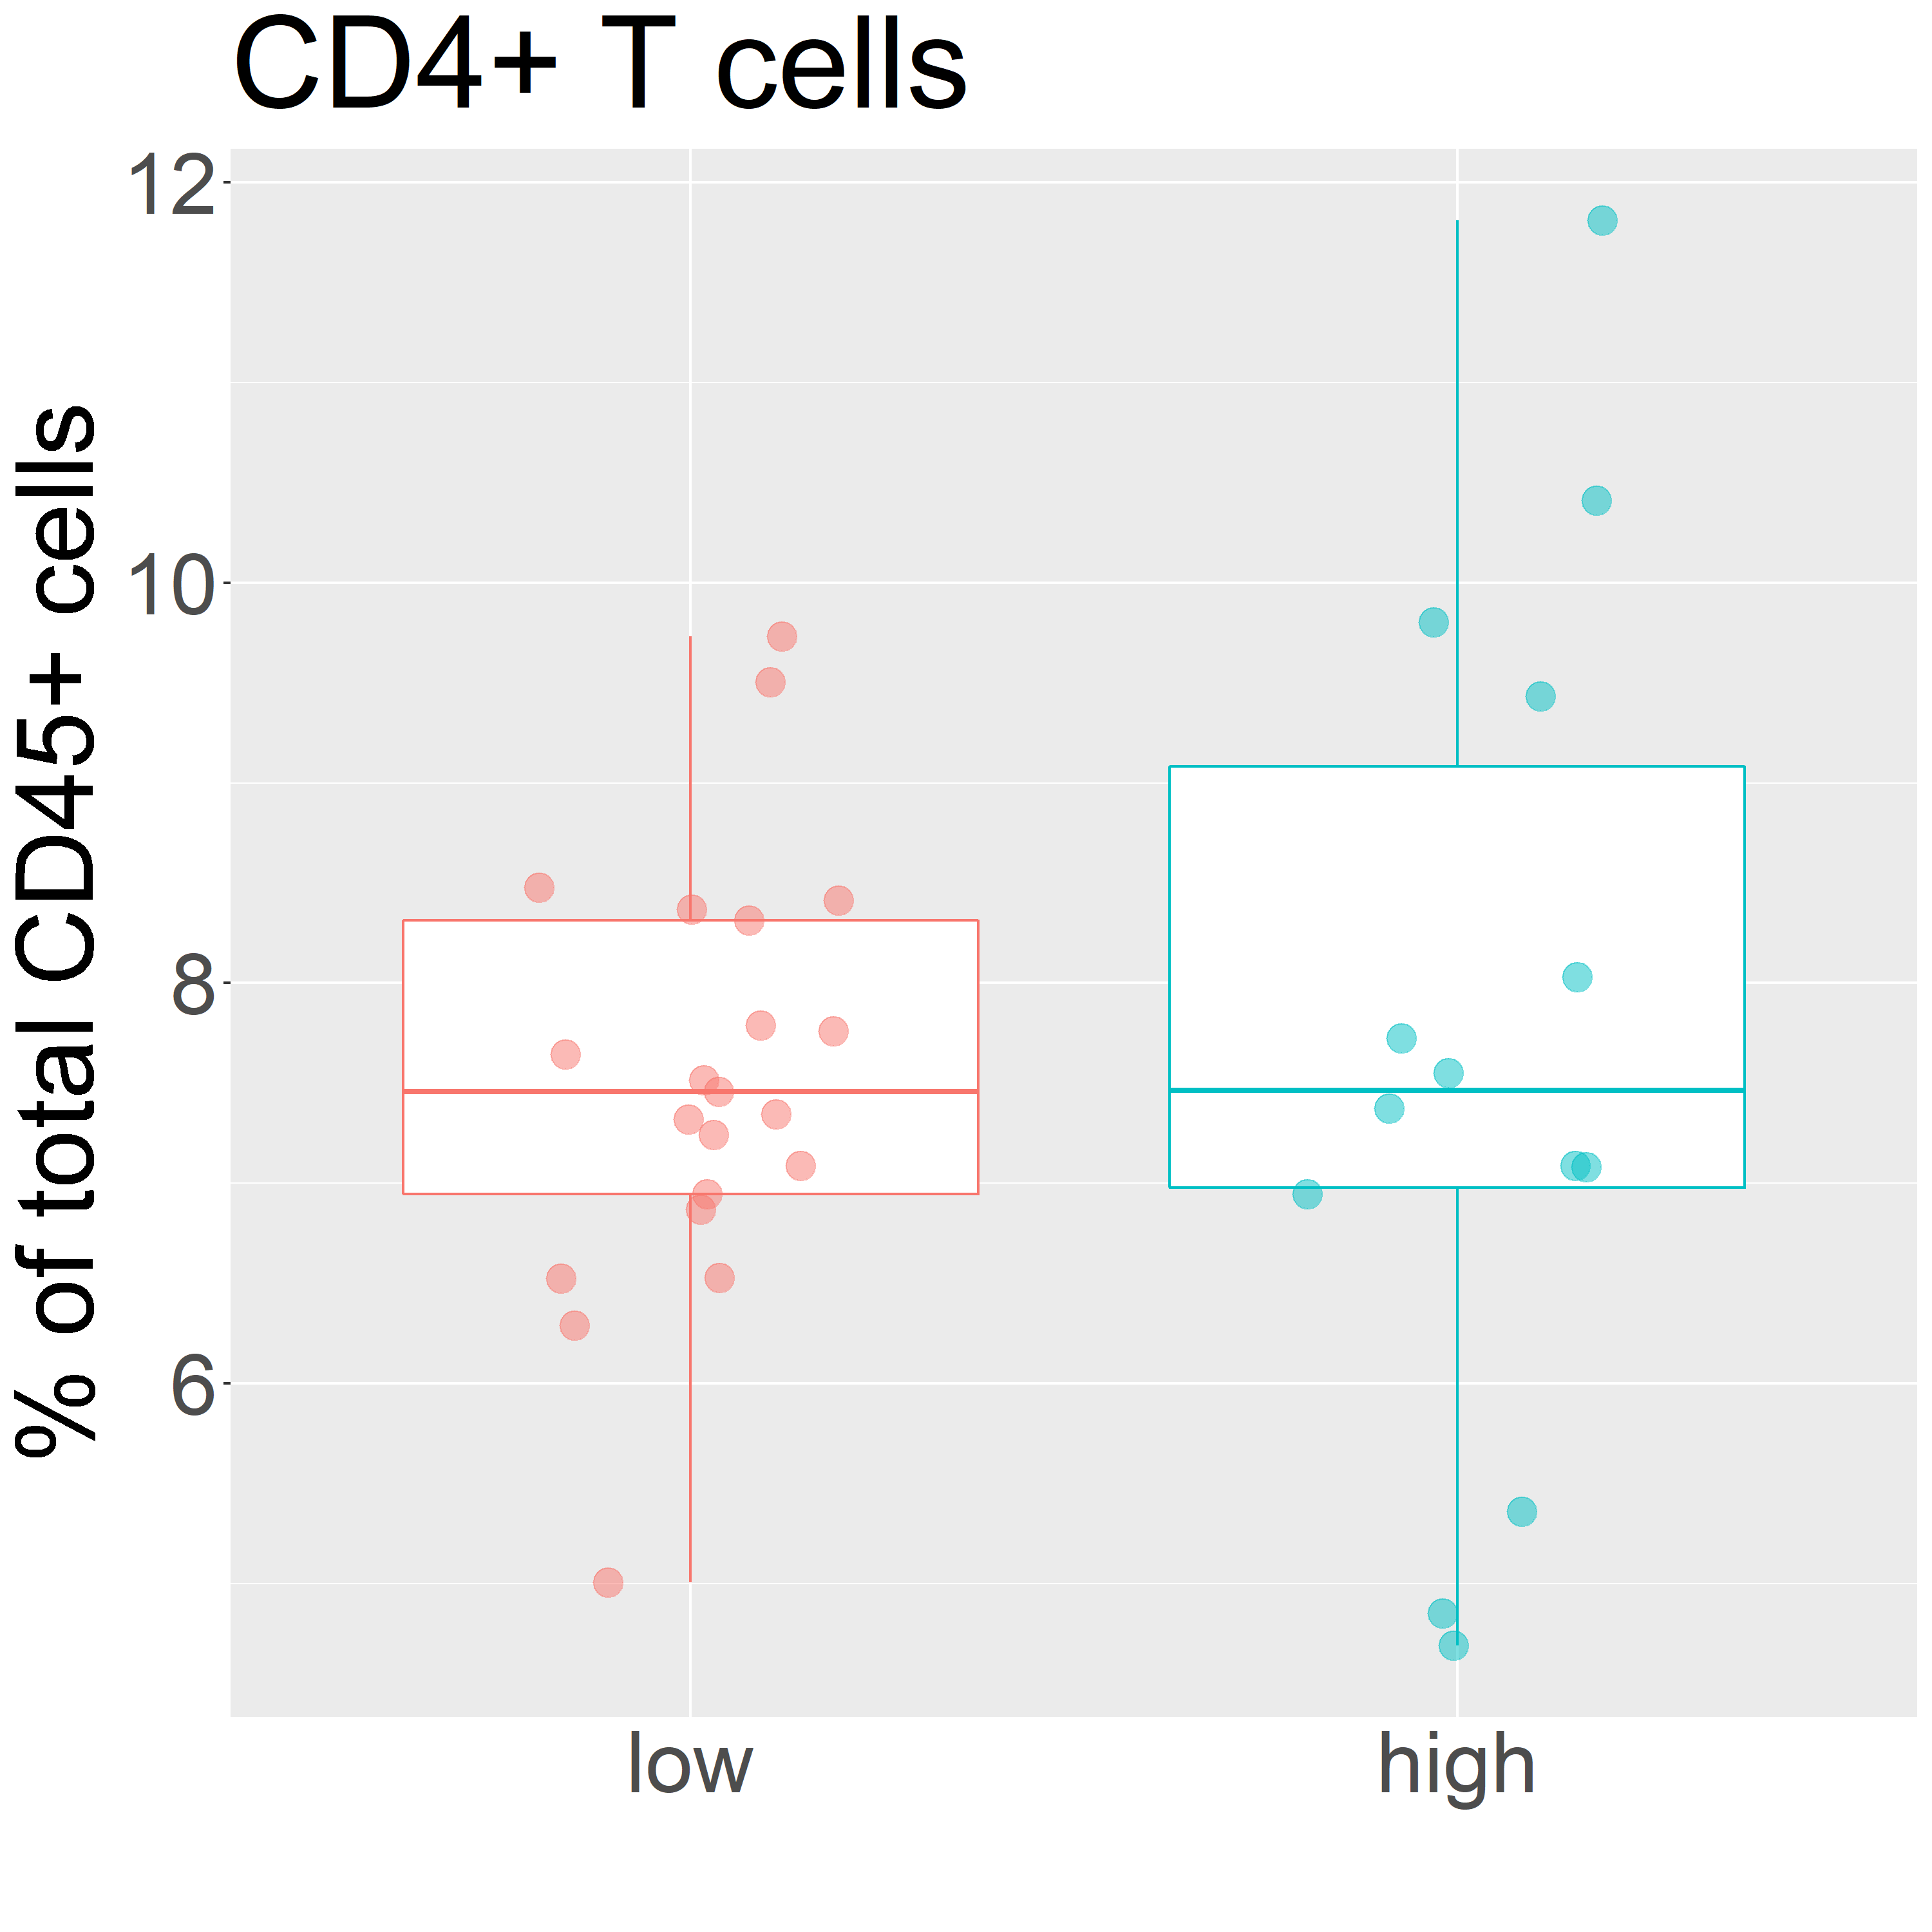
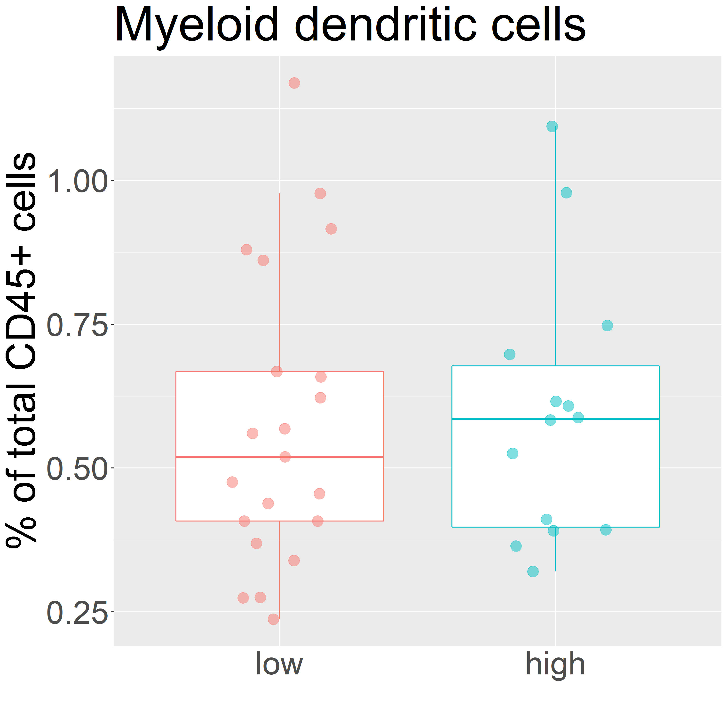
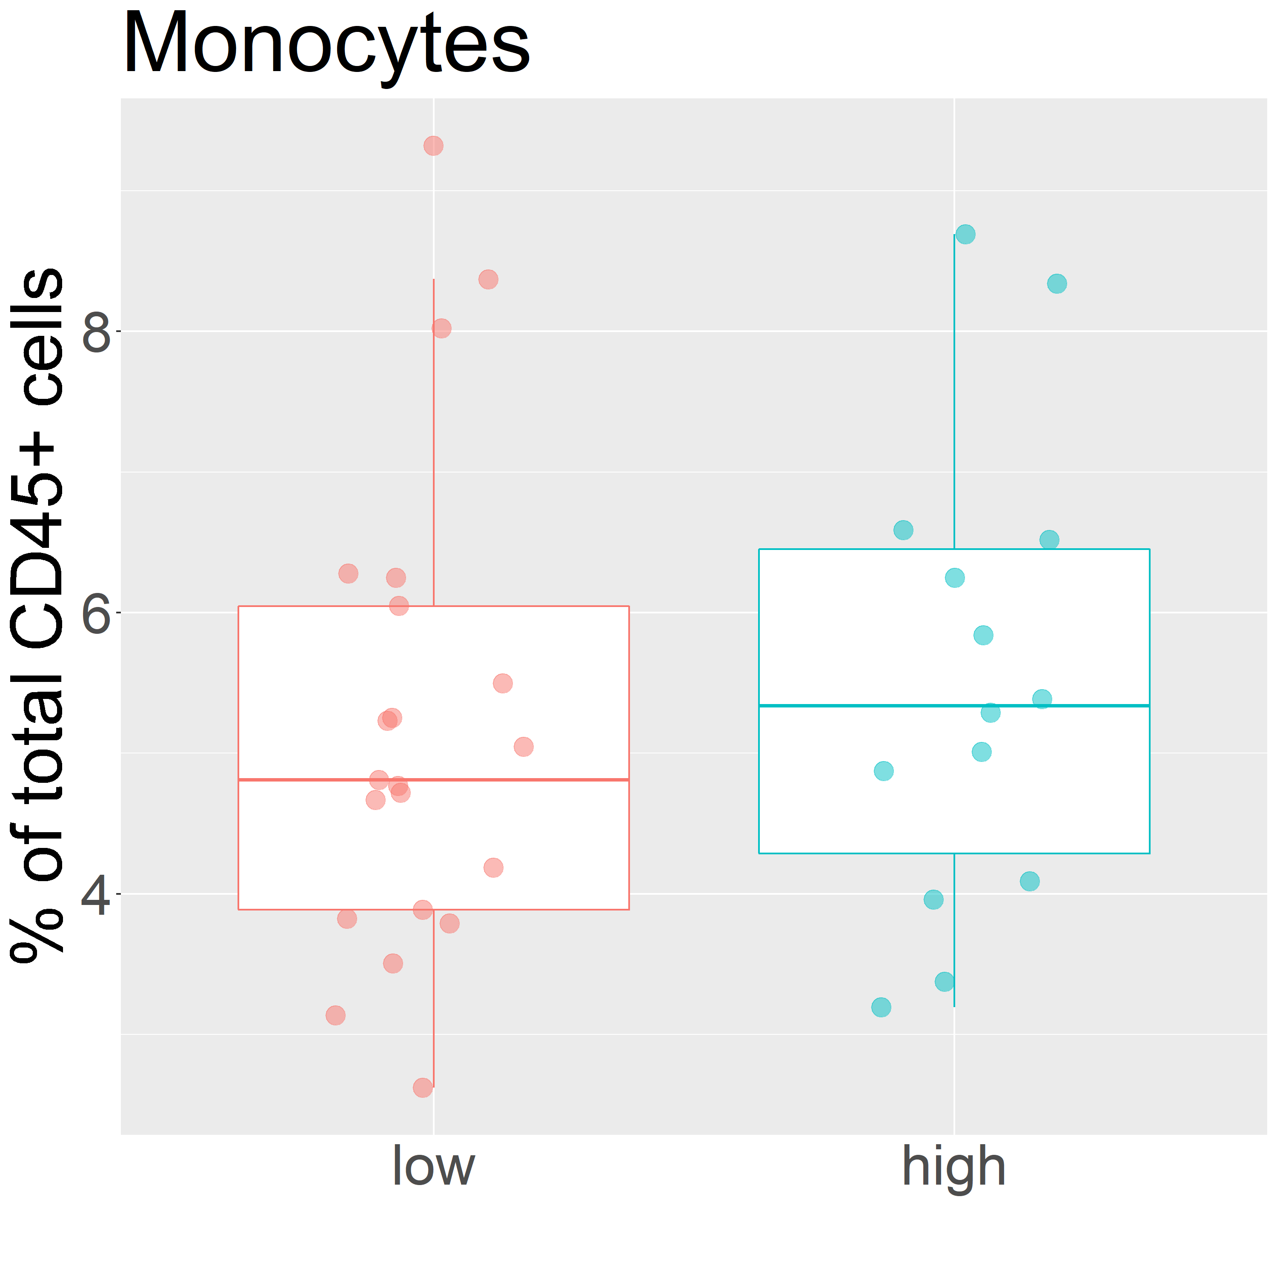
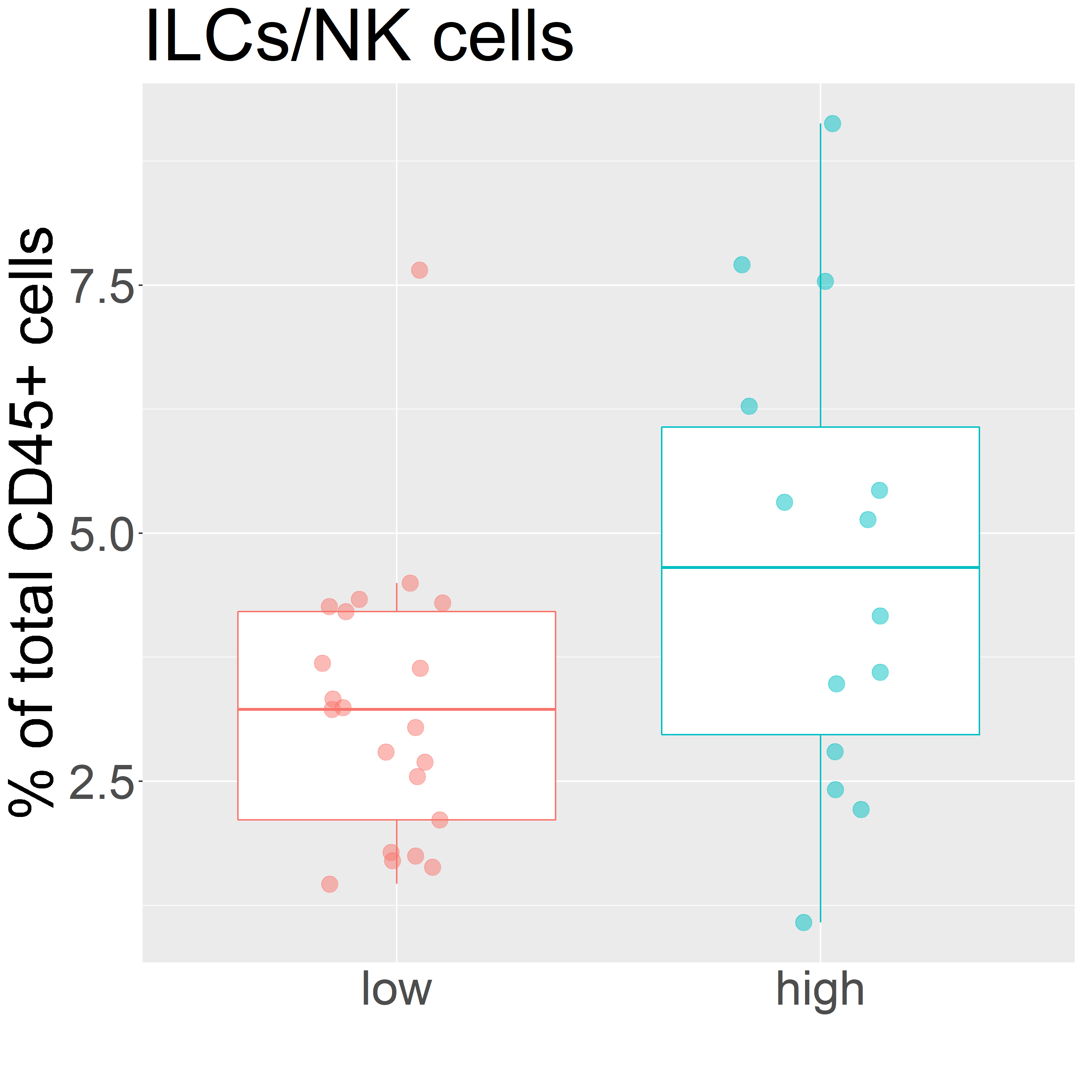
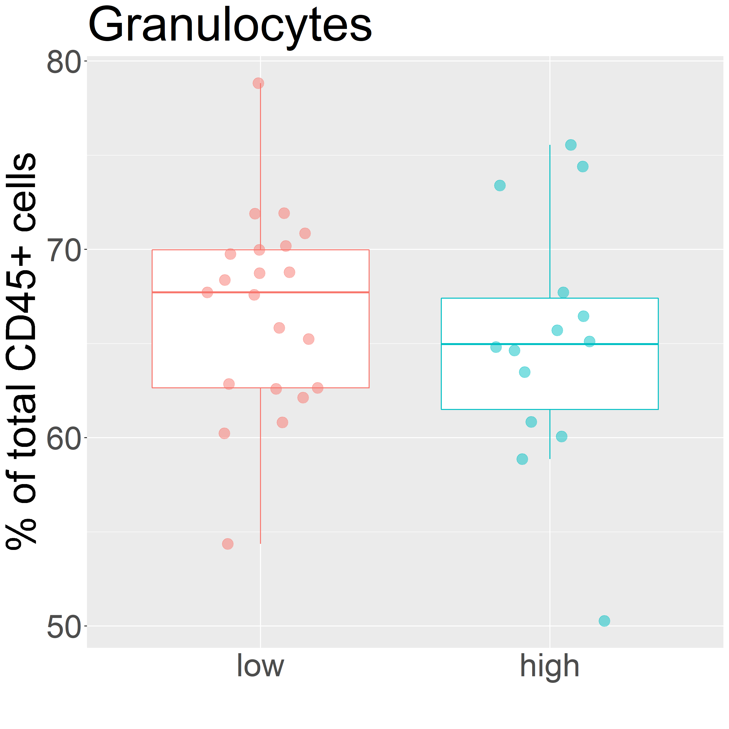
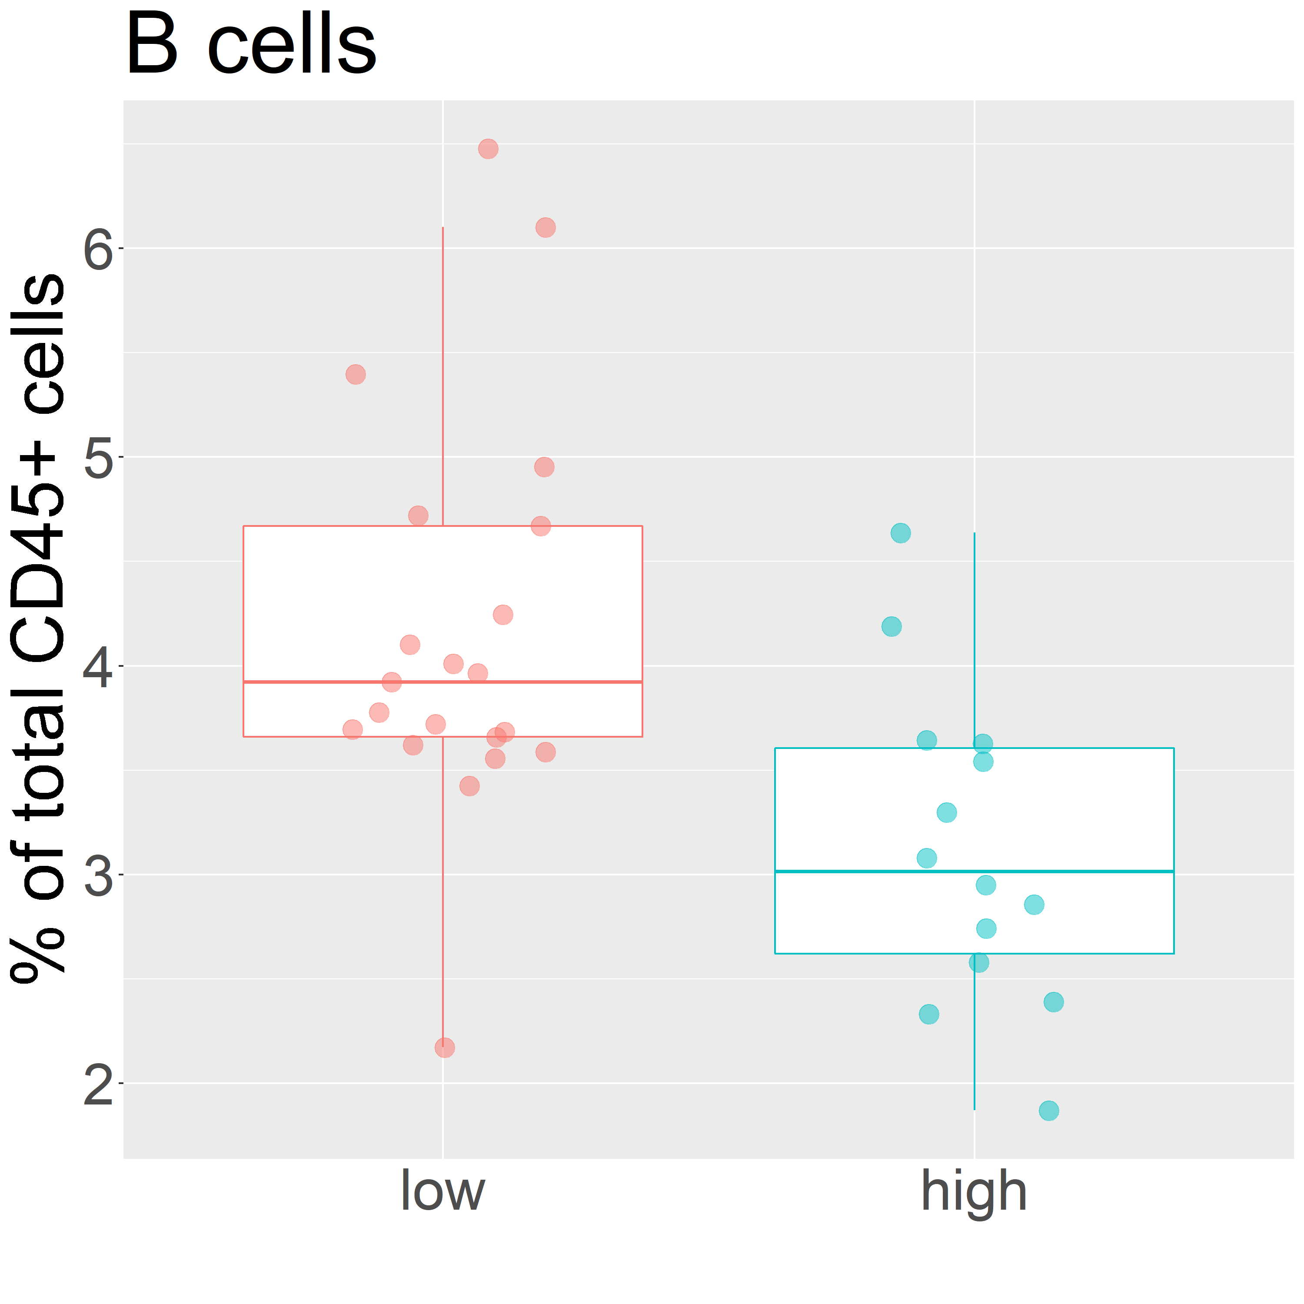
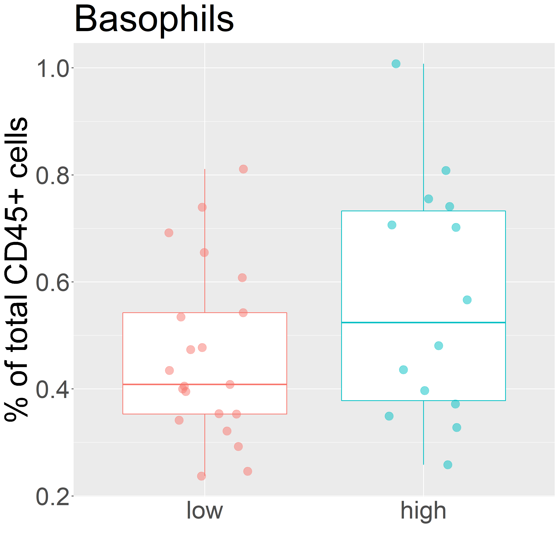

p =0.245
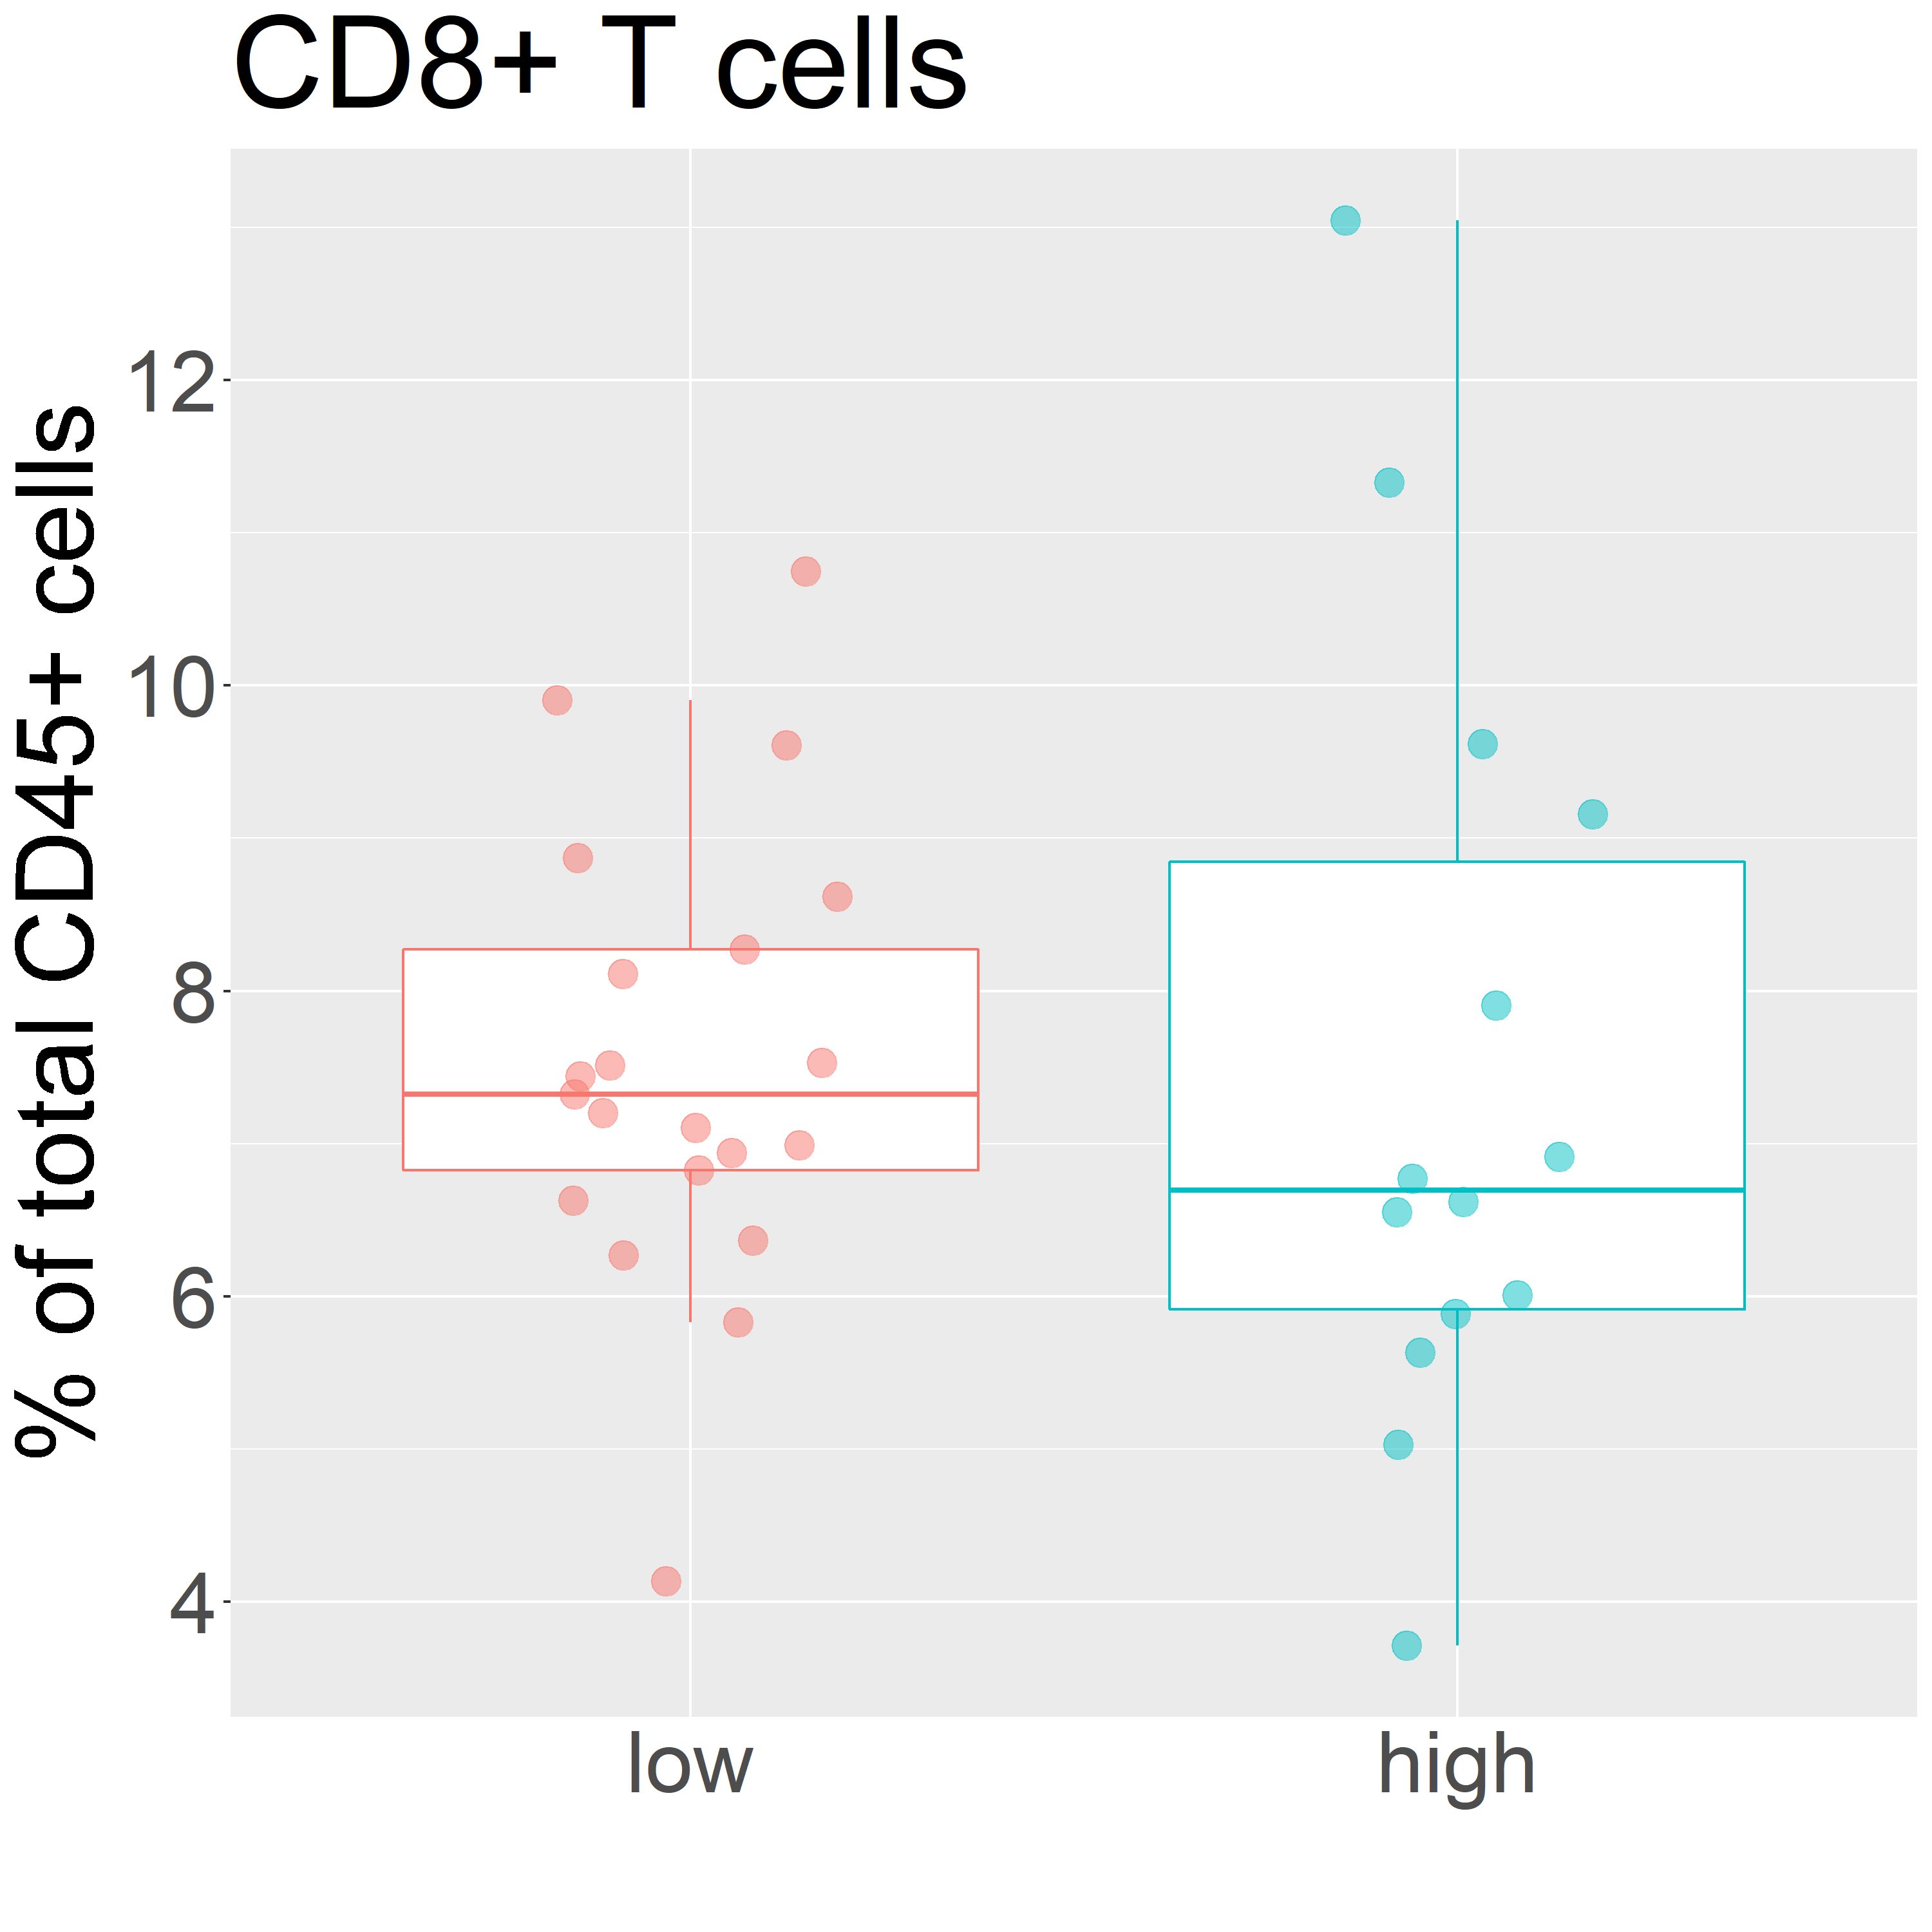
p =0.008
p =0.270

p=0.970
p=0.068
p =0.180

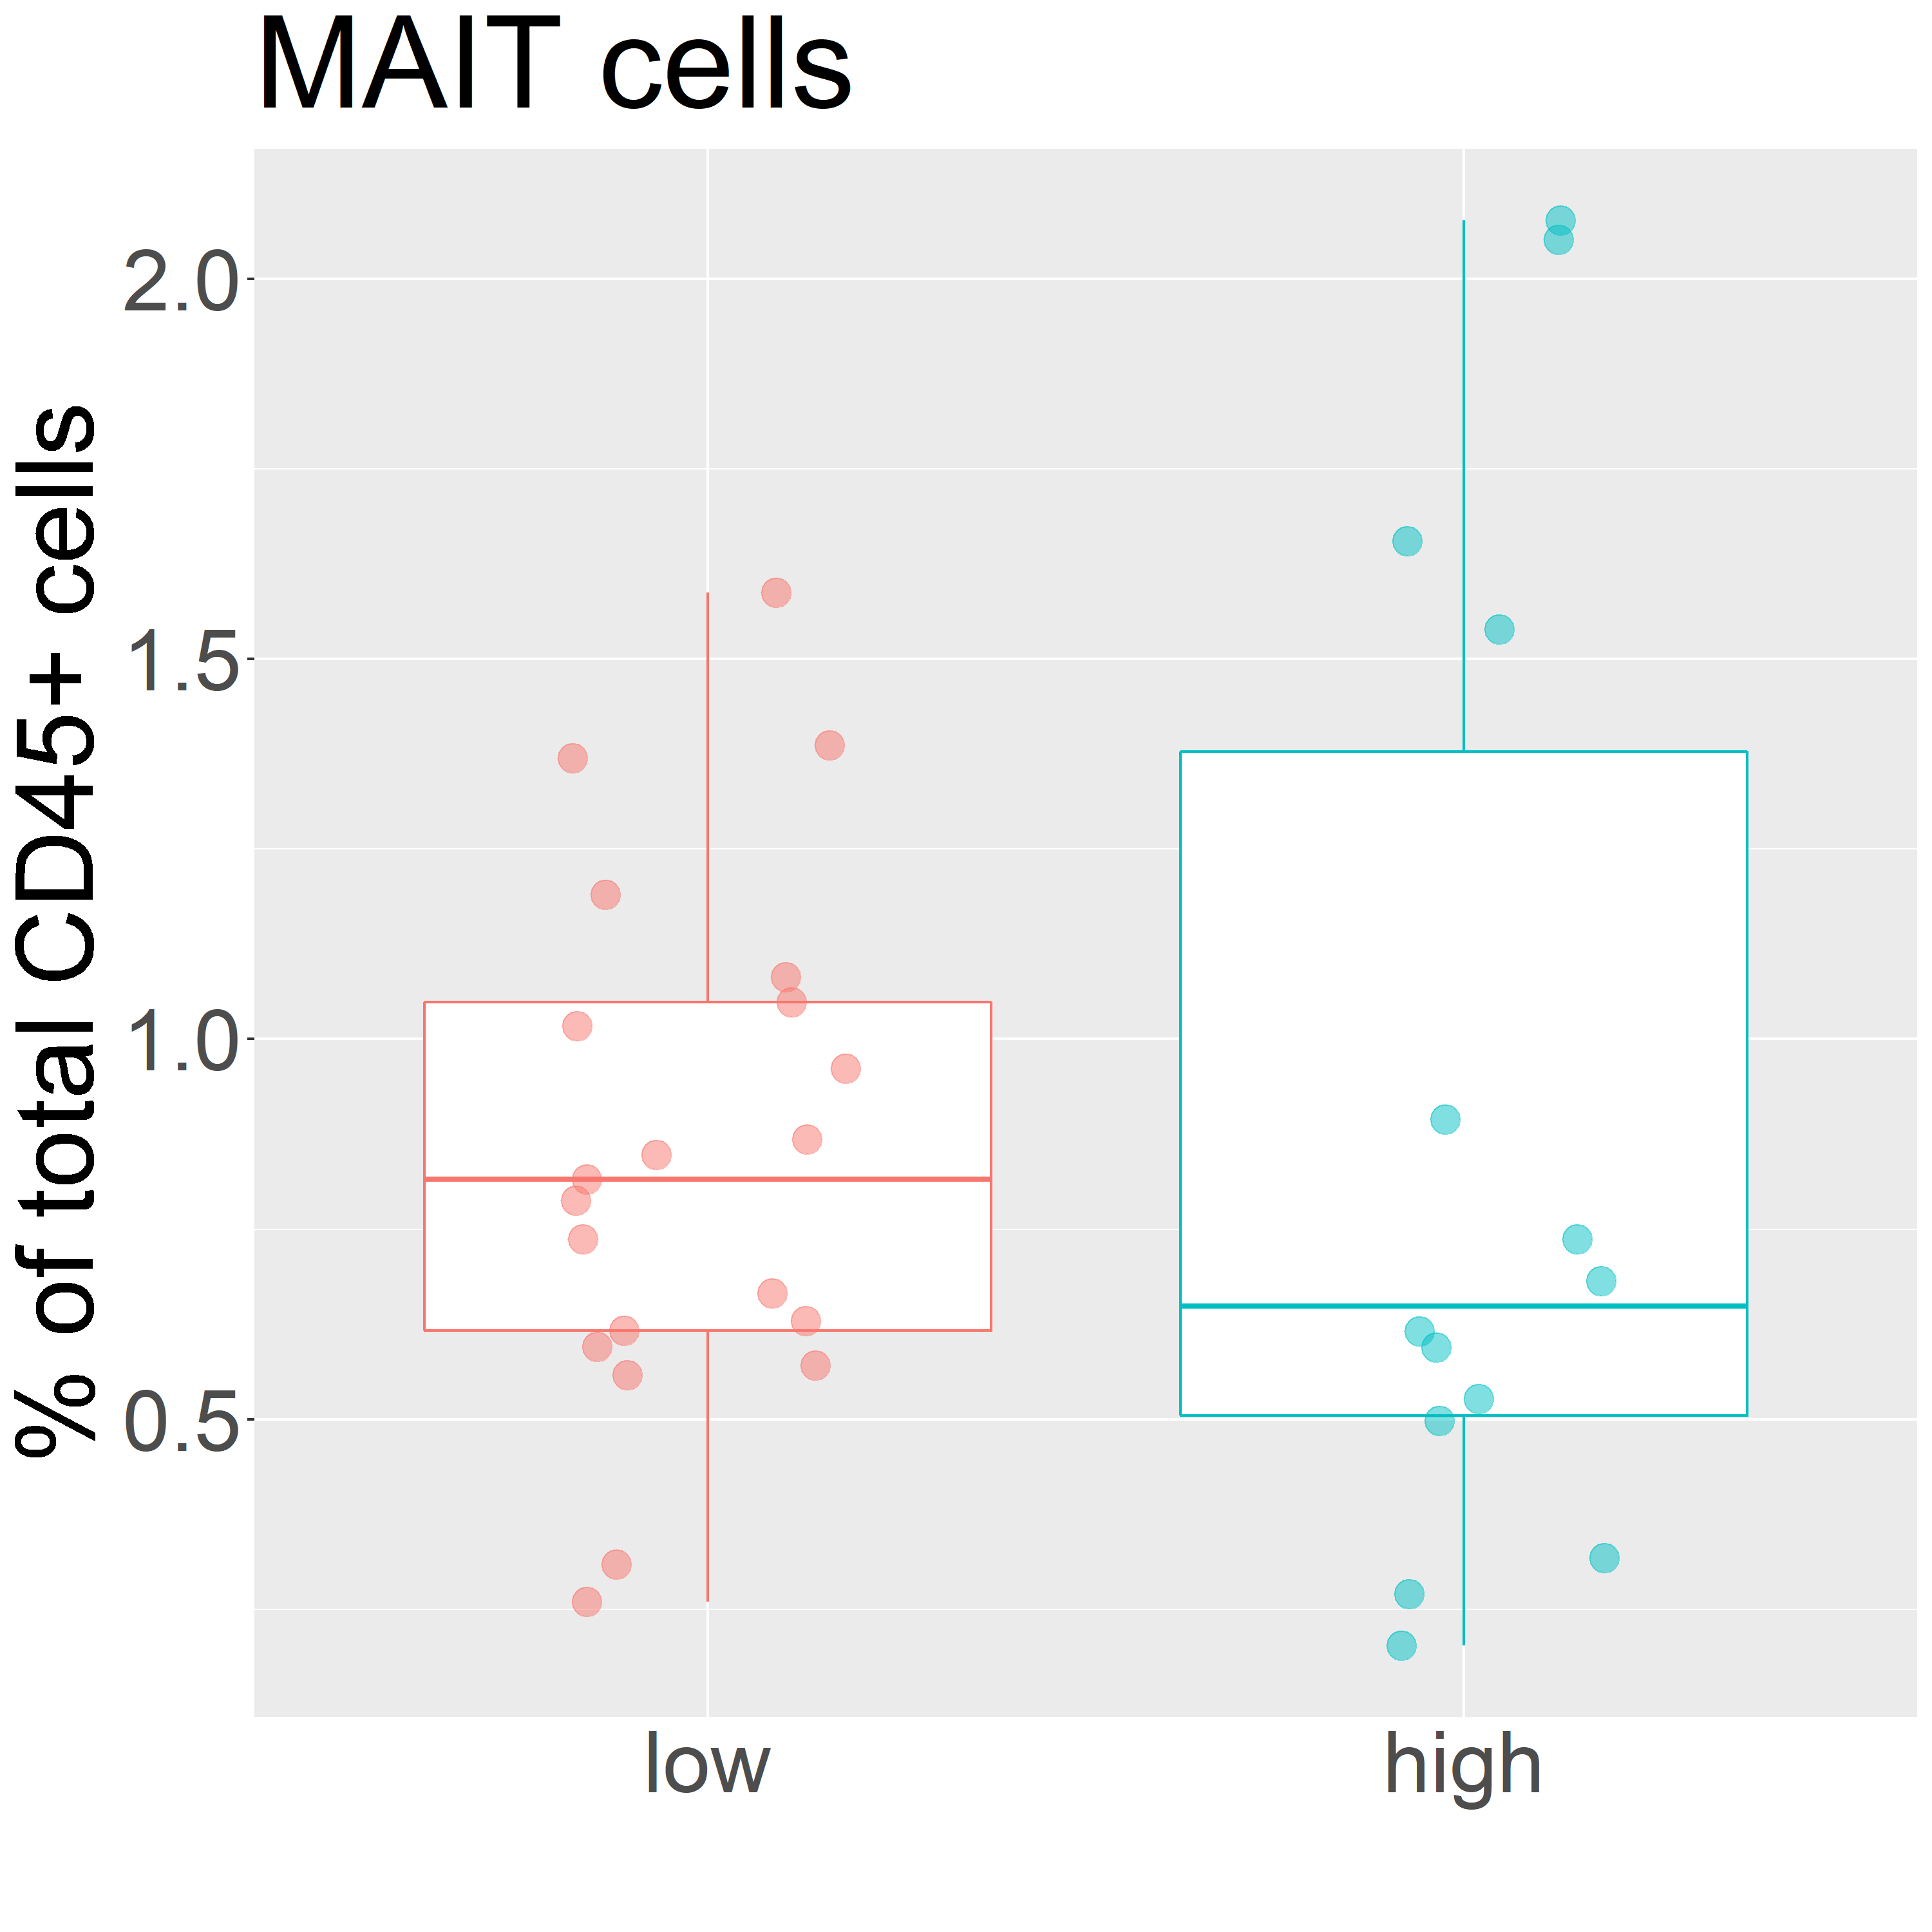

p=0.152
p=0.824
p=0.144

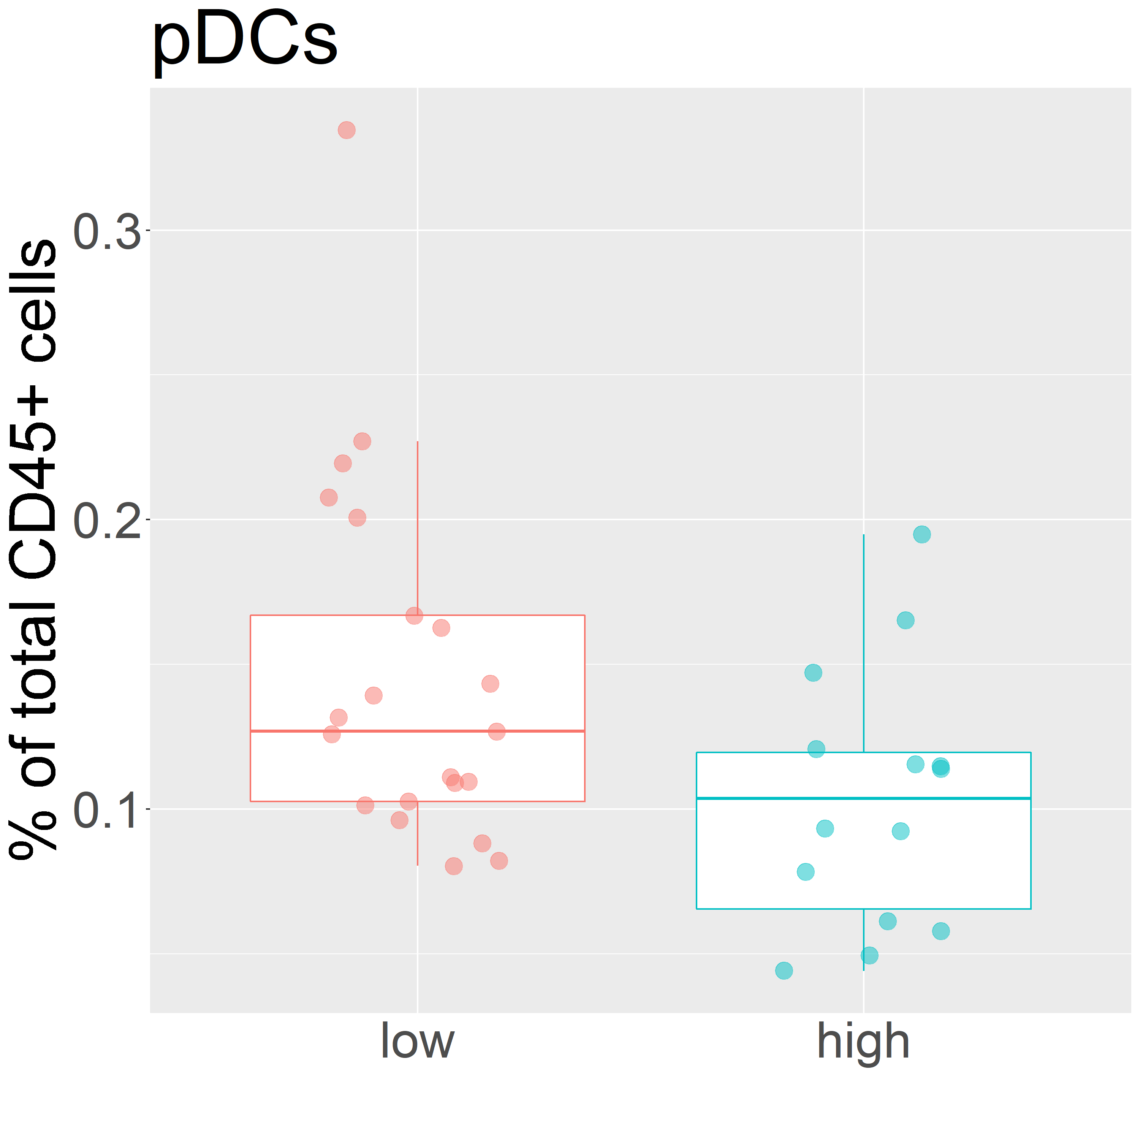
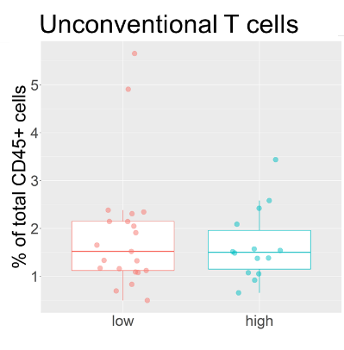
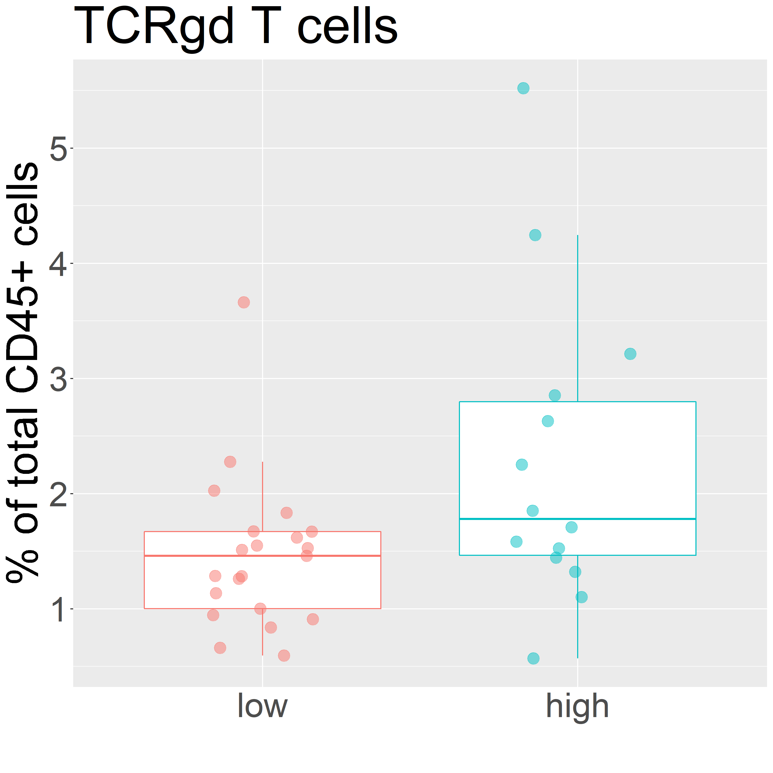

p=0.202
p=0.375
p=0.562

Supplementary Figure S3: Major immune lineages annotated on the basis of lineage marker expression. Boxplots depicting the comparison of the frequency of these major immune lineage relative to number of total CD45⁺ cells in high and low SES. Differences were tested using a Student’s t test.

