Suppl 1. Contrast-enhanced CT in a 65-year-old male with HCC. Red mask is the demonstration of ROIs placement on axial phase image.

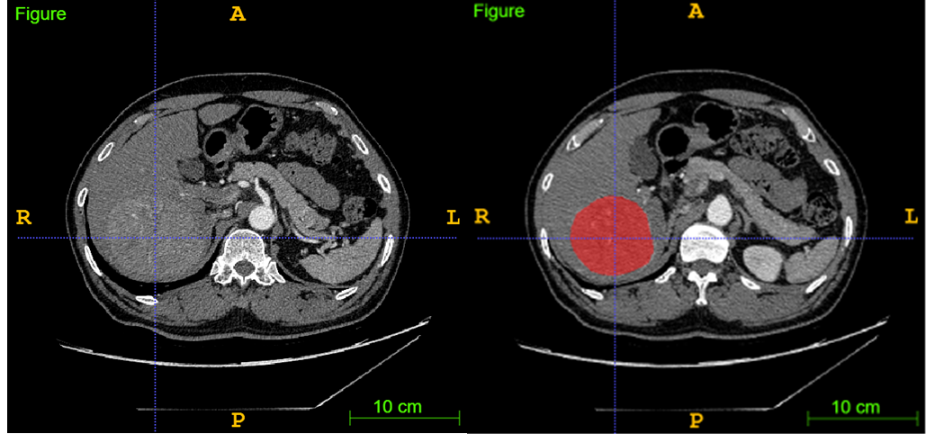

ROIs = regions of interest
Suppl 2. Feature selection using the LASSO algorithm. (a) Selection of the tuning parameter (λ) using 10-fold cross-validation and the minimum criteria. A plot of the partial likelihood deviance was made against log (λ). The minimum and 1-SE criteria were used to draw the dotted vertical lines at the optimal values. (b) Profiles of the LASSO coefficients for the texture features. The vertical line was drawn at a value selected from the log (λ) sequence using 10-fold cross-validation. Twenty-two features of non-zero coefficients are shown. (c) The selected texture features and corresponding coefficients.
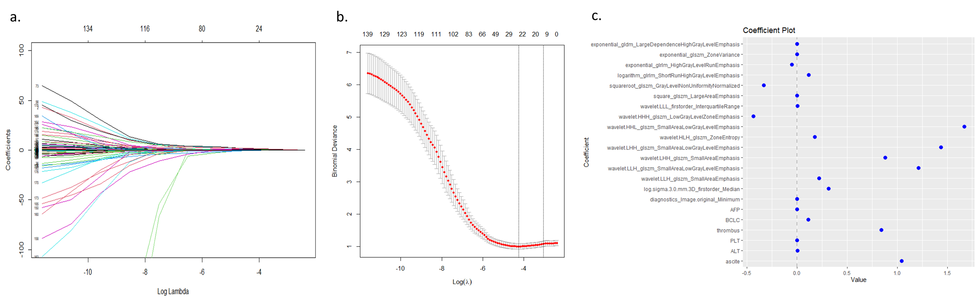

LASSO = least absolute shrinkage and selection operator

Suppl 3. Summary of general imaging features

 |  | Whole cohort | Training set | Testing set | p
Largest tumor diameter (cm) |  | 9.60  (range: 1.50-21.1) | 9.60  (range: 1.50-18.9) | 9.45  (range: 3.40-21.1) | 0.701
Number of lesions | Single lesion | 110 (36.5 %) | 88 (36.5 %) | 22 (36.7 %) | 0.983
Number of lesions | Multiple lesions | 191 (63.5 %) | 153 (63.5 %) | 38 (63.3 %)
The presence or absence of portal vein thrombus | Presence | 111 (36.9 %) | 95 (39.4 %) | 16 (26.7 %) | 0.067
The presence or absence of portal vein thrombus | Absence | 190 (63.1 %) | 146 (60.6 %) | 44 (73.3 %)
The presence or absence of ascites | With ascites | 271 (90.0 %) | 218 (90.5 %) | 53 (88.3 %) | 0.623
The presence or absence of ascites | Without ascites | 30 (10.0 %) | 23 (9.5 %) | 7 (11.7 %)

