Supplementary Material

Table S1 The retention time of PAH components
Table S2 Attribute table of the molecular ratio method
Table S3 Comparison of PAH concentration in the sediments
Fig. S1 L/H, ACL, and P_{aq} value of n-alkanes
Fig. S2 Comparison of PAH concentration in the Yangtze River Basin

Table S1 The retention time of PAH components
Compounds | Retention time, min
Nap | 16.6
Acy | 18.5
Ace | 20.5
Flu | 21.2
Phe | 22.1
Ant | 23.4
Fla | 24.5
Pyr | 25.4
BaA | 28.5
Chr | 29.3
BbF | 31.6
BkF | 32.9
BaP | 33.9
DahA | 35.7
BghiP | 36.3
IcdP | 37.4

Table S2 Attribute table of the molecular ratio method (Sun et al. 2015; Chen et al. 2022)
Ant/(Ant+Phe) |  |  |  | InP/(InP+BghiP) |  |  | Fla/(Fla+Pyr） |  | BaA/(BaA+Chr)
 | <0.1 | Oil leakage | <0.2 |  | Oil leakage | <0.4 |  | Oil leakage |  | <0.2 | Oil leakage
 | >0.1 | Incomplete combustion | 0.2–0.5 |  | Petroleum combustion | >0.4 |  | Incomplete combustion |  | >0.2 | Incomplete combustion
 |  |  | >0.5 |  | Coal, wood and other biomass sources | 0.4–0.5 |  | Liquid fossil fuel
 |  |  |  |  |  | >0.5 |  | Coal, wood and other biomass sources

Table S3 Comparison of PAH concentration in the sediments (Wang et al. 2020; Li et al. 2019; Wang et al. 2019; Brewster et al. 2018; Silva et al. 2013; Lubecki et al. 2019)
Lake/Reservoir/River | Location | Concentration (ng g⁻¹)
Lake/Reservoir/River | Location | average | range
Yangzhou Catchment | Yangtze River delta, China | 2579.96 | 389.31–5794.06
Yellow River Estuary | China | 150 | 40–290
Taihu Lake | Yangtze River delta, China | – | 150–5000
Liaodong Peninsula | Northeast China | 50.50 | 3.90–211.50
Fox River | Wisconsin | – | 519.30–5802
Mundaú River | Brazil | – | 86–208.40
Gdańsk Gulf | Norway | – | 250–4500

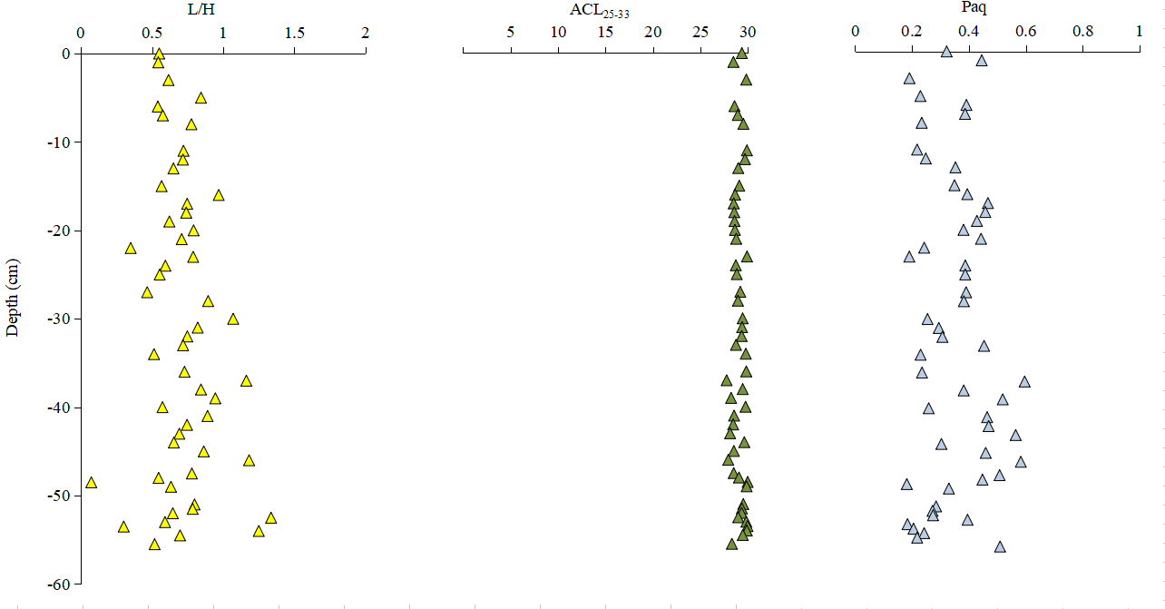
Note: Several environmental proxies for n-alkanes i.e., L/H, ACL, and P_{aq} were developed to express the n-alkane distribution in terms of numbers and odd-even predominance, which were calculated using equations as follows. RA_{i} refers to the relative abundance of n-alkane C_{i}.
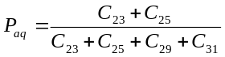

Fig. S1 L/H, ACL, and P_{aq} value of n-alkanes (Derrien et al. 2017; Seopela et al. 2020; Ficken et al. 2000)

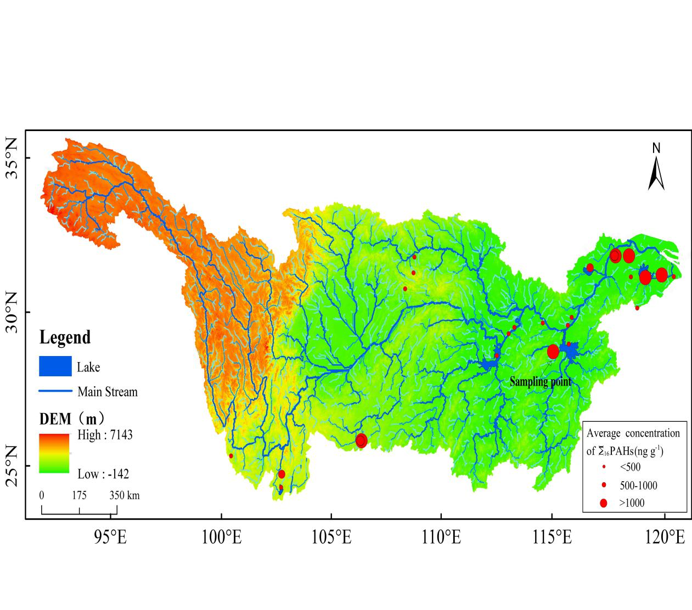
Fig. S2 Comparison of PAH concentration in the Yangtze River Basin

References
Sun CZ, Zhen L, Wang C, Yan B, Cao XC, Wu RZ (2015) Impacts of Ecological Restoration and Human Activities on Habitat of Overwintering Migratory Birds in the Wetland of Poyang Lake, Jiangxi Province, China. J Mount Sci 12(5):1302-1314. https://doi.org/10.1007/s11629-014-3128-8
Chen Y,Wang YH,Yu KK, Zhao ZH, Lang XL (2022) Occurrence characteristics and source appointment of polycyclic aromatic hydrocarbons and n-alkanes over the past 100 years in southwest China. Sci Total Environ 808:151905-151905. https://doi.org/10.1016/J.SCITOTENV.2021.151905
Wang CY, Yu LJ, Zou YM, Ji L, Li YW (2020) Sources and historical sedimentary record: Temporal variability of n-alkane and PAHs from the Yellow River Estuary, China. Appl Geochem 114:104475. https://doi.org/10.1016/j.apgeochem.2019.104475
Li A, Beek T, Schubert M, Yu ZY, Schiedek T, Schüth C (2019) Sedimentary archive of Polycyclic Aromatic Hydrocarbons and perylene sources in the northern part of Taihu Lake, China. Environ Pollut 246:198–206. https://doi.org/10.1016/j.envpol.2018.11.112
Wang CL, Liu Q, Gao JH, Sheng H, Ai Q, Shi Y, Zhang DL, Wang YP (2019) Sedimentary record of polycyclic aromatic hydrocarbons in mud deposits along the southeastern coast of Liaodong Peninsula and its relation to the anthropogenic and natural activities in the Northeast China. Chemosphere 216:31–39. https://doi.org/10.1016/j.chemosphere.2018.10.093
Brewster CS, Sharma VK, Cizmas L, McDonald TJ (2018) Occurrence, distribution and composition of aliphatic and polycyclic aromatic hydrocarbons in sediment cores from the Lower Fox River, Wisconsin, US. Environ. Sci Pollut Res 25(5):4974–4988. https://doi.org/10.1007/s11356-017-0819-z
Silva TR, Lopes SRP, Spörl G, Knoppers BK, Azevedo DA (2013) Evaluation of anthropogenic inputs of hydrocarbons in sediment cores from a tropical Brazilian estuarine system. Microchem J 109:178–188. http://doi.org/10.1016/j.microc.2012.02.012
Lubecki L, Oen AMP, Breedveld GD, Zamojska A (2019) Vertical profiles of sedimentary polycyclic aromatic hydrocarbons and black carbon in the Gulf of Gdańsk (Poland) and Oslofjord/Drammensfjord (Norway), and their relation to regional energy transitions. Sci Total Environ 646:336–346. https://doi.org/10.1016/j.scitotenv.2018.07.300
Derrien M, Yang LY, Hur J (2017) Lipid biomarkers and spectroscopic indices for identifying organic matter sources in aquatic environments: A review. Water Res 112:58–71. https://doi.org/10.1016/j.watres.2017.01.023
Seopela MP, McCrindle RI, Combrinck S, Augustyn W (2020) Occurrence, distribution, spatio-temporal variability and source identification of n-alkanes and polycyclic aromatic hydrocarbons in water and sediment from Loskop dam, South Africa. Water Res 186:116350. https://doi.org/10.1016/j.watres.2020.116350
Ficken KJ, Li B, Swain DL, Eglinton G (2000) An n-alkane proxy for the sedimentary input of submerged/floating freshwater aquatic macrophytes. Org Geochem 31(7):745–749. https://doi.org/10.1016/S0146-6380(00)00081-4

