Supplemental Data

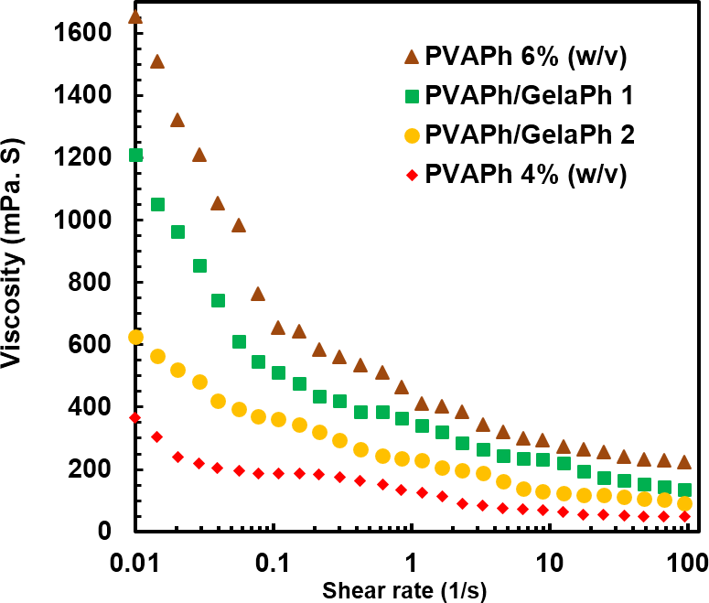

Fig. S1. Viscosity measurement of fabricated PVAPh based fibrous mats

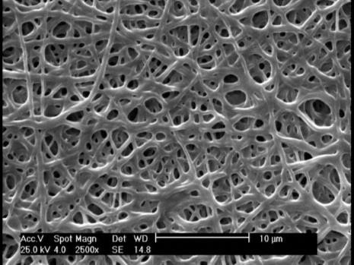

Fig. S2. SEM of fabricated fibrous mats from PVAPh 4% (w/v)

