Table 1 Parametric values of 3D model based on 2D images

INPUT IMAGE | PSNR | MSE | SSIM
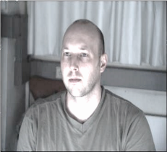 | 23.04 | 12.47 | 0.864
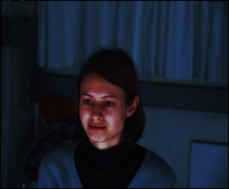 | 24.70 | 11.488 | 0.869
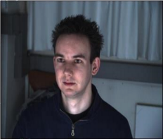 | 27.78 | 9.87 | 0.915

Table 2 Parametric values of 3D reconstruction using our Proposed Micro and Macro level features

INPUT IMAGE | PSNR | MSE | SSIM | Non-occ | All | Disc
 | 38.987 | 9.65 | 0.984 | 1 | 5.26 | 25.90
 | 38.761 | 8.345 | 0.967 | 1 | 5.02 | 25.85
 | 38.542 | 9.367 | 0.955 | 1 | 5.83 | 25.73

Table 3 Comparison of existing state-of-art deep learning based stereo approaches with our proposed model

 | Methods | Non-occ | Occ | All
 | PSMNet [12] | 1.71 | 2.83 | 1.86
 | SegStereo [13] | 1.76 | 2.33 | 1.88
 | iResNet [14] | 2.07 | 1.9 | 2.25
 | GC-Net [15] | 2.02 | 2.54 | 2.21
 | PDSNet [16] | 2.09 | 1.22 | 2.29
 | Our Proposed Model | 1.13 | 1.66 | 1.9

