PRM-based quantitative proteomics analysis of altered HSPs expression in villi and decidua of
early missed abortion patients
Supplementary material Fig.1 Western blot analysis to verify selected differentially expressed proteins HSP90AB1, HSPD1 and HSPA13; Candidate proteins were examined in triplicate and normalized to GAPDH levels for quantitative analysis

HSP90AB1 90kDa
1 2 3 4 5 6 1 2 3 4 5 6
EMA group Control group

HSPD1 60 kDa
1 2 3 4 5 6 1 2 3 4 5 6
EMA group Control group

HSPA13 52kDa
1 2 3 4 5 6 1 2 3 4 5 6
EMA group Control group
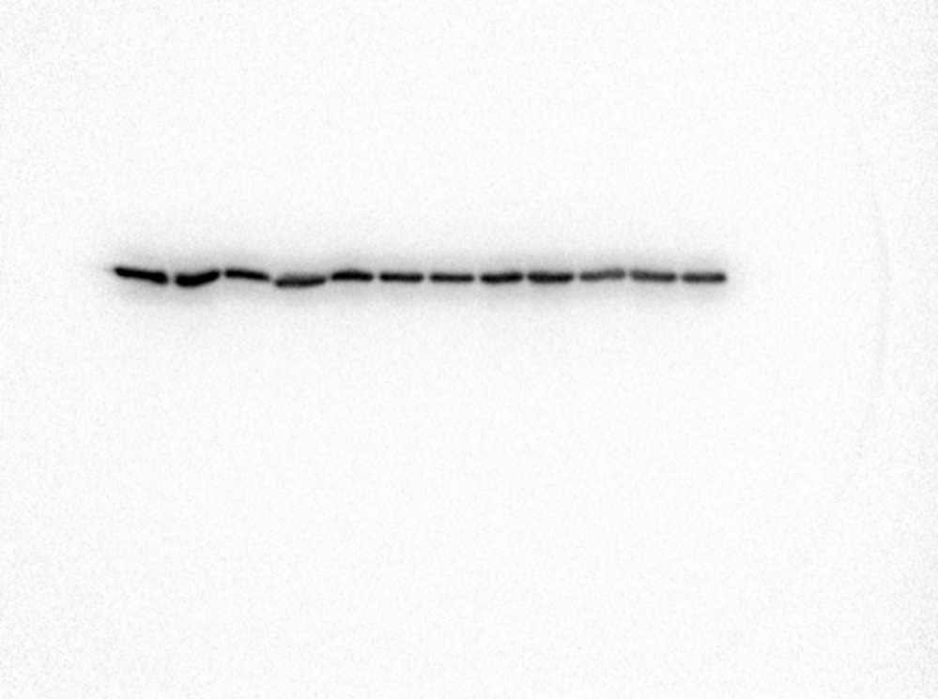
GAPDH 35.9kDa
1 2 3 4 5 6 1 2 3 4 5 6
EMA group Control group

