List of Figures:

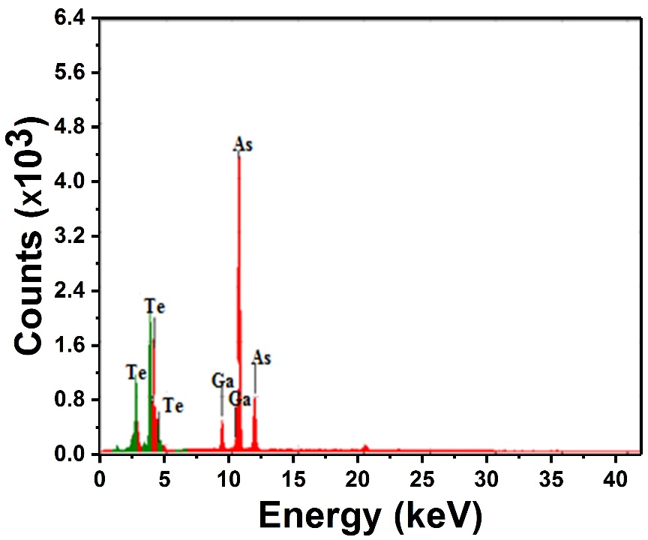
Fig. 1: Energy dispersive X-ray (EDX) spectrum of the As₃₀Te₆₄Ga₆ bulk alloy.
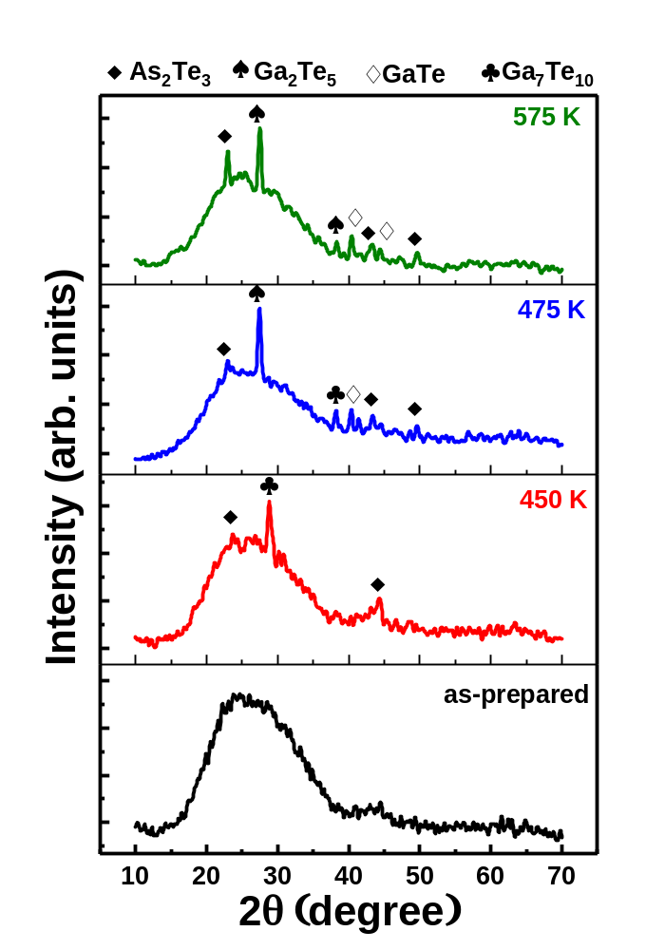
Fig. 2: X-ray diffraction patterns of the as-prepared As₃₀Te₆₄Ga₆ glassy alloy and annealed samples at 450, 475, and 575 K for 1 h under vacuum.

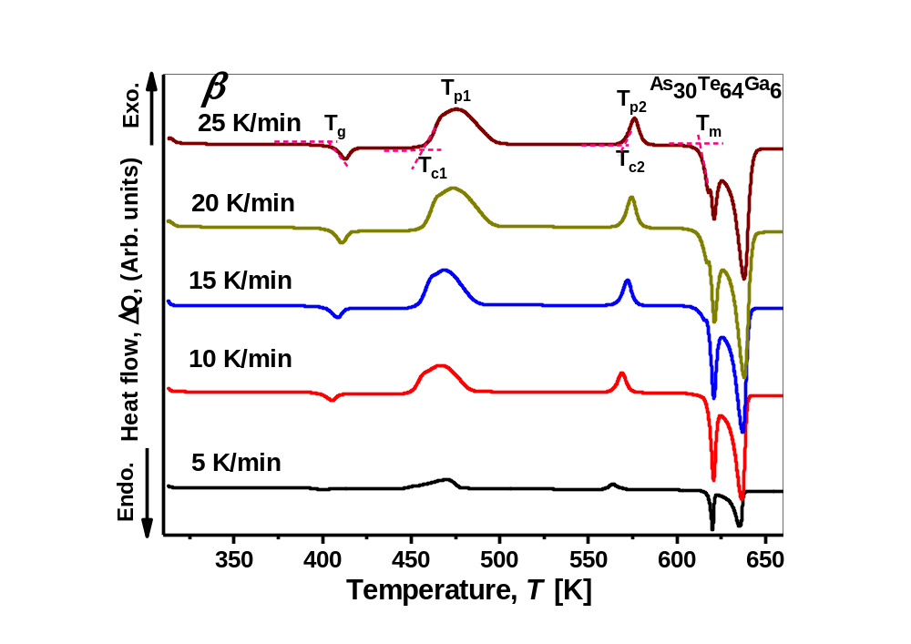

Fig. 3: DSC thermo-grams for bulk the As₃₀Te₆₄Ga₆ glass at the different heating rates (β).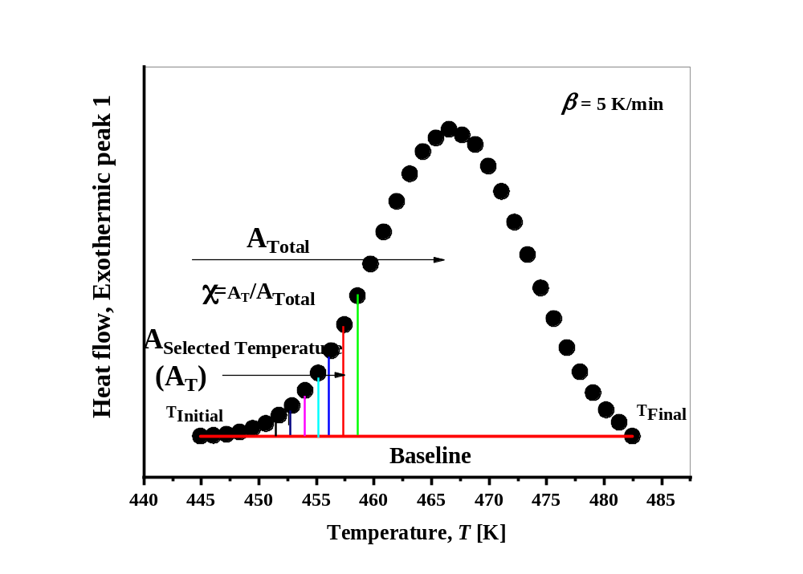

Fig. 4: DSC trace for bulk As₃₀Te₆₄Ga₆ glass at a heating rate β = 5 K min⁻¹; (the first exothermic peak), the lined area A_{T} shown between T_{i} and T_{f} of the peak, T_{i}, T_{f,} and T are according to the text.
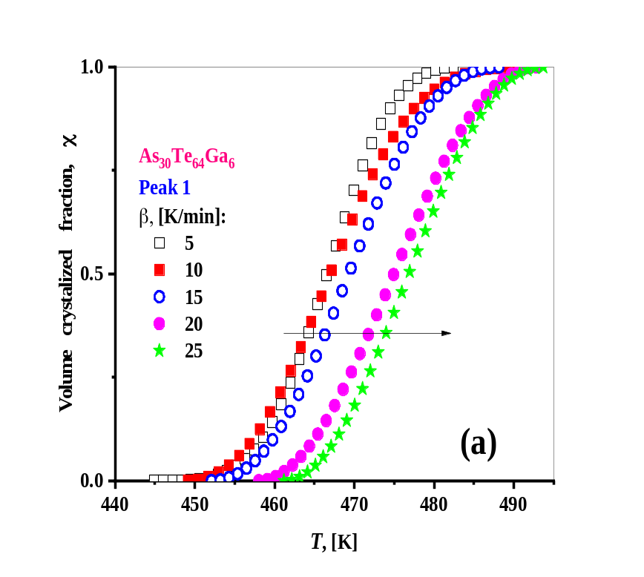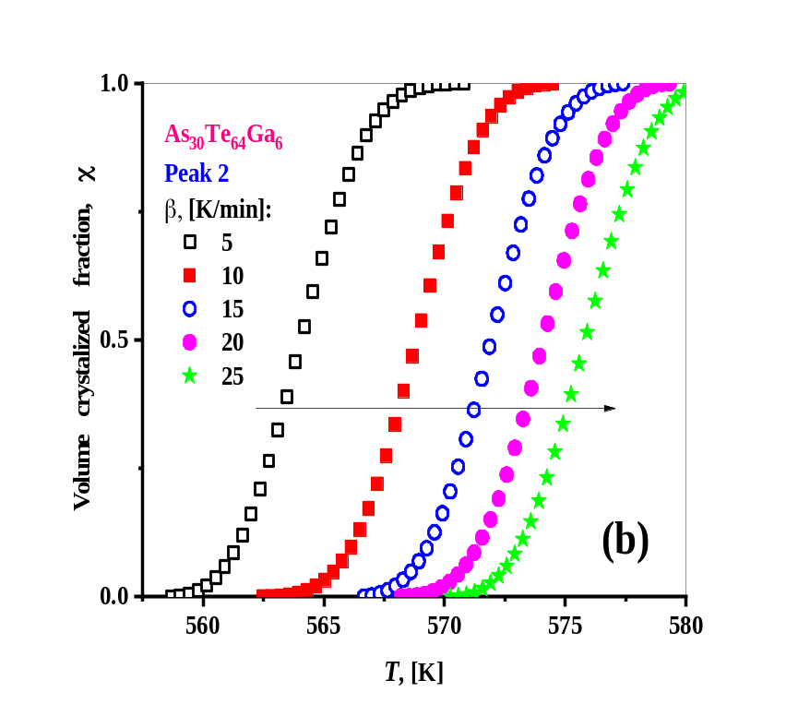

Fig. 5: The typical sigmoid curve of the volume fraction crystallized (χ) as a function of temperature (T) for bulk As₃₀Te₆₄Ga₆ glass alloy at the different heating rates (β).
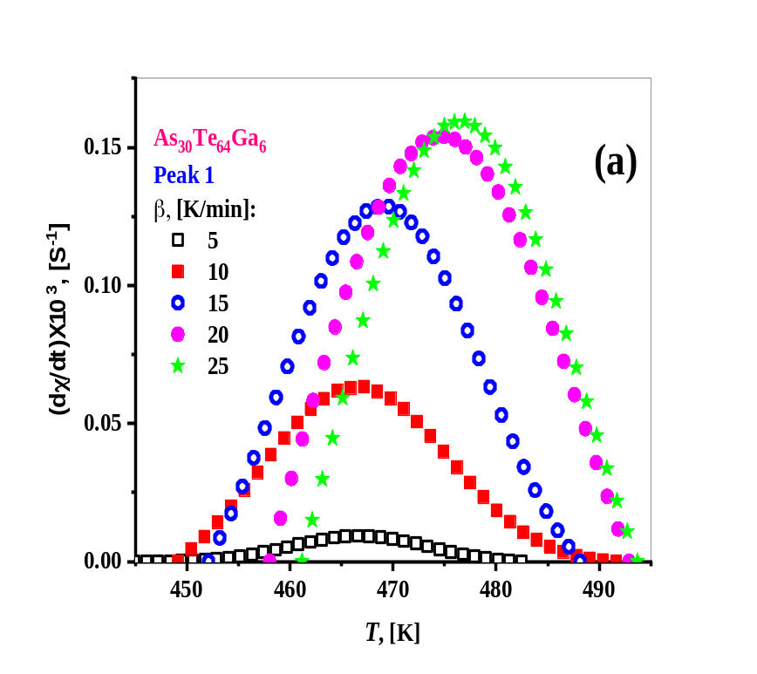
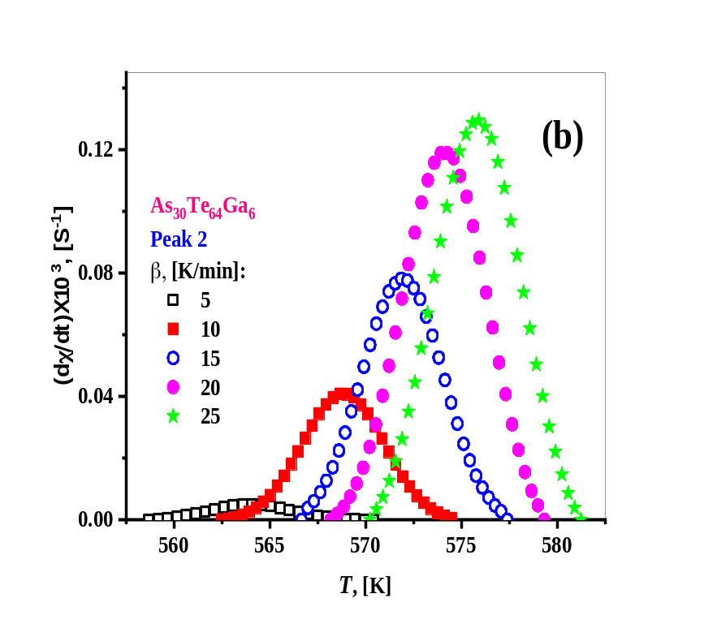

Fig. 6: Crystallization rate ($\frac{dχ}{dt}$) versus temperature (T) of the exothermal peaks for bulk As₃₀Te₆₄Ga₆ glass alloy at different heating rates (β).

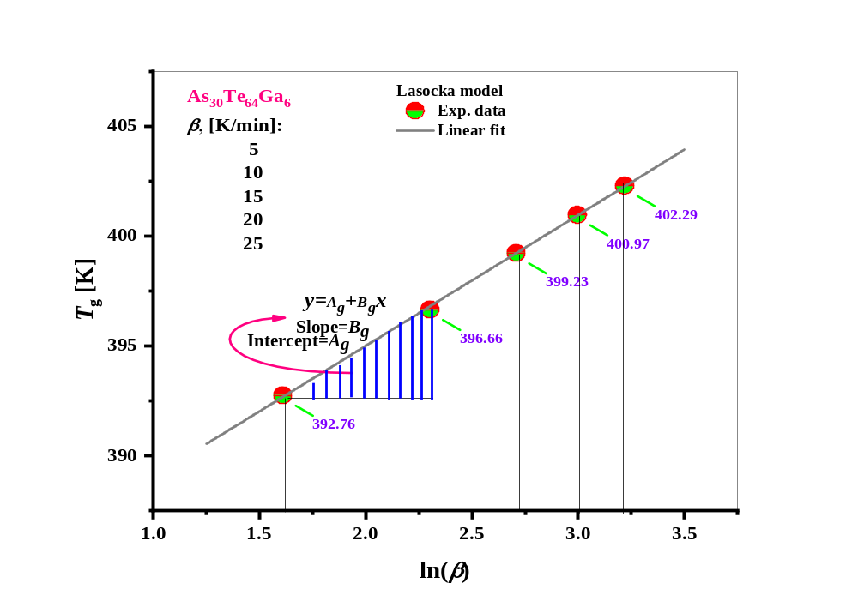

Fig. 7: The test of the validity of relation’s Lasocka for bulk As₃₀Te₆₄Ga₆ glass alloy at different heating rates (β).
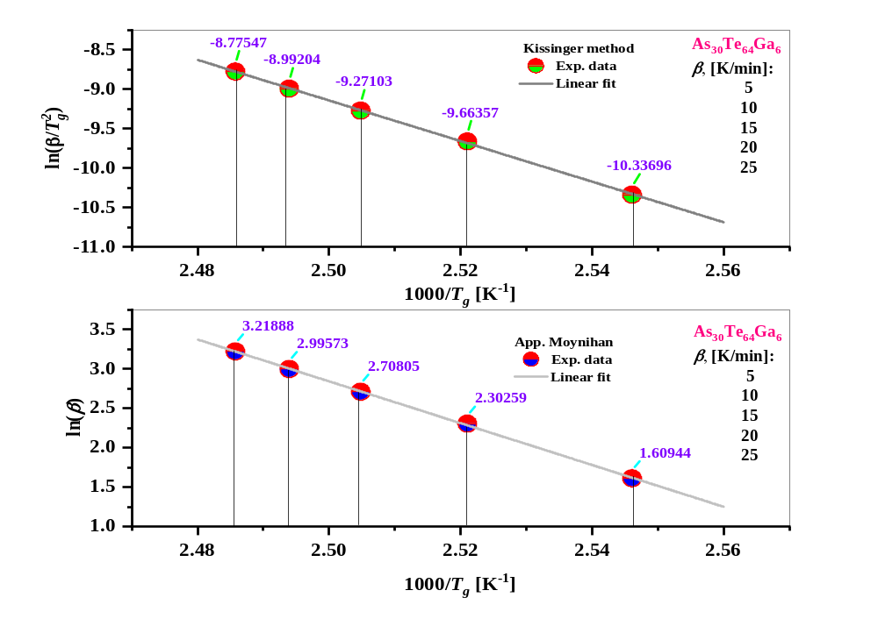

Fig. 8: The plot of $\ln\left(\frac{β}{{T_{g}}^{2}}\right)$ versus 1000/ $T_{g}$ and also the plot of $\ln\left(β\right)$ versus 1000/ $T_{g}$ for bulk As₃₀Te₆₄Ga₆ glass alloy at different heating rates (β).

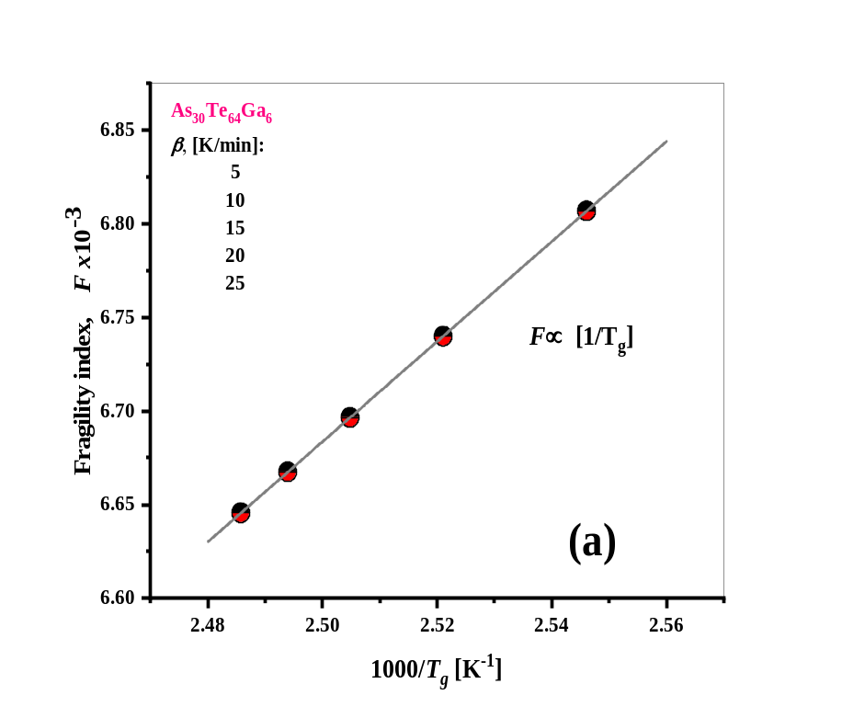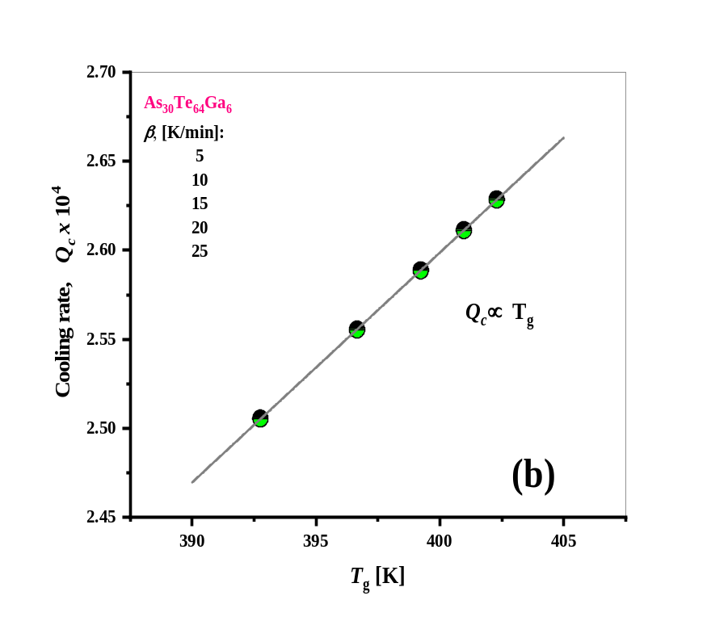

Fig. 9: The plot of the liquid fragility (F) versus 1000/ $T_{g}$ and plot of the cooling rate (Q_{c}) as a function of the glass transition temperature ($T_{g}$) for bulk As₃₀Te₆₄Ga₆ glass alloy at different heating rates (β).
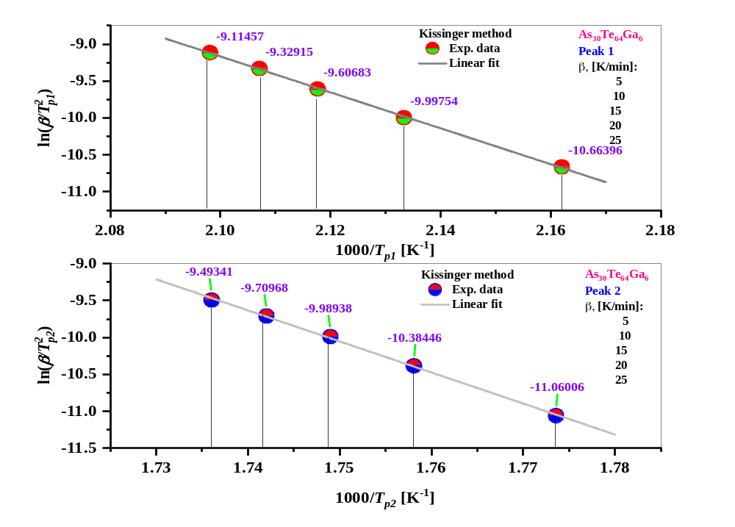

Fig. 10: The plot of $\ln\left(\frac{β}{{T_{p}}^{2}}\right)$ versus $(\frac{1000}{T_{p}})$ for bulk As₃₀Te₆₄Ga₆ glass alloy at different heating rates (β).

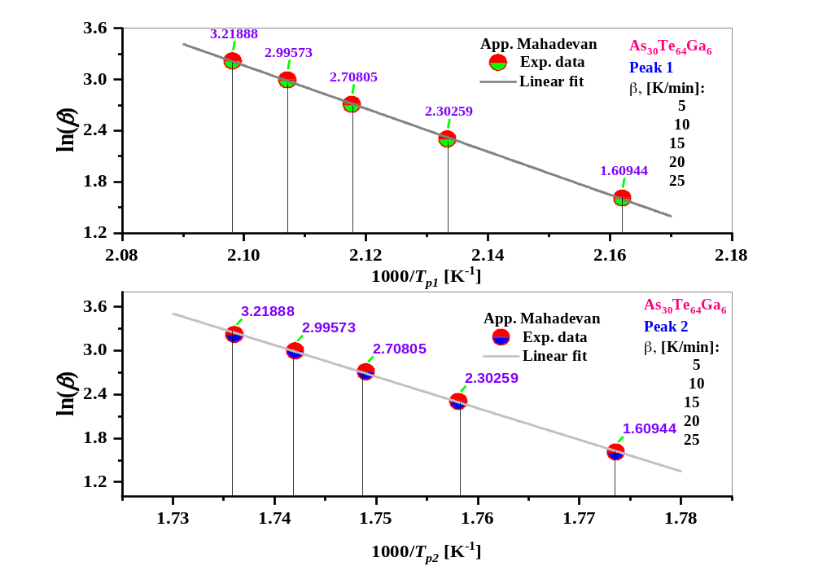

Fig. 11: The plot of $\ln\left(β\right)$ versus $(\frac{1000}{T_{p}})$ for bulk As₃₀Te₆₄Ga₆ glass alloy at different heating rates (β).

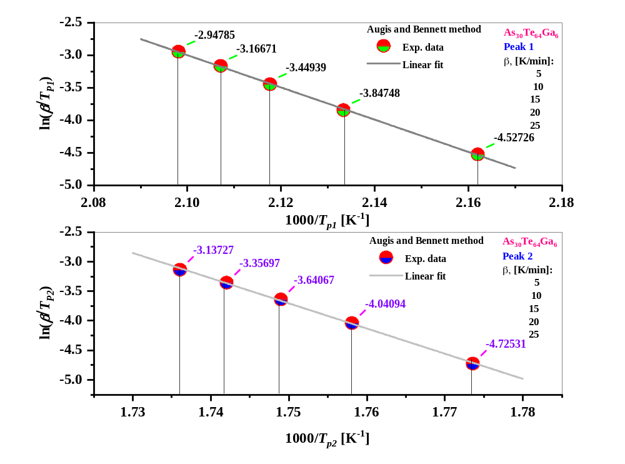

Fig. 12: The plot of $\ln\left(\frac{β}{T_{p}}\right)$ versus $(\frac{1000}{T_{p}})$ for bulk As₃₀Te₆₄Ga₆ glass alloy at different heating rates (β).

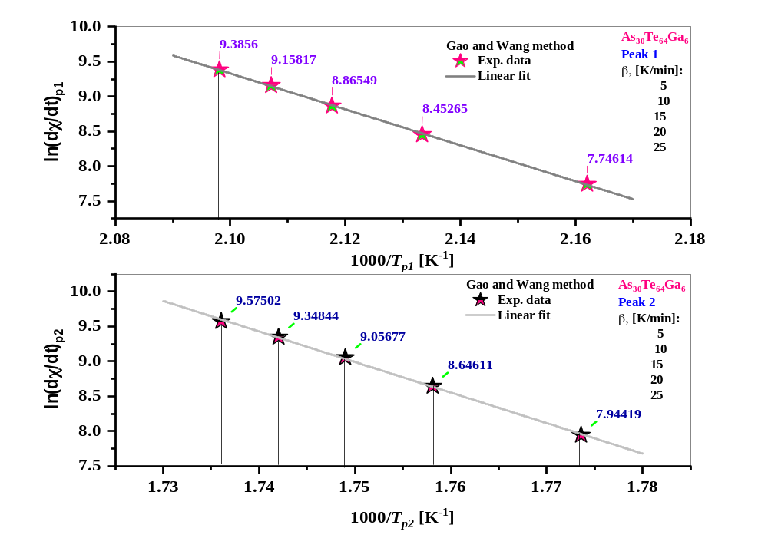

Fig.13: The plot of $(dχ/dt)_{p}$ versus $(1000/T_{P})$ for bulk As₃₀Te₆₄Ga₆ glass alloy at different heating rates (β).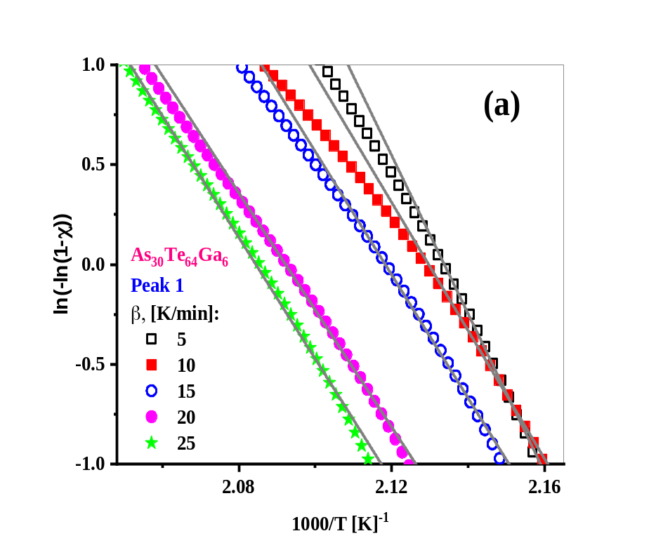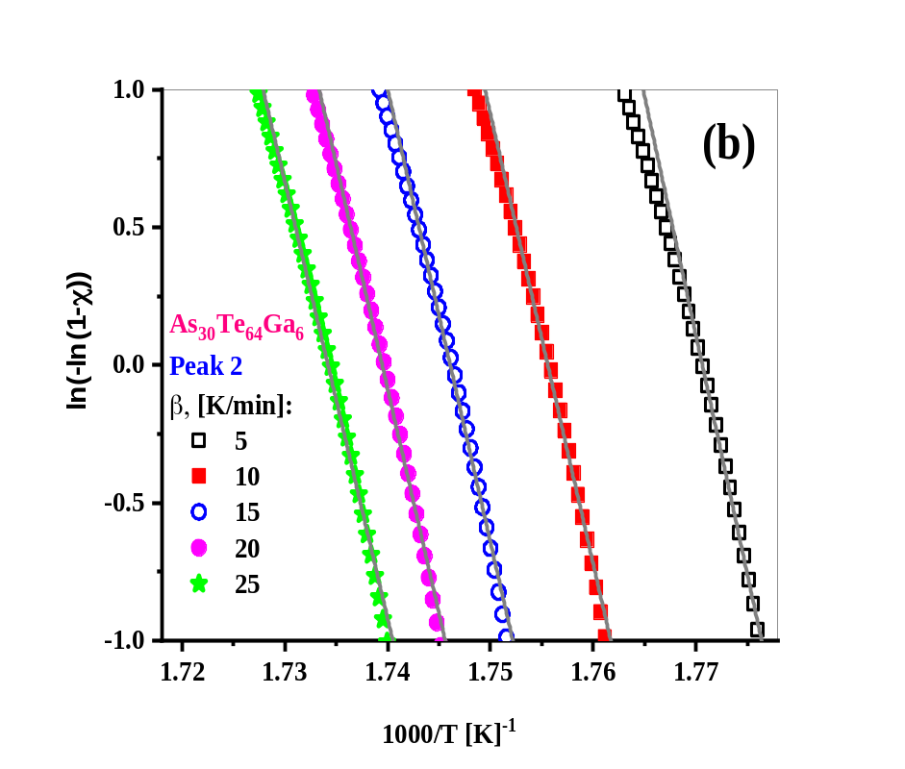

Fig. 14: The plot of $\ln{(}-\ln{(}1-χ)$ versus (1000$/T$) at different heating rates (β) for bulk As₃₀Te₆₄Ga₆ glass alloy for (a) first, and (b) second crystallization peak.

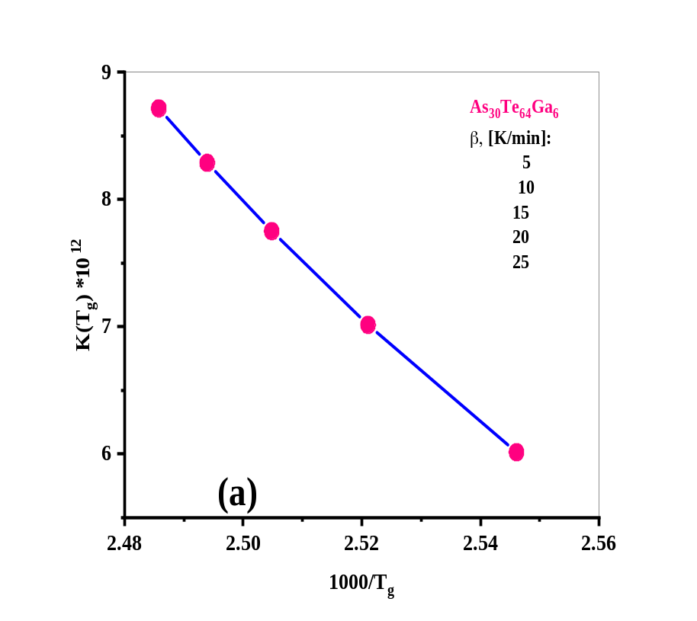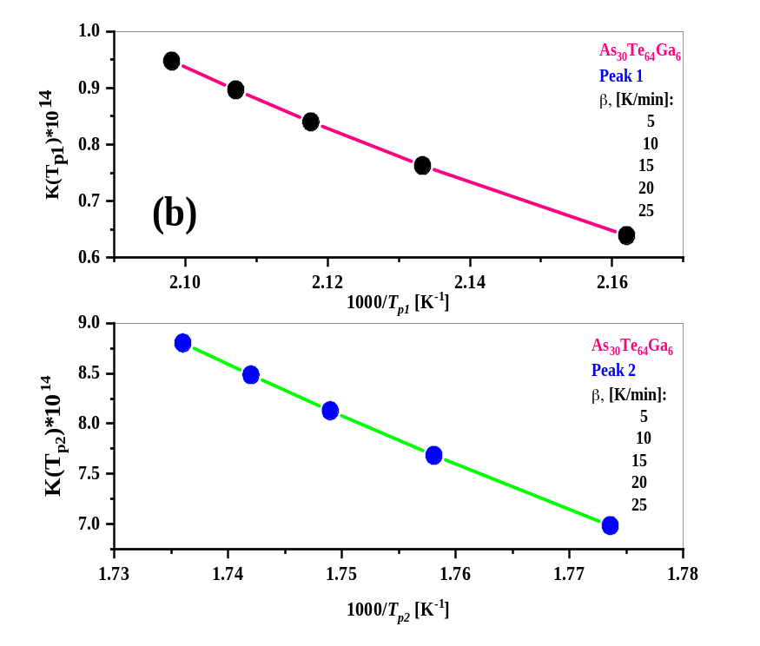

Fig. 15: The plot of (a) $K(T_{g})$, and (b) $K(T_{p})$ as a function of $T_{g}$ and $T_{p}$ for the As₃₀Te₆₄Ga₆ sample.
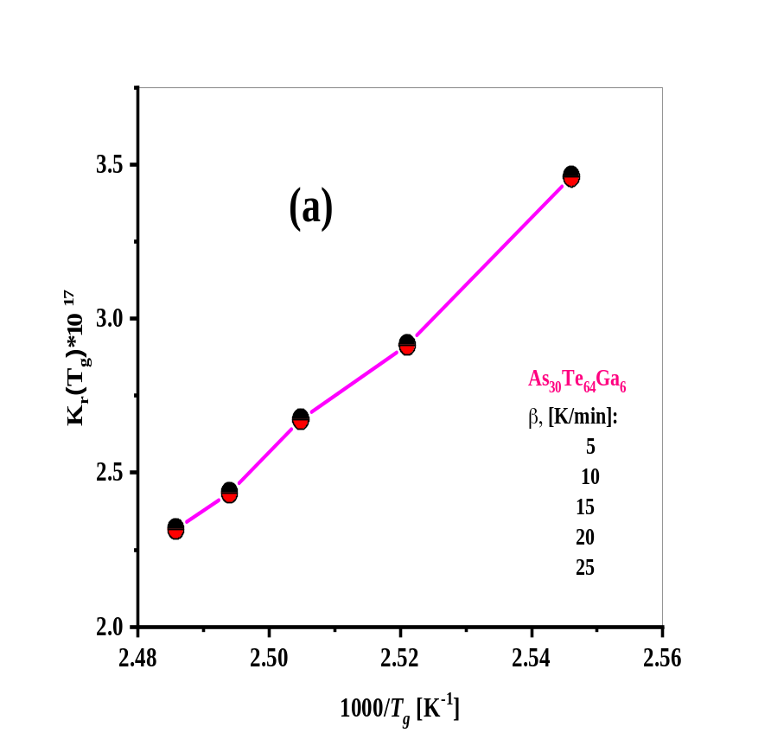

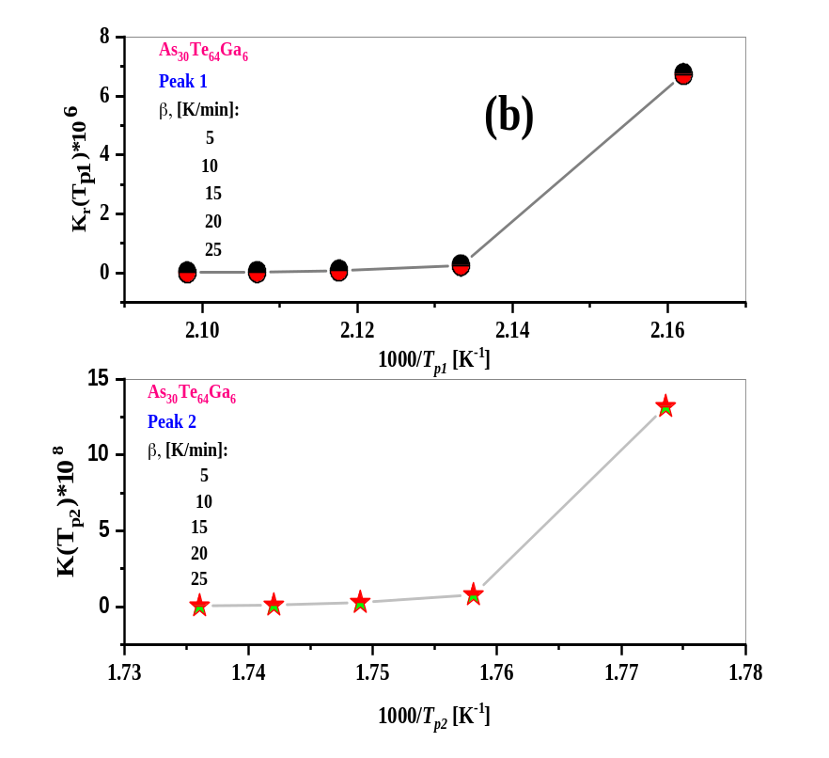

Fig. 16: The plot of (a) $K_{r}(T_{g})$, and (b) $K_{r}(T_{p})$ as a function of $T_{g}$ and $T_{p}$ for the As₃₀Te₆₄Ga₆ sample.

