Supporting Information

Manufacturing unclonable anti-counterfeiting labels using robust diamond microparticles on heterogeneous substrates

Tongtong Zhang,¹ Lingzhi Wang,¹ Jing Wang,² Zhongqiang Wang,³ Madhav Gupta,¹ Xuyun Guo,⁴ Ye Zhu,⁴ Yau Chuen Yiu,^{1, 5} Tony K.C. Hui,⁵ Yan Zhou,⁶ Can Li,¹ Dangyuan Lei,⁷ Kwai Hei Li,⁸ Xinqiang Wang^{3, 9}, Qi Wang,^{3, *} Lei Shao,^{10, *} and Zhiqin Chu^{1, 11, *}

¹ Department of Electrical and Electronic Engineering, The University of Hong Kong, Pokfulam Road, Hong Kong, China
² Computational Science Research Center, Beijing, China
³ Dongguan Institute of Opto-Electronics, Peking University, Dongguan, China
⁴ Department of Applied Physics, Research Institute for Smart Energy, The Hong Kong Polytechnic University, Hung Hom, Hong Kong, China
⁵ Master Dynamic Ltd., Hong Kong, China
⁶ School of Science and Engineering, The Chinese University of Hong Kong, Shenzhen, China
⁷ Department of Material Science and Engineering, City University of Hong Kong, Hong Kong, China
⁸ School of Microelectronics, Southern University of Science and Technology, Shenzhen, China
⁹ State Key Laboratory for Mesoscopic Physics and Frontiers Science Center for Nano-optoelectronics, School of Physics, Peking University, Beijing, China
¹⁰ School of Electronics and Information Technology, Sun Yat-sen University, Guangzhou, China
¹¹ School of Biomedical Sciences, The University of Hong Kong, Hong Kong, China
* Correspondence and requests for materials should be addressed to Q.W. (wangq@pku-ioe.cn), L.S. (shaolei5@mail.sysu.edu.cn), and Z.Q.C. (zqchu@eee.hku.hk).

Supplementary figures
Fig. S1. SEM image of the CVD-grown diamond particles on substrate with different coverage (calculated in the area of 30 µm × 40 µm).

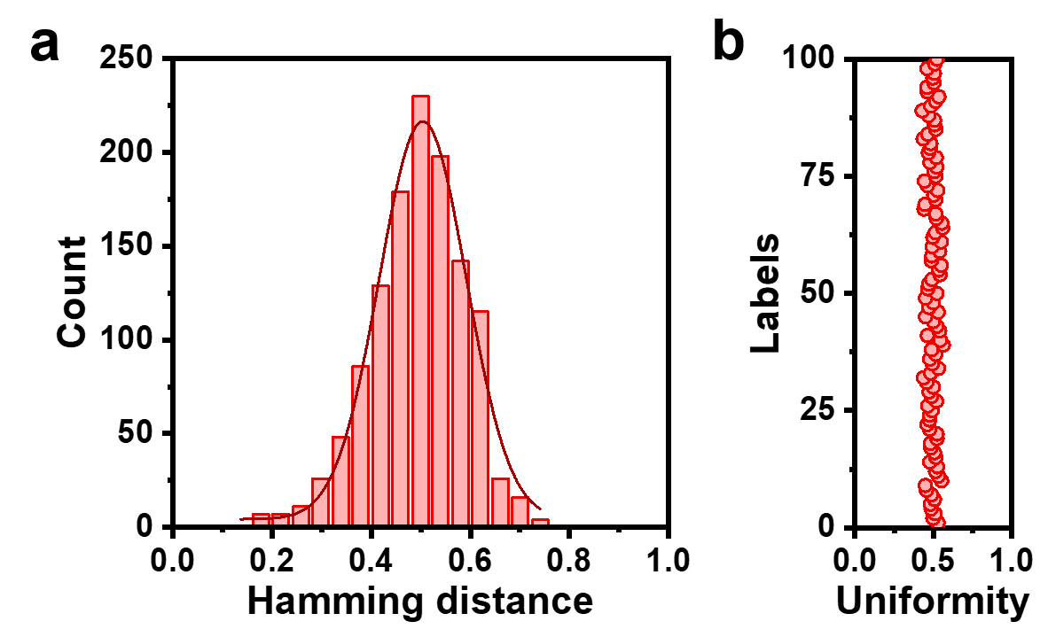
Fig. S2. a The Hamming interdistance (normalized) of the corresponding binary encoding matrix shown in Fig. 3c. b Uniformity of the binary keys generated from 100 labels.
Fig. S3. Numerical calculated scattering spectra of diamond microparticles with different a shapes (on Si substrate), b sizes (on Si substrate), c substrates, and d crystallinity (D: double crystals, T: triple crystals).

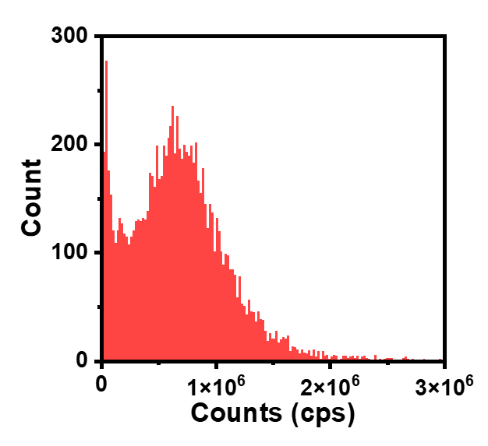
Fig. S4. The distribution of the PL intensity (photon counts: cps) in the measured area shown in Fig. 4b.
Fig. S5. SEM image of the CVD-grown diamond particles after the 4 rounds of air oxidation in the selected area in Fig. 5a for time-dependent encoding.

Fig. S6. SEM images of the multigenerational microstructures of the diamond microparticles after air oxidation.

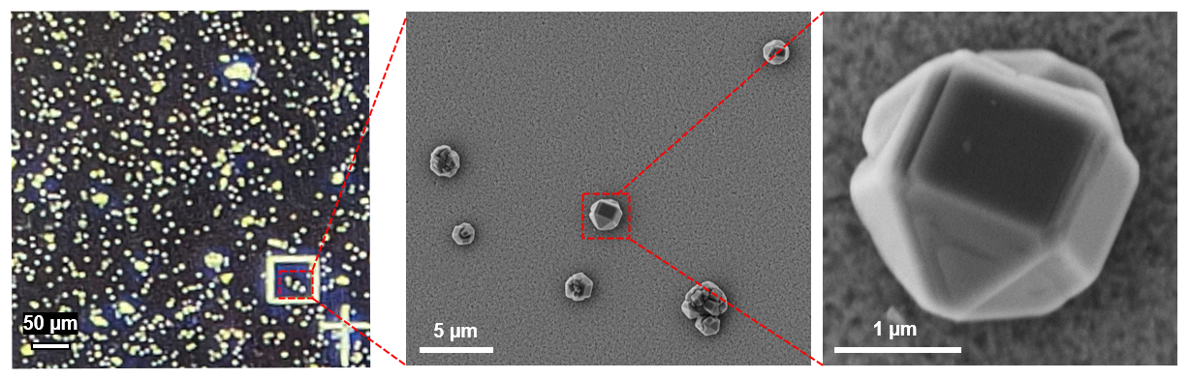
Fig. S7. SEM images of the marked CVD-grown diamond particles after the stability treatments shown in Fig. 6a

Fig. S8. SEM image of the CVD-grown diamond particles after the stability treatments in the measured area of confocal fluorescence image in Fig. 5d

