Supplementary Information
Stable Discharge Plateau Induced by Reversible Ammonium Ion Intercalation in Layered VOPO₄·2H₂O

Fei Ye¹, Ruilvjing Pang¹, Chengjie Lu¹, Qiang Liu¹, Chaoyang Chen¹, Hongliang Dong², Yuping Wu³, Renzhi Ma⁴, Linfeng Hu¹*

[1] School of Materials Science and Engineering, Southeast University, Nanjing, 211189, China
[2] Center for High Pressure Science and Technology Advanced Research, Shanghai, 201203, P. R. China
[3] School of Energy and Environment, Southeast University, Nanjing, 211189, P. R. China
[4] International Center for Materials Nanoarchitectonics (WPI-MANA), National Institute for Materials Science (NIMS), Namiki 1-1, Tsukuba, Ibaraki 305-0044, Japan.

These authors contributed equally: Fei Ye, Ruilvjing Pang, Chengjie Lu
Address correspondence to: linfenghu@seu.edu.cn

Supplementary Figure 1 Thermogravimetry analysis (TGA) of the VOPO₄·nH₂O sample with temperature range from 50 ℃ to 800 ℃.

Supplementary Figure 2 Identical CV curves of VOPO₄·2H₂O cathode performed at various aqueous electrolytes in a three-electrode configuration.

Supplementary Figure 3 GCD profiles of VOPO₄·2H₂O cathode performed at various aqueous electrolytes in a three-electrode configuration.

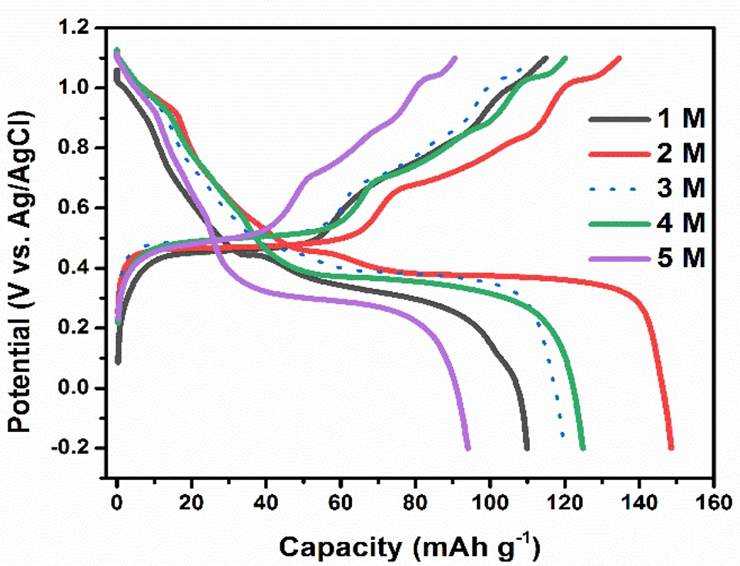
Supplementary Figure 4 GCD profiles at 1.0, 2.0, 3.0, 4.0, 5.0 M NH₄OTf aqueous electrolyte.

Supplementary Figure 5 (a) CV curves at different scan rates in NH₄OTf aqueous electrolyte. (b) Logarithm dependence of peak current density and scan rate in the CV test.

Supplementary Figure 6 CV curves in NH₄OTf aqueous and anhydrous acetonitrile electrolyte.

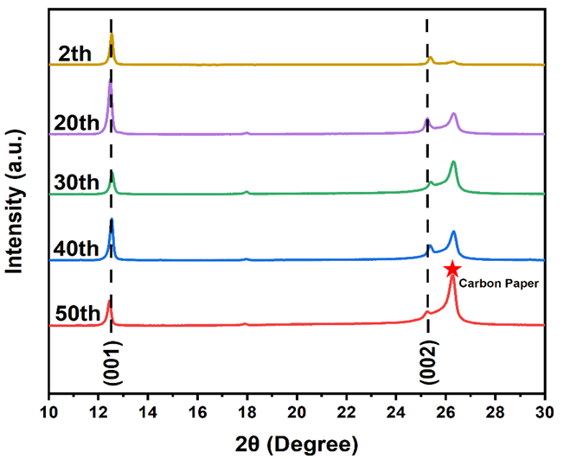
Supplementary Figure 7 XRD patterns of the VOPO₄∙2H₂O cathodes at 2-50th GCD cycles.

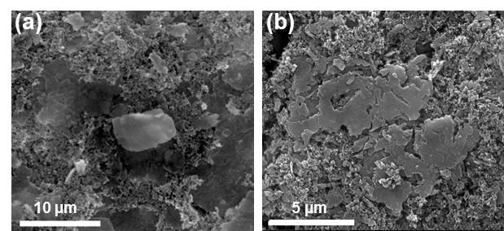
Supplementary Figure 8 SEM images of the cathode after (a) 20 and (b) 100 cycles.

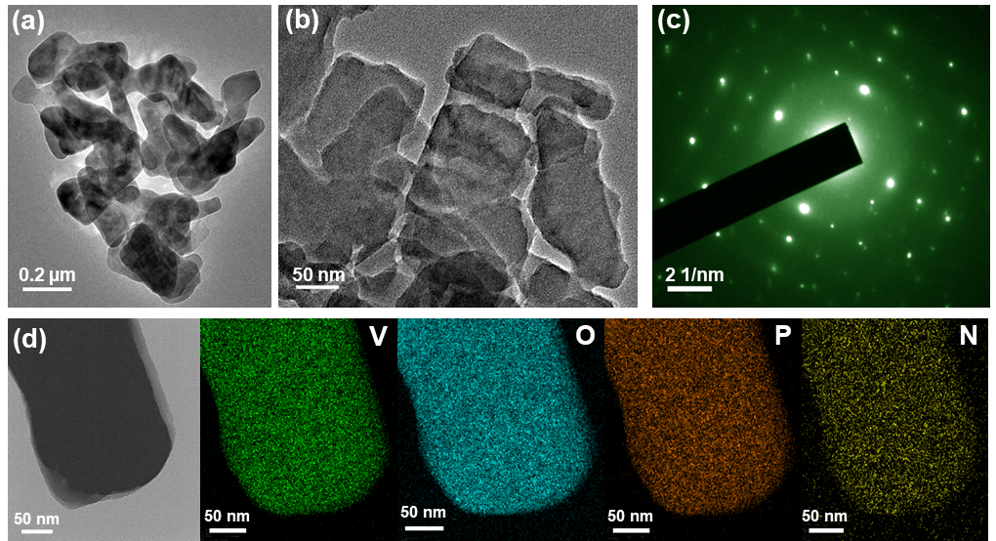
Supplementary Figure 9 HRTEM images of the cathodes undergoing (a) 20 and (b) 100 cycles. (c) The corresponding SAED pattern and (d) EDS mapping of V, O, P, N in an individual nanosheet after 100 cycles.

Supplementary Figure 10 Cycle performance of VOPO₄·2H₂O, VOP-100 and VOP-400 cathodes in nonaqueous acetonitrile NH₄OTf electrolyte at 0.1 A g⁻¹.

Supplementary Figure 11 GCD profiles of VOPO₄·2H₂O, VOP-100 and VOP-400 cathodes in aqueous NH₄OTf electrolyte at 0.1 A g⁻¹.

Supplementary Figure 12 Cycle performance of VOPO₄·2H₂O, VOP-100 and VOP-400 cathodes in aqueous NH₄OTf electrolyte at 0.1 A g⁻¹.

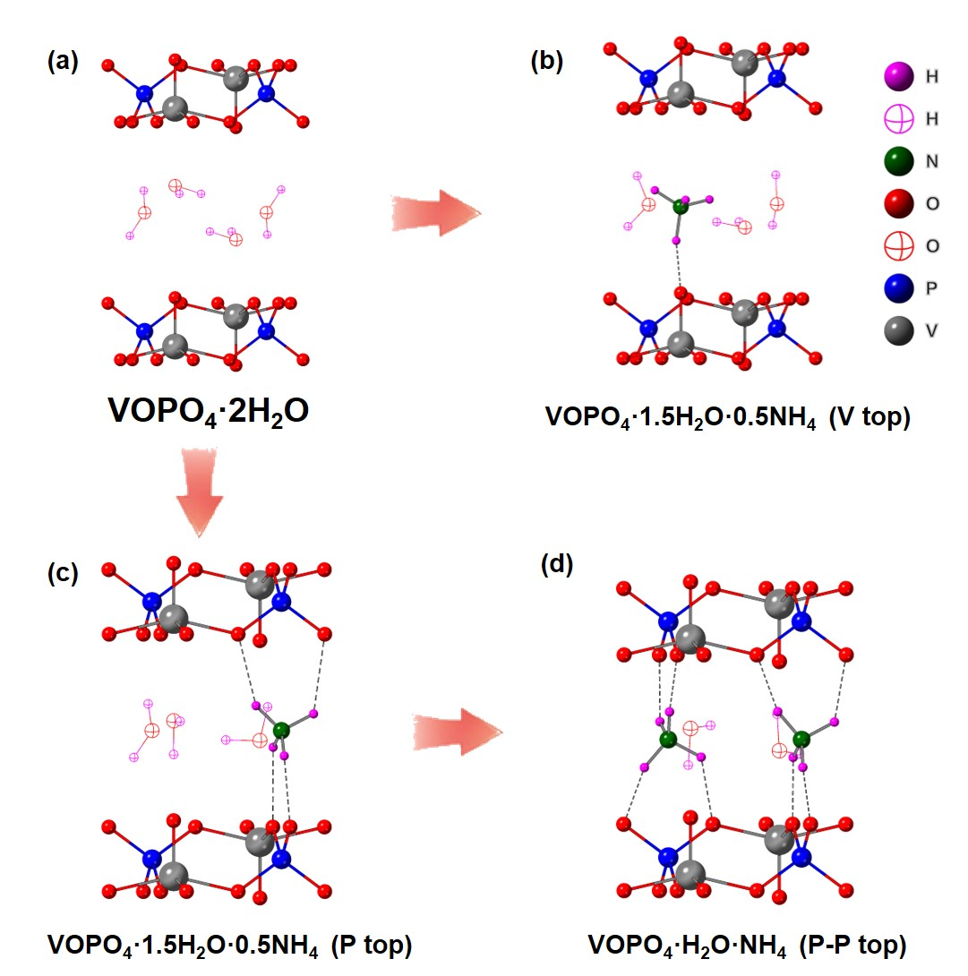
Supplementary Figure 13 Simulated models for substitution process. Model of (a) VOPO₄·2H₂O; (b)VOPO₄·1.5H₂O·0.5NH₄ (V top); (c) VOPO₄·1.5H₂O·0.5NH₄ (P top); (d) VOPO₄·H₂O·NH₄.

Supplementary Figure 14 Electronic property investigation of VOPO₄·2H₂O and VOPO₄·H₂O·NH₄: band structure showing increased band gap with the substitution crystal water by ammonium ion at P top; hybridization scheme showing the affected bonding feature of [PO6] octahedron inspite of the presence of NH₄ at the top of [VO4].

Supplementary Table S1. pH value of different NH₄OTf salt concentrations.
Concentration | pH
1.0 M | 4.87
2.0 M | 4.83
3.0 M | 4.75
4.0 M | 4.64
5.0 M | 4.53

Supplementary Table S2. Discharged capacities and potential plateaus of various electrolytes.
Electrolyte Type | Discharged Capacity (mAh g⁻¹) |  |  |  |  | Potential plateau  (V vs. Ag/AgCl)
Electrolyte Type | 1st | 2nd | 3rd | 4th | 5th | Potential plateau  (V vs. Ag/AgCl)
NH₄OTf | 148.6 | 134.3 | 129.2 | 126.2 | 123.3 | 0.40
NH₄Cl | 166.9 | 113.0 | 99.5 | 91.4 | 85.8 | 0.39
(NH₄)₂SO₄ | 126.6 | 102.3 | 91.0 | 85.9 | 82.9 | 0.33
NH₄Ac | 89.0 | 58.4 | 40.1 | 32.7 | 28.5 | 0.03

