Supplemental Fig 1 the forest plot of secondary outcomes of crude data about RCTs. a excellent outcomes (mRS score: 0-1). b SR. c aICH. d mortality.

Supplemental Fig 2 continued
Supplemental Fig 2 the forest plot of secondary outcomes of crude data about OS. a excellent outcomes (mRS score: 0-1). b SR. c aICH. d mortality.
Supplemental Fig 3 the forest plot of secondary outcomes of adjusted data about RCTs. a excellent outcomes (mRS score: 0-1). b SR. c aICH. d mortality.
Supplemental Fig 4 the forest plot of secondary outcomes of adjusted data about OS. a excellent outcomes (mRS score: 0-1). b SR. c aICH. d mortality.

Supplemental Fig 5 continued
Supplemental Fig 5 the sensitivity analysis about the outcome of crude data of RCTs. a FI. b sICH. c excellent outcomes (mRS score: 0-1). d SR. e aICH. f mortality.

Supplemental Fig 6 continued
Supplemental Fig 6 the sensitivity analysis about the outcome of adjusted data of RCTs. a FI. b sICH. c excellent outcomes (mRS score: 0-1). d SR. e aICH. f mortality.
Supplemental Fig 7 the sensitivity analysis about the outcome of crude data of OS. a FI. b sICH. c excellent outcomes (mRS score: 0-1). d SR. e aICH. f mortality.

Supplemental Fig 8 the sensitivity analysis about the outcome of adjusted data of OS. a FI. b sICH. c excellent outcomes (mRS score: 0-1). d SR. e aICH. f mortality.
Supplemental Fig 9 the funnel plot about the secondary outcome of crude data of OS. a excellent outcomes (mRS score: 0-1). b SR. c aICH. d mortality.
Supplemental Fig 10 the funnel plot about the outcome of mortality of adjusted data OS.
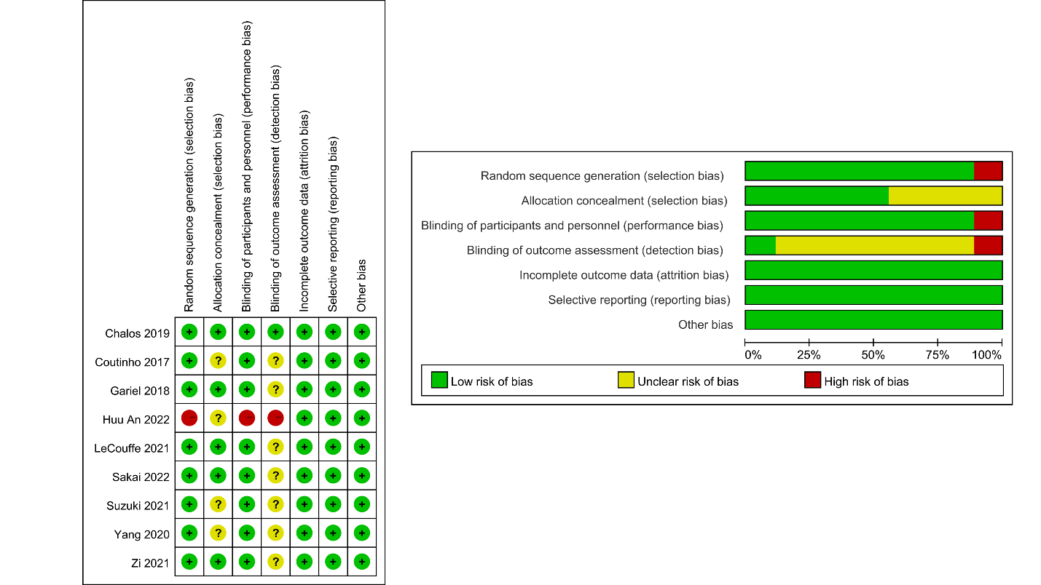
Supplemental Fig 11 assessment of quality using the RoB (RCTs)

Supplemental Table1 Subgroup analysis in RCTs
Outcomes | Crude data
Area | North America | Europe | Asia
FI
No of studies | 1 | 4 | 4
OR and 95% CI | 1.50 (0.94-2.40) | 1.46 (1.07-1.98) | 0.95 (0.75-1.21)
Heterogeneity | - | 505 | 0
χ² | 5.99
P-value | 0.05
sICH
No of studies | 1 | 4 | 4
OR and 95% CI | 0.32 (0.06-1.67) | 1.10 (0.70-1.56) | 1.35 (0.83-2.21)
Heterogeneity | - | 0 | 0
χ² | 2.78
P-value | 0.25
excellent outcomes (mRS score:0-1)
No of studies | 1 | 4 | 4
OR and 95% CI | 1.27(0.79-2.06) | 1.42 (0.99-2.03) | 0.93 (0.71-1.20)
Heterogeneity
χ² | 3.91
P-value | 0.14
SR
No of studies | 1 | 4 | 4
OR and 95% CI | 0.96 (0.50-1.84) | 1.24 (1.02-1.51) | 1.29 (0.91-1.81)
Heterogeneity | - | 0 | 0
χ² | 0.64
P-value | 0.73
aICH
No of studies | - | 3 | 4
OR and 95% CI | - | 1.04 (0.80-1.37) | 1.54 (1.05-2.27)
Heterogeneity |  | 0 | 41%
χ² | - | 2.64
P-value | - | 0.10
Mortality
No of studies | 1 | 4 | 3
OR and 95% CI | 0.64 (0.29-1.37) | 0.55 (0.44-0.69) | 1.07 (0.78-1.48)
Heterogeneity | - | 13% | 0
χ² | 11.18
P-value | ＜0.01

Supplemental Table 2 Subgroup analysis of study area in observational studies
Outcomes | Crude data |  |  | adjusted data
Area | North America | Europe | Asia | North America | Europe | Asia
FI
No of studies | 8 | 23 | 9 | 2 | 9 | 3
OR and 95% CI | 1.23 (1.00-1.51) | 1.46 (1.13-1.87) | 1.13 (0.93-1.36) | 1.56 (1.03-2.36) | 1.48 (1.19-1.84) | 1.11 (0.82-1.49)
Heterogeneity |  |  |  | 0 | 60% | 5%
χ² | 2.52 |  |  | 2.80
P-value | 0.28 |  |  | 0.25
sICH
No of studies | 7 | 22 | 7 | - | 9 | 2
OR and 95% CI | 1.05 (0.67-1.64) | 1.06 (0.87-1.30) | 1.16 (1.12-1.21) | - | 0.93 (0.73-1.18) | 0.65 (0.35-1.23)
Heterogeneity |  |  |  | - | 5% | 29%
χ² | 0.92 |  |  | 1.01
P-value | 0.63 |  |  | 0.31
excellent outcomes (mRS score:0-1)
No of studies | 2 | 9 | 5 | - | 6 | 2
OR and 95% CI | 1.58 (1.24-2.02) | 1.43 (1.19-1.73) | 1.05 (0.67-1.66) | - | 1.59 (1.31-1.93) | 1.26 (0.76-2.10)
Heterogeneity | 0 | 25% | 74% | - | 0 | 63%
χ² | 2.37 |  |  | - | 0.70
P-value | 0.31 |  |  | - | 0.40
SR
No of studies | 6 | 21 | 10 | 1 | 5 | 3
OR and 95% CI | 1.25 (0.95-1.71) | 1.25 (0.98-1.61) | 1.40 (0.90-1.45) | 1.21 (0.85-1.74) | 1.51 (0.23-1.86) | 0.59 (0.29-1.21)
Heterogeneity | 0 | 75% | 24% | - | 48% | 72%
χ² | 0.44 |  |  | 6.49
P-value | 0.93 |  |  | 0.04
aICH
No of studies | 3 | 13 | 6 | - | - | -
OR and 95% CI | 1.55(0.99-2.43) | 1.27 (1.01-1.59) | 1.11 (0.73-1.70) | - | - | -
Heterogeneity | 48% | 18% | 67% | - | - | -
χ² | 4.76 |  |  | -
P-value | 0.19 |  |  | -
Mortality
No of studies | 5 | 21 | 8 | 1 | 10 | 3
OR and 95% CI | 0.59 (0.44-0.78) | 0.65 (0.54-0.79) | 0.79 (0.58-1.07) | 0.73 (0.56-0.94) | 0.76 (0.54-1.08) | 0.69 (0.49-0.98)
Heterogeneity | 0 | 53% | 41% | - | 76% | 0
χ² | 1.95 |  |  | 1.28
P-value | 0.38 |  |  | 0.53

Supplemental Table 3 Subgroup analysis of study design in observational studies
Outcomes | Crude data |  | adjusted data
Study design | Retrospective study | Prospective study | Retrospective study | Prospective study
FI
No of studies | 27 | 13 | 8 | 6
OR and 95% CI | 1.20 (0.98-1.47) | 1.51 (1.21-1.88) | 1.39 (1.06-0.83) | 1.41 (1.16-1.72)
Heterogeneity | 71% | 65% | 56% | 40%
χ² | 2.27 |  | 0.01
P-value | 0.13 |  | 0.93
sICH
No of studies | 24 | 12 | 5 | 6
OR and 95% CI | 1.07 (0.92-1.24) | 1.28 (1.01-1.63) | 0.82 (0.56-1.21) | 0.87 (0.63-1.20)
Heterogeneity | 0 | 0 | 0 | 39%
χ² | 1.64 |  | 0.05
P-value | 0.20 |  | 0.82
excellent outcomes (mRS score:0-1)
No of studies | 8 | 8 | 4 | 4
OR and 95% CI | 1.12 (0.87-1.45) | 1.46 (1.14-1.85) | 1.78 (1.28-2.47) | 1.39 (1.11-1.74)
Heterogeneity | 50% | 69% | 0 | 29%
χ² | 2.14 |  | 1.48
P-value | 0.14 |  | 0.22
SR
No of studies | 27 | 11 | 5 | 4
OR and 95% CI | 1.17 (0.94-1.46) | 1.35 (1.10-1.64) | 1.07 (0.51-2.23) | 1.33 (1.17-1.51)
Heterogeneity | 62% | 27% | 86% | 0
χ² | 0.80 |  | 0.33
P-value | 0.37 |  | 0.57
aICH
No of studies | 15 | 8 | 4 | 2
OR and 95% CI | 1.21 (0.95-1.55) | 1.30 (0.98-1.72) | 1.03 (0.53-1.98) | 1.05 (0.83-1.35)
Heterogeneity | 51% | 325 | 47% | 29%
χ² | 0.15 |  | 1.48
P-value | 0.70 |  | 0.22
Mortality
No of studies | 21 | 13 | 8 | 6
OR and 95% CI | 0.66 (0.56-0.82) | 0.67 (0.53-0.83) | 0.95 (0.68-1.34) | 0.58 (0.43-0.78)
Heterogeneity | 40% | 51% | 41% | 65%
χ² | 0.01 |  | 4.65
P-value | 0.92 |  | 0.03

Supplemental Table 4 Assessment of quality using the Newcastle-Ottawa quality assessment scale (observational study)
Studies | Selection |  |  |  | Comparability | Outcome |  |  | Score
Studies | 1 | 2 | 3 | 4 | 1 | 1 | 2 | 3 | Score
Dávalos, et al (2012) | * | * | * |  | * | * | * | * | 7
Pfefferkorn, et al (2012) | * | * | * |  | ** | * | * | * | 8
Kass-Hout, et al (2014) | * | * | * |  | ** | * | * | * | 8
Guedin, et al (2015) | * | * | * | * | ** | * | * |  | 8
Leker, et al (2015) | * | * | * | * | ** | * | * |  | 8
Broeg-Morvay, et al (2016) | * | * | * | * | ** | * | * |  | 8
Behme, et al (2016) | * | * | * | * | ** | * | * |  | 8
Minnerup, et al (2016) | * | * | * | * | ** | * | * |  | 8
Froehler, et al (2017) | * | * | * | * | ** | * | * |  | 8
Alonso de Leciñana, et al (2017) | * | * | * | * | ** | * | * | * | 9
Weber, et al (2017) | * | * | * |  | ** | * | * |  | 7
Merlino, et al (2017) | * | * | * | * | ** | * | * |  | 8
Bellwald, et al (2017) | * | * | * |  | ** | * | * | * | 8
Abilleira, et al (2017) | * | * | * | * | * | * | * | * | 8
Bourcier, et al (2017) | * | * | * |  | ** | * | * | * | 8
Maier, et al (2017) | * | * | * | * |  | * | * | * | 7
Wang, et al (2017) | * | * | * |  | ** | * | * | * | 8
Wee, et al (2017) | * | * | * |  | ** | * | * | * | 8
Park, et al (2017) | * | * | * | * | ** | * | * | * | 9
Ferrigno, et al (2018) | * | * | * | * | ** | * | * |  | 8
Choi, et al (2018) | * | * | * | * | ** | * | * |  | 8
Al-Khaled, et al (2018) | * | * | * |  | * | * | * | * | 8
Gong, et al (2018) | * | * | * |  | ** | * | * | * | 8
Imbarrato, et al (2018) | * | * | * |  |  | * | * | * | 6
Leker, et al (2018) | * | * | * | * | ** | * | * |  | 8
Rai, et al (2018) | * | * | * |  | * | * | * | * | 7
Sallustio, et al (2018) | * | * | * |  | ** | * | * | * | 8
Heinrichs, et al (2018) | * | * | * | * | ** | * | * |  | 8
Di Maria, et al (2018) | * | * | * |  | ** | * | * | * | 8
Goyal, et al (2019) | * | * | * |  | ** | * | * | * | 8
Guimarães Rocha, et al (2019) | * | * | * | * | ** | * | * | * | 9
Balodis, et al (2019) | * | * | * | * | * | * | * | * | 8
Maingard, et al (2019) | * | * | * |  | ** | * | * | * | 8
Casetta, et al (2019 | * | * | * |  | ** | * | * | * | 8
Hassan, et al (2019)
Reiff, et al (2020) | * | * | * |  | * | * | * | * | 7
Yi, et al (2020) | * | * | * | * | ** | * | * |  | 8
Hinsenveld, et al (2020) | * | * | * | * | ** | * | * |  | 8
Jian, et al (2021) | * | * | * | * | ** | * | * | * | 9
Kandregula, et al (2021) | * | * | * |  | * | * | * | * | 8
Tong, et al (2021) | * | * | * | * | ** | * | * | * | 9
Zha, et al (2021) | * | * | * | * | ** | * | * |  | 8
Machado, et al (2021) | * | * | * |  | * | * | * | * | 7
Platko, et al (2022) | * | * | * |  | * | * | * | * | 7
Dicpinigaitis, et al (2022) | * | * | * |  | ** | * | * |  | 7

Supplemental Table 5 The comparison with prior meta-analysis
Study  (Author, year) | populations | NO. of studies | Studies design | NO. of Outcomes | Adjusted data
Katsanos et.al 2019 | 11,798 | 38 | OS | (1) mRS score: 0-2  (2) successful recanalization  (3) mortality at 3 months or discharge  (4) sICH and aICH  (5) onset to groin puncture time  (6) groin puncture to reperfusion time | Yes
Vidale et.al 2020 | 9,117 | 35 | RCTs and OS | (1) mRS score:＜3  (2) successful recanalization  (3) mortality at 90 days  (4) sICH | NO
Vidale et.al 2021 | 1,657 | 5 | RCTs | (1) mRS score:＜3  (2) successful recanalization  (3) mortality at 90 days  (4) sICH | NO

