Chemical |  |  | Mutagenicity Study
Cofactor Mix |  | D-Glucose-6-Phosphate | 128.01 mg
 |  | β-NADP | 280.02 mg
 |  | Magnesium Chloride | 144.01 mg
 |  | Potassium Chloride | 216.02 mg
 |  | Sodium Phosphate Buffer | 80 mL
Total |  |  | 80 mL
S9 Mix | Co-factor Mix |  | 54 mL
S9 Mix | S9 Homogenate |  | 6 mL
Total |  |  | 60 mL
S9 Mix (%) |  |  | 10
Table1: Chemicals and S9 homogenate
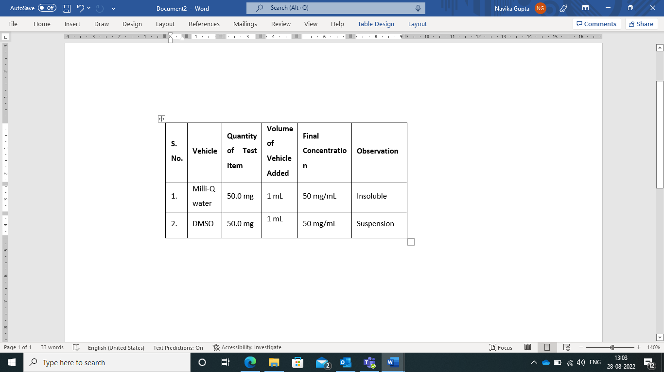
Table2: Vehicle Selection Process
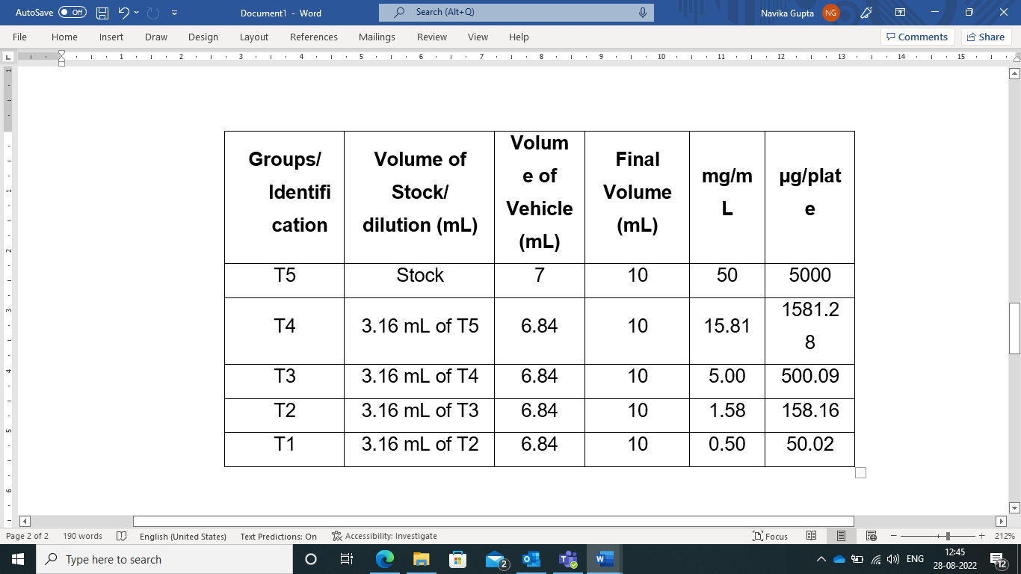
Table3: Oleanolic acid Stock/dilution
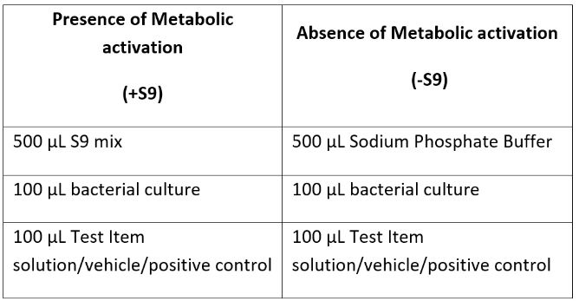
Table4: Plate Incorporation
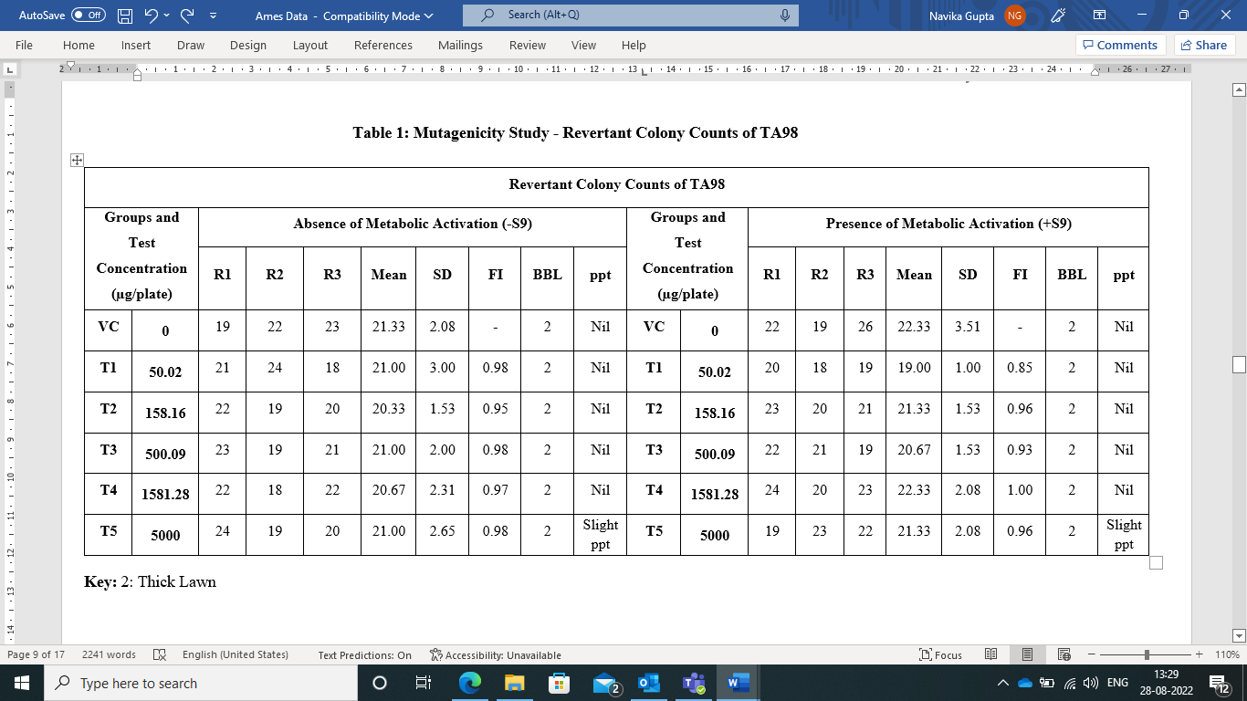
Table5: Mutagenicity Assay - Revertant Colony Counts of TA98

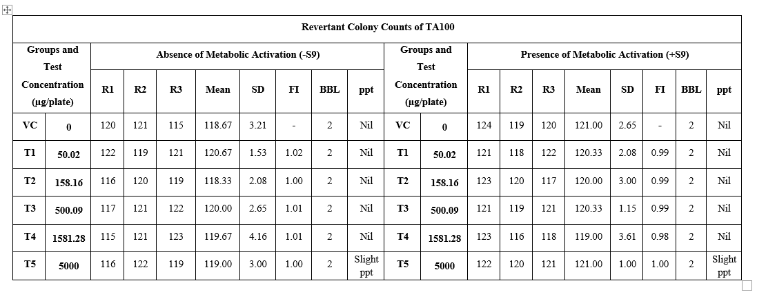
Table6: Mutagenicity Assay - Revertant Colony Counts of TA100
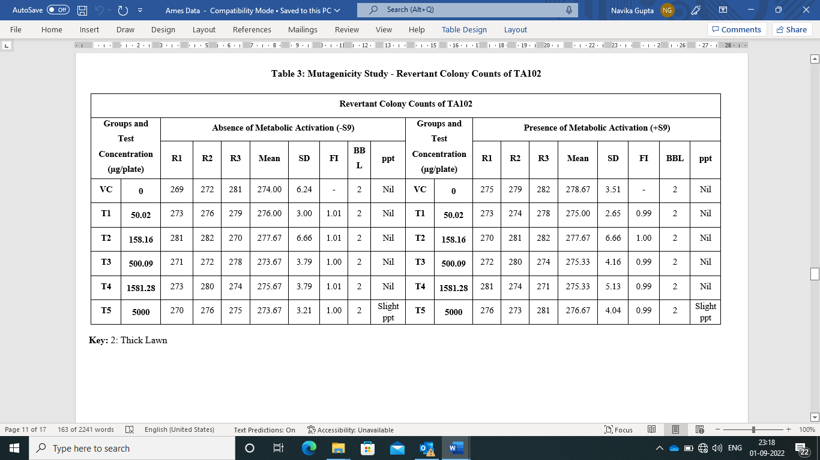
Table 7: Mutagenicity Assay - Revertant Colony Counts of TA102
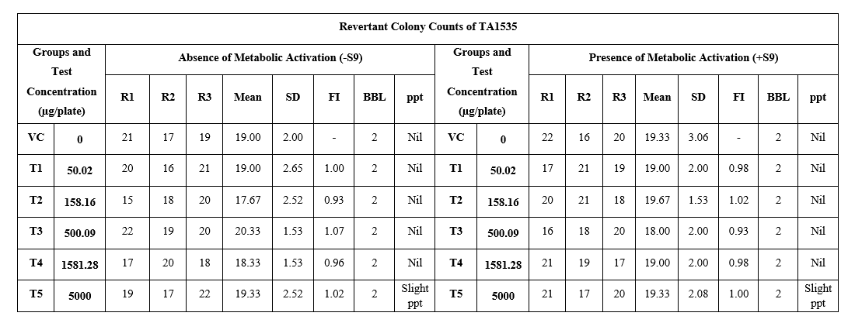
Table 8: Mutagenicity Assay - Revertant Colony Counts of TA1535
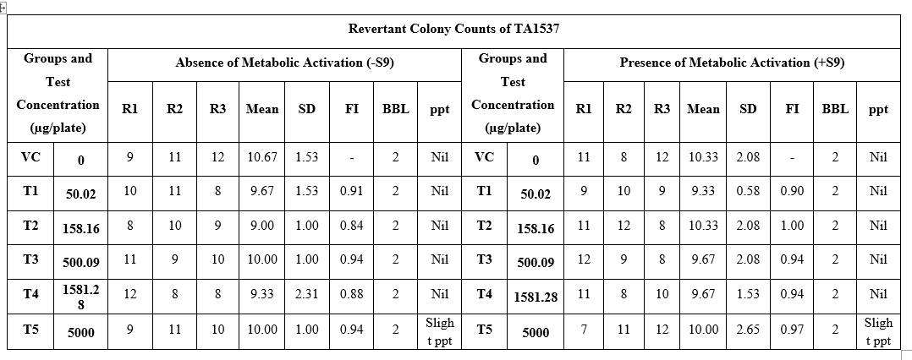
Table 9: Mutagenicity assay - Revertant Colony Counts of TA1537
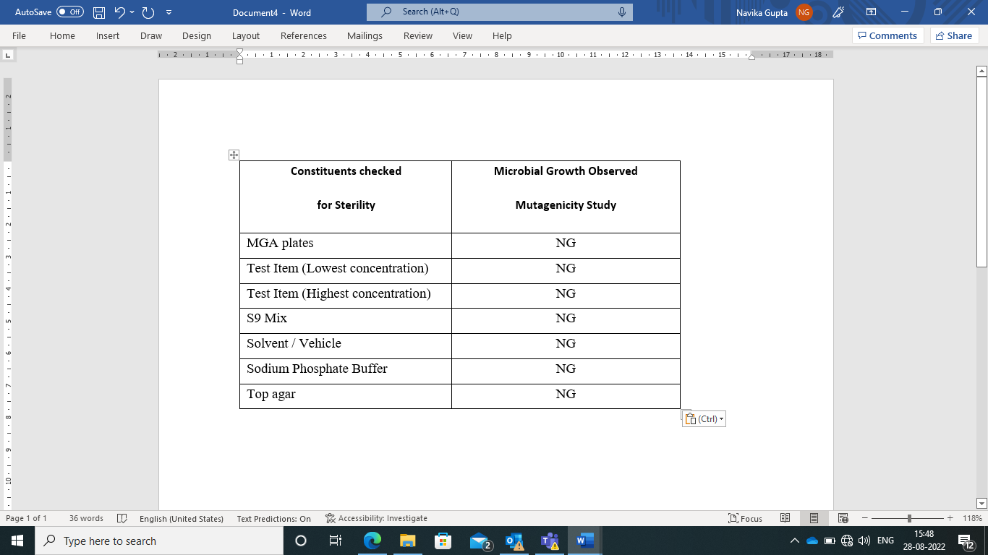
Table 10: Appendix – Sterility Check

