Supplementary material:
To verify the cytotoxicity of LPS on NCM460 cells, we assessed cell viability using the CCK-8 assay. When the LPS concentration was 10 μg/mL, the cell viability could be significantly reduced within 24 h, while the LPS concentration of 5 μg/mL could also reduce the cell viability within 36 h, 48 h, and 72 h. Therefore, 1, 2.5, and 3 μg/mL LPS were considered as safe concentrations for in vitro modeling (Fig.1A). In order to further determine the effect of LPS on the EMT of NCM460 cells, we observed the cell morphology and analyzed the effect of LPS on the EMT markers of NCM460 cells by immunofluorescence. Compared with the control group, The morphology of LPS intervened cells gradually changed into spindle-like changes (Fig.1B). When NCM460 cells were stimulated with 2.5 μg/mL LPS for 14 days, the fluorescence of E-cadherin was significantly reduced, and the fluorescence of Vimentin was significantly enhanced. Although the fluorescence of E-cadherin and Vimentin at 3 μg/mL LPS changed, they were both weaker than 2.5 μg /mL. The fluorescence of 1 μg/mL LPS group E-cadherin and Vimentin remained essentially unchanged. NCM460 cells were stimulated by LPS for 21 days, the fluorescence of E-cadherin and Vimentin were significantly changed at 1, 2.5, and 3 μg/mL LPS. We take into account that the experimental time is long and there is no significant difference from the intervention 14d, therefore 2.5 μg/mL LPS induced NCM460 cells for 14 days was selected as the best condition for establishing the in vitro model
A
B
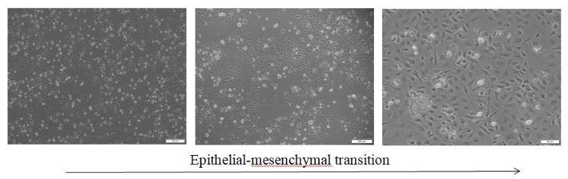

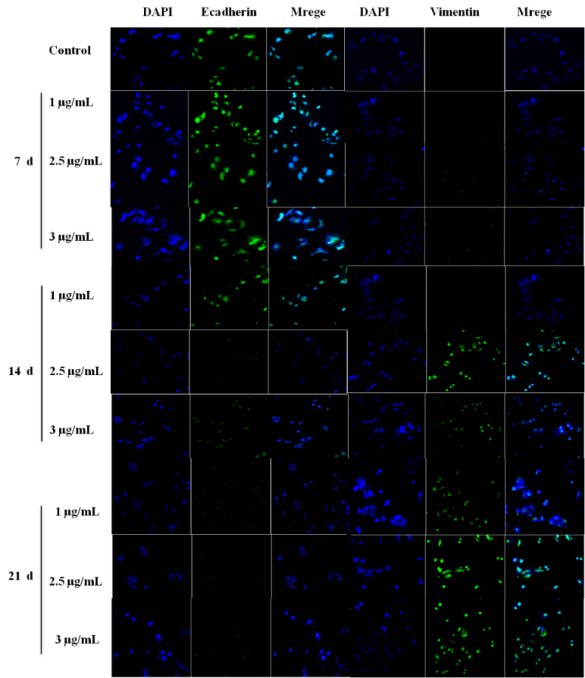
C

Figure1 Establishment of EMT model of MCM460 cells (A) Effects of LPS on NCM460 viability. Cells were treated with 0, 1, 2.5, 3, 5, and 10 µg/mL of LPS for 12,24,36,48,72h. Cell viability was then measured using the CCK-8 assay.(B) Morphological changes in NCM460 cells during interstitial transition. (C) Effects of LPS on the Fluorescence Expression of Mesenchymal Transition Markers in NCM460 . Cells were treated with 1, 2.5 and 3 µg/Ml of LPS for7,14,21d. Fluorescent expression of markers was detected by immunofluorescence techniques.

