SUPPLEMENTARY MATERIAL
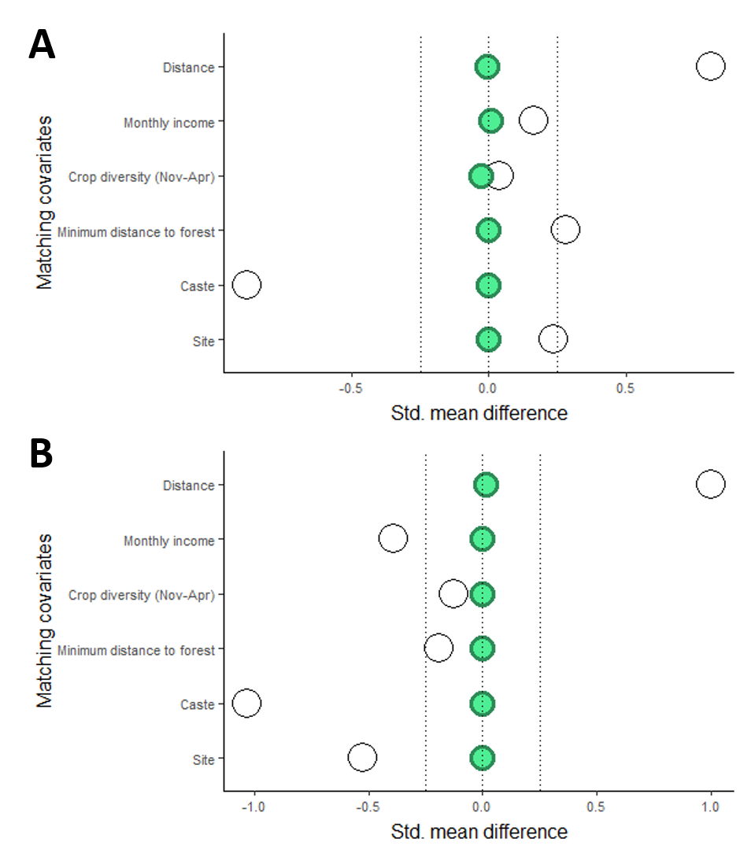
Figure 5. Balance of covariates before and after genetic matching for June (A) and July (B), using wild food consumption as treatment. Standardized mean difference for confounding covariates before matching (open circles) and after matching without using calipers (green circles). Dotted lines indicate acceptable standard mean difference after matching to reach balance (Stuart 2010).

 | June 2017 |  | July 2017
 | Wild foods consumed  (n=41) | No wild foods consumed  (n=529) | Wild foods consumed  (n=95) | No wild foods consumed  (n=475)
Household characteristics
Household income (rupees), mean (SD) | 90.3 (89.4) | 92.01 (81.37) | 108.14 (109.72) | 74.57 (45.02)
Number of different crops harvested (Nov-Apr), mean (SD) | 1.98 (1.62) | 2.023 (1.68) | 2.05 (1.80) | 1.84 (1.46)
Distance (km) to nearest forest, mean (SD) | 0.79 (0.97) | 0.86 (0.98) | 1.18 (1.40) | 0.63 (1.16)
Bankura (n) | 239 | 192 | 33 | 77
Palamu (n) | 290 | 283 | 8 | 18

Table 1. Household characteristics of unmatched sample of women that consumed wild foods and those that did not consume wild foods in June and July 2017 in Palamu and Bankura, India.

 | June 2017 |  | July 2017
 | Wild foods consumed  (n=41) | No wild foods consumed  (n=529) | Wild foods consumed  (n=95) | No wild foods consumed  (n=475)
DDS, mean (SD) | 3.85 (0.69) | 3.53 (1.14) | 3.80 (0.68) | 3.42 (1.08)
Met MDD, % | 9.8 | 17.4 | 11.6 | 15.8
Consumed leafy green vegetables in past 24h, % | 41.5 | 12.2 | 28.4 | 0.042
Consumed leafy green vegetables in past 7d, % | 80.5 | 53.7 | 43.2 | 28.4
Consumed vitamin-A rich fruits and vegetables in past 24h, % | 4.9 | 9.8 | 4.2 | 11.6
Consumed vitamin-A rich fruits and vegetables in past 7d, % | 7.3 | 19.5 | 7.4 | 15.8

Table 2. Unmatched diet indicators among women who did and did not consume wild foods in June and July 2017 in Palamu and Bankura, India.

Despite the importance of forests to diets, forests in India are not always accessible and wild food collection is not permitted. Whether people have legal access to the surrounding forest might influence the types of products that they can source from the forest which in turn can then influence their food consumption pattern. To account for this, we assessed the number and types of forest use rights across the 79 forest areas included in our sample (Fig. S1). We focused on 15 mutually exclusive forest use rights: Agricultural inputs, charcoal, commercial timber, firewood, grass fodder, grazing, green manure, hunting, leaf fodder, leaf litter, medicine products, NTFPs, raw materials for home production, small timber, and wild food. Most areas (n=25) had 14 different use rights, with hunting as the only restriction. Only 7 areas had less than 6 use rights.
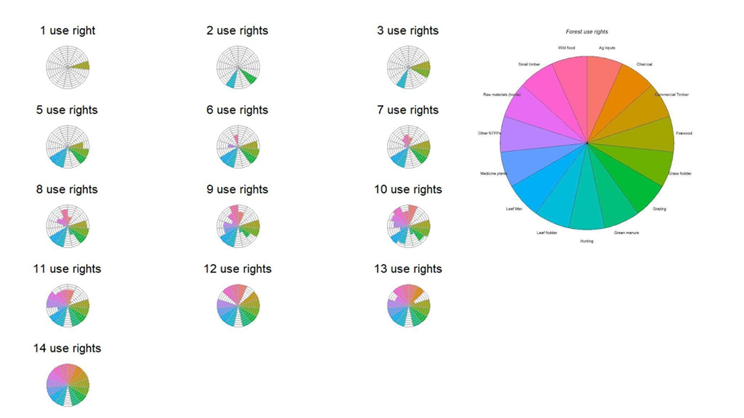

Figure 6. Flower diagrams illustrating the bundles of forest use rights across various levels of use rights (1-14 use rights). The length of each petal represents the proportion of forest areas within each level of use rights (1-14) where the specific right was present. Each of the line increments is equivalent to 10%. N=79 forest areas.

