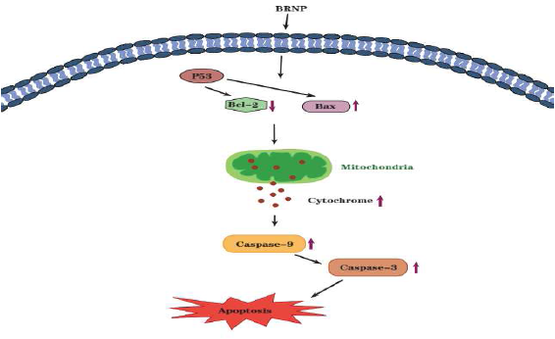
1.graphical abstract
2.Mouse model
Changes in mice injected with A549 cells were observed regularly every day. Concave–convex objects were formed in 7–10 days. When the average diameter of subcutaneous tumors in all mice reached 5 mm, the model was considered to be successfully prepared. Treatment was then started. The mouse model is shown in Figure 1.
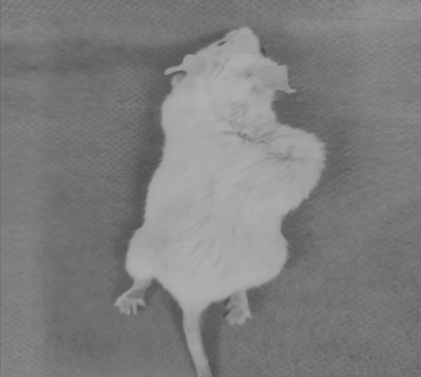Fig. 1 Mouse model
3.Effect of cisplatin on inhibition of human lung adenocarcinoma A549 cells
At the same administration time, the inhibitory effect of cisplatin on human lung adenocarcinoma A549 cells was enhanced with increasing drug dose in a concentration-dependent manner (Table 1).
Table 1 Effect of cisplatin on the proliferation of human lung adenocarcinoma A549 cells (x ± s,n = 6)
grouping | n | OD₄₅₀(24h) | inhibition ratio（%）
Blank group  Positive control group  5 µg/mL cisplatin | 6  6  6 | 0.150.01a  0.970.08  0.800.05 a | -  -  20.73±0.91
10 µg/mL cisplatin | 6 | 0.450.04 a | 63.41±1.37
20 µg/mL cisplatin | 6 | 0.380.03 a | 71.95±1.53
Note: a: compared with negative control group, P<0.01, 24 h after administration, significant difference was observed between low-concentration (5 µg/mL) cisplatin group and medium-concentration (10 µg/mL) and high-concentration (20 µg/mL) cisplatin groups, but no significant difference was detected between medium- and high-concentration groups. IC₅₀ was close to medium concentration the cisplatin group, so 10 µg/mL cisplatin was used for subsequent administration.
4.Effects of BRNP on the clonal formation of lung cancer cells
4.1Clone formation experiment
Lung cancer A549 cells were inoculated in a six-well plate at 500 cells per well. After the cells adhered to the wall, the medium was fully removed. The cells were then added with respective culture medium for the negative control group, cisplatin group, medium-dose group, and half-dose combined group for 24 h. The cells were further cultured in an incubator for 10 days and washed twice with PBS buffer. The cells were fixed with fixed solution for 15 min and washed with PBS buffer twice. After crystal violet staining for 15 min, the cells were thoroughly washed with PBS buffer and dried. The number of cell clones in each group was calculated under an inverted microscope.
Compared with the negative control group, BRNP significantly decreased the clone formation rate of A549 cells (P < 0.01). The clone formation rate of the dose-reduction combined group was only 0.2%, indicating that BRNP had a strong weakening effect on the proliferation ability of lung cancer A549 cells (Table 3).
Table 3 Effect of BRNP on the formation of lung cancer cells (x ± s, n = 3)
Grouping | C (µg/mL) | cell clone number | Cloning efficiency（%）
Positive control group | - | 8 | 1.6±0.01
Cisplatin group | 10 | 0a | 0.0±0.00 b
BRNP | 400 | 3 a | 0.6 ±0.03b
Joint group | 10+400 | 1 a | 0.2± 0.01b
Note: Number of cell clones: a P<0.01 vs. negative control group; Clone formation rate; b P<0.01vs. negative control group 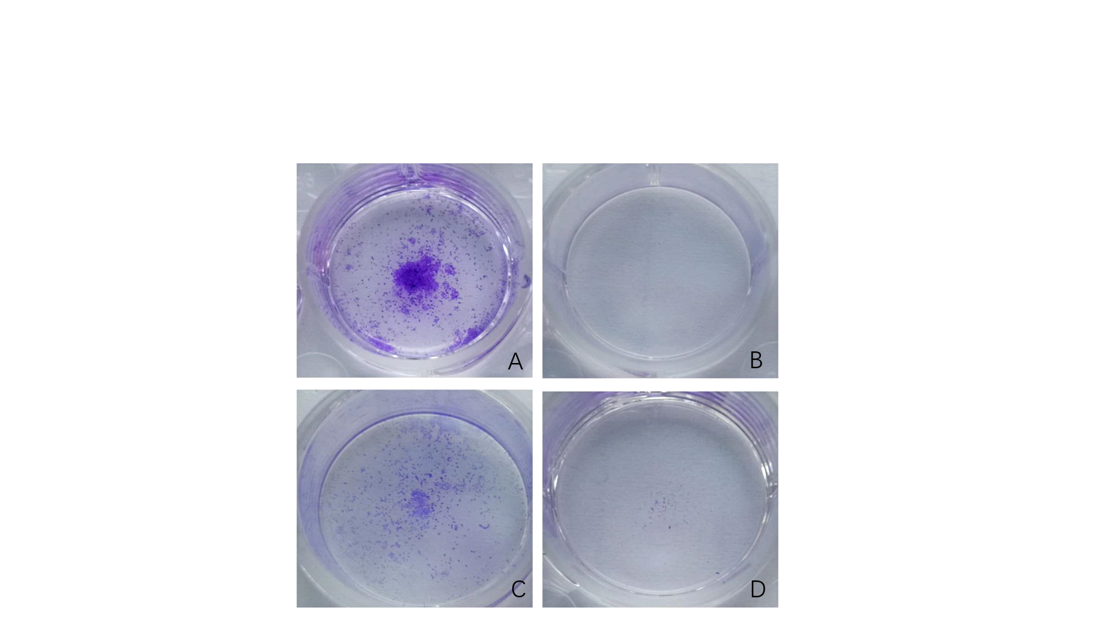
Fig. 2 Effect of BRNP on the formation of lung cancer cells (n = 3)
5.Effects of BRNP on A549 cell morphology
As shown in Fig. 1A, the cells had normal spindle shaped and dense growth. Fig. 1B shows changes in cell morphology, with most cells shrinking and their number decreasing. Fig. 1C presents the morphological changes; some cells were wrinkled, condensed, and rounded. As shown in Fig. 1D, a small number of cells exhibited morphological changes. In the negative control group, the cells grew slowly, and a small number of cells were wrinkled and round.
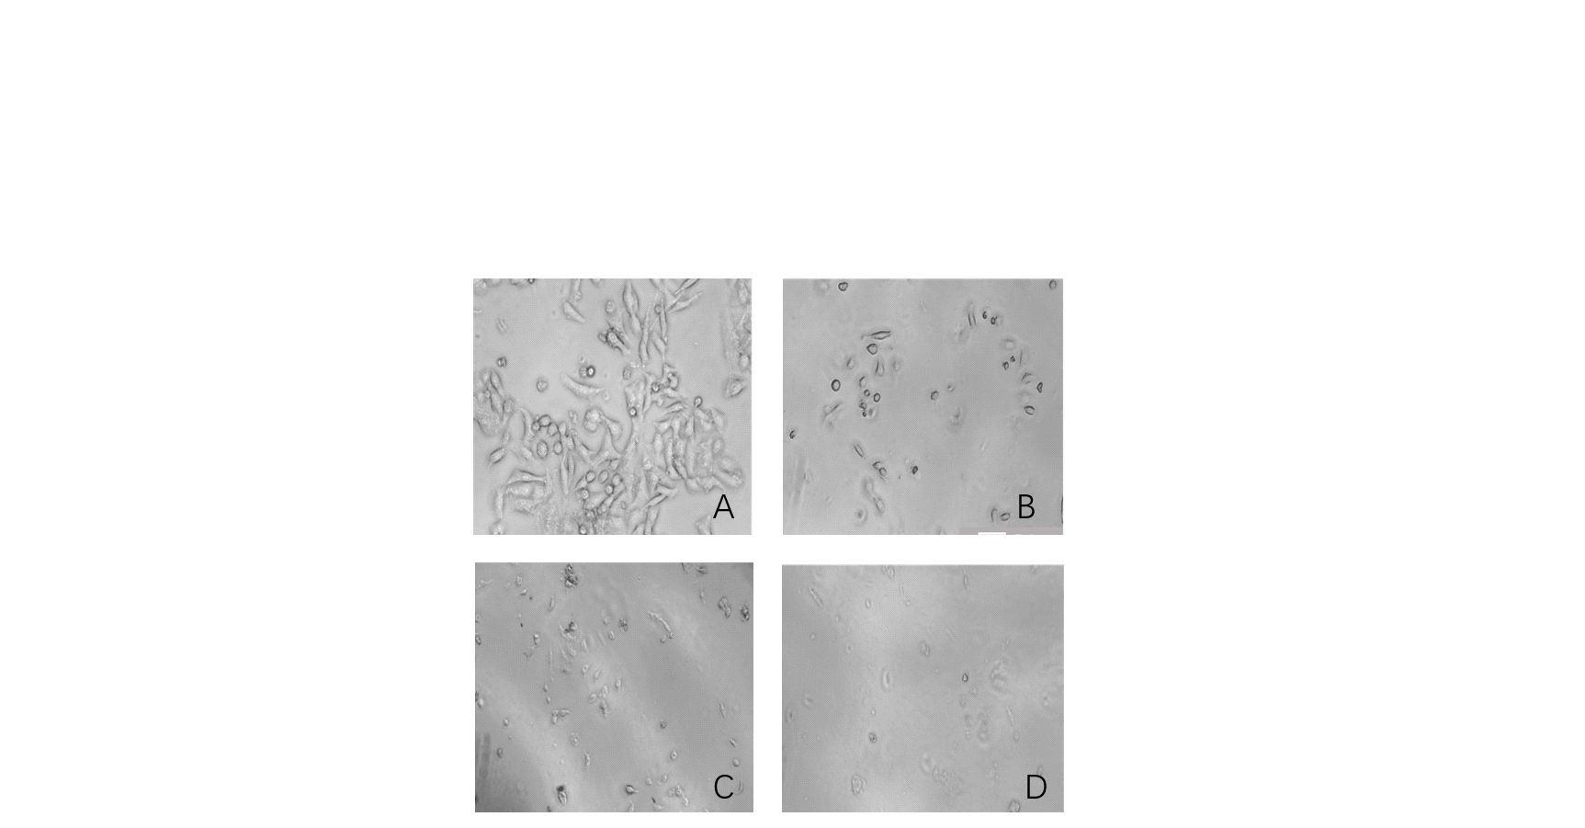
Fig. 1 Morphological changes in A549 cells under an inverted microscope (n=3)
Note: Fig. A negative control group (no drug intervention); Fig. B cisplatin group (10 µg/mL); Fig. C BRNP (400 µg/mL); Fig. D Combined group (400 µg/mL BRNP + 10 µg/mL cisplatin, dose halved)
7.Cell culture
The bottle of cells was removed from liquid nitrogen tank, rapidly dissolved by thawing in a 37 ℃ water bath pot, in frozen storage tube surface spraying 75% alcohol to get to work station. The thawed cell suspension was transferred into a 15 mL centrifuge tube with a 1000 µL pipette gun, added with 3 mL, cultured completely, and centrifuged (1000 r/min, 5 min). The supernatant was discarded, to join in centrifuge tube 2 mL culture completely. to beat evenly, remove the cell suspension to T25 cells culture in a bottle, then add 3 mL culture completely, with eight blending method ensures equal distribution of cells. The cells were labeled, and their morphological characteristics were observed under a microscope. The surface of the culture bottle was sprayed with 75% alcohol, and it was placed in an incubator (37 ℃, 5% CO₂) for culture.

