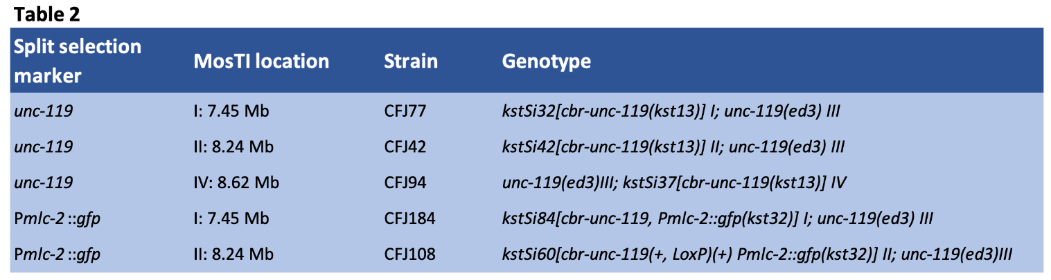
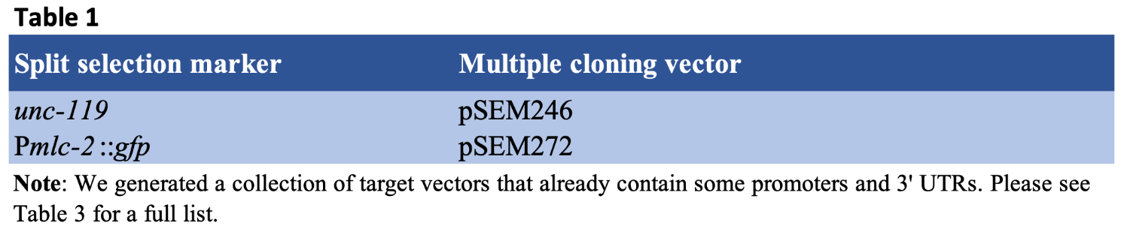

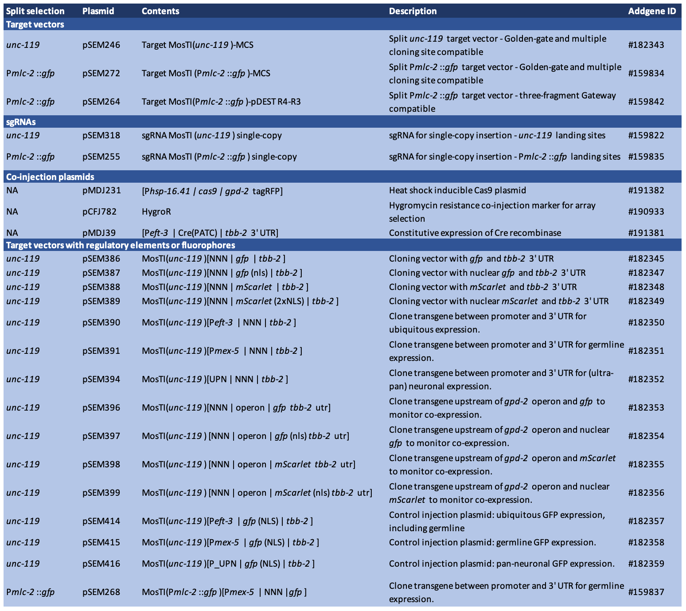
Table 3: Extended table of MosTI plasmids

Table 4: PCR primers for MosTI validation
Selection | Chr. | Forward primer | 5' - 3' sequence | Reverse primer | 5' - 3' sequence | Amplicon size
unc-119 | I | oSEM842 | TTTGGGATTCACCCCGCGGT | oSEM854 | GGAATCCACAACTCCTGCTC | 2018 bp + transgene
unc-119 | II | oSEM842 | TTTGGGATTCACCCCGCGGT | oSEM855 | CGCCATTGTTTCCTGAAAAT | 2222 bp + transgene
unc-119 | IV | oSEM842 | TTTGGGATTCACCCCGCGGT | oSEM860 | ATTTCATTCGTGGCGAGAGT | 2066 bp + transgene
Pmlc-2::gfp | I | oSEM874 | TCTATATCATGGCCGACAAG | oSEM854 | GGAATCCACAACTCCTGCTC | 1288 bp + transgene
Pmlc-2::gfp | II | oSEM874 | TCTATATCATGGCCGACAAG | oSEM855 | CGCCATTGTTTCCTGAAAAT | 1476 bp + transgene

