Support information

η3-allyl-Pd(II) complexes of 2-, 3- and 4-pyridylmethyl-coumarin esters
Simplicio González-Montiel^{a,*}, René Veláquez-Jiménez^{a,b}, Raúl Segovia-Pérezª, Willyfredo Fragoso-Sotoª, Diego Martínez-Otero^{c}, Noemí Andrade-Lópezª, Verónica Salazar-Peredaª, Julián Cruz-Borbollaª

ª Área Académica de Química, Centro de Investigaciones Químicas, Universidad Autónoma del Estado de Hidalgo, km. 4.5 Carretera Pachuca-Tulancingo, Ciudad del Conocimiento, C.P. 42184, Mineral de la Reforma, Hidalgo, México.

^{b} Parque Científico y Tecnológico, Universidad Autónoma del Estado de Hidalgo, Blvd. Ciudad del Conocimiento, mza. 15 lote 2, Santa Catarina, San Agustín Tlaxiaca, Hidalgo 42162, Mexico

^{c} Centro Conjunto de Investigación en Química Sustentable, UAEM-UNAM, Carretera Toluca-Atlacomulco km. 14.5, C.P. 50200 Toluca, Estado de México, Mexico

Corresponding author.
* Phone: +52 771 71 72 000 ext 2210.
e-mail address: gmontiel@uaeh.edu.mx (S. González-Montiel)

Figure S1. ¹H NMR spectrum of ligand 1.

Figure S2. ¹³C NMR spectrum of ligand 1.

Figure S3. COSY 2D-NMR spectrum of ligand 1.

Figure S4. HSQC 2D-NMR spectrum of ligand 1.

Figure S5. ¹H NMR spectra of ligand 1.

Figure S6. ¹³C NMR spectrum of ligand 2.

Figure S7. COSY 2D-NMR spectrum of ligand 2.

Figure S8. HSQC 2D-NMR spectrum of ligand 2.

Figure S9. ¹H NMR spectrum of ligand 3.

Figure S10. ¹³C NMR spectrum of ligand 3.

Figure S11. COSY 2D-NMR spectrum of ligand 3.

Figure S12. HSQC 2D-NMR spectrum of ligand 3.

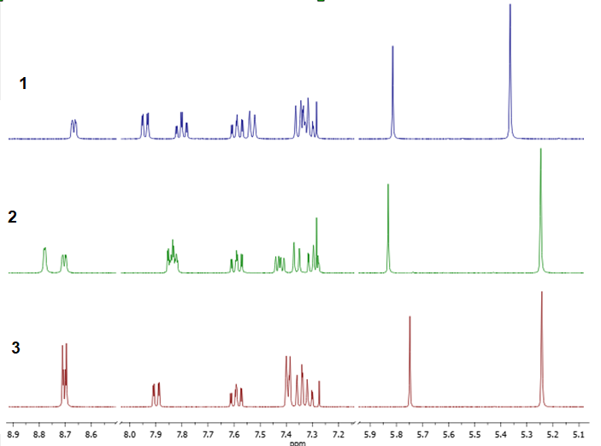
Figure S13. ¹H NMR stacked spectra of ligands 1 – 3.

Figure S14. ¹H NMR spectrum of complex 1-Pd.

Figure S15. ¹³ C NMR spectrum of complex 1-Pd.

Figure S16. COSY 2D-NMR spectrum of complex 1-Pd.

Figure S17. HSQC 2D.NMR spectrum of complex 1-Pd.

Figure S18. ¹H NMR spectrum of complex 2-Pd.

Figure S19. ¹³C NMR spectrum of complex 2-Pd.

Figure S20. COSY 2D-NMR spectrum of complex 2-Pd.

Figure S21. HSQC 2D-NMR spectrum of complex 2-Pd.

Figure S22. ¹H NMR spectrum of complex 3-Pd.

Figure S23. ¹³C NMR spectrum of complex 3-Pd.

Figure S24. COSY 2D-NMR spectrum of complex 3-Pd.

Figure S25. HSQC 2D-NMR spectrum of complex 3-Pd.

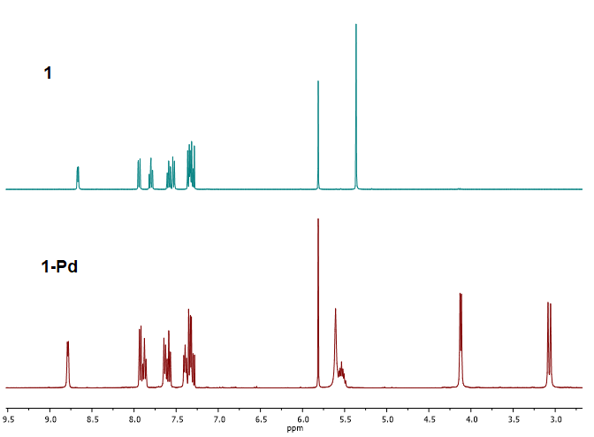
Figure S26. A comparison of ¹H NMR stacked spectra of ligand 1 and complex 1-Pd.

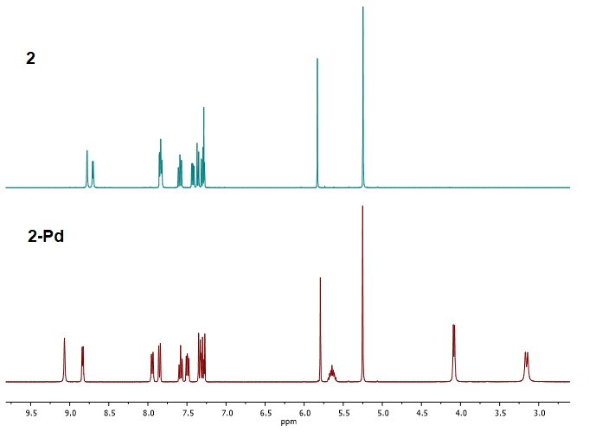
Figure S27. A comparison of ¹H NMR stacked spectra of ligand 2 and complex 2-Pd.

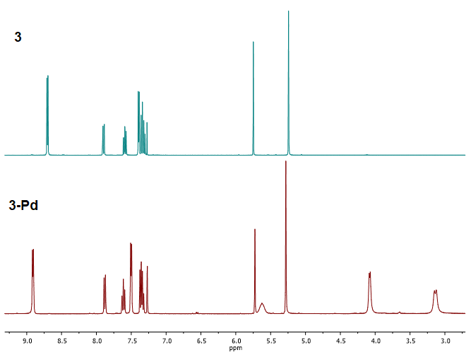
Figure S28. A comparison of ¹H NMR stacked spectra of ligand 3 and complex 3-Pd.

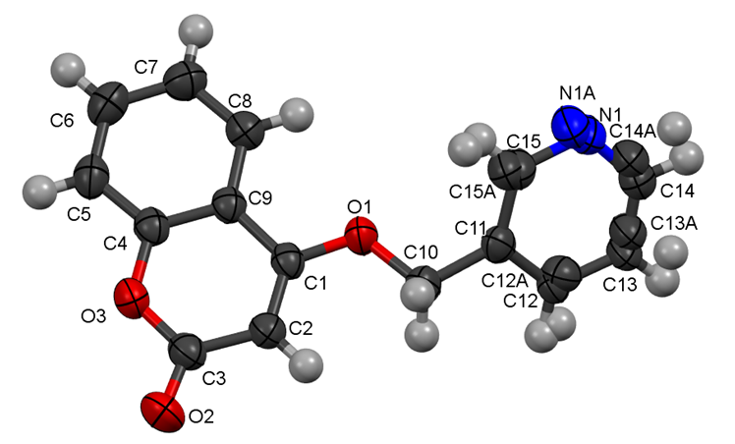
Figure S29. Molecular structure of ligand 2 displaying the numeration of the atoms, see Table S1.
Table S1. Bond lengths (Å) and bond angles (°) of 2.
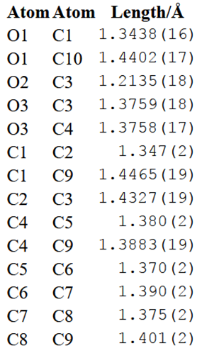 | 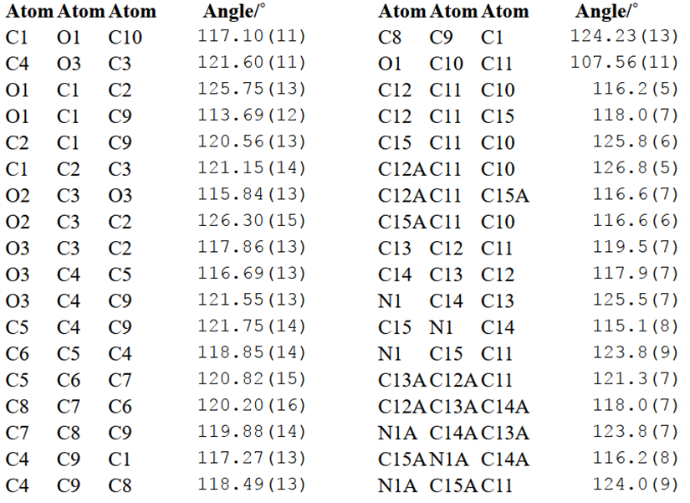
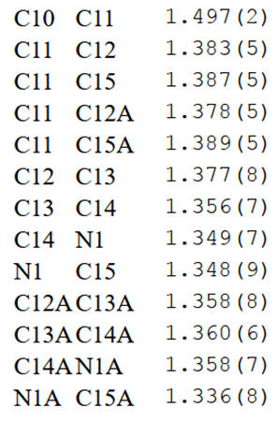

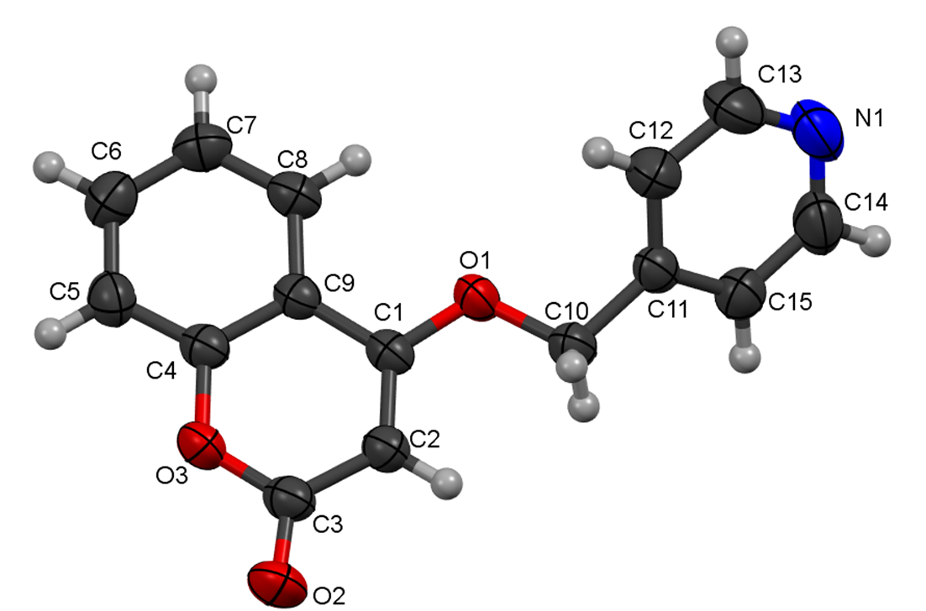
Figure S30. Molecular structure of ligand 3 displaying the numeration of the atoms, see Table S2.

Table S2. Bond lengths (Å), bond and torsion angles (°) of 3.
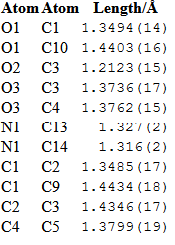  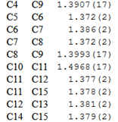 | 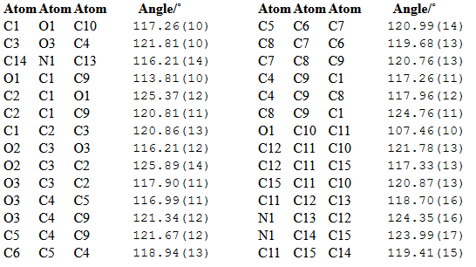

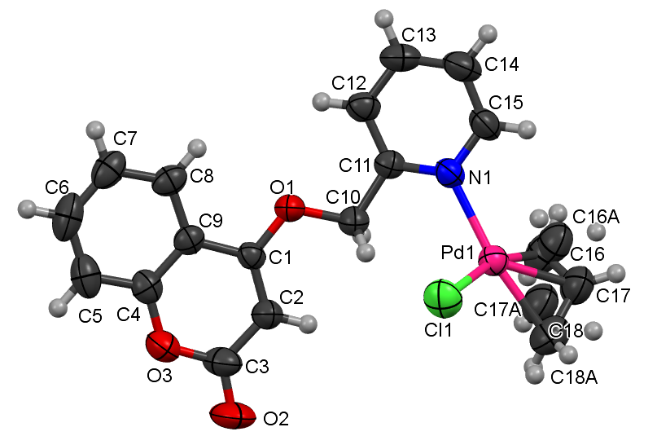
Figure S31. Molecular structure of ligand 1-Pd displaying the numeration of the atoms, see Table S3.

Table S3. Bond lengths (Å) and bond angles (°) of 1-Pd.
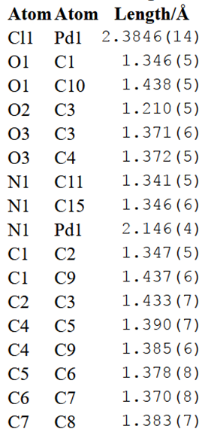  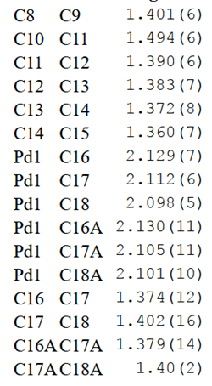 | 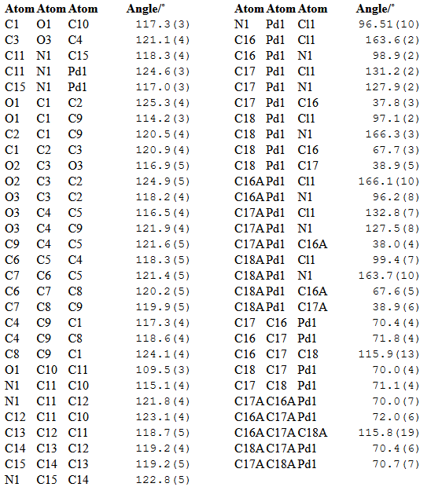

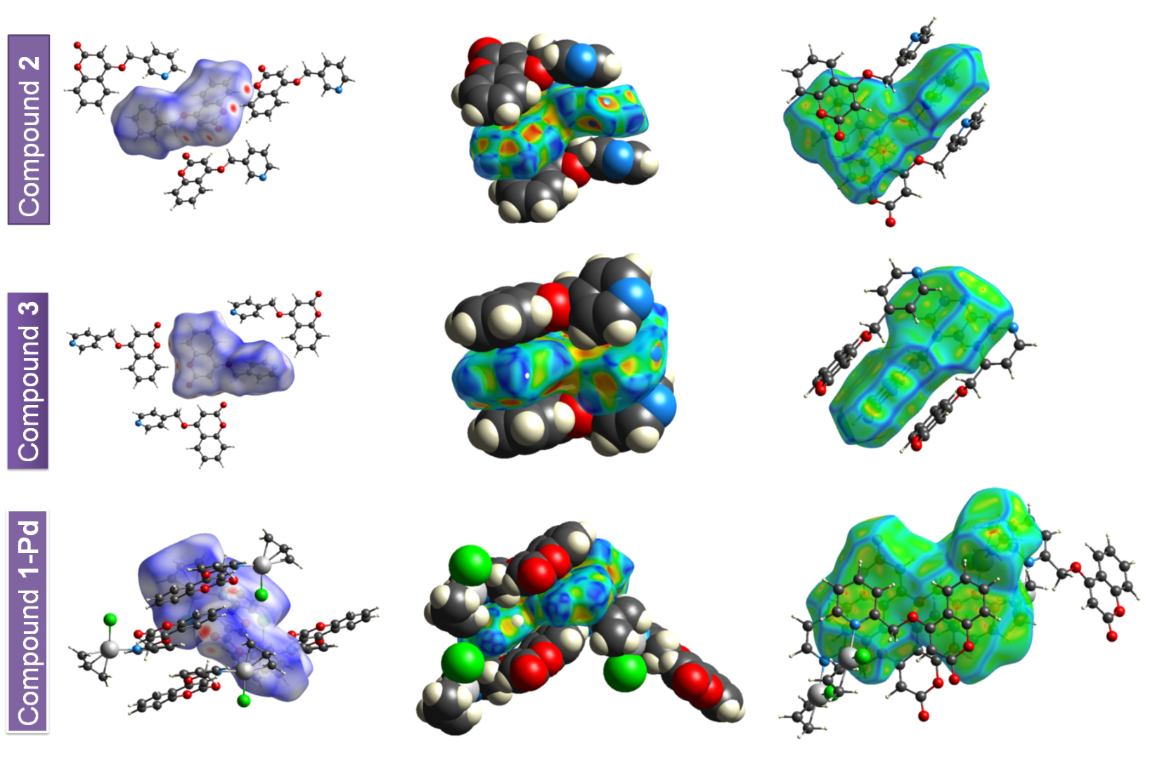
Figure S32. Hirshfeld surfaces mapped with d_{nomr} (left), shape index (middle) and curveness (right) of the compounds 2, 3 and 1–Pd.

