Supplementary information

Pharmacokinetics and pharmacodynamics characterization of subjects with novel CYP2D6 genotypes using probe drug metoprolol

Jianchang Qian¹, Tao Xu¹, Peipei Pan¹, Wei Sun^{1,2}, Jianping Cai^{1, *}, Guoxin Hu^{1, *}

¹ Institute of Molecular Toxicology and Pharmacology, School of Pharmaceutical Sciences, Wenzhou Medical University, Wenzhou, Zhejiang 325035, China
² Department of Pharmacy, The Second Affiliated Hospital and Yuying Children’s Hospital of Wenzhou Medical University, Wenzhou, China

Supplementary Figures: 4
Supplementary Tables: 3

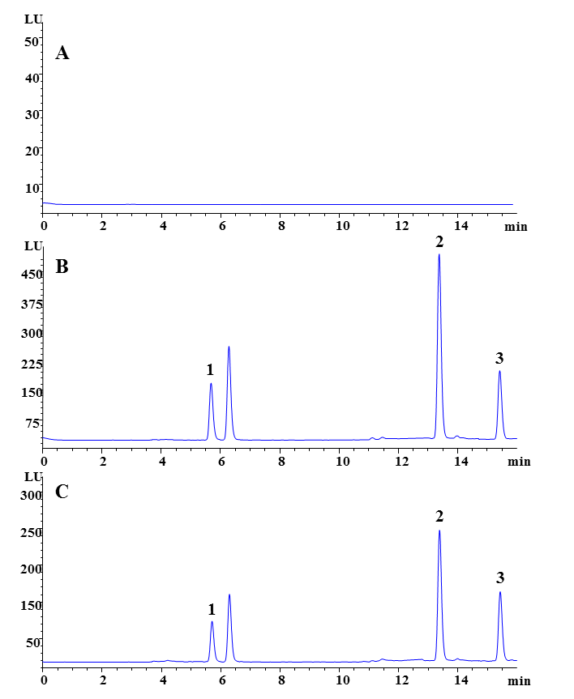
Supplementary Figure 1. Representative high performance liquid chromatogram of metoprolol and α-hydroxymetoprolol in plasma. A Drug-free plasma. B Plasma spiked with 600 ng/mL metoprolol, 300 ng/mL α-hydroxymetoprolol and 500 ng/mL IS. C Plasma obtained at 2.5 h after a single oral dose of 100 mg metoprolol. 1 α-hydroxymetoprolol, 2 metoprolol, 3 esmolol.

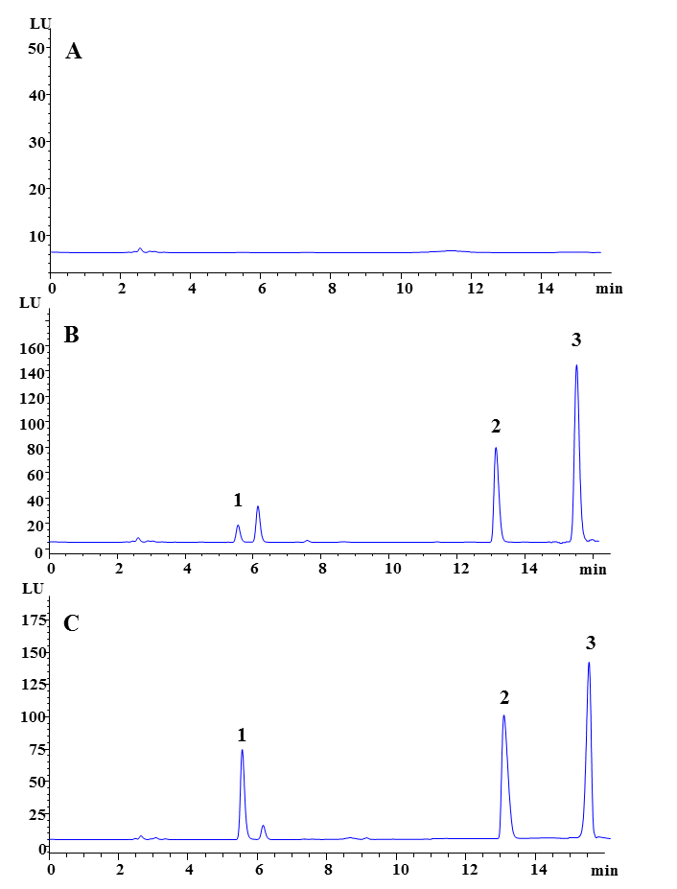
Supplementary Figure 2. Representative high performance liquid chromatogram of metoprolol and α-hydroxymetoprolol in urine. A Drug-free urine. B Urine spiked with 25 ng/mL metoprolol, 12.5 ng/mL α-hydroxymetoprolol and 500 ng/mL IS. C Urine obtained at 12-24 h after a single oral dose of 100 mg metoprolol. 1 α-hydroxymetoprolol, 2 metoprolol, 3 esmolol.

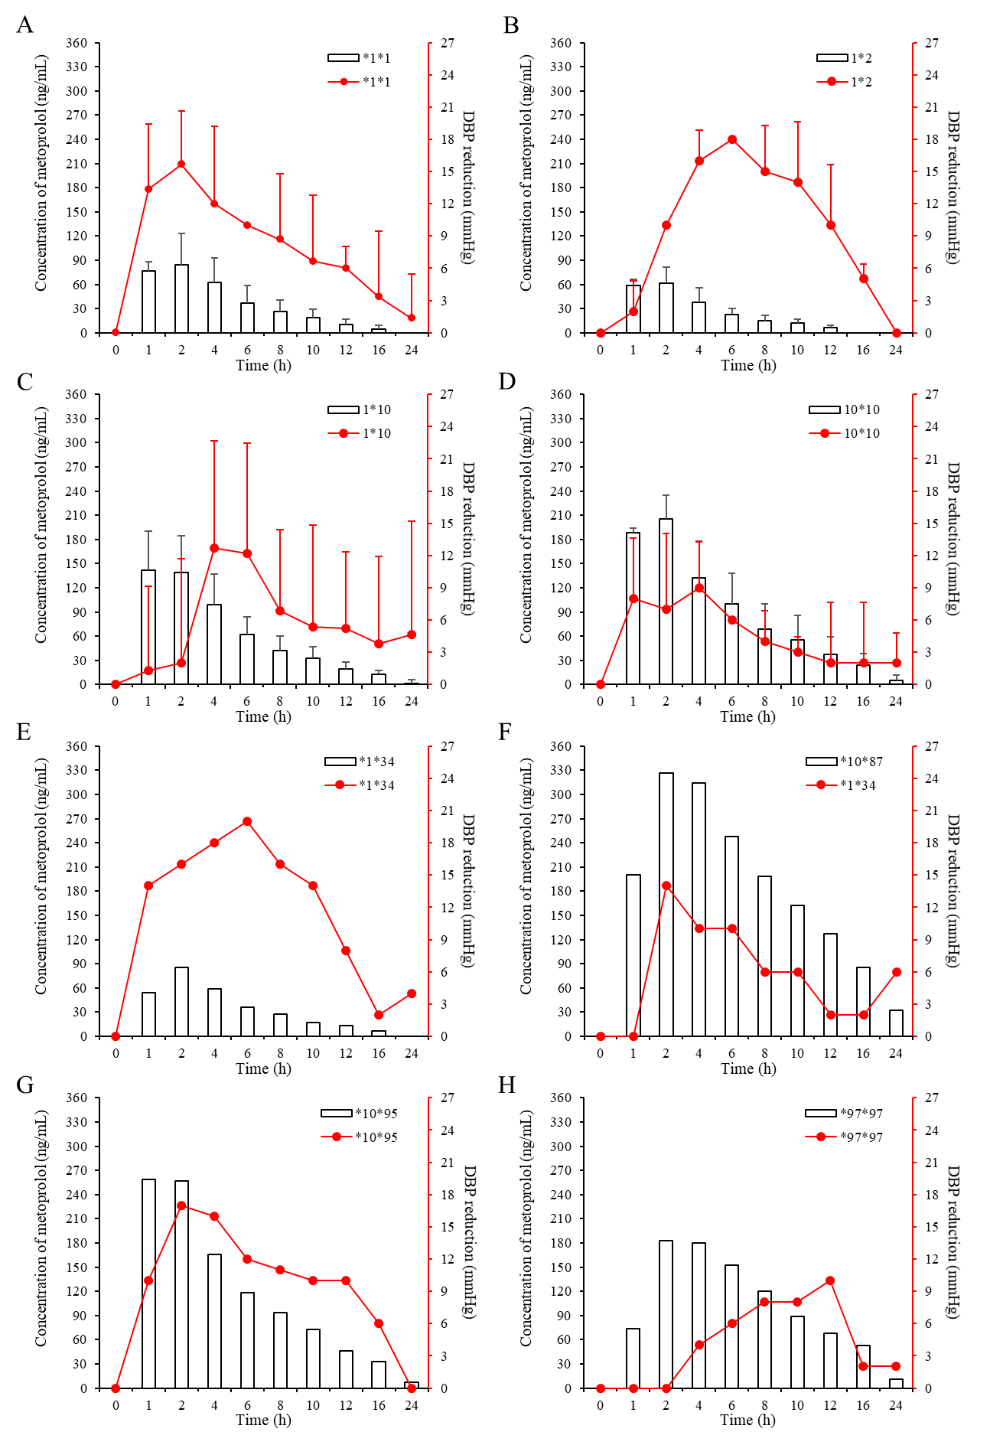
Supplementary Figure 3. Correlation of metoprolol blood concentration with diastolic blood pressure. The diastolic blood pressure (DBP) of subjects was monitored at the indicated time-point. The concentration of metaporolol and reduction in DBP were co-plotted (A-H).

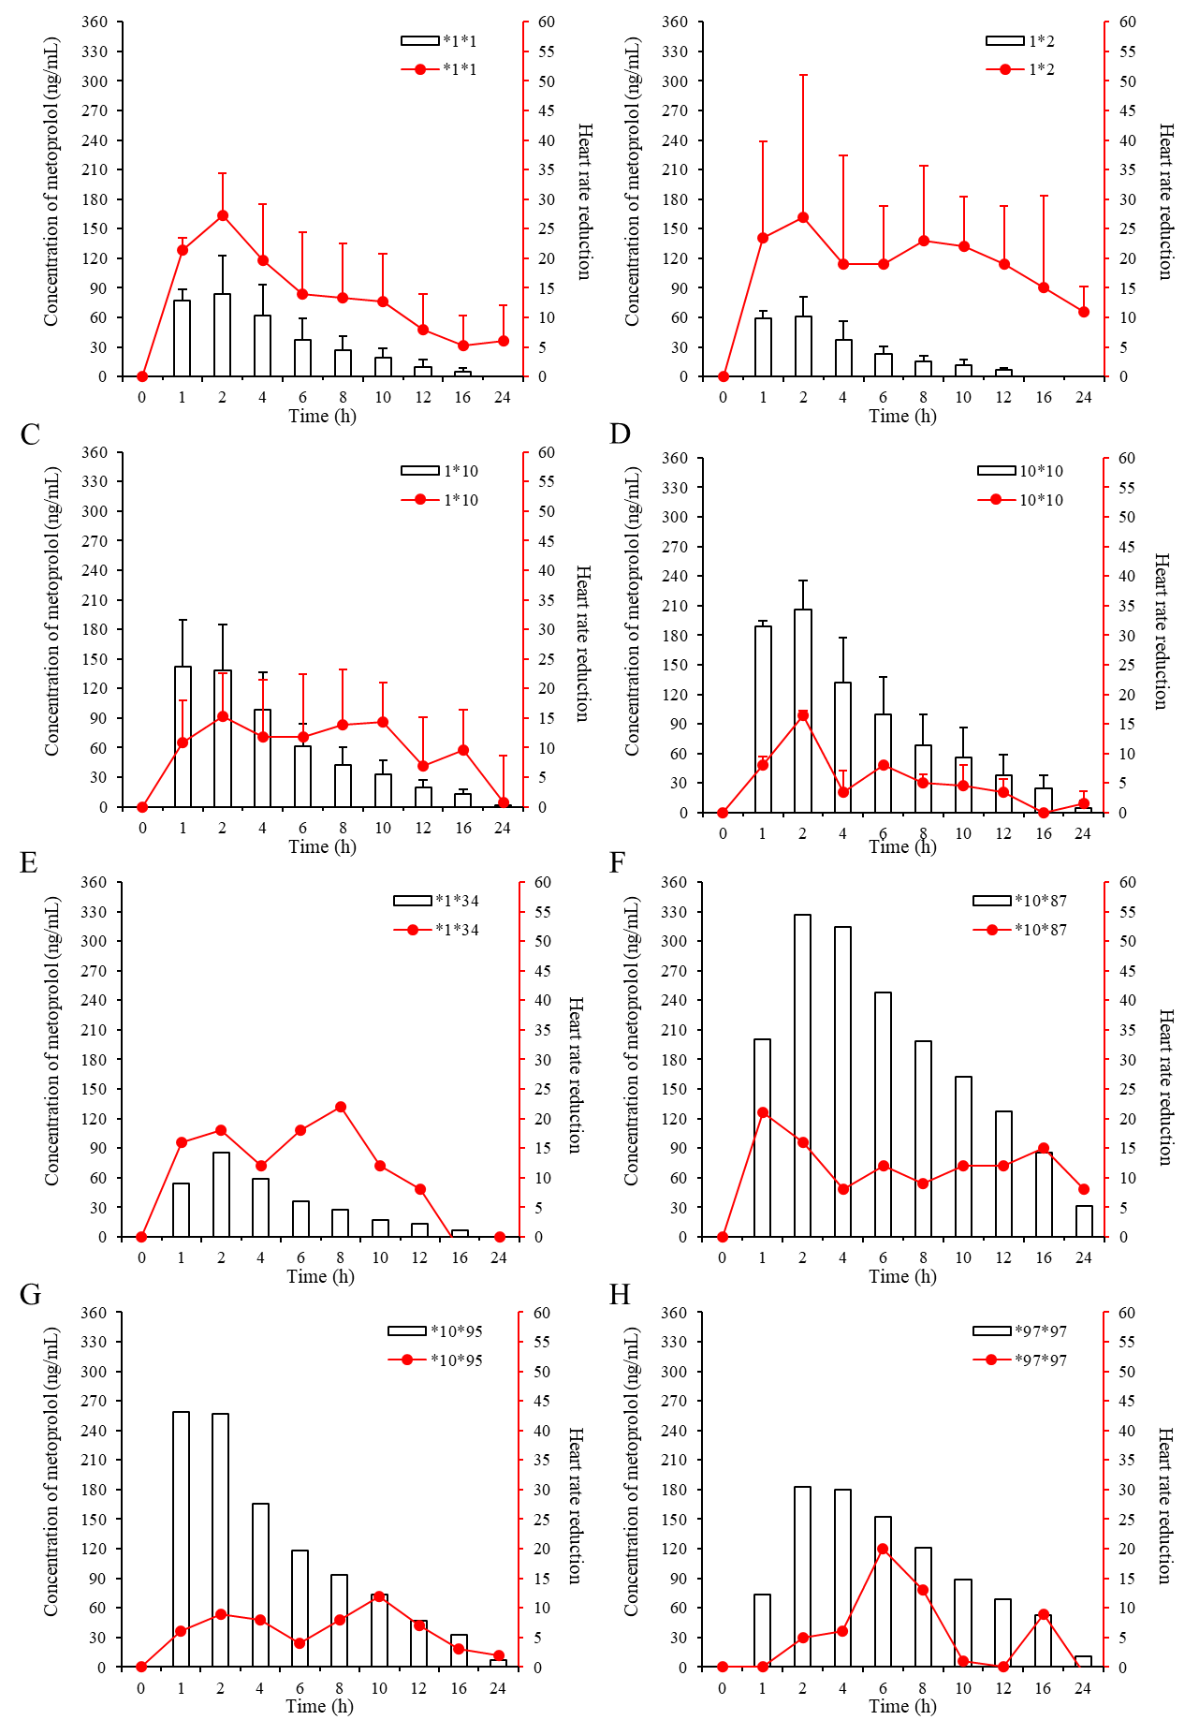
Supplementary Figure 4. Correlation of metoprolol blood concentration with heart rate. The heart rate of subjects was monitored at the indicated time-point. The concentration of metaporolol and reduction in hear rate were co-plotted (A-H).

Supplementary Table 1. Linear relationship between metoprolol and its metabolite α-hydroxymetoprolol in plasma and urine.

Analyte | Parameter | Mean ± SD
Analyte | Parameter | Plasma | Urine
Metoprolol | Slope | 0.0056±0.0009 | 0.0053±0.0014
Metoprolol | Intercept | 0.014±0.0119 | 0.021±0.0066
Metoprolol | Correlation coefficient (r) | 0.9993±0.0005 | 0.9991±0.0005
α-hydroxymetoprolol | Slope | 0.0037±0.0005 | 0.0052±0.0016
α-hydroxymetoprolol | Intercept | 0.0096±0.0067 | 0.020±0.0070
α-hydroxymetoprolol | Correlation coefficient (r) | 0.9993±0.0004 | 0.9994±0.0003

Supplementary Table 2. Evaluation of precision and accuracy of the method.
 | Analyte |  | Concentration (ng/mL) |  | RSD (%) | RE (%)
 | Analyte |  | Theoretical value | Actual measurement | RSD (%) | RE (%)
Plasma | Metoprolol | Intraday | 10 | 10.4±0.22 | 2.11 | 4.08
Plasma | Metoprolol | Intraday | 100 | 103.8±4.77 | 4.6 | 3.75
Plasma | Metoprolol | Intraday | 400 | 388.5±11.8 | 3.05 | -2.88
Plasma | Metoprolol | Interday | 10 | 10.28±0.33 | 3.18 | 2.82
Plasma | Metoprolol | Interday | 100 | 105.8±6.39 | 6.05 | 5.79
Plasma | Metoprolol | Interday | 400 | 399.2±7.98 | 2 | -0.22
Plasma | α-hydroxymetoprolol | Intraday | 5 | 5.09±0.10 | 1.64 | 1.97
Plasma | α-hydroxymetoprolol | Intraday | 50 | 52.1±1.49 | 2.86 | 4.11
Plasma | α-hydroxymetoprolol | Intraday | 200 | 197.1±3.08 | 1.56 | -1.45
Plasma | α-hydroxymetoprolol | Interday | 5 | 5.15±0.27 | 5.4 | 3.03
Plasma | α-hydroxymetoprolol | Interday | 50 | 49.5±3.49 | 6.97 | -1.01
Plasma | α-hydroxymetoprolol | Interday | 200 | 201.6±6.26 | 3.13 | 0.81
Urine | Metoprolol | Intraday | 10 | 10.35±0.46 | 4.47 | 3.47
Urine | Metoprolol | Intraday | 100 | 106.9±2.52 | 2.36 | 6.91
Urine | Metoprolol | Intraday | 600 | 595.6±12.2 | 2.04 | -0.74
Urine | Metoprolol | Interday | 10 | 10.48±0.72 | 6.86 | 4.77
Urine | Metoprolol | Interday | 100 | 103.76±2.90 | 2.8 | 3.76
Urine | Metoprolol | Interday | 600 | 595.4±2.21 | 0.37 | -0.77
Urine | α-hydroxymetoprolol | Intraday | 5 | 5.12±0.22 | 4.26 | 2.37
Urine | α-hydroxymetoprolol | Intraday | 50 | 48.9±3.25 | 6.64 | -2.21
Urine | α-hydroxymetoprolol | Intraday | 300 | 310.6±5.17 | 1.66 | 3.53
Urine | α-hydroxymetoprolol | Interday | 5 | 5.11±0.18 | 3.57 | 2.29
Urine | α-hydroxymetoprolol | Interday | 50 | 51.6±2.37 | 4.59 | 3.28
Urine | α-hydroxymetoprolol | Interday | 300 | 302.6±6.39 | 2.11 | 0.86

Supplementary Table 3. Recovery of metoprolol and α-hydroxymetoprolol in human plasma and urine

 | Analyte | Standard (ng/mL) | Recovery % | RSD (%)
Plasma | Metoprolol | 10 | 86.91±0.05 | 6.27
Plasma | Metoprolol | 100 | 98.95±0.02 | 1.35
Plasma | Metoprolol | 400 | 95.74±0.02 | 1.46
Plasma | α-hydroxymetoprolol | 5 | 99.04±0.06 | 5.80
Plasma | α-hydroxymetoprolol | 50 | 93.95±0.03 | 2.80
Plasma | α-hydroxymetoprolol | 200 | 95.74±0.06 | 6.53
Urine | Metoprolol | 10 | 96.05±0.05 | 5.22
Urine | Metoprolol | 100 | 97.27±0.01 | 1.10
Urine | Metoprolol | 600 | 94.12±0.05 | 5.02
Urine | α-hydroxymetoprolol | 5 | 93.43±0.03 | 3.32
Urine | α-hydroxymetoprolol | 50 | 97.14±0.05 | 5.06
Urine | α-hydroxymetoprolol | 300 | 97.80±0.02 | 1.71

