SUPPLEMENTARY DATA
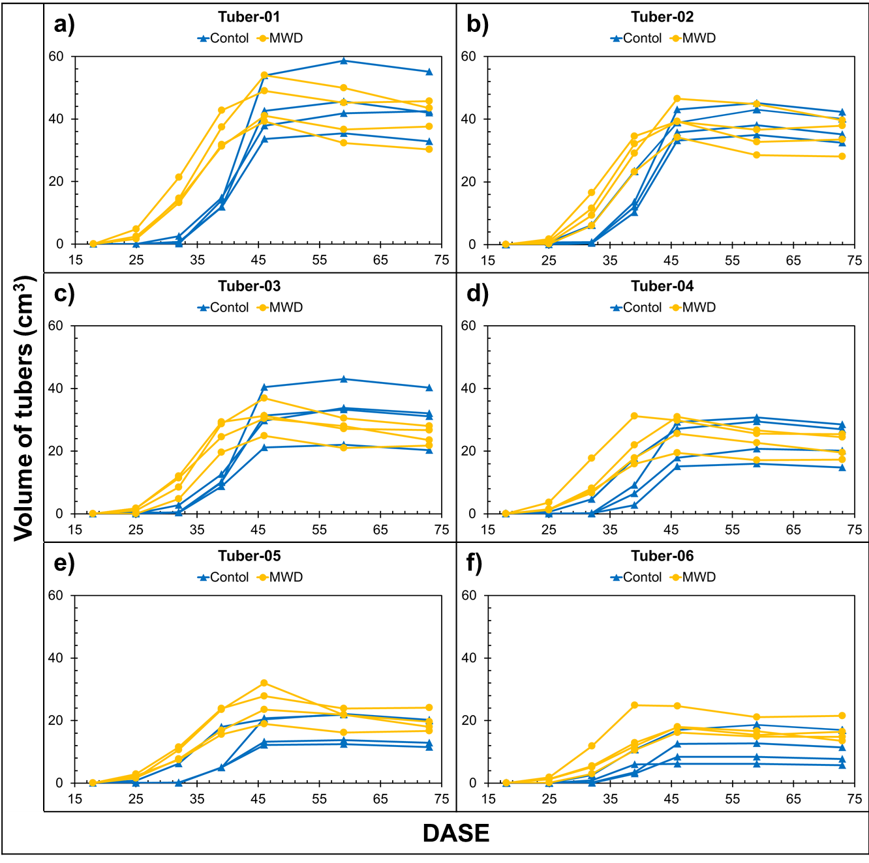
Supplementary Figure S1: Evolution of individual volume of the six biggest tubers of each plant analyzed by MRI during growth expressed as Days After Shoot Emergence (DASE). The volume was determined from 3D MRI images. Tubers were assigned Tuber-01 to 06 (a to f, respectively) according to their volumes in decreasing order at the last measurement day before harvest (73 DASE).

Supplementary Table 1. Groups by ANOVA followed by Tukey HSD test aplied on parameters shown in Figure 1 (R software, alpha = 5%)
 | a) Hull Area  Topview |  |  | b) Area  Topview |  |  | c) Hull Area  Sideview |  |  | d) Area  Sideview |  |  | e) Height |  |  | f) Width |  |  | g) ExG
DASE | Control | M  W  D | S  W  D | Control | M  W  D | S  W  D | Control | M  W  D | S  W  D | Control | M  W  D | S  W  D | Control | M  W  D | S  W  D | Control | M  W  D | S  W  D | Control | M  W  D | S  W  D
18 | a | a | a | a | a | a | a | a | a | a | a | a | a | a | a | a | a | a | a | a | a
21 | a | a | a | a | a | a | a | a | a | a | a | a | a | a | a | a | a | a | a | b | b
25 | a | a | a | a | a | a | a | a | a | a | ab | b | a | a | a | a | a | a | a | b | b
28 | a | b | b | a | b | b | a | b | b | a | b | c | a | b | c | a | b | b | a | b | b
32 | a | b | c | a | b | c | a | b | c | a | b | c | a | b | c | a | b | c | a | b | b
34 | a | b | c | a | b | c | a | b | c | a | b | c | a | b | c | a | b | c | a | b | c
40 | a | b | c | a | b | c | a | b | c | a | b | c | a | b | c | a | b | c | a | b | c
43 | a | b | c | a | b | c | a | b | c | a | b | c | a | b | c | a | b | c | a | b | c
46 | a | b | c | a | b | c | a | b | c | a | b | c | a | b | c | a | b | c | a | b | c
47 | a | b | c | a | b | c | a | b | c | a | b | c | a | b | c | a | b | c | a | b | c
49 | a | b | c | a | b | c | a | b | c | a | b | c | a | b | c | a | b | c | a | b | c
53 | a | b | c | a | b | c | a | b | c | a | b | c | a | b | c | a | b | c | a | b | c

Supplementary Table 2. List of primers used for qRT-PCR.
GENE | ACCESSION NO. | FORWARD PRIMER | REVERSE PRIMER | AMPLICON SIZE (BP)
StAREB1 | XM_006346349 | 5’-GGCTCAAGGCGGAGTTATG-3’ | 5’-GGGAAGGTGAAAGAGACGATG-3’ | 125
StAREB2 | XM_015312047 | 5’-CAGAACCATCAACCACAGCA-3’ | 5’-ATACCAACCATCCCTACCCTC-3’ | 143
StDREB1 | XM_006358327 | 5’-ACTTGCACGAAACATCAACATC-3’ | 5’-TTATCCCTCCTTCTCACTCCC-3’ | 148
StDREB2 | JN125858 | 5’-AAAGCAGAGGGAACACCAAC-3’ | 5’-GGGAAGAATAAGAACCAAGCCA-3’ | 128
StDHN1 | XM_015304546 | 5’-AGGAGAAATTGCCAGGAGGT-3’ | 5’-GTGCCTTCCATACCATAACCAG-3’ | 85
StTAS14 | XM_015304540 | 5’-TGGCACTCAAGGTAGCGG-3’ | 5’-TCCTCCTCCTGGCATCTTCT-3’ | 175
StERD7 | XM_006359626 | 5’-TGGGGATGTTACTGTGGATAGG-3’ | 5’-GAGACCTTCACTACACCTGAGA-3’ | 180
StRD22 | JX839749 | 5’-CACACAGTTAGCAAGAGCAAAG-3’ | 5’-GGTATCCAAGTGACAAACAGCA-3’ | 93
StHSP100 | XM_006338326 | 5’-GCAAGTTTATGTTGACCAGCC-3’ | 5’-GCCGTGTCTGAAATGCGA-3’ | 105
StRPL2 | DQ252497 | 5’-GAGGGAGAGAGAGAAGAGAGAG-3’ | 5’-GGTGGTGGGTATGGGATTTG-3’ | 100
StEF1α | AB061263 | 5’-GATGATTCCCACCAAGCCCA-3’ | 5’-TGACAACACCGACAGCAACA-3’ | 107
StACTIN | DQ252512 | 5’-GTGTGATGGTGGGTATGGGT-3’ | 5’-GGCTTCAGTTAGGAGGACAGG-3’ | 200
StGAPDH | NM_001288348 | 5’-TGCTCCTATGTTTGTCGTTGG-3’ | 5’-TTCTGAGTGGCTGTGATGGA-3' | 177

