Supporting Information:

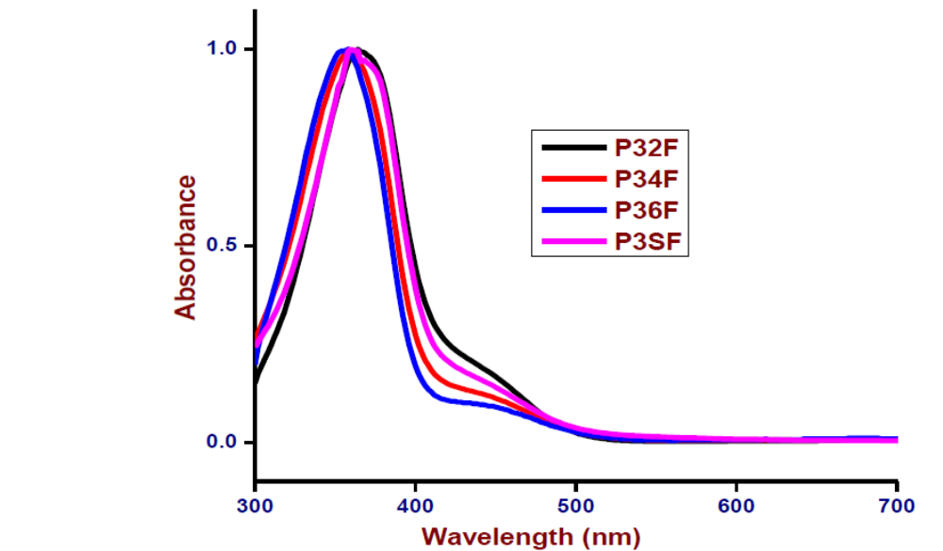
Figure 1 UV visible spectra of Poly(azobenzene)-ester

Figure 2 FTIR spectrum of aromatic diol monomer (3)
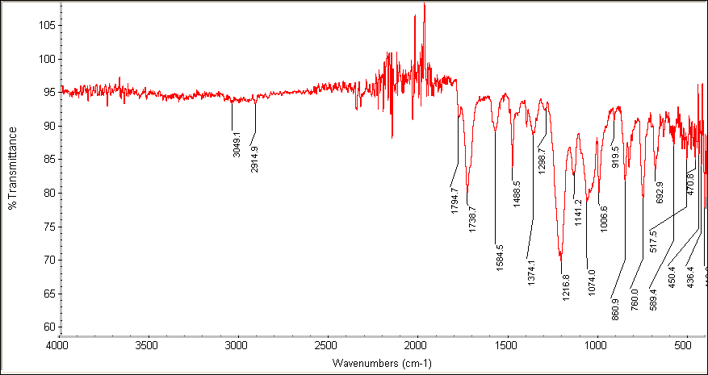
Figure 3 FTIR spectrum of poly(azobenzene)-ester (P32F)

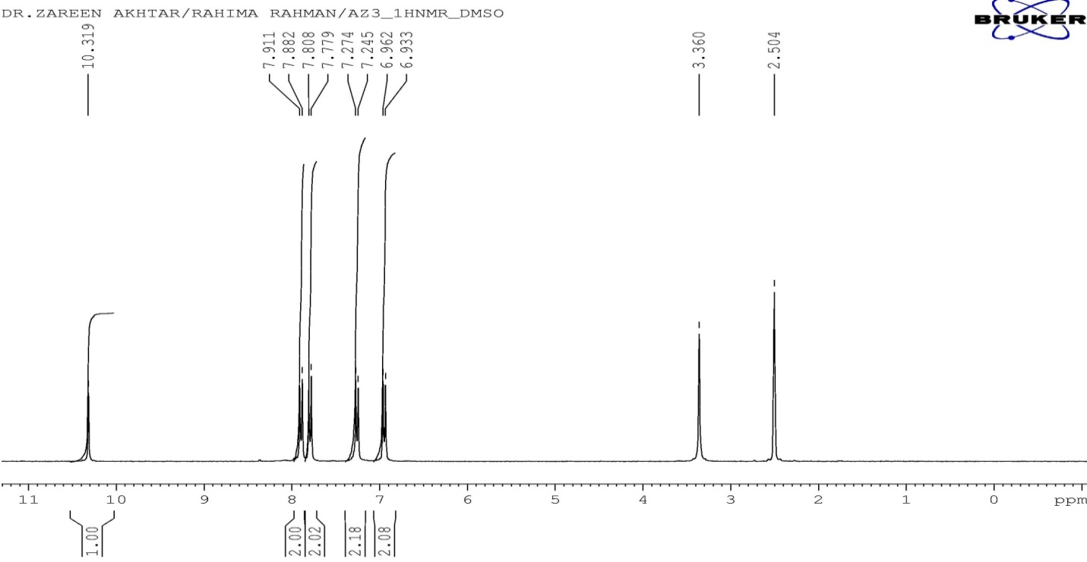 Figure 4 ¹H NMR Spectrum of aromatic diol monomer (3)

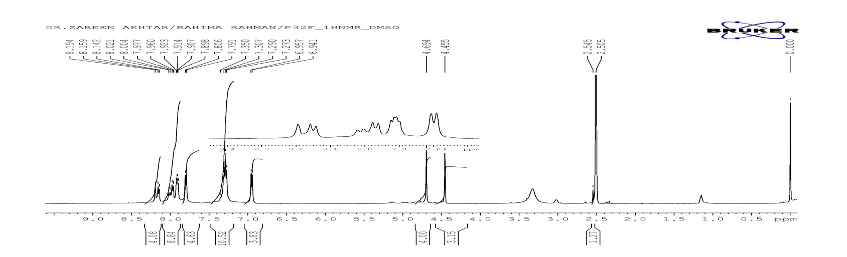
Figure 5 ¹H NMR Spectrum of poly(azobenzene)-ester P32F

