Supplementary Information

Effects of domestic solid fuel combustion emissions on biomarkers of homemakers in rural areas of Fenwei Plain, China

Fig. S1 a) Epidemiological questionnaires for subjects; b) Photos of biomass user households; c) Photos of coal user households; d) Photos of non-solid user households.
Table S1 Mean and standard deviation for biomarker concentration and health indicator.

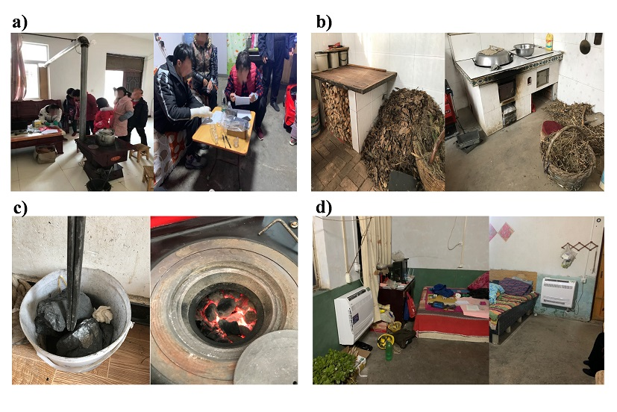
Fig. S1 (a-d)
Table S1 Mean and standard deviation for biomarker concentration and health indicator.

 | Winter (N=61) |  |  |  |  | Summer (N=61)
Main household energy | Biomass | Coal |  | Non-solid fuel | Biomass |  | Coal | Non-solid fuel
 | N=24 | N=27 |  | N=10 | N=24 |  | N=27 | N=10
Urinary biomarkers
IL-6 (pg/ml) | 4.74±4.98 | 5.01±7.38 |  | 1.79±1.85 | 2.27±4.70 |  | 1.91±2.23 | 1.17±1.58
8-OHdG (pg/ml) | 118.02±41.62 | 129.07±61.28 |  | 152.06±62.51 | 72.62±19.08 |  | 72.82±29.12 | 84.87±34.80
TNF-α (pg/ml) | 2.33±0.46 | 2.68±1.30 |  | 2.48±0.32 | 2.96±0.82 |  | 3.16±0.77 | 3.18±1.06
Creatinine (mmol/L) | 7.31±3.88 | 6.45±4.12 |  | 6.18±4.50 | 5.94±3.45 |  | 6.79±3.80 | 4.96±2.64
Urinary biomarkers normalized by urinary creatinine
IL-6 (μg/mol UCr) | 0.75±0.76 | 0.69±0.57 |  | 0.35±0.23 | 0.48±0.87 |  | 0.28±0.22 | 0.25±0.22
8-OHdG (μg/mol UCr) | 22.90±16.02 | 29.05±23.57 |  | 29.21±18.35 | 22.65±35.16 |  | 14.17±8.50 | 18.03±10.60
TNF-α (μg/mol UCr) | 0.43±0.27 | 0.61±0.54 |  | 0.54±0.29 | 0.92±1.53 |  | 0.59±0.30 | 0.77±0.37

