Supplementary Note 2
Cross-case synthesis of interactions (further information)

As noted in the main manuscript, although we recommend that the 13 principles presented here are always applied as a comprehensive set, how they interact with one another will likely differ from case to case. This is best illustrated using a number of examples that show the 13 principles interacting with one another in specific cases. The cases are summarised in Fig. S1, which synthesises the interactions between the principles focusing on supporting/enabling interactions (Fig. S1a) and constraining/conflicting interactions (Fig. S1b). Note that Fig. S1 is replicated from Fig. 5 in the main manuscript but is included here for ease of reference.

From a methodological standpoint, it is important to note that we are not claiming we used case study as a research approach (as per Yin¹). Instead, the cases used in the manuscript (and described here in further detail) provide illustrations of how the 13 principles could be applied in practice. The cases were selected using the following five criteria:
- The cases should collectively display a range of potential applications of the principles, supporting projects, initiatives, frameworks, metrics and regulatory mechanisms, and policy- and law-making.
- The cases should be multi-faceted, with each case ideally containing a complex mix of social, institutional, ecological, and/or technical dimensions that resist simple solutions.
- The cases should feature multiple stakeholders and/or categories of stakeholders, adding further complexity to the multi-dimensional nature.
- The cases should be at different institutional levels and apply to diverse geographies.
- At least one of the 21 co-authors of the manuscript should be familiar with the case, either via their direct involvement or via their analysis of the case (to this end, all co-authors were invited to suggest cases and provide rationales and descriptions).

The cases are introduced in Table S.1 alongside a brief rationale, with a cross-case synthesis in Fig. S.1.

Table S.1 | Overview of the five cases.
Case |  | Institutional level | Overview | Rationale
Case 1 | The Algoa Bay project | Sub-national | The Algoa Bay project is a multi-institutional and multi-disciplinary research project based in South Africa, with the broad objective of developing an ecosystem-based marine spatial plan (MSP), with a particular focus on inclusivity. | Algoa Bay is the most well-researched bay in the Southern Hemisphere² and is a national pilot project for integrated ocean management (IOM).
Case 2 | Strategic framework to support Marine Spatial Planning in the Western Indian Ocean (WIO) region | Regional | A Strategic Framework to support MSP was developed for the Western Indian Ocean (WIO) region, funded by the United Nations Environment Programme. The Framework uses a systems thinking approach, with outputs intended to be useful at both national and regional scales and to inform continental strategies. | Millions of people live along the coastlines of the countries that make up the WIO and there are significant pressures on coastal and marine resources. The region is also under-capacitated in terms of technical expertise and is characterised by extensive governance challenges. There is, at this point, no strategic support for regional-level marine spatial planning.
Case 3 | The Monterrey Framework for socially responsible seafood | Global | In response to human rights abuses in the global value chain, NGOs developed ‘The Monterrey Framework’ for socially responsible seafood as a means of ensuring that seafood is both socially responsible as well as ecologically sustainable. | A combination of collapsing fisheries and extensive human rights abuses in the global seafood industry point to the importance of frameworks and certifications that support both social responsibility alongside ecological sustainability.
Case 4 | Ocean governance incentives | Global | A framework of 36 incentives covering five categories of different approaches to governance was developed³, which argues that a diversity of governance incentives is needed in integrated ocean governance. This framework was developed through the analysis of >50 Marine Protected Area (MPA) governance case studies and has been adapted and applied to 12 integrated ocean management case studies. | In the development of this framework of governance incentives, >50 governance case studies were analysed using a common template (categorised by “context, objectives, drivers and conflicts, governance framework/approach, incentives effectiveness; and cross-cutting themes”). This common template facilitated cross-comparisons of what incentives exist, how they have been implemented and what success they have had, out of which Jones et al.’s framework of 36 incentives covering five categories of different approaches to governance was developed³.
Case 5 | The US Ocean-based Climate Solutions Act | National | The Ocean-based Climate Solutions Act (which is under consideration as a bill in the US House of Representatives) was proposed in 2020 as the first comprehensive piece of legislation for ocean-based climate solutions, including reducing greenhouse gas emissions, promoting offshore renewable energy, protecting blue carbon, expanding MPAs and improving ocean health. | As the first piece of legislation for ocean-based climate solutions in the USA, the Ocean-Based Climate Solutions Act is an important example of a national-level governance intervention. Given the comprehensiveness of the bill’s proposals and the USA’s superpower status the bill has potential far-reaching implications for equivalent legislation globally.

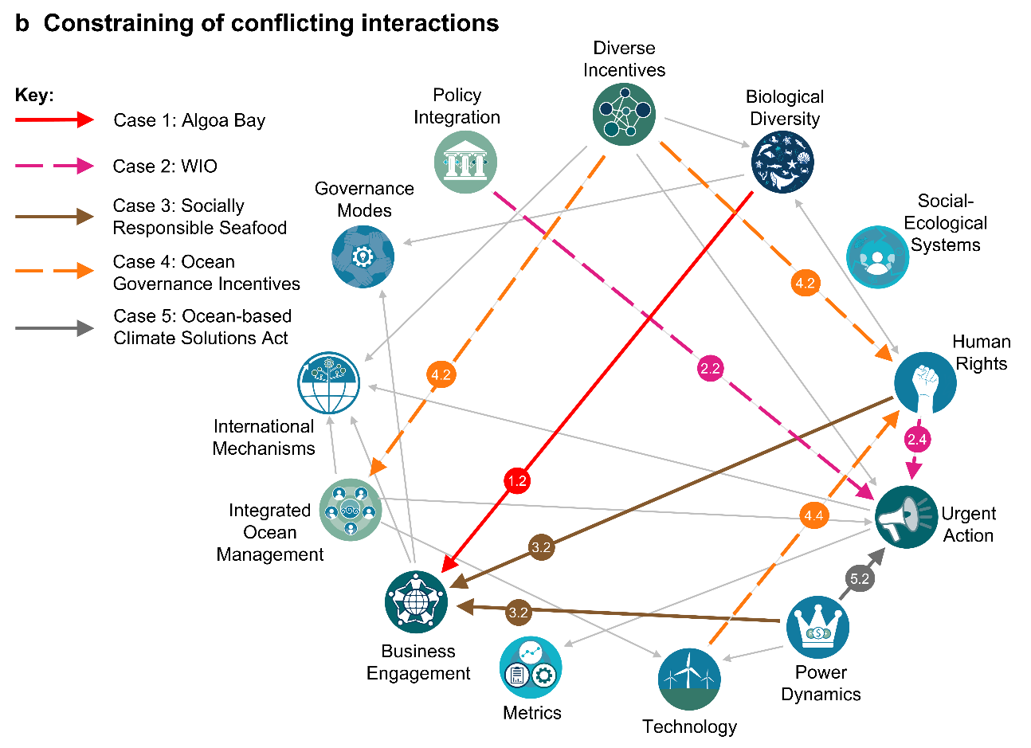
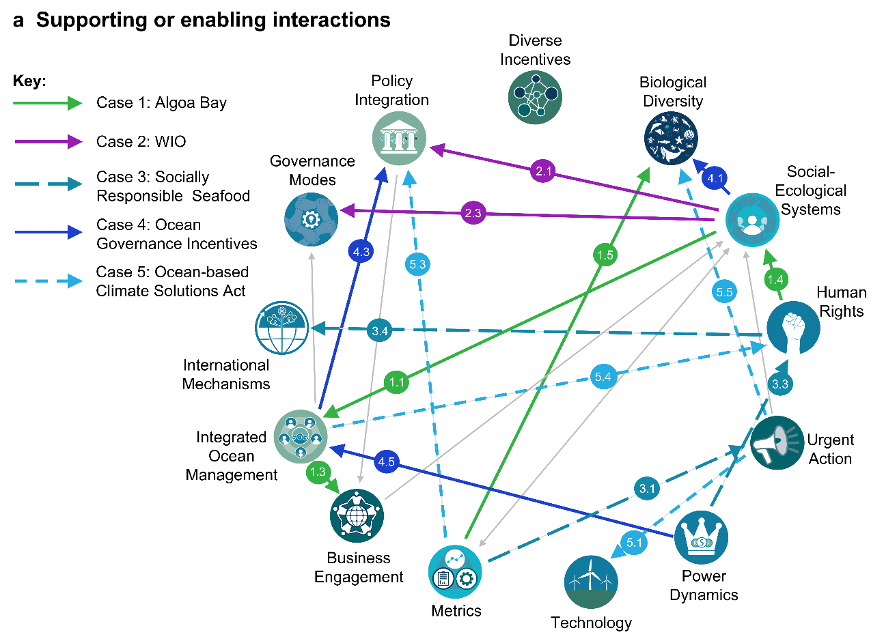
Cross-case synthesis of interactions

Fig. S1 | Five cases that show how the 13 principles can interact. The numbered arrows cross-reference directly with the text in the main manuscript and this Supplementary note.
Case 1: Algoa Bay

This multi-institutional and multi-disciplinary research project is a sub-component of a larger Community of Practice in Marine Science in Algoa Bay². The project's objective is to develop a local Marine Spatial Plan (MSP) for the bay, guided by the UNESCO step-by-step approach towards an ecosystem-based management MSP process⁴, with a focus on inclusivity. The outputs are intended to be scalable so as to inform the implementation of South Africa's new national MSP legislation⁵.

Examples of how the project applies some of the 13 principles, in interaction with one another, are provided below:

1.1. SES approaches supporting inclusive and transparent IOM processes:
- Vermeulen et al.⁶ developed an exploratory System Dynamics Model to support MSP in Algoa Bay (as one type of IOM process) and provided a visual user interface (VUI) that stakeholders can use for scenario-planning and decision making to inform and support MSP.
- This model and interface emphasised marine sustainability, showing the necessity for healthy marine ecosystems in order to support the multiple sectors in the bay that are reliant upon them. The systems model incorporated many feedbacks both within and between sectors and between the social and ecological sub-systems.
- The systemic framing of the broader Algoa Bay project is additionally demonstrated by the ecosystem-based approach to MSP adopted by the project⁷, which recognises that healthy marine ecosystems and biological diversity are both key for resilient ecosystems.

1.2. Biological diversity as constraining business engagement:
- To protect foraging grounds of the endangered African penguin (Spheniscus demersus) in Algoa Bay, fishery exclusion zones⁸ and a marine protected area have been implemented.
- The small-pelagic fishery industry was averse to these exclusions, citing perceived negative impacts on catch and travel time to alternative fishing grounds.
- In a subsequent study, Ginsburg⁹ attempted to interview members of the fishing industry to gain a better understanding of their views and to start building a collaborative platform for discussion on dynamic ocean management.
- The fishing industry was initially reluctant to participate in the engagement process, perceiving the biodiversity emphasis of the closures as a potential constraint on their business.
- The industry later agreed to participate. Their views and insights actually supported closures, as long as the impacts of the closures were not significantly negative, and this work has now opened up a mechanism for coordinated stakeholder engagement between conservation and fishery managers, and the fishing industry.

1.3. IOM supporting coordinated engagement / engaging business:
- The Algoa Bay MSP process was specifically designed to be inclusive, transparent and integrated.
- Stakeholder engagement was bottom-up and was achieved through ongoing meetings, workshops and outreach activities.
- As part of this stakeholder engagement, ocean businesses and other diverse ocean stakeholders were involved in, and contributed to, multiple parts of the MSP process, including through participatory mapping, collaborative modelling, and one-on-one meetings.

1.4. Human rights supporting SES:
- The MSP process recognised the value of incorporating different knowledge systems and methodologies and including diverse stakeholders as knowledge holders.
- Particular sub-projects included:
  - (i) a dedicated PhD study that works with local knowledge holders using arts-based methods such as photovoice, digital storytelling and photography; and
  - (ii) the investigation of tangible and intangible biocultural heritages as a means of surfacing peoples’ diverse conceptions and valuations of the oceans and coasts.
- These projects are contributing to ‘cultural layers’ in the MSP, reflecting the social-ecological systems framing of the overall MSP.

1.5. Metrics supporting biological diversity:
- To support site prioritisation and zoning (an important part of MSP), the project determined quantitative conservation targets for marine ecosystems in the bay (Holness et al. In Review).
- The impacts of Harmful Algal Blooms (HABs) on aquaculture, bathing, and sea life (amongst others) were monitored and assessed using a HABs Decision Support Tool developed by the National Oceans and Coastal Information System (https://www.ocims.gov.za/hab/app/).
- Other nationally set thresholds for environmental management were also drawn upon (including catch limits for fishing, both recreational and commercial, and water quality thresholds for aquaculture).

Case 1 References
- Yin, R. K. Case Study Research and Applications: Design and Methods (6th ed) (Sage Publications, 2018).
- Dorrington, R. A. et al. Working together for our oceans: a marine spatial plan for Algoa Bay, South Africa. South African Journal of Science 114(3-4), 1-6 (2018).
- Jones P. J. S. & Long S. D. Analysis and discussion of 28 recent marine protected area governance (MPAG) case studies: challenges of decentralisation in the shadow of hierarchy. Marine Policy 127, 104362 (2021).
- Ehler, C. & Douvere, F. Marine Spatial Planning: a step-by-step approach toward ecosystem-based management (Intergovernmental Oceanographic Commission and Man and the Biosphere Programme, 2009).
- Government of the Republic of South Africa. Marine Spatial Planning Act No. 16 of 2018 (Government Gazette No. 42444, 647, 2019).
- Vermeulen, E. A., Clifford-Holmes, J.K., Scharler, U. & Lombard, A.T. A System Dynamics Model to Support Marine Spatial Planning in Algoa Bay, South Africa. Environmental Modelling and Software (In Press).
- Holness, S. D. et al. Using systematic conservation planning to align priority areas for biodiversity and nature-based activities in marine spatial planning: A real-world application in contested marine space. Biological Conservation 271(April), 109574 (2022).
- Sherley, R. B. et al. Bayesian inference reveals positive but subtle effects of experimental fishery closures on marine predator demographics. Proceedings of the Royal Society B: Biological Sciences 285(1871), 20172443 (2018).
- Ginsburg, T. Involving fishermen in seabirds’ conservation: bridging the gap between socioeconomic needs of industry and the needs of seabirds (MSc thesis Nelson Mandela University, 2019).

Case 2: Western Indian Ocean (WIO)

This Strategic Framework was developed for the United Nations Environment Programme in response to requests from member countries of the Nairobi Convention¹. The Framework's objective is to provide principles, guidance and methodology for regional MSP, and for member countries to apply as they develop (or continue developing) their national MSPs, with a focus on inclusivity. The Framework uses a systems thinking approach to illustrate and emphasise the connectivity of marine social-ecological systems in the region and advocates an ecosystem-based approach to MSP. The outputs are intended to be useful at both national and regional scales, and to inform continental strategies such as the Africa Blue Economy Strategy², Africa’s Integrated Maritime Strategy³ and the African Strategy for Ocean Governance⁴.

Examples of how the project applies some of the 13 principles, in interaction with one another, are provided below:

2.1. SES supporting integration of cross-sectoral policies:
- The Framework defines a vision, goal, 11 objectives and nine strategic objectives for the WIO region, and a systems thinking approach is one of its guiding principles.
- A systemic perspective on the strategic priorities is provided, with accompanying causal loop diagrams (CLDs) to illustrate the interactions and feedbacks of different components of the WIO social-ecological system.
- By understanding the complex and interconnected nature of marine social-ecological systems in the region, the systemic perspective (illustrated by the CLDs) can inform the development of marine spatial plans that can drive positive outcomes and minimise negative outcomes.
- By doing so, the impacts of one sector on another can be assessed and an integrated, holistic picture of the coastal and marine context can be developed.
- A systemic approach can also be used to help identify strategic leverage points in the policy landscape that can be addressed to shift the WIO region (i.e., the system) towards social and ecological sustainability over time, therefore achieving social and ecological connectivity.

2.2. Human rights constraining being able to take urgent action across governance levels:
- Population growth has resulted in increased numbers of people living in coastal areas, with intensifying pressures on coastal systems.
- The WIO's ocean assets have supported the well-being of its communities for centuries (Obura et al. 2017).
- Prioritising human requirements has resulted in many of these ocean assets being undermined.
- Urgent actions that are proposed to address these challenges (e.g. Obura et al.⁵) have proposed transforming national developmental models to minimise the impacts on ocean health.
- Human-centric priorities for development, focusing on poverty alleviation through economic development (for example), could constrain stakeholders’ abilities to take the urgent action as proposed above.

2.3. SES supporting dynamic, inclusive and adaptive modes of governance:
- Governance of the WIO region must address broad-scale processes that are often dynamic and spatially extensive, for example, migratory species and Illegal, Unreported and Unregulated (IUU) fisheries.
- A systemic approach helps make explicit the trade-offs between policies and desired outcomes, showing where policies can constrain or conflict with one another, versus how they can reinforce and support one another.
- Participatory systems-based approaches (such as participatory modelling) can support more broad-based, inclusive, and multi-stakeholder processes that recognise the necessity to effectively conserve and protect ecosystem services upon which human well-being depends (i.e. the social-ecological system of the WIO).
- Systemic approaches also make explicit the fact that external drivers, outside of the system boundary, can act as major disruptors (an example of which is the impacts of the COVID-19 pandemic on eco-tourism in the WIO).

2.4. Integration of cross-sectoral policies as (negatively) constraining urgent action:
- The cross-sectoral and trans-national perspectives on regional-level MSP are informed by the Strategic Framework’s basis in systems thinking.
- Aiming to integrate cross-sectoral policies systemically requires investments in time and technical resources, which can constrain and conflict with being able to take urgent action.

Case 2 References

- UNEP-Nairobi Convention. A Strategic Framework for Marine Spatial Planning in the Western Indian Ocean (UNEP-Nairobi Convention, WIOMSA, Nelson Mandela University, and Macquarie University, 2021). https://nairobiconvention.org/clearinghouse/sites/default/files/WIO%20MSP%20Strategy_8Oct2021_0.pdf
- African Union-IBAR. Africa Blue Economy Strategy (Nairobi, Kenya, 2019).
- African Union. 2050 Africa's integrated maritime strategy (2050 AIM Strategy). https://au. int/en/documents-38 (2012).
- African Strategy for Ocean Governance (https://www.unep.org/events/conference/third-consultative-meeting-development-african-strategy-ocean-governance)
- Obura, D., Smits, M., Chaudhry, T., McPhillips, J., Beal, D. & Astier, C. Reviving the Western Indian Ocean economy: actions for a sustainable future (World Wide Fund for Nature (Formerly World Wildlife Fund), Switzerland, 2017) 1-63.

Case 3: Socially responsible seafood

In response to human rights abuses in global value chains, NGOs involved in sustainable seafood certification adopted human rights perspectives to address violations in civic, judicial and political rights and violations and shortfalls in economic, social and cultural rights¹. This was to ensure sustainable seafood is socially responsible as well as ecologically sustainable².

The resulting framework, called ‘The Monterrey Framework’, consists of three pillars:
- Protecting human rights and dignity and respecting access to resources;
- Ensuring equality and equitable opportunities to benefit; and
- Improving food and livelihood security¹.

Examples of how the framework applies some of the 13 principles, in interaction with one another, are provided below:

3.1. Metrics supporting urgent action:
- The pervasiveness and severity of human rights violations in the global seafood industry necessitates urgent action.
- Socially responsible seafood certification, as a form of metric, meets the urgent need for broadly accepted and commercially-viable quantitative measures of social sustainability.

3.2. Human rights and sensitivity to existing and potential power dynamics as constraining business engagement:
- The Monterrey Framework’s emphasis on ‘ensuring equality and equitable opportunities’ as part of ‘socially responsible and environmentally sustainable seafood’ is built on the recognition that much of the existing value of seafood is captured by large, often multi-national, ocean businesses.
- However, most of the catch for direct human consumption is supplied by small-scale and customary fishers for whom a critical issue is the right to resource access.
- The Monterrey Framework’s focus on human rights and sensitivity to power dynamics could be seen to threaten the current operations of large seafood businesses, reducing their willingness in participate in coordinated engagement.

3.3. Sensitivity to power dynamics supporting human rights:
- Fishing communities are frequently at risk of human rights violations, which range from slavery to less acute, but more pervasive, practices such as withholding of wages, poor working conditions, and restrictions on freedoms:
- “… ensuring that seafood is equitably produced requires that benefits accrue to all participants in the supply chain (e.g. fishers, processors, and distributors) not just those with financial or political power”¹.

3.4. Human rights supporting international mechanisms:
- Existing policy instruments include:
  - International Labour Organization’s Work in Fishing Convention;
  - The UN FAO’s Guidelines for Securing Small-Scale Fisheries; and
  - the UN’s guiding principles on business and human rights.
- The Monterrey Framework frames the social responsibility aspects of sustainable seafood and has the potential to assist “in global alignment among governments, businesses, civil society, and nonprofit organizations, driving integration of social responsibility into policy, practice, and ultimately performance in the sector”¹.

Case 3 References

- Kittinger, J. N.et al. Committing to socially responsible seafood. Science 356(6341), 912–913 (2017)
- Hicks, C. C. et al. Engage key social concepts for sustainability. Science 352(6281), 38–40 (2016).

Case 4: Ocean governance incentives, focusing on the importance of a diversity of incentives in integrated ocean governance

Jones¹ developed a framework of 36 incentives covering five categories of different approaches to governance (namely legal; participatory; economic; knowledge-based; and awareness-raising approaches). This framework was developed through the analysis of >50 Marine Protected Area (MPA) governance case studies (www.mpag.info) around the world and has been adapted and applied to 12 integrated ocean management (IOM) case studies around Europe².

This analysis argues that a diversity of governance incentives is needed in integrated ocean governance to promote the resilience of both social and ecological systems, i.e. “diversity is the key to resilience, both of species in ecosystems and incentives in governance systems”³.

Examples of how the framework applies some of the 13 principles, in interaction with one another, are provided below:

4.1. SES approaches as supporting biological diversity:
- Recognising and accounting for social and ecological connectivity can lead to a virtuous cycle in which a reduction in human impacts on the marine environment benefits biodiversity health, which sustains ecosystem services that lead to greater human benefits and increased capacity to resist the incentives to undertake high-impact activities (incentives such as short-term profit at the expense of longer-term sustainability).
- An increase in capacity to resist the high-impact activities leads to fewer impacts on marine systems, which results in an overall increase in biodiversity health, creating a second reinforcing feedback loop³.
- The recognition of social and ecological connectivity, with associated feedback loops, highlights the importance of a systemic perspective toward supporting biological diversity.

4.2. Incentives as (negatively) constraining inclusive and transparent IOM and human rights approaches:
- In an analysis of 12 IOM case studies in Europe⁴, it was seen that sectoral growth priorities (with their associated economic incentives) are often considered to be of national importance.
- In many of the cases analysed by Qiu and Jones⁴ the prioritisation of sectoral growth effectively overrides local public opinions.
- The narrower focus on one type of incentive (namely economic incentives) erodes the principles of inclusivity and transparency that are central to IOM in general and to human rights approaches, in particular.
- In Jones’ framework¹, the principles of inclusivity and transparency are recognised through participatory, knowledge-based and awareness-raising approaches to governance, which are often minimised or excluded in practice.

4.3. IOM as supporting and enabling integration of cross-sectoral policies (to achieve social and ecological connectivity):
- The emphasis within IOM on recognising the interconnections between different sectoral activities helps reduce sources of conflict between those same sectors.
- The IOM goal of supporting ecosystem conservation alongside sustainable ‘blue economy’ activities recognises social and ecological connectivity and, in so doing, enables the transition from fragmented ocean governance towards integrated and transformative ocean governance.

4.4. Technology as sometimes constraining human rights:
- Advances in deep seabed mining and bottom trawling show how technology can disadvantage small-scale users of coastal and marine resources in the regions where the mining and trawling happens.

4.5. Sensitivities to existing and potential power dynamics as supporting IOM:
- Power dynamics between small-scale fisherpeople and IUU fishing:
- Small-scale users have limited resources for monitoring and there are large spatial scales to grapple with.
- Technology can be harnessed here – vessel monitoring systems (and their associated smartphone applications) use a combination of satellite imagery and remote sensing that allow for small-scale users to track fishing fleets and therefore have a ‘virtual’ presence on the water, even when the users doing the tracking have limited resources and large spatial scales to work with³.

Case 4 references

- Jones, P. J. S. Governing marine protected areas: resilience through diversity (Routledge, 2014).
- Jones, P. J. S., Lieberknecht, L. M. & Qiu, W. Marine spatial planning in reality: Introduction to case studies and discussion of findings. Marine Policy 71, 256-264 (2016).
- Jones P. J. S. & Long S. D. Analysis and discussion of 28 recent marine protected area governance (MPAG) case studies: challenges of decentralisation in the shadow of hierarchy. Marine Policy 127, 104362 (2021).
- Qiu, W. & Jones, P. J. S. The emerging policy landscape for marine spatial planning in Europe. Marine Policy 39, 182-190 (2013).

Case 5: The Ocean-Based Climate Solutions Act

The Ocean-Based Climate Solutions Act is under consideration as a bill in the US House of Representatives. It was first proposed in 2020, with comments incorporated into a revision, which was released in mid-2021¹. The proposed legislation contains comprehensive climate-based solutions that include reducing greenhouse gas (GHG) emissions associated with the ocean sector, promoting offshore renewable energy, protecting blue carbon, supporting climate-ready fisheries, expanding MPAs, and improving ocean health².

Examples of how the act illustrates the interactions between some of the 13 principle are provided below:

5.1. Urgent action as supporting technological innovations:
- The Ocean-Based Climate Solutions Act (‘the Act’) positions ocean-related technical innovation as part of the urgent actions.
- The Act provides the framework for supporting technological innovations both directly and indirectly.
- Direct support is provided in proposed actions like incentives for increasing the fuel efficiency of fleets of fishing vessels; indirect support is provided via research into marine energy technologies and restorative ocean aquaculture, for example³.

5.2. Power dynamics could constrain taking urgent action:
- Negotiating who will benefit by the proposed changes, how and when, will be difficult: powerful actors, such as industry bodies, can use the legal system to block and/or delay proposals that conflict with their activities.
- Hence, existing power dynamics could result in delays in taking urgent action.

5.3. Metrics supporting integration of cross-sectoral policies for social and ecological connectivity:
- The Act proposes a range of ways in which metrics can support integration includes proposals to enhance ocean data collection and monitoring, with researching [and] forecasting ocean acidification and harmful algal blooms³.
- Other monitoring-related proposals include the monitoring, reporting and verification requirements of greenhouse gas emissions for all vessels over 5,000 gross tons.
- As of July 2021, the updated bill proposes an additional "near Real-Time Large Whale Monitoring and Mitigation Program"¹, complimenting earlier proposals of protecting marine mammals through vessel speed programs³.
- The bill further proposes the "establishment of an Inter-Agency Working Group on Blue Carbon that creates a database for tracking blue carbon stocks and fluxes in the United States and utilizes models to estimate blue carbon storage potential"².
- This combination of new data collection and management instruments can provide the empirical basis for a range of metrics to support integration of cross-sectoral policies for social and ecological connectivity.

5.4. IOM as supporting human rights:
- The bill promotes “coastal resiliency and adaptation through... coastal community adaptation”³ as one way in which IOM measures could support human rights.
- The intention of helping “frontline communities most at risk in the face of climate change" includes practical responses such as a “coordinated Federal response to support the voluntary relocation of communities impacted by sea level rise”².
- Finally, the bill establishes “a grant program for projects that promote climate resilient coastlines and fisheries, aimed at assisting communities of colour, as well as low-income, Tribal, and rural communities"².

5.5. Urgent action as supporting biological diversity:
- The bill seeks to set an ambitious target of "protecting at least 30% of our ocean by 2030"³, which, via Marine Protected Areas (MPAs), will help to protect and conserve existing biological diversity, including at-risk species.
- The bill additionally mandates the creation of a “federal task force to review the inventory of existing MPAs and new areas that deserve additional protection”².

Case 5 references
- Conner, D. L., Garland, B., Hobbs, J. T., Ruge, M. & Tohan, A. K. Shipping Emissions Remain a Focus of Reintroduced House Bill. The National Law Review 6(165), 1–4 (2021).
- Ocean Conservancy. The Ocean-Based Climate Solutions Act of 2020: Fact Sheet. Available at: https://oceanconservancy.org/wp-content/uploads/2020/10/Ocean-Based-Climate-Solutions-Bill-Fact-Sheet.pdf (2020).
- Natural Resources Committee. The Ocean-Based Climate Solutions Act: Fact sheet. U.S. House of Representatives. Available at: https://naturalresources.house.gov/imo/media/doc/Oceans Climate Action Factsheet.pdf (2020).

