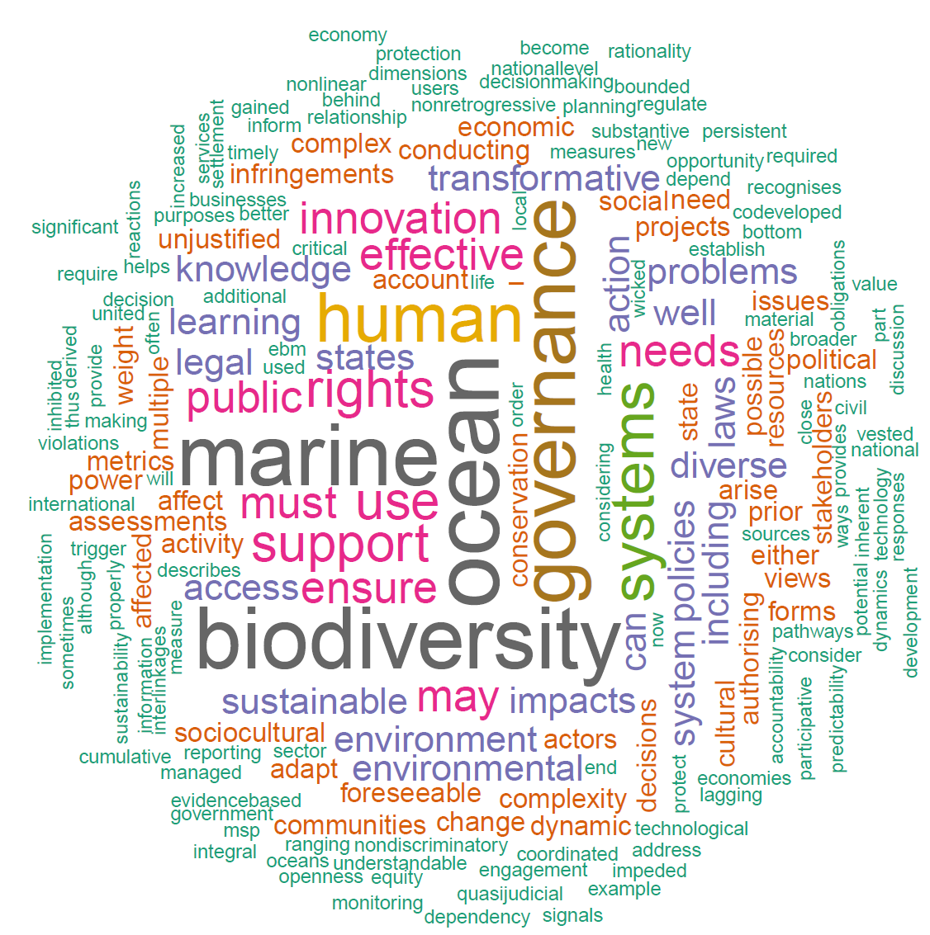
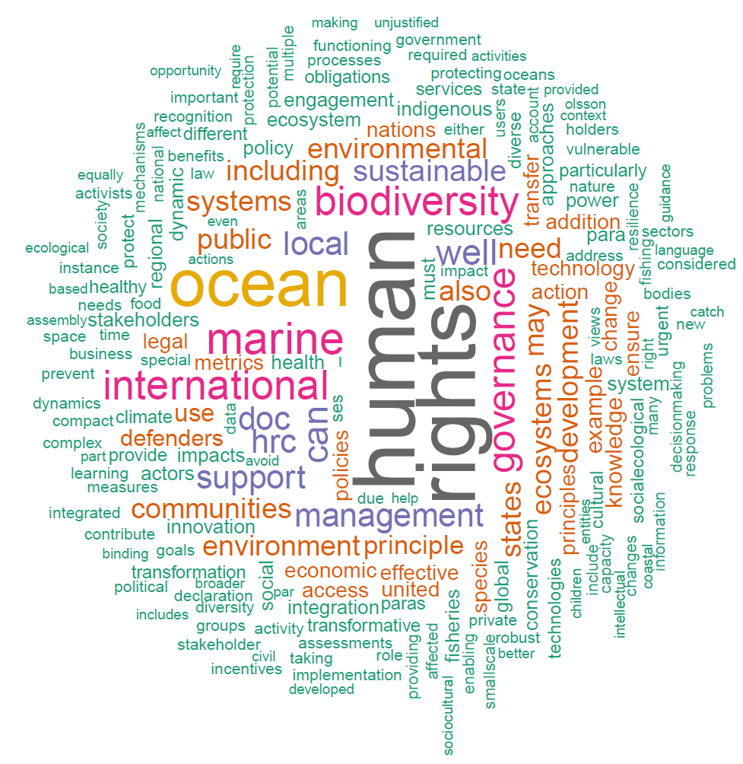
b

a

Supplementary Fig. 1 | Word cloud generated from the brief text (a) and longer narratives (a) of the 13 principles from Table 1 and Supplementary Note 1 respectively.

Supplementary Fig. 2 | Frequencies of word occurrences within the six high level themes that emerged from the word clouds in Supplementary Fig. 1.

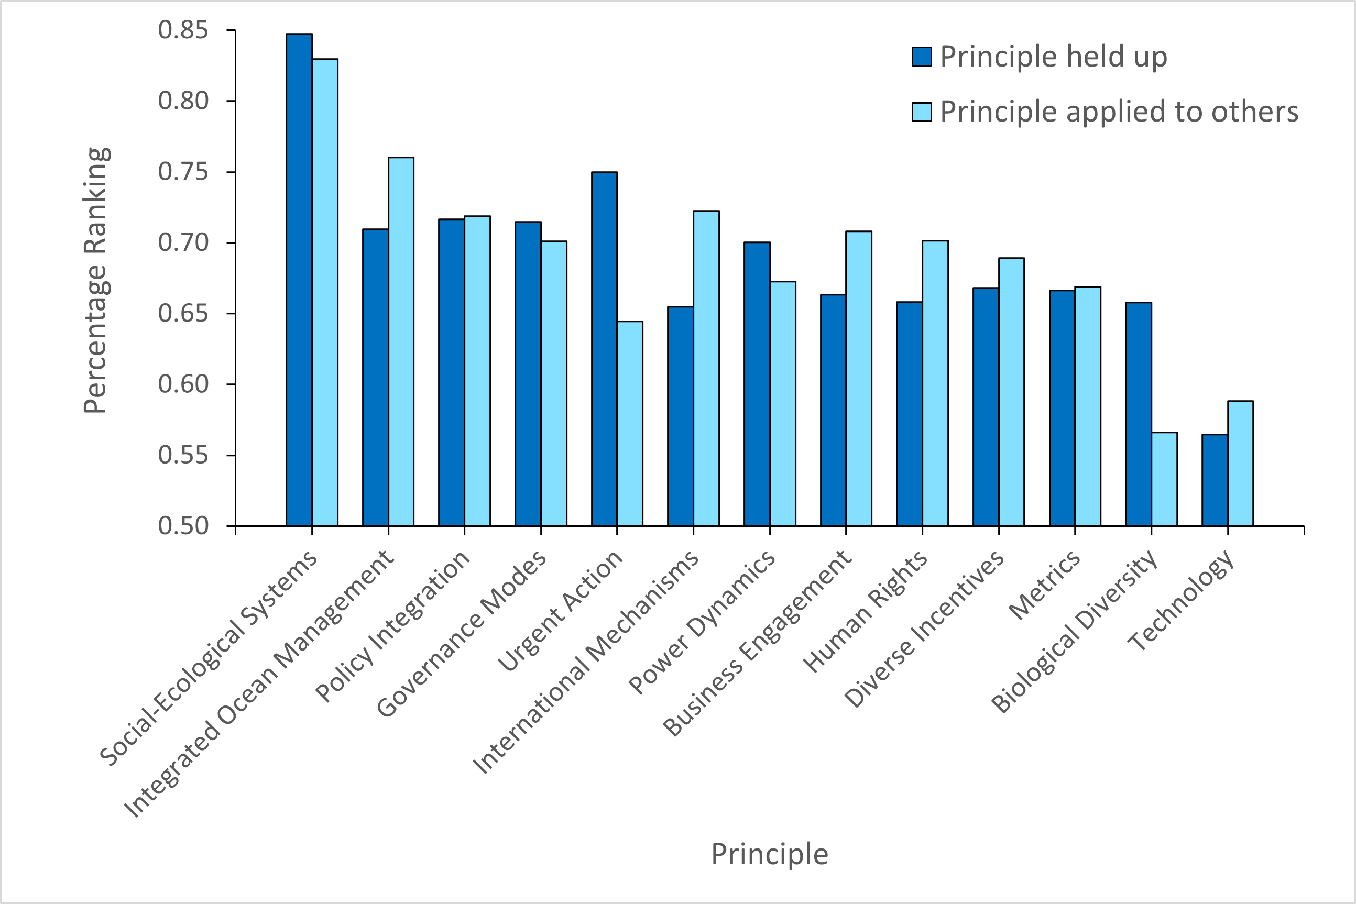
Supplementary Fig. 3 | The percentage of respondents who identified a supporting or enabling relationship between principles. The questions were asked in two directions with the plot illustrating “Principle held up”: when that principle is held up and each other principle is applied (dark blue); and “Principle applied to others”: when that principle is applied to all other principles being held up (light blue). The plot is ordered based on the sum of the combined percentages per principle. Social-Ecological Systems was the most supported principle in both directions. Urgent Action and Biological Diversity both showed stronger supporting relationships when considered as the principle being held up, however, a much lower percentage support when they were applied to other principles being held up.

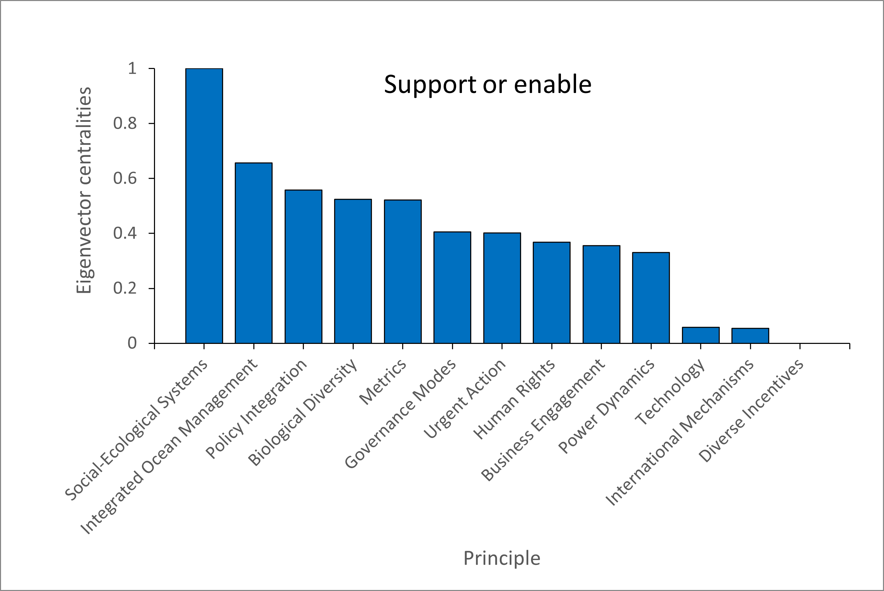

Supplementary Fig. 4 | The Figure shows the eigenvector centralities. This measure is calculated during the social network analysis and provides a measure of the influences of the principles in terms of the supporting and enabling relationships. A score is assigned to each principle based on the idea that connections to high-scoring principles contribute more to the score of the principle in question than connections to low-scoring principles. Social-Ecological Systems is the most influential principle, while Technology, International Mechanisms and Diverse Incentives are the least influential.

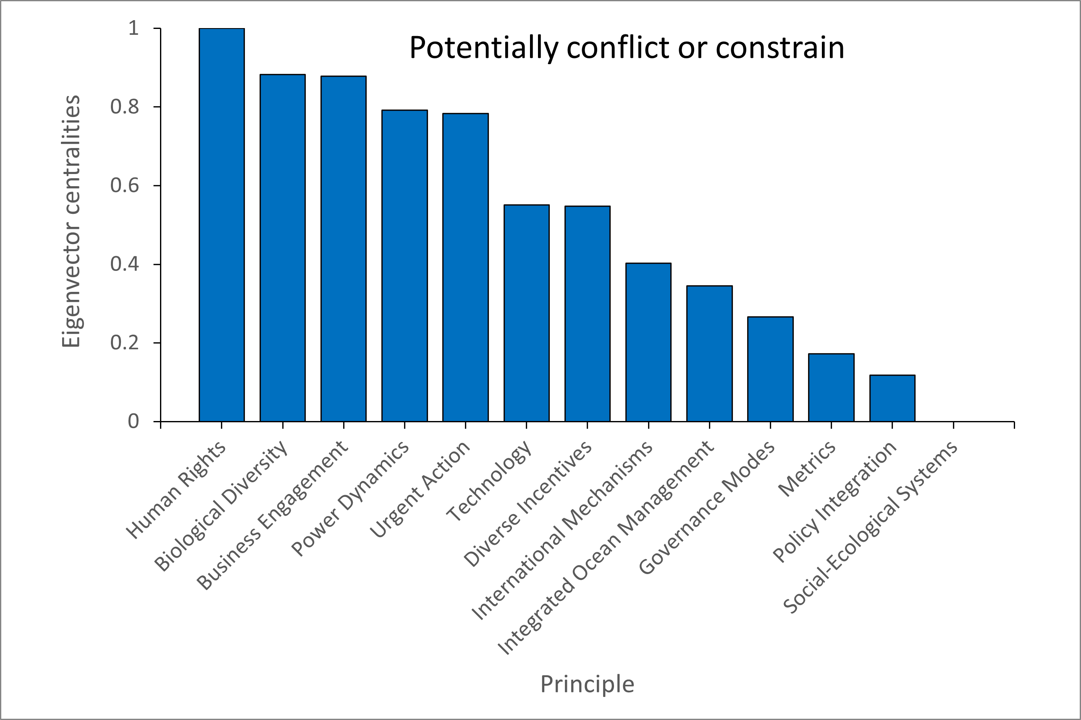

Supplementary Fig. 5 | The eigenvector centralities for the potentially conflicting or constraining relationships between the principles. Human Rights, Biological Diversity and Business Engagement are the three most influential principles in terms of conflicting relationships. Metrics, Policy Integration and Social Ecological Systems are the least influential in terms of conflicting relationships.

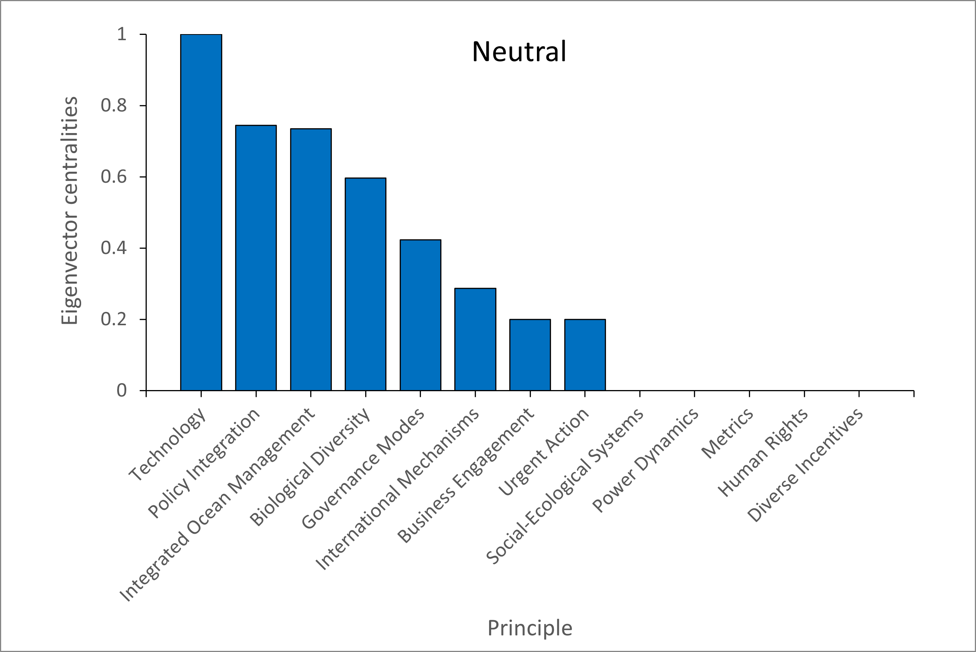
Supplementary Fig. 6 | The eigenvector centralities for the neutral relationships between the principles. Technology was the most influential principle in terms of neutral relationships.

