Supplementary Note 1
Thirteen principles for transformative ocean governance: full narratives

Transformative ocean governance…
- …maintains biological diversity, which is key for resilient ocean ecosystems.
Keywords: Biological Diversity
Thematic links: Systemicity; Importance of Diversity
Biological diversity (often referred to as biodiversity) includes ecosystem, species and genetic diversity, all of which play a vital role in the structure, functioning and productivity of ecosystems. High biodiversity also provides insurance against environmental change and fluctuation (for example, storm events or shifting ocean fronts) and increases the resilience of ecosystems and species to this change1^{I}. Biologically diverse ecosystems are more likely to contain species with diverse traits (for example, wide temperature tolerances), and this in turn means that at least some species can adapt to and survive human-induced change (for example intense fishing pressure, ocean acidification, ocean warming). Healthy marine ecosystems are extremely important to society because of the ecosystem services they provide, including oxygen production, nutrient cycling, weather and climate regulation and buffering, food provision, cultural and recreational services, and resources for many other economic activities²⁻⁴. Ocean ecosystems have evolved over billions of years, and before the onset of the Anthropocene (i.e. the current geological age in which human activity has been the dominant influence on climate and the environment), rich biodiversity fuelled productive and resilient marine ecosystems. Although marine species extinctions are not as numerous as terrestrial and fresh-water extinctions, the Anthropocene has changed the structure, functioning and productivity of many marine ecosystems and altered their states, rendering them incapable of providing the ecosystem services they once did. Ecosystem, species and genetic diversity are the building blocks of healthy marine ecosystems, and these in turn underpin healthy societies. Given this dependence, the maintenance and rebuilding⁵ of biodiversity should be a founding principle in any ocean governance strategy. International recognition of the importance of biodiversity conservation and sustainable use is provided by the United Nations (UN) Convention on Biological Diversity (see cbd.int), and the UN Human Rights Council emphasizes the inter-dependence of biodiversity and human rights for human well-being, including economic, social and cultural dimensions (see Principle on ‘Human Rights’).

References
- Oliver, T. H. et al. Biodiversity and resilience of ecosystem functions. Trends in Ecology & Evolution 30(11), 673-684 (2015).
- WHO World Health Organization and Secretariat of the Convention on Biological Diversity, 2015. Connecting Global Priorities: Biodiversity and Human Health. A State of Knowledge Review. Downloaded 25Aug2022 from https://www.who.int/publications/i/item/connecting-global-priorities-biodiversity-and-human-health
- Boyce, D. G., Lotze, H. K., Tittensor, D. P., Carozza, D. A. & Worm, B. Future ocean biomass losses may widen socioeconomic equity gaps. Nature Communications 11(1), 1-11 (2020).
- Sala, E. et al. Protecting the global ocean for biodiversity, food and climate. Nature 592(7854), 397-402 (2021).
- Duarte, C. M. et al. Rebuilding marine life. Nature 580(7801), 39-51 (2020).

Transformative ocean governance…
- …upholds human rights approaches, which are essential for human well-being.
Keywords: Human Rights
Thematic links: Social inclusivity; Sustainable Development; Importance of Diversity
Human wellbeing is dependent on healthy and functioning ecosystems, that provide benefits in terms of physical and mental health as well as social, economic and cultural benefits¹. Just as conservation of biodiversity can help realise substantive human rights (see Principle on ‘Biological Diversity’), such as those to health, culture and food, the awareness of human rights can also help create an enabling environment for achieving conservation objectives², by legitimizing local people as human rights holders in their role as ecosystem stewards³ and clarifying the obligations for all States, other duty-bearers and relevant stakeholders, including business². Human rights approaches and standards thus contribute to transformative ocean governance, supporting the integration of inter-dependence of biodiversity and human wellbeing in decision-making, the recognition of ecosystem stewards and the duties of public authorities and others.
In 2021, the Human Rights Council recognised “the right to a clean, healthy and sustainable environment as a human right that is important for the enjoyment of human rights” (UN Doc A/HRC/RES/48/13). While States have different views on whether they are already subject to binding international legal obligations in this connection (and often use this argument to avoid taking necessary action at the national level), both from a legal and scientific perspective the understanding of the binding character of international law can contribute to the transformation needed in ocean governance (see Principle on ‘International Mechanisms’). Rightsholders, courts and government officials need to achieve a consensus on the binding nature of international environmental and human rights law and apply and enforce these commitments, which states have already adopted as parties to international human rights treaties. Underpinning this interpretation is the need to consider carefully how marine ecosystems contribute to the protection and realization of human rights. Accordingly, States authorising any activity, either conservation or sustainable use of marine ecosystems (including living and non-living resources), must ensure that no unjustified, foreseeable infringements of human rights may arise from their decisions (UN Doc A/HRC/34/49, 2017, para 33-35 and 69). To that end, States are to conduct prior assessments of possible socio-cultural and environmental impacts of projects or policies that may affect biodiversity. This is based both on potential public interventions that may infringe biodiversity-dependent human rights and on States’ obligations to prevent business entities from violating these rights (UN Doc A/HRC/34/49, 2017, paras 33-34) in the context of extractive activities, agriculture, the creation of protected areas, climate change response measures, or the development of renewables. As further specified in the Framework Principles on Human Rights and the Environment presented by the UN Special Rapporteur in 2017, these assessments “must include a careful examination of the impacts on the most vulnerable,” to avoid discrimination (UN Doc A/HRC/37/59, para 43) and ensure fulfilment of the obligations owed to those who are particularly vulnerable to environmental harm (UN Doc A/HRC/37/59, Principles 14 and 15). This specifically applies to indigenous peoples and small-scale fishers as well as children⁴.
For ocean governance to transform, States and other duty-bearers must ensure: affordable, effective and timely public access to information on biodiversity, in a language understandable to those affected; public participation in decision-making on biodiversity taking public views, including children’s views, into account; and access to effective remedies for violations of human rights and biodiversity laws by private and public actors (Doc A/HRC/34/49, 2017, paras 27–32).
States and other duty-bearers must protect biodiversity defenders as human rights defenders, including activists that “protect components of ecosystems whose benefits to humans may be less obvious, such as endangered species” (Doc A/HRC/34/49, 2017, paras 31-32). This means that the UN Declaration on human rights defenders (UN Doc A/RES/53/144, 1999) is applicable to biodiversity activists, who are “environmental human rights defenders”. Knox⁵ also recommended following international guidance on providing a safe and enabling environment for human rights defenders and generally protecting rights of freedom of expression, association and peaceful assembly in relation to biodiversity (Doc A/HRC/34/49, 2017, para 68).

References
- Summers, J. K., Smith, L. M., Case, J. L. & Linthurst, R. A. A review of the elements of human well-being with an emphasis on the contribution of ecosystem services. Ambio 41(4), 327-340 (2012).
- Campese, J. Rights-based approaches to conservation: An overview of concepts and questions. In: Campese, J. Sunderland, T., Greiber, T. & Oviedo, G. (Eds.). Rights-based approaches Exploring issues and opportunities for conservation, 1- 40 (2009).
- Jana, S. Rights-based approaches to natural resource management in buffer zone community forests: Learning from the grassroots. In: Campese, J. Sunderland, T., Greiber, T. & Oviedo, G. (Eds.). Rights-based approaches Exploring issues and opportunities for conservation, 187-202 (2009).
- Morgera, E. & Sweeney, M. ‘Don’t forget a healthy ocean as part of children’s right to a healthy environment’ One Ocean Hub Policy Brief (Glasgow, 2021) at (https://oneoceanhub.org/publications/policy-brief-dont-forget-a-healthy-ocean-as-part-of-childrens-right-to-a-healthy-environment/) (2021).
- Knox, J. Report of the Special Rapporteur on the issue of human rights obligations relating to the enjoyment of a safe, clean, healthy and sustainable environment: Framework Principles on Human Rights and the Environment, UN Doc A/HRC/37/59 (2018).

Transformative ocean governance…
- …adopts social-ecological systems approaches.
Keywords: Social-Ecological Systems
Thematic links: Systemicity; Integration Imperative
In arguing for a unified approach to oceans, the World Commission on Environment and Development noted that “interconnected cycles of energy, climate, marine living resources, and human activities move through coastal waters, regional seas, and the closed oceans”¹. Considered holistically, the ocean can therefore be defined neither as a state-governed public good, nor as a commodity or private good. Ocean governance faces the challenge of reflecting the multi-dimensional and interconnected role that the ocean plays in environmental health, economic prosperity and human well-being, including justice and equity (see Principle on ‘Policy Integration’). Systems approaches can assist with this multidimensionality and interconnectivity.
Considering oceans as social-ecological systems provides a useful overarching systemic framework. Social-ecological systems (SESs) are characterised by the high connectivity of social and biophysical variables that result in complex behaviour across spatial and temporal scales². Complexity in coupled human and natural systems exhibits a range of behaviour including “nonlinear dynamics with thresholds, reciprocal feedback loops, time lags, resilience, heterogeneity, and surprises”³.
Systems approaches, including systems thinking and modelling, can help scientists, managers and many other kinds of stakeholders to better understand the complexity of these interactions in order to improve systems outcomes against multiple metrics (see Principle on ‘Metrics’). Systems modelling approaches, such as system dynamics modelling, strive to “demonstrate the disadvantages of non-systemic solutions to complex issues and to formulate, test and demonstrate the advantages of systemic solutions”⁴. Other systems frameworks include the SES framework developed by Ostrom and colleagues, which analyses the multiple pathways of interactions in diverse governance systems⁵. SES scholars have also focussed their efforts on analysing governance mechanisms and the way in which SESs can be positively transformed^{6,7}. Important factors for accomplishing transformations in SESs include the role of innovation, transition strategies, enabling legislations, dynamic networks, entrepreneurship, leadership and different knowledge systems⁷.

References
- WECD. Report of the World Commission on Environment and Development: Our Common Future (Oxford University Press) (1987).
- Schlüter, M. et al. New horizons for managing the environment: A review of coupled social-ecological systems modeling. Natural Resource Modeling 25(1), 219–272 (2012).
- Liu, J. et al. Complexity of Coupled Human and Natural Systems. Science 317(September), 1513–1517 (2007).
- Wolstenholme, E. Using generic system archetypes to support thinking and modelling. System Dynamics Review 20(4), 341–356 (2004).
- Colding, J. & Barthel, S. Exploring the social-ecological systems discourse 20 years later. Ecology and Society 24(1) (2019).
- Mascareño, A., Cordero, R., Azócar, G., Billi, M., Henríquez, P. A. & Ruz, G. A. Controversies in social-ecological systems. Ecology and Society 23(4) (2018).
- Olsson, P., Bodin, Ö. & Folke, C. Building transformative capacity for ecosystem stewardship in social–ecological systems. In Adaptive capacity and environmental governance, 263-285 (Springer, Berlin, Heidelberg) (2010).

Transformative ocean governance…
- …integrates cross-sectoral policies to achieve social and ecological connectivity.
Keywords: Policy Integration
Thematic links: Systemicity; Integration Imperative; Implementation; Social Inclusivity
Given the interconnected nature of ocean systems (see Principle ‘Social-Ecological Systems’), it is imperative that policies are integrative across governance, knowledge and stakeholder siloes¹. Integration is, unsurprisingly, an important part of Integrated Ocean Management (IOM) (see Principle on ‘IOM’). Particular IOM approaches, such as Marine Spatial Planning (MSP), can be a way of achieving integration in marine governance. In a cross-case analysis of MSP, Smythe and McCann² found that integration was achieved “through formal and informal techniques, with informal techniques being especially useful” and with “the use of a mix of formal and informal techniques to facilitate stakeholder, sectoral, and knowledge integration”. The IPCC Special Report on the Ocean and the Cryosphere in a Changing Climate³ recognised that there are, however, multiple challenges with integration in practice (see Box 1).
Box 1 | Examples of the challenges of policy integration. Reproduced from the IPCC Special Report³ (see report for full references).
Case studies of integration note major problems, for example:
- weak coordination among government agencies (Seidler et al. 2018);
- lack of data and user-friendly information to guide decision making at the local level (Jones et al. 2017) and the need for the central governmental support for data availability (Putra et al. 2018);
- fragmentation due to competing local objectives (Forino et al. 2017);
- dependence on regional and international frameworks in the absence of a national framework (Rivera and Wamsler, 2014);
- limited availability of formal training in integration (Hemstock et al. 2017); and
- turf wars between responsible government agencies (Nemakonde and Van Niekerk, 2017).
Achieving social and ecological connectivity will likely require a minimum of four types of integration: governance integration; transboundary integration; knowledge integration; and stakeholder integration, which are illustrated in Fig. 1 and briefly outlined here, drawing primarily on Liebernecht¹. Governance integration focuses on the mechanisms of information exchange, communication, and coordination, incorporating collaboration between public sector organisations. Both horizontal and vertical integration is important, with ‘cross-sectoral integration’ effectively being the same as horizontal integration. Transboundary integration incorporates the coordination of governance and information exchange across two main types of boundaries, namely, the land-sea boundary (via coordination with terrestrial governance bodies) and international boundaries (including Areas Beyond National Jurisdiction – see Principle on ‘International Mechanisms’). Stakeholder integration includes mechanisms that meaningfully engage stakeholders both in decision-making processes and in the resulting implementation.

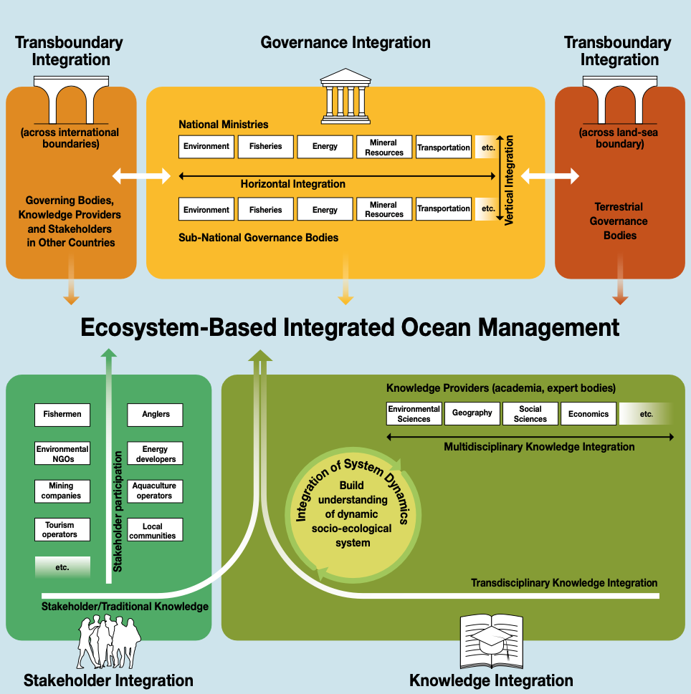
Fig. 1 | Five categories of integration in Ecosystem-based Integrated Ocean Management (reproduced from Lieberknecht¹).
Finally, knowledge integration emphasises drawing from multiple fields of academic expertise and from stakeholders, using tools and approaches to synthesise across the different sources of knowledge. As noted by Liebernecht¹, stakeholders “often hold valuable local or traditional knowledge of relevance…”, which means that, in practice, “… stakeholder integration and knowledge integration mechanisms may need to be linked”. The recognition of the value of local and traditional knowledge is an important part of addressing inequities (see principle on ‘Power Dynamics’). Knowledge integration is also required in order to develop a comprehensive understanding of the dynamics of the particular social-ecological system (SES). It is useful to distinguish between ‘data, model, and platform integrators’ and ‘conceptual integrators’ (who “broker the relationships within the broader team; manage creative tension and conflict; and help push boundaries especially up and down scales, as well as across disciplines and sectors”⁴). In building an understanding of a complex SES, ‘data, model, and platform integrators’ provide the technical skills, but the broader enabling environment for this work is what the ‘conceptual integrators’ create and lead. Developing a comprehensive understanding of a particular SES is required for “creating the information base needed to underpin sound management measures”¹. The complex dynamics and associated uncertainty motivate for modes of governance that are adaptive. For this reason, adaptive management strategies may be useful in order “to improve integration of best-available scientific information into flexible, responsive policy frameworks”⁵ (see Principle on ‘Governance Modes’).

References
- Lieberknecht, L. M. Ecosystem-Based Integrated Ocean Management: A Framework for Sustainable Ocean Economy Development. A report for WWF-Norway by GRID-Arendal, Norway, 1-54 (2020).
- Smythe, T. C. & McCann, J. Achieving integration in marine governance through marine spatial planning: Findings from practice in the United States. Ocean and Coastal Management 167(September 2018), 197–207 (2019).
- IPCC. Special Report on the Ocean and Cryosphere in a Changing Climate (eds Pörtner, H. O. et al.) (IPCC, 2019).
- Bammer, G. Disciplining Interdisciplinarity: Integration and Implementation Sciences for Researching Complex Real-World Problems (ANU Press, 2013).
- Petes, L. E., Howard, J. F., Helmuth, B. S. & Fly, E. K. Science integration into US climate and ocean policy. Nature Climate Change 4(8), 671-677 (2014).

Transformative ocean governance…
- …employs simple, robust and diverse metrics of social-ecological systems status.
Keywords: Metrics
Thematic links: Systemicity; Integration Imperative; Implementation; Importance of Diversity
The use of metrics to support ocean governance provides the opportunity to report on the state of a system, measure change and trigger an action. If metrics are properly used, they can support accountability, effective monitoring, reporting and learning purposes, as well as evidence-based decision making and scenario planning. In order for metrics to be effective they should be simple to use and understandable, capturing the human-ocean coupled system and allow the impact of our actions to be recorded over time and space. Metrics should be robust, maintaining the output even when subjected to external and unpredictable perturbations. The outcome of these metrics should stimulate actions to improve ocean health and have uptake and impact in the decision-making arena. For example, the Ocean Health Index¹ is an integrated metric that establishes reference points for ten widely accepted social-ecological goals that represent the benefits provided by healthy oceans. A standardised metric such as this facilitates ocean health comparisons across space (different geographic areas) as well as time (by measuring change at the same place). Alternatively, single metrics also have advantages, for example, measurements of total nitrogen have successfully facilitated the restoration of ecosystem services in the Tampa Bay estuary in the USA².
South Africa uses two headline metrics, threat status and protection level of species as well as ecosystems, to assist with policy recommendations for land, freshwater and marine management³. The use of ecological thresholds (thresholds of potential concern) to inform resource management are also useful metrics⁴ but are complex and require in depth knowledge of the non-linear dynamics in ecological systems. For example, bycatch limits which trigger move-on rules in fisheries require spatial and temporal data on fisheries catch and by-catch, and real-time management is required to implement management actions to limit by-catch.
Social indicators, such as those falling into the categories of ‘well-being’, ‘values’, ‘agency’ and ‘inequality’, can also be approximated via select quantitative social indices, including the Human Development Index and the Multidimensional Poverty Index⁵. These provide more realistic measures of quality of life than the commonly used metric of Gross Domestic Product (GDP) which ignores social costs, environmental impacts and income inequality⁶. Measures of progress in sustainable development and ocean economies include adaptations of, and additions to, the standardized system of national accounting, known as the System of National Accounts (SNA)⁷. SNA measures a country’s economy and can integrate the environment and natural resources using the System of Environmental Economic Accounting (SEEA). Based on these two international statistical standards (SNA and SEAA), the Global Ocean Accounts Partnership (GOAP) has published technical guidance on Ocean Accounting for Sustainable Development⁸.
New technologies, such as digital dashboards of metrics and indicators, facilitate rapid comparison of indicators that cannot be aggregated into a single metric⁷. Simple, robust and diverse metrics that can report on a system across the social-ecological continuum cannot replace these more complex metrics, but they are a much-needed additional tool that can provide clear and transparent information that speaks directly to a specific management action that can move the system closer to its desired state.

References
- Halpern, B. S. et al. An index to assess the health and benefits of the global ocean. Nature 488(7413), 615-620 (2012).
- Greening, H., Janicki, A., Sherwood, E. T., Pribble, R. & Johansson, J. O. R. Ecosystem responses to long-term nutrient management in an urban estuary: Tampa Bay, Florida, USA. Estuarine, Coastal and Shelf Science 151, A1-A16 (2014).
- Sink, K. J., Van der Bank, M., Majiedt, P., Harris, L., Atkinson, L., Kirkman, S. & Karenyi, N. South African National Biodiversity Assessment 2018 Technical Report Volume 4: Marine Realm. South African National Biodiversity Institute (2019).
- Foley, M.M. et al. Using ecological thresholds to inform resource management: current options and future possibilities. Frontiers in Marine Science 2, 95 (2015).
- Hicks, C. C. et al. Engage key social concepts for sustainability. Science 352(6281), 38–40 (2016).
- Costanza, R. et al. Development: Time to leave GDP behind. Nature 505(7483), 283-285 (2014).
- Fenichel, E. P., Addicott, E. T., Grimsrud, K. M., Lange, G. M., Porras, I. & Milligan, B. Modifying national accounts for sustainable ocean development. Nature Sustainability 3(11), 889–895 (2020).
- GOAP. Ocean Accounting for Sustainable Development, Detailed Technical Guidance for account compilers, data providers, and end-users (v0.9, global consultation). in: Bordt Michael, B. Milligan, T. Praphotjanaporn (Eds.), Ocean Accounting for Sustainable Development, Global Ocean Accounts Partnership (2021).

Transformative ocean governance…
- …requires inclusive and transparent integrated ocean management processes.
Keywords: Integrated Ocean Management
Thematic links: Integration Imperative; Social Inclusivity
The ocean is a dynamic and connected environment, and current sectoral instruments and organisations are failing to halt a decline in ocean health and ecosystem service delivery. An integrated approach to management, that conserves species, resources and manages human activities, is required. To achieve this, and promote a sustainable ocean economy, integrated ocean management needs to be ecosystem-based. Ecosystem-based integrated ocean management (henceforth referred to as IOM) is defined as “an adaptive approach for governing human activities at sea, rooted in the ecosystem approach, …, with a strong focus on improving the ecological status of the ocean and on strategic integration across governance, knowledge and stakeholder silos”¹. Integration is central to IOM, “including horizontal integration across sectoral governance structures, vertical integration across multiple tiers of administration, as well as integration of stakeholders, multi- and transdisciplinary integration (bringing together multiple spheres of knowledge), and integration across geographical scales and jurisdictional boundaries”¹ (see Principle on ‘Policy Integration’).
In addition to multi-sectoral and multi-institutional approaches, adaptive management is also central to IOM, and requires continuous and iterative improvement of management measures, as well as the application of the precautionary principle (given the current uncertainties associated with changing physical, biological and socio-ecological systems). Adaptive management enables a continuously evolving knowledge base to inform dynamic and targeted responses² (see Principle on ‘Governance Modes’). The goal of IOM is thus to “enable human society to live within ecological boundaries at planetary, regional, and local scales by halting and reversing biodiversity loss, pollution, climate change, ocean acidification, oxygen depletion and land and freshwater degradation while also lifting the social foundations to enable a life of quality for all”².
To achieve IOM, collaborative research programmes will be required “to develop new knowledge, tools, and techniques to facilitate an advanced understanding of social-ecological system dynamics and ensure a science-policy interface that advances adaptive decision- making based on this new understanding of social-ecological system dynamics”² (see Principle on ‘SES approaches’). Six opportunities to help achieve IOM and support sustainable ocean economies include: harnessing science and knowledge; establishing partnerships between public and private sectors (see Principle on ‘Business Engagement’); strengthening stakeholder engagement and stewardship; improving capacity building; implementing regulatory frameworks; and encompassing climate change and other environmental changes in adaptive management systems³.
Established management frameworks that can support IOM include ecosystem-based management, integrated coastal zone management, adaptive ocean management, dynamic ocean management, marine spatial planning, and area-based measures including marine protected areas⁴.

References
- Lieberknecht, L. M. Ecosystem-Based Integrated Ocean Management: A Framework for Sustainable Ocean Economy Development. A report for WWF-Norway by GRID-Arendal, Norway, 1-54 (2020).
- Hazin, C., Bueno, P., Gjerde, K., Boteler, B., Durussel, C. & Waugh, S. Integrated Ocean Management for the Conservation and Sustainable Use of ABNJ in the Southeast Atlantic and Southeast Pacific. STRONG High Seas Project (2022).
- Winther, J. G. et al. Integrated ocean management for a sustainable ocean economy. Nature Ecology & Evolution 4(11), 1451-1458 (2020).
- Winther, J.G. & Dai, M. Integrated Ocean Management. High Level Panel for a Sustainable Ocean Economy. Washington, DC: World Resources Institute. Available online at www.oceanpanel.org/blue-papers/integrated-ocean-management (2020).

Transformative ocean governance…
- …coordinates engagement between ocean businesses and other diverse ocean stakeholders.
Keywords: Business Engagement
Thematic links: Implementation; Importance of Diversity
Ocean resources are not equitably distributed globally and many of their benefits flow to a select few¹. This inequity is a systemic feature of ‘business as usual’ trajectories for ocean economies and is entrenched in existing political and economic systems that do not support the realisation of the Sustainable Development Goals (SDGs), particularly SDG 14. As the primary user of ocean resources, the private sector (particularly big business) has a critical role in promoting the sustainable development of oceans and coasts. “A sustainable ocean economy should respect the environment, protect human rights, improve human well-being, stimulate inclusion and gender equity, and prioritise recognition, diversity and equal access to resources to provide fair opportunities consistent with sustainable development. It should also address corruption and tax evasion, demand responsible and transparent business practices and create a shared economy that facilitates a fair redistribution of wealth and benefits. A sustainable ocean economy should be aware of environmental and social limits on growth and consider degrowth where appropriate”².
This vision for a sustainable ocean economy requires meaningful and coordinated stakeholder engagement processes between governments, policy makers and diverse ocean stakeholders. Stakeholder engagement is most often dominated by power dynamics, where stakeholders that demonstrate economic or political gains are most powerful (see Principle on ‘Power Dynamics’). Bringing together stakeholders to build collaboration is necessary to address priority ocean issues such as overfishing, pollution, marine debris, biodiversity protection, climate change impacts, maritime accidents and security, the introduction of invasive species, while improving marine science and observations. Stakeholder engagement improves risk management practices, streamlines policy and program development, enhances community confidence in the public and private sectors and enhances the capacity to innovate.
Guiding principles for responsible businesses and platforms for business engagement do already exist and should be mainstreamed into future ocean governance policies and laws. The United Nations (UN) guiding principles on business and human rights³ recognise the importance of business responsibility to respect human rights, and as a special initiative of the UN Secretary-General, the UN Global Compact encourages businesses to follow ten universally accepted principles in the areas of human rights, labour, environment and anti-corruption (see unglobalcompact.org). These ten principles are drawn from the Universal Declaration of Human Rights, the International Labour Organization’s Declaration on Fundamental Principles and Rights at Work, the Rio Declaration on Environment and Development, and the United Nations Convention Against Corruption. The UN General Assembly is currently drafting a legally binding instrument under the UN Nations Convention on the Law of the Sea on the conservation and sustainable use of marine biological diversity of areas beyond national jurisdiction (see un.org/bbnj). The High Level Panel for a Sustainable Ocean Economy, supported by the World Resources Institute, has published a series of Blue Papers that address “Transformations for a Sustainable Ocean Economy. A Vision for Protection, Production and Prosperity” (see oceanpanel.org).
Platforms that support coordinated engagement between ocean businesses and diverse ocean stakeholders include the Global Partnership for Business and Biodiversity of the Convention on Biological Diversity (see www.cbd.int/business/gp.shtml) and the International Union for Conservation of Nature's business and government engagements including its new Centre for Economy and Finance (see www.iucn.org/theme/business-and-biodiversity). Platforms for corporate ocean stewardship include the World Ocean Council, an international business alliance for corporate ocean responsibility (see www.oceancouncil.org) and the Seafood Business for Ocean Stewardship (SeaBOS) initiative, a collaboration among 10 global seafood companies to transform business operations for both wild capture fisheries and aquaculture production (see seabos.org/). Market incentive schemes such as Marine Stewardship Certification (see msc.org) and the Southern African Sustainable Seafood Initiative (see wwfsassi.co.za/), together with public-private partnerships such as the Global Sustainable Seafood Initiative (see ourgssi.org), all work towards the common goal of providing sustainable seafood.
This principle aims to increase the quality of the discourse, engagement and transparency between policy makers and ocean stakeholders providing a voice to all, irrespective of the power dynamics at play (see Principle on ‘Power Dynamics’).

References
- Sumaila, U. R. et al. Financing a sustainable ocean economy. Nature Communications 12(1), 1-11 (2021).
- Ocean Panel. Transformations for a Sustainable Ocean Economy. A Vision for Protection, Production and Prosperity. High Level Panel for a Sustainable Ocean Economy (2020).
- UN Guiding Principles on Business and Human Rights, UN Doc A/HRC/17/31, 2011

Transformative ocean governance…
- …encourages diverse incentives to promote and enable sustainable ocean use practices.
Keywords: Diverse Incentives
Thematic links: Implementation; Importance of Diversity; Sustainable Development
For integrated ocean management (IOM) to achieve transformative ocean governance, a combination of participative, economic and regulatory approaches is needed. This particularly requires inter-jurisdictional coordination (owing to the multiple institutional jurisdictions and biophysical boundaries dealt with) and inter-sectoral integration (owing to the many sectors using, and relying upon, coastal and marine resources in ways that interact both with one another and with the environment) (see Principles on ‘Policy Integration’, ‘IOM’ and ‘SES approaches’). The use of rigorously designed, functionally integrated and effective diverse incentives, ranging from legal (top-down), participative (bottom-up), economic (markets and economies), knowledge (collective learning) and interpretative (awareness-raising), can help ensure that sectors are managed and governed in ways that are appropriate to each sector and to the broader system. Examples of incentives under each of the aforementioned categories are provided in Table 1 below, which is based on the framework developed for Marine Protected Area Governance¹ (see also Case 4 in the main manuscript).

Table 1 | Examples of incentives, adapted from the full list of 36 incentives developed in the Marine Protected Area Governance framework¹.
Category | Incentive | Associated governance approach(es)
Legal | Capacity for enforcement | Top-down (the state steers)
Legal | Cross-jurisdictional coordination | Top-down (the state steers)
Legal | Legal adjudication platforms | Top-down (the state steers)
Participative | Rules for participation | Bottom-up (people steer)
Participative | Neutral facilitation | Bottom-up (people steer)
Participative | Independent arbitration panels | Bottom-up (people steer)
Economic | Assigning property rights | Market-based
Economic | Investing MPA income/funding in facilities for local communities | Market-based
Knowledge | Promoting collective learning | Supporting all three approaches (i.e. top-down, bottom-up, and market-based)
Knowledge | Agreeing on approaches for addressing uncertainty
Interpretative / communication | Raising awareness
Interpretative / communication | Promoting recognition of benefits, regulations and restrictions

The categories in Table 1 are useful for distinguishing between diverse types of incentives, but these categories are not absolute: for example, ‘assigning property rights’ may be categorised as a market-based incentive, but without the ‘capacity for enforcement’ from the state, these property rights will likely not be respected. The value of encouraging diverse incentives for transformative ocean governance is consistent with the broader point that “the key to resilience is diversity – both of species in ecosystems and incentives in governance systems”¹.
An applied example regarding fishing subsidies is useful here²: “The prohibition of harmful fishing subsidies would likely have further consequences on other aspects of the blue economy such as aims seeking to advance technical and human capacity, livelihoods, and well-being. A reduction in ‘perverse subsidies’ may open opportunities to redirect public funding to alternative modes of support such as investment in the research and promotion of ecologically sound methods of fishing and aquaculture or the provision of specialised health and education programmes for fishers^{3,4}. While subsidy removal is thought essential to protect the productivity of global fisheries and therefore the right to food for fish protein dependent communities⁵, adverse consequences are also possible, such as potential (likely temporary) changes in domestic fish supply for these same communities⁶. These negative impacts although temporary could cause progress towards both the SDGs and blue economy aims to falter. Programmes for the removal of fishing subsidies should be considered as part of a broader strategy to mitigate against negative consequences for small-scale fishing communities and women that may have been reliant to some degree on subsidised fisheries. Again, such a programme could incorporate activities and capacity enhancement for diversification in addition to education and health programmes that support progress towards the SDGs and a wide range of blue economy aims⁶”.

References
- Jones P. J. S. & Long S. D. Analysis and discussion of 28 recent marine protected area governance (MPAG) case studies: challenges of decentralisation in the shadow of hierarchy. Marine Policy 127, 104362 (2021).
- Niner, H. et al. Issues of context, capacity and scale: Essential conditions and missing links for a sustainable blue economy Environmental Science and Policy 130, 25-35 (2022).
- Sumaila, U. R. et al. WTO must ban harmful fisheries subsidies. Science 374, 544 (2021).
- Sumaila, U. R. et al. Ocean Finance: Financing the Transition to a Sustainable Ocean Economy. (World Resources Institute, 2020).
- Villasante, S. et al. Strengthening European Union fisheries by removing harmful subsidies. Marine Policy 136, p.104884 (2022).
- Harper, S. & Sumaila, U. R. Distributional Impacts of Fisheries Subsidies and their reform: case studies of Senegal and Vietnam (IIED Working Paper, 2019) at https://pubs.iied.org/sites/default/files/pdfs/migrate/16655IIED.pdf

Transformative ocean governance…
- … promotes sustainable and inclusive technological and other innovation.
Keywords: Technology
Thematic links: Social Inclusivity; Sustainable Development
Technological innovation can support transformative ocean governance in many ways. For example, satellite tracking can be incorporated into marine protected area enforcement and used for vessel tracking to help reduce illegal, unregistered, and unauthorised fishing¹. Technology can also support management innovations, including Integrated Ocean Management (IOM) (see Principle on ‘IOM’) and dynamic ocean management (see Principle on ‘Governance Modes’), as illustrated in Table 2.

Table 2 | Examples of how technologies can enable management innovations, with a particular focus on data systems and management (reproduced from Leape et al.¹).
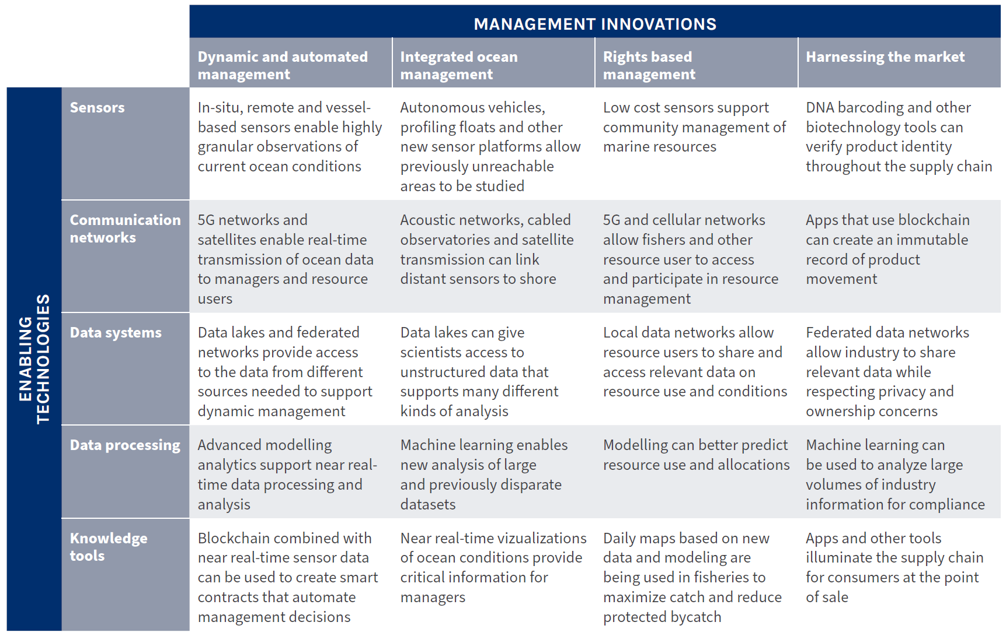

Technological innovation does, however, come with a number of risks. These risks include the way in which technologies can end up excluding specific communities, such as small-scale fishers², and the way in which the development of new technologies may become an end in and of itself and stymie governance transformation (for example, the development of data portals and GIS technologies was a limiting factor in marine spatial planning development in the US, but when implemented, had a minimal impact in reforming governance processes³.
For the transformative potential to materialize, technological innovation needs to take into account multiple dimensions of sustainability, equity issues (access, availability, know-how) and be co-developed with end users and those that may be affected by the technology. It is equally important to consider other sources and forms of innovation beyond technology, such as social, cultural and economic innovations. At the same time, small-scale fishers’, indigenous peoples’ and other communities’ local technologies can support sustainable use, as well as contribute to protect indigenous and local knowledge and support further local innovation, as well as protecting human rights, whereas technologies promoted by international donors may be ill-adapted to local contexts and threaten the survival of local knowledge systems⁴. International human rights standards suggest prioritizing the development of “simple and inexpensive technologies that can improve the life of marginalized populations rather than innovations that disproportionately favour educated and economically affluent individuals and regions”⁵.
As part of transformative ocean governance, it is also necessary to grapple with power dynamics that can be entrenched in a particular technology (or set of technologies). For example, recent advances in gene sequencing technologies and bioinformatics are underpinning emerging biotechnologies within the field of ocean genomic research. As noted by Blasiak et al.⁶: “the capacity to undertake genomic research and to access and use sequence data is inequitably distributed among countries, highlighting an urgent need to build capacity, promote inclusive innovation and increase access to affordable technologies” (see principles on ‘Human Rights’ and ‘Power Dynamics’).
A further aspect of technological innovation with complex governance dimensions is marine technology transfer. The need to increase international cooperation on marine technology transfer has been broadly recognised⁷, particularly in light of the fact that the United Nations Convention on the Law of the Sea (UNCLOS)⁸ provisions on technology transfer are some of the least-implemented of the Convention (A/65/164 at par 28; A/66/119 at par 36; A/69/177 at par 75). However, the implementation of technology transfer raises the vexing question of intellectual property rights. Developed countries are generally opposed to the transfer of any technologies that are subject to intellectual property rights, arguing that, as per Article 267, when promoting the development and transfer of marine technology, states shall have due regard for all legitimate interests, which includes the rights and duties of holders, suppliers and recipients of marine technology transfer. On the other hand, developing countries regard the exercise of intellectual property rights to be contrary to the UNCLOS mandate to promote the development and transfer of marine science and technology on terms and conditions that are fair and reasonable, as provided by Article 266(1). This dichotomy complicates achieving the objective of marine technology transfer.

References
- Leape, J., Abbott, M. & Sakaguchi, H. Technology, Data and New Models for Sustainably Managing Ocean Resources. High Level Panel for a Sustainable Ocean Economy. Washington, DC: World Resources Institute. https://oceanpanel.org/publication/technology-data-and-new-models-for-sustainably-managing-ocean-resources/ (2020).
- Petrik, M. & Raemaekers, S. The Case for Supporting Small-Scale Fisheries Governance Through ICT. South African Institute of International Affairs. (Policy Briefing 177, 2018).
- Boucquey, N., Fairbanks, L., Martin, K. S., Campbell, L. M. & McCay, B. The ontological politics of marine spatial planning: Assembling the ocean and shaping the capacities of ‘community’ and ‘environment’. Geoforum 75, 1-11 (2016).
- Morgera, E. & Ntona, M. Linking Small-Scale Fisheries to International Obligations on Marine Technology Transfer Marine Policy 93, 214-222 (2018).
- UNGA. Report of the Special Rapporteur in the field of cultural rights: the right to enjoy the benefits of scientific progress and its applications (UN Doc A/HRC/20/26, 14 May 2012).
- Blasiak, R. et al. The ocean genome and future prospects for conservation and equity. Nature Sustainability 3(8), 588-596 (2020).
- Minas, S. Technology Transfer for the High Seas: Potential Modalities for Technology Transfer Under the International Legally Binding Instrument. Peking University School of Transnational Law Research Paper (2020).
- United Nations Convention on the Law of the Sea (UNCLOS) (UNCLOS, 1982).

Transformative ocean governance…
- …leverages international mechanisms that support inclusive decision-making for sustainable development
Keywords: International Mechanisms
Thematic links: Implementation; Social Inclusivity; Sustainable Development
The term ‘international mechanisms’, as deployed here, encompasses a range of mechanisms from international agreements to accountability-oriented mechanisms, in addition to commissions, corporate alliances, and global targets, amongst others. Table 1 provides a high-level summary of different types of international mechanisms, with a rough distinction being made between mechanisms that apply globally versus those that apply primarily (or exclusively) at a regional level.

Table 1 | Examples of international mechanisms at global and regional scales.
Global or regional? | Mechanism | Examples of mechanisms | Source(s)
Global and regional | International agreements | UN Fish Stock Agreement: decision-making over highly migratory and straddling fish stocks + establishes formal arrangements for regional cooperation and benefit sharing | Haas et al.¹
Global | Formal institutions created by treaties | MARPOL: International Convention for the Prevention of Pollution from Ships | Haas et al.¹
Global | Compliance and enforcement mechanisms | The International Convention on Standards of Training, Certification and Watchkeeping for Seafarers | Haas et al.¹
Global | Accountability-oriented mechanisms | Marine Stewardship Council Certification: provides independent legitimacy of products from certified fisheries | Haas et al.¹
Global and regional | Co-operative mechanisms between regional and global agreements | Arctic Council: “a high-level intergovernmental forum that promotes cooperation, coordination and interaction among Arctic States with 8 Arctic States and 6 Arctic indigenous organizations acting as permanent participants” (Haas, 2022: 258) | Haas et al.¹
Regional | Regional Seas Programmes (RSP) | Western Indian Ocean (WIO) RSP | Rochette et al.², Haas et al.³
Regional | Regional Fishery Bodies (RFBs) and Regional Fisheries Management Organizations (RFMOs) | Pacific Salmon Commission (PSC), which features extensive participation of indigenous groups as part of the management and conservation of salmon stocks on the northwest coast of America | Rochette et al.², Haas et al.³
Regional | Large Marine Ecosystems (LMEs) | Agulhas-Somali Current LME, encompassing much of the WIO | Rochette et al.², Haas et al.³
Regional | Ecosystem and biodiversity assessments | International Union for the Conservation of Nature (IUCN) ‘Red List’ for threatened and endangered species: Regional Red List Assessment for the Mediterranean region | https://www.iucnredlist.org/regions/mediterranean
Regional | Regional commissions | The Sargasso Sea Commission: aiming to encourage and facilitate voluntary collaboration toward the conservation of the Sargasso Sea | Freestone⁴
Global and regional | Funding mechanisms | Global Environmental Facility (GEF) funding of LMEs around the world: Agulhas-Somali Current LME in the WIO | Rochette et al.²
Global | Corporate alliances | The World Ocean Council (WOC): international business alliance for corporate ocean responsibility | www.oceancouncil.org
Global | Corporate alliances | The Seafood Business for Ocean Stewardship (SeaBOS) initiative: a collaboration of 10 of the largest global seafood companies | seabos.org/
Global | Goals and targets | The UN Sustainable Development Goals (SDGs): SDG14 (‘Life under water’) | Haas et al. ¹
Global | Goals and targets | The Convention on Biological Diversity (CBD)’s Aichi Biodiversity Targets: Target 6 (sustainable fishing) and Target 11 (conservation of coastal and marine areas). | Heinrich Boell Stiftuing⁵
Global | Goals and targets | The Convention on Biological Diversity (CBD)’s New Global Framework for Managing Nature Through 2030 (30x30 targets). | www.cbd.int/article/draft-1-global-biodiversity-framework

The various bodies of the United Nations (UN) system (see Figure 1) are central to the international governance structures for the ocean. Amongst other roles, these various UN bodies provide legal and technical support, monitoring, judicial and quasi-judicial settlement of disputes. UN bodies can support governments in advancing their ocean governance in human rights-centred ways (see Principle on ‘Human Rights’). For instance, the UN Special Rapporteurs on Human Rights and the Environment, on Human Rights Defenders and on the Right to Food can carry out in-country missions to assess whether international human rights are respected in the context of ocean governance and provide recommendations for improvement. Equally, the Food and Agriculture Organisation (FAO), the United Nations Environment Programme (UNEP) and other international agencies have developed guidance, capacity-building tools and other support that can help communities, civil society, governments, law-makers and judges in decision-making. In addition, regional bodies, such as human rights tribunals, and economic integration organizations such as the European Union (EU), the African Union (AU), the Association of Southeast Asian Nations (ASEAN) and the Caribbean Community Secretariat (CARICOM), can also provide enabling environments and institutional support for inclusive and transparent decision-making.
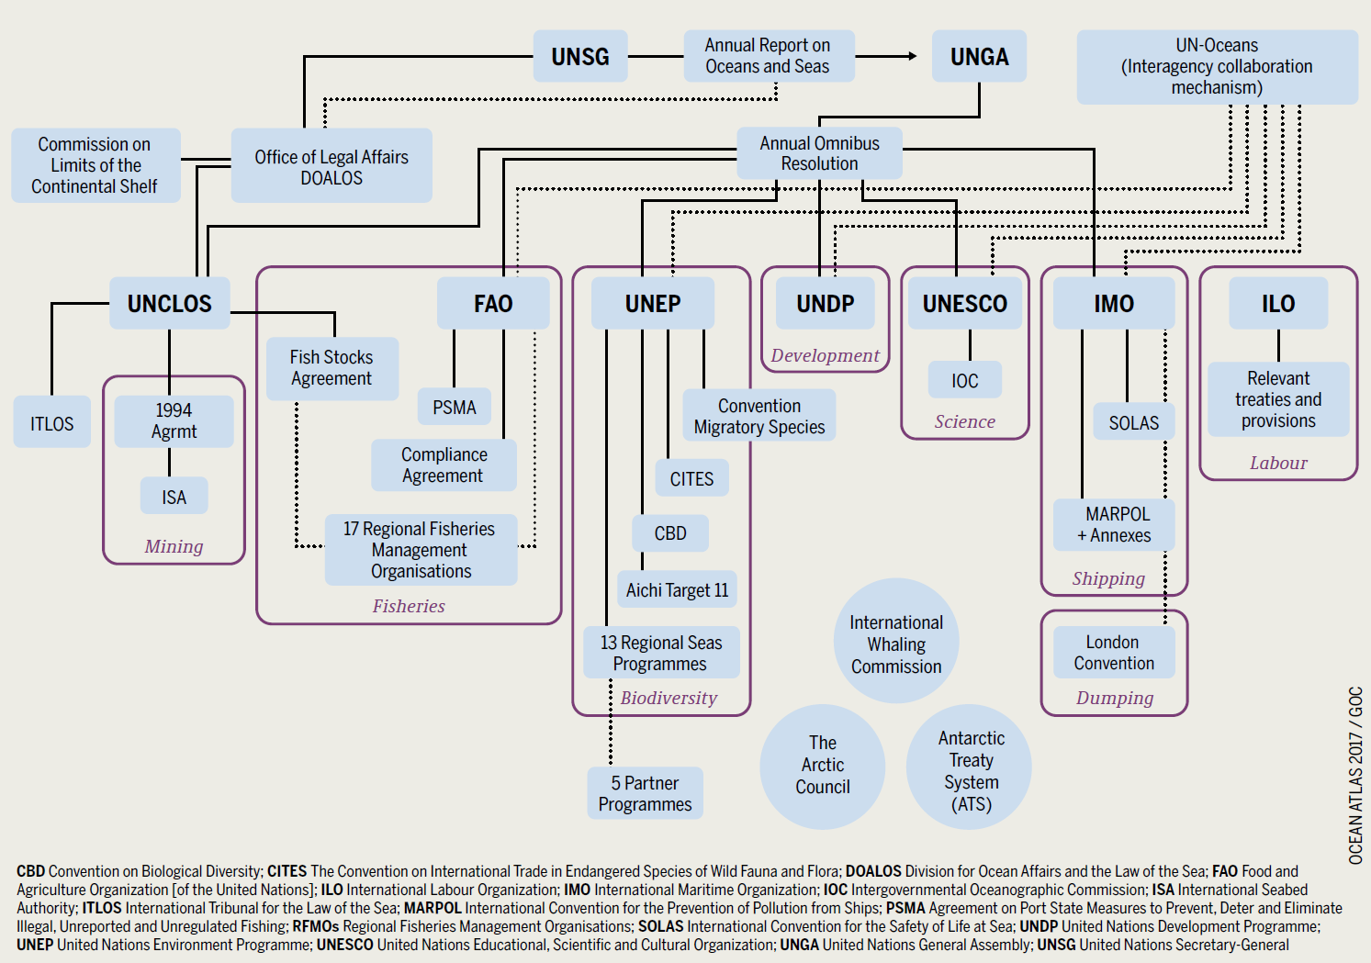
Fig. 1: International governance structures for the ocean. Reproduced from The Ocean Atlas (Heinrich Boell Stiftuing⁵).
Other global organisations, outside of the UN system, also contribute to the “organisational and infrastructural support for… transnational ocean regulations”⁶ and, as such, are also important to the international mechanisms that can be leveraged as part of transformative ocean governance. One example is the World Trade Organisation (WTO), which, in June 2022, agreed to end fishing subsidies as part of its ‘WTO Geneva Package’. Policy positions agreed upon by member countries included (a) the end of national subsidies for any fishing operations supporting or participating in Illegal, Unreported and Unregulated (IUU) fishing; (b) prohibiting national subsidies for fishing on the high seas anywhere not managed by regional fishing management bodies; and (c) making provisions for developing countries, to assist them in migrating to the requirements of the new treaty (see https://www.iucn.org/news/marine-and-polar/202206/iucn-applauds-wto-trade-ministers-decision-fishing-subsidies).
Many trans-national organisations function at regional levels (see 1), both driven by UN bodies (such as the UNEP Regional Seas Programmes) and driven by other organisations, as many of the Regional Fisheries Management Organizations (RFMOs) are.
A major challenge for transformative ocean governance is the fragmented nature of global ocean governance, which, as shown in Figure 1, is even fragmented within the UN system. It is broadly recognised that “there is too little international agreement, consensus, and cooperation... [and] agreed-upon rules and goals are not implemented, or not implemented effectively”⁵. For this reason, some experts recommend that a ‘meta-governance institution’ may be required as “a rule-setting global institution to represent a common world view or value system, and to create good governance-inspired flexible frameworks for the implementation, monitoring and management of blue economy activities”⁷. Regardless of what form such an agency takes (e.g. whether it is restructured from existing global institutions), the governance systems will need to “be coherent, reflexive and responsive to rapidly shifting ocean dynamics in time and space to facilitate decision-making in deep uncertainty”⁸ (see Principle on ‘Governance Modes’).
Leveraging international mechanisms can be critical to support local-level and national-level human rights-holders when the national and local government are lagging behind in implementing their international obligations on marine biodiversity, the protection of the marine environment and human rights. Governments may lag behind for a number of reasons, such as lack of capacity, lack of political will and pressure from powerful industry sectors, including international legal constraints arising from the need to protect the expectations of foreign investors who benefit from strong protection under international investment law⁹ (see also Principle on ‘Power Dynamics’).

References
- Haas, B. et al. The future of ocean governance. Reviews in Fish Biology and Fisheries 32, 253–270 (2022).
- Rochette, J., Billé, R., Molenaar, E. J., Drankier, P. & Chabason, L. Regional oceans governance mechanisms: A review. Marine Policy, 60, 9–19 (2015).
- Haas, B., Haward, M., McGee, J. & Fleming, A. Regional fisheries management organizations and the new biodiversity agreement: Challenge or opportunity? Fish and Fisheries 22(1), 226–231 (2021).
- Freestone, D. The Sargasso Sea Commission: An Evolving New Paradigm for High Seas Ecosystem Governance? Frontiers in Marine Science 8, 1–10 (2021).
- Heinrich Böll Stiftung. Ocean Atlas. facts and figures on the threats to our marine ecosystem. (Heinrich Böll Foundation Schleswig-Holstein, the Heinrich Böll Foundation (national foundation) and the University of Kiel’s Future Ocean Cluster of Excellence, 2017).
- Adewumi, I. J. Exploring the Nexus and Utilities Between Regional and Global Ocean Governance Architecture. Frontiers in Marine Science 8, 1–22 (2021).
- Brodie Rudolph, T., Ruckelshaus, M., Swilling, M., Allison, E. H., Österblom, H., Gelcich, S. & Mbatha, P. A transition to sustainable ocean governance. Nature Communications 11(1), 1-14 (2020).
- Martin, M. A. et al. Ten new insights in climate science 2021: a horizon scan. Global Sustainability 4(e25), 1–20 (2021).
- Cotula, L. & Berger, T. ‘Blue economy’: why we should talk about investment law. (IIED Briefing, 2020).

Transformative ocean governance…
- …advocates for dynamic, inclusive and adaptive modes of governance.
Keywords: Governance Modes
Thematic links: Systemicity, Social Inclusivity
An urgent need to adopt more integrated ocean management (IOM) approaches has been recognised in policies such as the United Nations Sustainable Development Goals (SDGs) (see Principle on ‘Integrated Ocean Management’). Policies and laws extend over multiple levels and consist of several overarching, as well as sector-specific, instruments, including international conventions, regional agreements, as well as national legislation and policies that address human activities in various sectors. However, these policies and their goals need to be operational at local and regional scales, and national policies tend to be inconsistent and uncoordinated. In addition, management approaches (at any level) need to be dynamic, inclusive and adaptive and should address human and environmental needs and rights in transparent frameworks.
Given the inherent complexity in, and dynamic nature of, marine systems¹, as well as the complexity of governance systems that regulate or inform ocean use², governance modes require dynamic approaches that can respond to shifts in social-ecological systems. Dynamic ocean management is defined as “management that changes rapidly in space and time in response to the shifting nature of the ocean and its users based on the integration of new biological, oceanographic, social and/or economic data in near real-time”³. For example, dynamic management measures can increase the efficiency and efficacy of fisheries management⁴ and can be applied across spatial and temporal scales to reduce conflicts among ocean users. Existing legal capacity for voluntary dynamic ocean management practices is, however, limited and can face legal challenges owing to intellectual property and data protection concerns⁵.
Governance modes also require flexibility and openness to new knowledge and needs, as well as the recognition of the value, and respectful integration and inclusion, of indigenous and local knowledge. Collaborative and inclusive forms of ocean governance include mechanisms such as Locally Managed Marine Areas (LMMEs)⁶, and marine networks (both formal and informal), which provide spaces for learning and collaborative and adaptable approaches to address the complexity in governing changing oceans⁷.
Although legal systems aim for stability and foreseeability, they need to adapt to the status of ecosystems and the non-linear reactions from both human and non-human pressures on these systems. Adaptation comes from learning⁸ and recognises different forms of knowledge that need to be considered for inclusivity and dynamic responses from all actors in marine social-ecological systems. The emphasis of many adaptive management frameworks, such as Strategic Adaptive Management⁹, is on dealing with the uncertainties of dynamic and unpredictable systems by iteratively testing assumptions and progressively improving management via structured cycles of planning, implementing, monitoring, and adjusting. More broadly, adaptive co-management builds resilience in social-ecological systems¹⁰, and together with diverse incentives (see Principle on ‘Diverse Incentives’), can increase the robustness of these systems to expected and unexpected perturbations.

References
- Long R. D., Charles, A., Stephenson, R. L. Key principles of marine ecosystem-based management. Marine Policy. 57, 53–60 (2015).
- Boyes, S. J. & Elliott, M. Marine legislation–The ultimate ‘horrendogram’: International law, European directives & national implementation. Marine Pollution Bulletin 86(1-2), 39-47 (2014).
- Maxwell, S. M. et al. Dynamic ocean management: Defining and conceptualizing real-time management of the ocean. Marine Policy 58, 42–50 (2015).
- Dunn, D. C., Maxwell, S. M., Boustany, A. M. & Halpin, P. N. Dynamic ocean management increases the efficiency and efficacy of fisheries management. Proceedings of the National Academy of Sciences 113(3), 668-673 (2016).
- Hobday, A. J. et al. Dynamic ocean management: Integrating scientific and technological capacity with law, policy and management. Stanford Environmental Law Journal 33(2),125–165 (2014).
- Diz, D., Johnson, D., Riddell, M., Rees, S., Battle, J., Gjerde, K., Hennige, S. & Roberts, J .M. Mainstreaming marine biodiversity into the SDGs: the role of other effective area-based conservation measures (SDG 14.5). Marine Policy 93, 251-261 (2018).
- Dalton, K., Skrobe, M., Bell, H., Kantner, B., Berndtson, D., Gerhardinger, L. C. & Christie, P. Marine-related learning networks: shifting the paradigm toward collaborative ocean governance. Frontiers in Marine Science 7, 952 (2020).
- Van Assche, K., Hornidge, A. K., Schlüter, A. & Vaidianu, N. Governance and the coastal condition: Towards new modes of observation, adaptation and integration. Marine Policy 112, 103413 (2020).
- Kingsford, R. T. & Biggs, H. C. Strategic Adaptive Management (SAM): guidelines for effective conservation of freshwater ecosystems in and around protected areas of the world. IUCN WCPA Freshwater Taskforce, Australian Wetlands and Rivers Centre, Sydney (2012).
- Olsson, P., Folke, C. & Berkes, F. Adaptive comanagement for building resilience in social–ecological systems. Environmental Management 34(1), 75-90 (2004).

Transformative ocean governance…
- …requires appropriate responses to existing and potential power dynamics.
Keywords: Power dynamics
Thematic links: Social Inclusivity; Implementation
Transformative ocean governance will require action to address persistent and wicked marine governance problems that are often derived from complex, sometimes unacknowledged, power dynamics. For example, power issues related to path dependency, bounded rationality or vested interests have been identified as problems that inhibit the implementation of transformative approaches to marine spatial planning and ecosystem-based managemenet¹. Without transformative governance, the growth of the ocean economy will likely continue to exacerbate existing inequalities². These inequalities are reflected in who has access to which coastal and marine resources (including the entitlements and/or rights to access and use these resources), along with who is involved in decision-making and to what degree this involvement has influence. Given the historical legacies of colonialism and dispossession prevalent in much of the world, disadvantaged groups who were historically maligned can continue to be caught in poverty traps (in systems terms, this is the competitive exclusion principle at work, i.e. a reinforcing feedback loop that rewards the winner of a competition with the means to win further competitions, resulting in a ‘rich get richer, and the poor get poorer’ dynamic)³.
By explicitly identifying the need to incorporate responses to power, this principle acknowledges that an awareness of power dynamics has to be a part of transformative ocean governance. In addition, when power imbalances are identified as negatively impacting on human rights (see Principle on ‘Human Rights’), and other common goods, measures should not only be limited to acknowledging but also to redressing these imbalances (which is also crucial given the ongoing effects of colonial legacies of dispossession).
The reality is that, on a large scale, powerful actors are able to influence the public agenda in order to “frame big choices, to influence legislators, and to get laws enacted or prevent them from being enacted”⁴. These power dynamics can manifest in multiple ways, such as in the negotiations between richer and poorer countries over shared resources and in the allocation of fishing rights between large corporations and small-scale fishers. Political institutions are biased towards those who have experience in using them (and the resources to do so). They also favour those with greater lobbying capacity and the ability to produce presently favoured political–economic effects (see Principle on ‘Business engagement’).
A further manifestation of power dynamics is the disadvantaging of certain individuals (and groups of individuals) in participatory processes. This can occur via participatory processes being undertaken only in English, the denigration of Traditional Knowledge Systems, and/or scientific concepts not being translated into formats amenable to non-scientific audiences, for example. Addressing these manifestations of power dynamics could lead to greater ‘epistemic justice’⁵, in addition to environmental and social justice.
In order to address power imbalances, proponents of transformative ocean governance will need to approach power dynamics in a very practical way, aiming to work and compromise across competing positions⁶, bearing in mind the question of “who does what to whom for whose benefit?”⁷. This question can be expanded into four sub-questions around the nature of power: (1) Where are we going?; (2) Who gains and who loses, and by which mechanisms of power?; (3) Is it [this development / change / transformation] desirable? And (4) What should be done?⁸
Actively seeking to address power dynamics requires resources and commitment. For example, hiring language interpreters, budgeting for translating scientific documents into non-technical formats, and contracting professional facilitators for multi-stakeholder engagements. These all require financial and time commitments to manage difficult processes and not just to focus on producing discrete products. Many of the required capacities, such as skilled facilitation, process design, language skills, etc., are in short supply in the ocean sector, particularly in developing countries where the same capacities are required most.

References
- Kelly, C., Ellis, G. and Flannery, W. Conceptualising change in marine governance: learning from transition management. Marine Policy 95, 24-35 (2018).
- Brodie Rudolph, T., Ruckelshaus, M., Swilling, M., Allison, E. H., Österblom, H., Gelcich, S. & Mbatha, P. A transition to sustainable ocean governance. Nature Communications 11(1), 1-14 (2020).
- Meadows, D. H. Thinking in Systems: A Primer (ed. Wright, D.) (Earthscan, 2011).
- Reich, R. B. The System: Who rigged it, how we fix it. (Vintage, 2020).
- Fricker, M. Epistemic Injustice: Power and the Ethics of Knowing. (Oxford University Press, 2007).
- Agnew, J. Waterpower: Politics and the Geography of Water Provision. Annals of the Association of American Geographers 101(3), 463–476 (2011).
- Guess, R. Philosophy and real politics. (Princeton University Press, 2008).
- Flyvbjerg, B. Making Social Science Matter: Why social inquiry fails and how it can succeed again. (Cambridge University Press, 2001).

Transformative ocean governance…
- requires urgent action across governance levels.
Keywords: Urgent Action
Thematic links: Integration Imperative; Implementation
The value of a blue, or oceans economy, has become an integral part of the sustainable development discussion and thus gained significant political weight. In addition to political weight, the demand on ocean resources and services has increased. The cumulative impacts on the ocean have amplified and the rapid deterioration of ocean health now signals that urgent action is required¹. The United Nations (UN) General Assembly has called for global action on an urgent basis for the conservation and sustainable use of the oceans, seas and marine resources². This urgency is being echoed at regional levels, for example, in the Western Indian Ocean, calling on leaders to take steps towards an inclusive, sustainable blue economy, in the interest of the people in the region and the environment that supports them³. Focal points for urgent action recommended by the UN include strengthening cooperation, policy coherence and coordination amongst institutions, and the promotion of effective and transparent multi-stakeholder partnerships². Comprehensive strategies should be developed to raise awareness of the natural and cultural significance of the ocean including ocean education and the provisioning of resources for ocean research. Urgent action is required to prevent and significantly reduce marine pollution of all kinds while enhancing sustainable fisheries management and ending destructive fishing practices and illegal, unreported, and unregulated fishing. The use of area-based management tools such as marine protected areas, and cross-sectoral approaches such as marine spatial planning and integrated coastal zone management can all support this urgent action (see Principle on ‘Policy Integration’). Approaches such as systems thinking and modelling can assist stakeholders to identify immediate actions that will provide long-term benefits (to oceans and people) and to weigh them against actions that will provide short-term benefits at the cost of long-term sustainability⁴. For example, the uncertainty of environmental impacts, versus the perceived economic benefits, of deep-seabed mining⁵ present a complex problem that requires a systems approach to guide decision-making. Uncertainty requires a precautionary approach, and without urgent action across governance levels to move towards systemic approaches and circular economies, the short-term economic gains of mining activities will drive decisions. Adaptive modes of ocean management are also required to respond to changes in dynamic marine social-ecological systems (see Principle on ‘Governance modes’). All these measures are required for the timely and effective implementation of SDG 14².

References
- Halpern, B. S. et al. Spatial and temporal changes in cumulative human impacts on the world’s ocean. Nature Communications 6(1), 1-7 (2015).
- Obura, D., Smits, M., Chaudhry, T., McPhillips, J., Beal, D. & Astier, C. Reviving the Western Indian Ocean economy: actions for a sustainable future. World Wide Fund for Nature (Formerly World Wildlife Fund), Gland, Switzerland, 1-63 (2017).
- United Nations, General Assembly. (2017). Resolution adopted by the General Assembly on 6 July 2017. Our ocean, our future: call for action. A/RES/71/312.
- Sterman, J. Stumbling towards Sustainability: Why organizational learning and radical innovation are necessary to build a more sustainable world - but not sufficient (eds Henderson, R., Tushman, M. & Gulati, R.) Organizational and Strategic Change and the Challenge of Sustainability (pp. 51–80) (Oxford University Press, 2015).
- Levin, L. A., Amon, D. J. & Lily, H. Challenges to the sustainability of deep-seabed mining. Nature Sustainability 3(10), 784-794 (2020).

