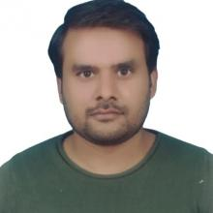
Dr. Mian Muhammad Sadiq Fareed is currently working as an Associate Researcher at The Institute of Artificial Intelligence and Marine Robots, Dalian Maritime University, Dalian, China. Previously, he worked as an Assistant Professor at the Department of Computer Science, Khwaja Fareed University of Engineering and Information Technology. He also worked as an Associate Professor at the School of Information Science, Guilin University of Technology, Guilin, China. He has completed a Post-doctoral Research Fellowship at the Computer Vision and Pattern Recognition Lab in the School of Electronics and Information Engineering, Xi’an Jiaotong University, Xi’an, China. Previously, he completed Ph.D. in Computer Science and Technology from Xi'an Jiaotong University, Xi’an, China. His research focuses on analyzing dynamic visual data, including video analysis and visualizations of multi-view data. His research awards and honors include a four-year scholarship from Xi’an Jiaotong University as an outstanding Ph.D. student, the best Ph.D. student of the year 2015, and a postdoctoral fellowship. Dr. Fareed has published in more than twenty journals and international conferences and working as an Academic Editor in the Journal of Healthcare Engineering.

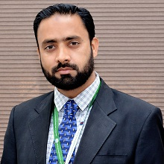
I received my Bachelor’s degree from the National Institute of Computer & Advance Studies in 2003, then my receid Master’s degree in 2005 from Bahauddin Zakariya University, Multan. From 2005 to 2009, I worked as a Manager IT and Network Administrator in various Multinational Companies. In 2009, I got Ph.D.hD Scholarship from China and earned my Ph.D. Degree from Chongqing University in 2012. During my Ph.D. study, I proposed a proactive mechanism to improve TCP Congestion Control. I joined Islamia University Bahawalpur as an Assistant Professor in August 2012. During my supervision and teaching there, I have worked and formulated an efficient routing stability mechanism in VANET. I also devised an adaptive TCP-ICCW Congestion Control Mechanism for quality of service in Renewable WSN, published in IEEE Sensors Journal. I joined Khwaja Fareed University of Engineering & IT in Feb 2016. My hobbies include tourism, traveling, playing badminton and cricket, and watching sports.

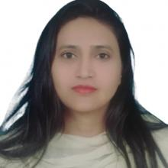
Dr. Gulnaz Ahmed is currently an Associate Researcher at The Institute of Artificial Intelligence and Marine Robots, Dalian Maritime University, Dalian, China. Previously, she worked as an Assistant Professor in the Department of Computer Science, Khwaja Fareed University of Engineering and Information Technology. She completed her Master’s in Computer Science with a specialization in telecommunications and Networking from Bahria University, Pakistan, in 2013. She achieved the highest CGPA in Master’s Study and was awarded a Gold Medal and a merit-based scholarship from Bahria University, Pakistan. In 2014, she was selected for the International Young Talent scholarship by Xian Jiaotong University and completed her Ph.D. in 2017. In 2017, she achieved the Best Student of the Year Award for annual performance from the School of International Education, Xian Jiaotong University, China. She has been awarded a SAN QIAN scholarship by the provincial government. She has completed many national-level and provincial-level projects during her post-doctoral fellowship.

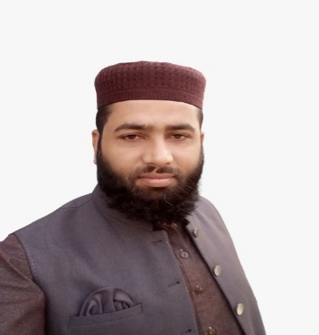
Saqib Mahmood was born in Rahim Yar Khan, Pakistan. He is working as an Assistant lecturer at the Department of Computer Science, Khawaja Fareed University of Engineering and Information Technology. He has completed a Master’s degree at Khawaja Fareed University of Engineering & Information Technology. In 2018-2020, he received a Distinction certificate (gold medalist) for his Master’s Degree. He has about five years of experience as a teacher. His current research interests include image processing, Computer Vision, Deep Learning, federated learning, and data science.

